Supplementary Table S1. Study-level derivation and transformation of overall, physical, and mental HRQoL outcomes used in the meta-analysis

Study | Instrument | Original reported data | Derived outcome | Transformation | Exercise group change | Control group change
1.Juesas et al., 2023 | SF-36 | PF, RP, BP, GH, VT, SF, RE, MH | Overall HRQoL change | [(PF+RP+BP+GH+VT+SF+RE+MH)/8]post − [(PF+RP+BP+GH+VT+SF+RE+MH)/8]baseline; SDchange estimated assuming inter-domain correlation r=0.50 | 7.49 ± 14.10  (n=35) | 2.28 ± 15.24  (n=12)
1.Juesas et al., 2023 | SF-36 | PF, RP, BP, GH | Physical HRQoL change | [(PF+RP+BP+GH)/4]post− [(PF+RP+BP+GH)/4]baseline | 6.02 ± 9.36 | 2.38 ± 11.95
1.Juesas et al., 2023 | SF-36 | VT, SF, RE, MH | Mental HRQoL change | [(VT+SF+RE+MH)/4]post− [(VT+SF+RE+MH)/4]baseline | 8.96 ± 9.33 | 2.18 ± 8.85
2.Kekäläinen et al., 2018 | WHOQOL-BREF | Physical QoL, Psychological QoL, Social QoL, and Environmental QoL | Physical HRQoL change | Δ = Post 3month Qol Physical − Baseline Physical | RT1 0.3 ± 1.70 (n=25)  RT2 0.4 ± 1.57 (n=27)  RT3 0.3 ± 1.97 (n=26) | 0.10 ± 1.90  (n=21) 3groups
2.Kekäläinen et al., 2018 | WHOQOL-BREF |  | Psychological HRQoL domain | Δ = Post 3month Qol Mental − Baseline Mental | RT1 0.4 ± 1.81  RT2 0.5 ± 1.70  RT3 0.7 ± 2.35 | 0.70 ± 1.77  (n=21) 3groups
3.Kimura et al., 2010 | SF-36 | PF, RP, BP, GH, VT, SF, RE, MH | Overall HRQoL change | [(PF+RP+BP+GH+VT+SF+RE+MH)/8]post − [(PF+RP+BP+GH+VT+SF+RE+MH)/8]baseline; SDchange estimated assuming inter-domain correlation r=0.50 | 1.64 ± 6.99  (n=65) | 0.19 ± 7.12  (n=54)
3.Kimura et al., 2010 | SF-36 | PF, RP, BP, GH | Physical HRQoL change | [(PF+RP+BP+GH)/4]post− [(PF+RP+BP+GH)/4]baseline  $$\text{S}{\text{D}}_{\text{c}\text{h}\text{ange}}\text{=}\sqrt{\frac{\sum{\text{(}}\text{S}{\text{D}}_{\text{pre}}^{\text{2}}\text{+}\text{S}{\text{D}}_{\text{post}}^{\text{2}}\text{−2}\text{rS}{\text{D}}_{\text{pre}}\text{S}{\text{D}}_{\text{post}}\text{)}}{\text{16}}}$$ | 1.67 ± 4.31 | 0.60 ± 4.11
3.Kimura et al., 2010 | SF-36 | VT, SF, RE, MH | Mental HRQoL change | [(VT+SF+RE+MH)/4]post− [(VT+SF+RE+MH)/4]baseline | 1.60 ± 4.34 | −0.23 ± 4.54
4.Wanderley et al., 2015 | SF-36 | PF, RP, BP, GH, VT, SF, RE, MH | Overall HRQoL change | [(PF+RP+BP+GH+VT+SF+RE+MH)/8]post − [(PF+RP+BP+GH+VT+SF+RE+MH)/8]baseline; SDchange estimated assuming inter-domain correlation r=0.50 | Resistance: 0.20 ± 3.09 (n=19)  Aerobic: 2.28 ± 2.42 (n=24) | −2.38 ± 3.10 (n=15)  −2.38 ± 3.10 (n=16)
4.Wanderley et al., 2015 | SF-36 | PF, RP, BP, GH,  PCS | PCS | post-intervention PCS − baseline PCS; SD change estimated with r=0.5; shared control group was split equally. | 2.20 ± 6.64  0.60 ± 5.00 | −2.00 ± 8.78
4.Wanderley et al., 2015 | SF-36 | VT, SF, RE, MH  MCS | MCS | post-intervention MCS − baseline MCS; SD change estimated with r=0.5; shared control group was split equally. | 0.20 ± 8.86  4.90 ± 12.61 | −2.60 ± 8.95
5.Jofré-Saldía et al., 2023 | SF-36 | PF, RP, BP, GH, VT, SF, RE, MH | Overall HRQoL change | [(PF+RP+BP+GH+VT+SF+RE+MH)/8]post − [(PF+RP+BP+GH+VT+SF+RE+MH)/8]baseline; SDchange estimated assuming inter-domain correlation r=0.50 | 7.93 ± 16.76 (n=35) | 1.09 ± 21.30 (n=20)
5.Jofré-Saldía et al., 2023 | SF-36 | PF, RP, BP, GH, | Physical HRQoL change | [(PF+RP+BP+GH)/4]post− [(PF+RP+BP+GH)/4]baseline | 9.91 ± 11.78 | −2.61± 14.79
5.Jofré-Saldía et al., 2023 | SF-36 | VT, SF, RE, MH | Mental HRQoL change | [(VT+SF+RE+MH)/4]post− [(VT+SF+RE+MH)/4]baseline | 5.96 ± 11.02 | 4.79 ± 14.57
6.Jiménez-García et al., 2019 | SF-36 | PF, RP, BP, GH, VT, SF, RE, MH | Overall HRQoL change | [(PF+RP+BP+GH+VT+SF+RE+MH)/8]post − [(PF+RP+BP+GH+VT+SF+RE+MH)/8]baseline; SDchange estimated assuming inter-domain correlation r=0.50 | MIIT: 4.45 ± 17.86 (n=24)  HIIT: 9.79 ± 18.73 (n=26) | −2.61 ± 20.23 (n=12)  −2.61 ± 20.23 (n=11)
6.Jiménez-García et al., 2019 | SF-36 | PCS | Physical HRQoL change | post-intervention PCS − baseline PCS; SD change estimated with r=0.5; shared control group was split equally. | 0.69 ± 15.77  10.44 ± 15.94 | −4.18 ± 21.69
6.Jiménez-García et al., 2019 | SF-36 | MCS | Mental HRQoL change | post-intervention MCS − baseline MCS; SD change estimated with r=0.5; shared control group was split equally. | 8.23 ± 18.78  9.13 ± 20.84 | −1.28 ± 22.14
7.Shams et al., 2021 | WHOQOL-  26 | WHOQOL-26 total scale | Overall HRQoL change | Δ = Post total score − Baseline total score | MIG(n=15)  17.40 ± 5.63  LIG(n=15)  5.90 ± 7.51 | (n=7 and 8)  0.50 ± 6.84
7.Shams et al., 2021 | WHOQOL-  26 | Physical QoL domain | Physical HRQoL change | Δ = Post Physical QoL − Baseline Physical QoL | 4.70 ± 3.20  1.60 ± 3.10 | 0.10 ± 3.54
7.Shams et al., 2021 | WHOQOL-  26 | Psychological QoL domain | Mental HRQoL change | Δ = Post Psychological QoL − Baseline Psychological QoL | 3.70 ± 3.08  1.30 ± 2.82 | 0.10 ± 2.75
8.Tajik et al., 2018 | LEIPAD | LEIPAD total score | Overall HRQoL change | Change score = post-intervention total score − baseline total score; SDchange estimated assuming r=0.5 | 12.03 ± 8.04 (n=66) | 0.21 ± 10.86  (n=66)
8.Tajik et al., 2018 | LEIPAD | Physical function domain | Physical HRQoL change | Change score = post-intervention physical function score − baseline score; SDchange estimated assuming r=0.5 | 1.69 ± 1.75 | 0.07 ± 2.03
8.Tajik et al., 2018 | LEIPAD | Mental function domain | Mental HRQoL change | Change score = post-intervention mental function score − baseline score; SDchange estimated assuming r=0.5 | 1.53 ± 1.86 | −0.03 ± 2.05
- Chen et al., 2009 | SF-12 | Physical health perception | Physical HRQoL change | Change = 6-month score − baseline score; SDchange estimated assuming r = 0.5 | 5.58 ± 6.33 (n=35) | −2.82 ± 10.48 (n=38)
- Chen et al., 2009 | SF-12 | Mental health perception | Mental HRQoL change | Change = 6-month score − baseline score; SDchange estimated assuming r = 0.5 | 6.52 ± 7.98 | −0.83 ± 8.39
- Zizhe, 2019 | SF-36 | Baseline and 2-month SF-36 total scores were reported | Overall HRQoL change | Change = 2-month score − baseline score; SDchange estimated assuming r = 0.5 | 16.39 ± 11.32 (n=80) | 2.12 ± 10.43 (n=80)
- Hariprasad et al., 2013 | WHOQOL | Physical, Psychological, Social and Environmental QOL domains | Overall HRQoL change | Mean of four domains at 6 months − mean of four domains at baseline | 5.84 ± 6.19 (n=31) | −2.00 ± 5.93  (n=41)
- Hariprasad et al., 2013 | WHOQOL | Physical health QOL at baseline and 6 months | Physical HRQoL change | 6-month score − baseline score; SDchange estimated assuming r=0.5 | 7.35 ± 13.47 | −6.38± 16.04
- Hariprasad et al., 2013 | WHOQOL | Psychological health QOL at baseline and 6 months | Mental HRQoL change | 6-month score − baseline score; SDchange estimated assuming r=0.5 | 5.54 ± 10.44 | −3.20± 10.57
- Oken et al., 2006 | SF-36 | Eight SF-36 domain scores (PF, RP, BP, GH, VT, SF, RE, MH) at baseline and 6 months | Derived Overall HRQoL change | [(PF+RP+BP+GH+VT+SF+RE+MH)/8]post − [(PF+RP+BP+GH+VT+SF+RE+MH)/8]baseline; SDchange estimated assuming inter-domain correlation r=0.50 | Yoga: 4.69 ± 13.57(n=44)  Aerobic: −3.33 ± 16.40(n=47) | −0.49 ± 13.77(n=22)  −0.49 ± 13.77(n=22)
- Oken et al., 2006 | SF-36 | Physical composite score at baseline and 6 months | Physical HRQoL change | Change = 6-month PCS − baseline PCS; SD change estimated assuming r=0.5 | Yoga: 1.20 ± 6.56; Aerobic: −2.10 ± 8.75 | −2.10 ± 6.20
- Oken et al., 2006 | SF-36 | Mental composite score at baseline and 6 months | Mental HRQoL change | Change = 6-month MCS − baseline MCS; SD change estimated assuming r=0.5 | Yoga: 2.20 ± 6.10; Aerobic: −0.40 ± 8.82 | 1.70 ± 6.50
- Ericson et al., 2018 | SF-12 | SF-12 PCS | Physical HRQoL change | Change = post-intervention PCS − baseline PCS; SDchange estimated assuming r=0.5 | 0.20 ± 6.26  (n=14) | 0.20 ± 6.36  (n=18)
- Ericson et al., 2018 | SF-12 | SF-12 MCS | Mental HRQoL change | Change = post-intervention MCS − baseline MCS; SDchange estimated assuming r=0.5 | 2.50 ± 8.67 | 0.00 ± 8.96

Supplementary Figure S2

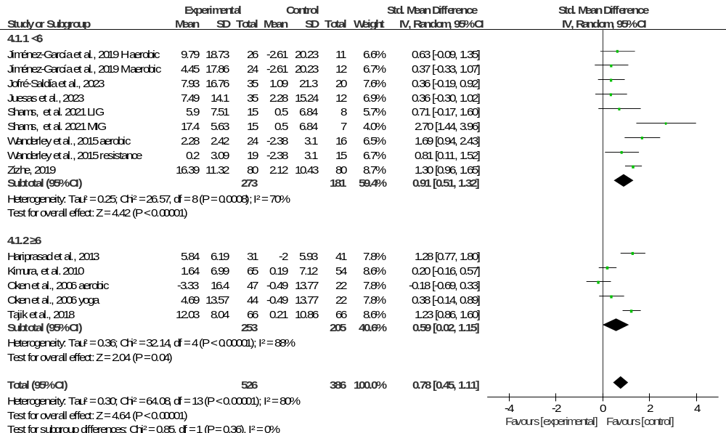

Supplementary Figure S3

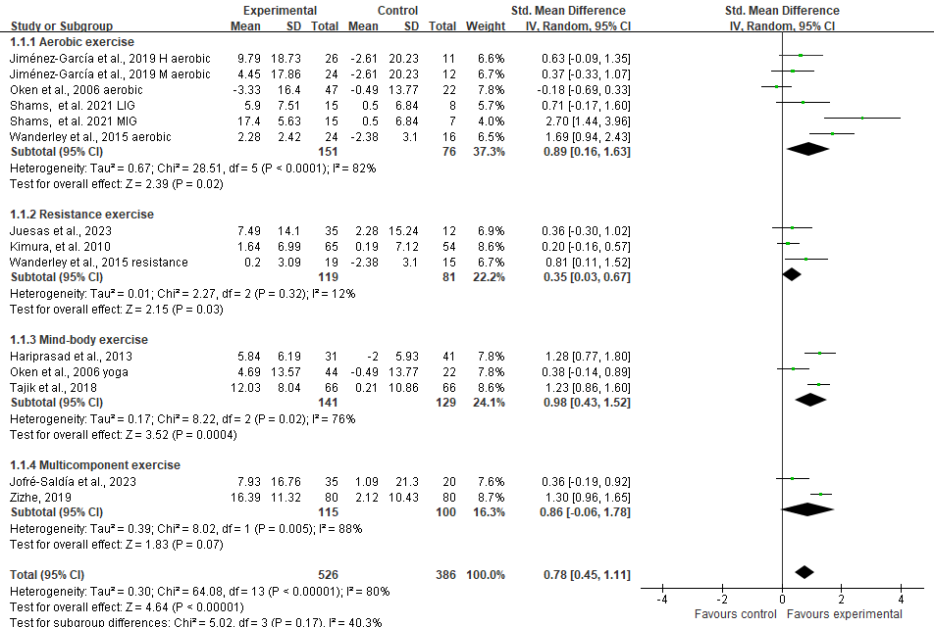

Figure S4. Meta-regression analyses of potential moderators of overall HRQoL. Panels show the associations between the effect of exercise on overall HRQoL and (A) weekly exercise frequency, (B) session duration, (C) total intervention duration, (D) mean age, and (E) female proportion. Each point represents an individual comparison included in the corresponding meta-regression analysis, and the solid line represents the fitted univariable random-effects meta-regression model. None of the examined moderators was significantly associated with the magnitude of the effect on overall HRQoL.

- Weekly exercise frequency
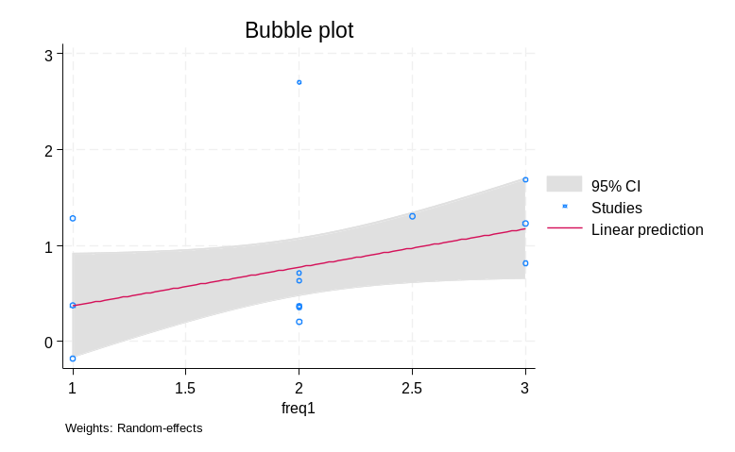

- Session duration
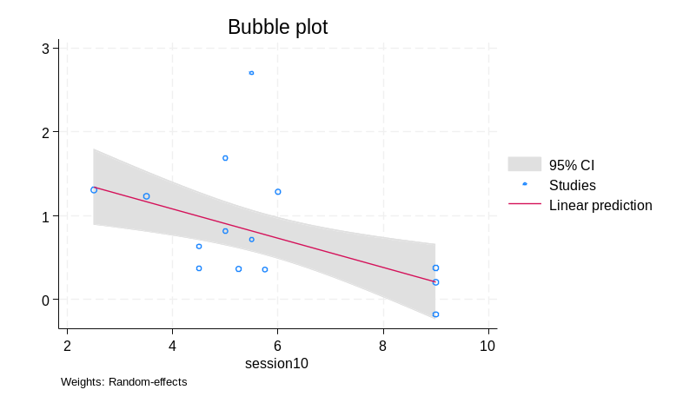

- Total intervention duration
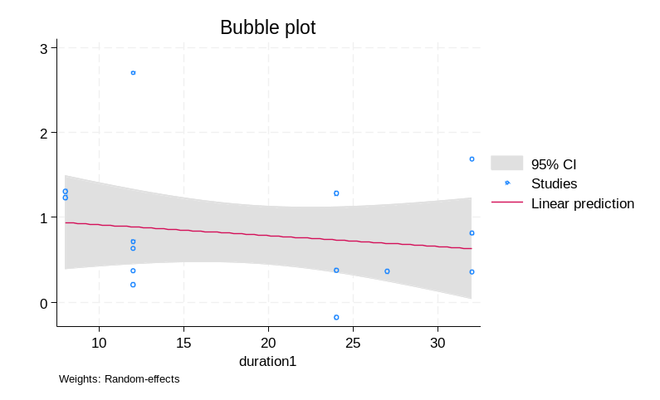

- Mean age
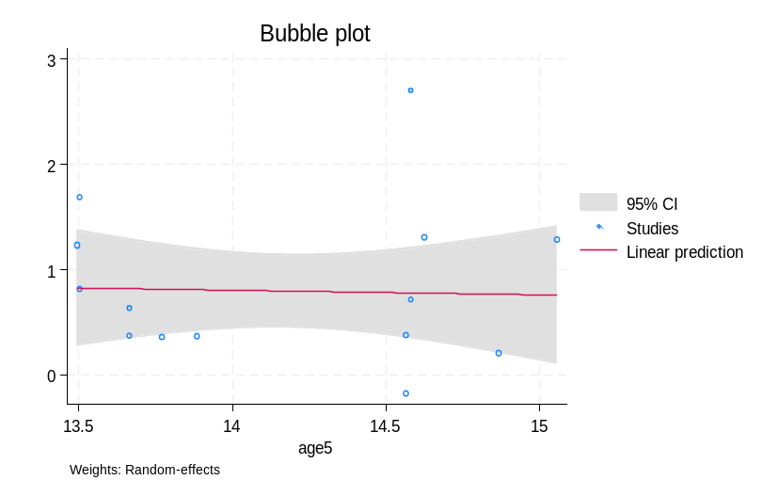

- Female proportion
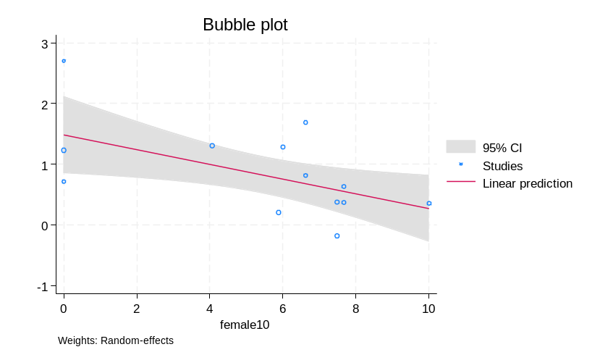

Supplementary Figure S5 Sensitivity analysis excluding studies with derived composite overall HRQoL scores.

