Appendix table 1. Utilization rate of home-based care services per 1,000 older adults by year
Year | Hospital-based Home Health Nursing care | Community-based Home Nursing care | Community-based Home care
2008 | 2.5 | 0.5 | 10.1
2009 | 2.9 | 1.1 | 22.3
2010 | 2.6 | 1.0 | 26.2
2011 | 2.4 | 0.9 | 25.4
2012 | 2.2 | 0.9 | 24.0
2013 | 2.1 | 0.9 | 25.9
2014 | 2.2 | 0.9 | 27.8
2015 | 2.5 | 1.1 | 30.2
2016 | 3.9 | 1.1 | 33.4
2017 | 6.2 | 1.3 | 36.5
2018 | 8.1 | 1.6 | 40.5
2019 | 10.0 | 1.7 | 45.9
Kendall's tau | 0.424 | 0.636 | 0.879
p-value | 0.055 | 0.004 | 0.000

Appendix table 2. Results of the Mann–Kendall Trend Test and Sen’s Slope for Home-Based Care Utilization rate by Region
Year | Hospital-based Home Health Nursing |  |  |  | Community-based Home Nursing care |  |  |  | Community-based Home care
Year | Kendall tau | P-value | Sen's slope | Sen’s slope category* | Kendall tau | P-value | Sen's slope | Sen’s slope category* | Kendall tau | P-value | Sen's slope | Sen’s slope category*
Seoul | 32 | 0.034 | 0.621 | Low Increasing trend | 40 | 0.007 | 0.043 | Low Increasing trend | 58 | <0.001 | 2.080 | Low Increasing trend
Busan | -22 | 0.150 | -0.050 | Not significant | 38 | 0.011 | 0.066 | Moderate Increasing trend | 48 | 0.001 | 2.190 | Moderate Increasing trend
Daegu | 8 | 0.631 | 0.025 | Not significant | 2 | 0.945 | 0.002 | Not significant | 52 | <0.001 | 1.960 | Low Increasing trend
Incheon | 56 | <0.001 | 1.040 | High Increasing trend | 62 | <0.001 | 0.393 | High Increasing trend | 60 | <0.001 | 3.000 | High Increasing trend
Gwangju | -14 | 0.373 | -0.099 | Not significant | 6 | 0.732 | 0.046 | Not significant | 46 | 0.002 | 2.740 | Moderate Increasing trend
Daejeon | 4 | 0.837 | 0.154 | Not significant | 16 | 0.304 | 0.007 | Not significant | 48 | 0.001 | 1.280 | Low Increasing trend
Ulsan | -24 | 0.115 | -0.152 | Not significant | 26 | 0.087 | 0.089 | Not significant | 44 | 0.003 | 1.990 | Low Increasing trend
Gyeonggi-do | 36 | 0.016 | 0.907 | High Increasing trend | 48 | 0.001 | 0.091 | High Increasing trend | 54 | <0.001 | 2.180 | Low Increasing trend
Gangwon-do | 58 | <0.001 | 0.323 | Low Increasing trend | 8 | 0.631 | 0.034 | Not significant | 64 | <0.001 | 2.700 | Moderate Increasing trend
Chungcheongbuk-do | 26 | 0.087 | 0.201 | Not significant | 16 | 0.304 | 0.026 | Not significant | 64 | <0.001 | 2.630 | Moderate Increasing trend
Chungcheongnam-do | 38 | 0.011 | 0.647 | Moderate Increasing trend | 58 | <0.001 | 0.081 | Moderate Increasing trend | 62 | <0.001 | 3.070 | High Increasing trend
Jeollabuk-do | 0 | 1.000 | -0.001 | Not significant | 34 | 0.024 | 0.190 | High Increasing trend | 64 | <0.001 | 3.190 | High Increasing trend
Jeollanam-do | 16 | 0.304 | 0.080 | Not significant | 20 | 0.193 | 0.061 | Not significant | 58 | <0.001 | 3.610 | High Increasing trend
Gyeongsangbuk-do | 6 | 0.732 | 0.024 | Not significant | -44 | 0.003 | -0.084 | Decreasing trend | 66 | <0.001 | 2.880 | High Increasing trend
Gyeongsangnam-do | 8 | 0.631 | 0.014 | Not significant | 48 | 0.001 | 0.034 | Low Increasing trend | 54 | <0.001 | 2.840 | Moderate Increasing trend
Jeju province | 5 | 0.782 | 0.038 | Not significant | 0 | 1.000 | 0.001 | Not significant | 16 | 0.304 | 0.334 | Not significant
Note. Statistically significant increasing trends were categorized as low, moderate, or high using service-specific tertiles of Sen’s slope. The tertile cutoffs were 0.630 and 0.820 for HHNC, 0.066 and 0.090 for CBHC, and 2.190 and 2.850 for CBHNC.

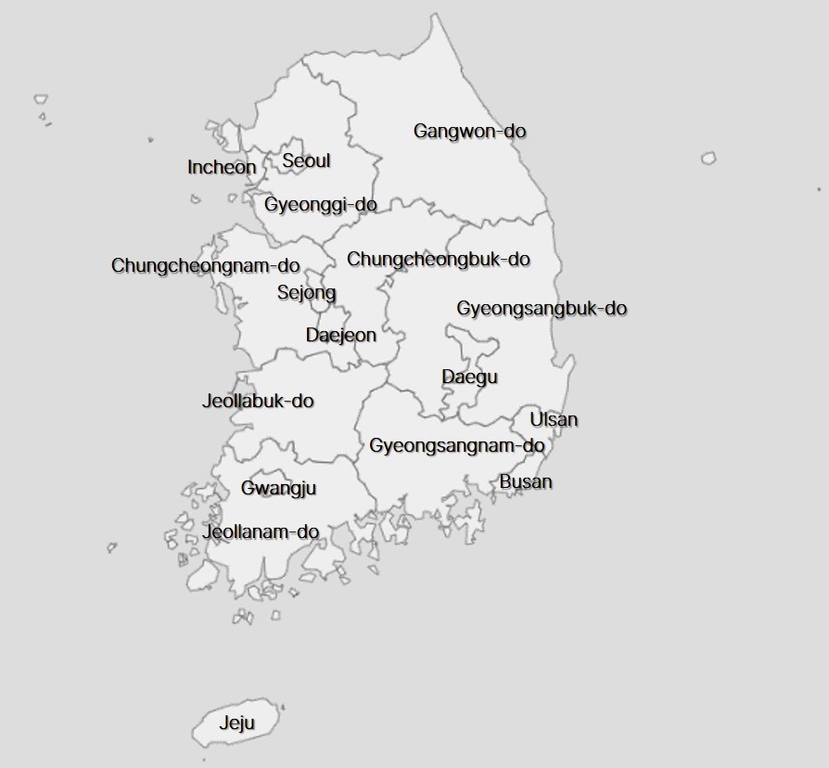
Appendix figure 1. Administrative Divisions of South Korea

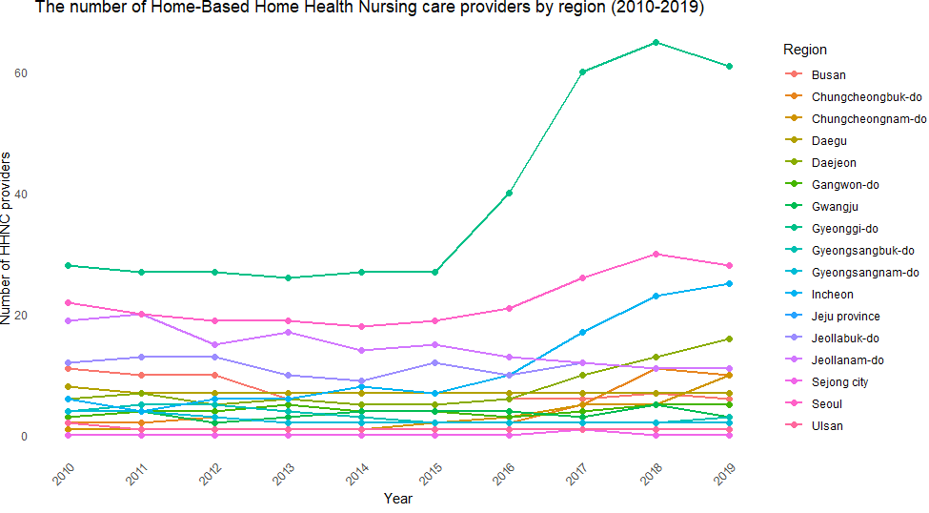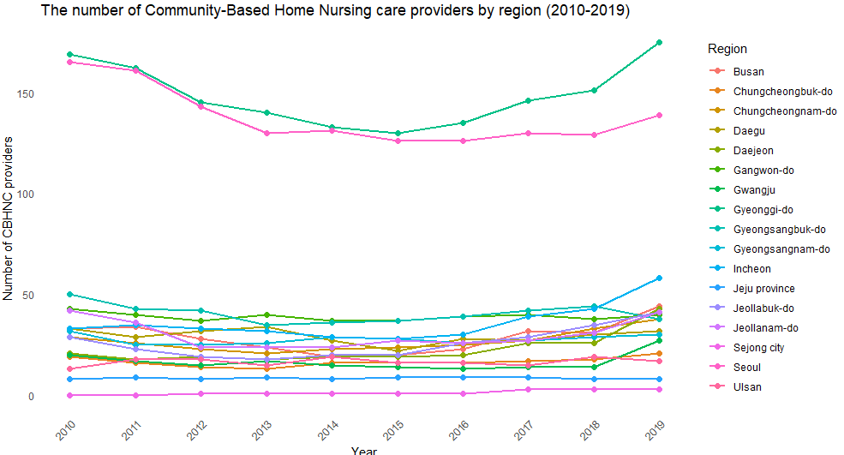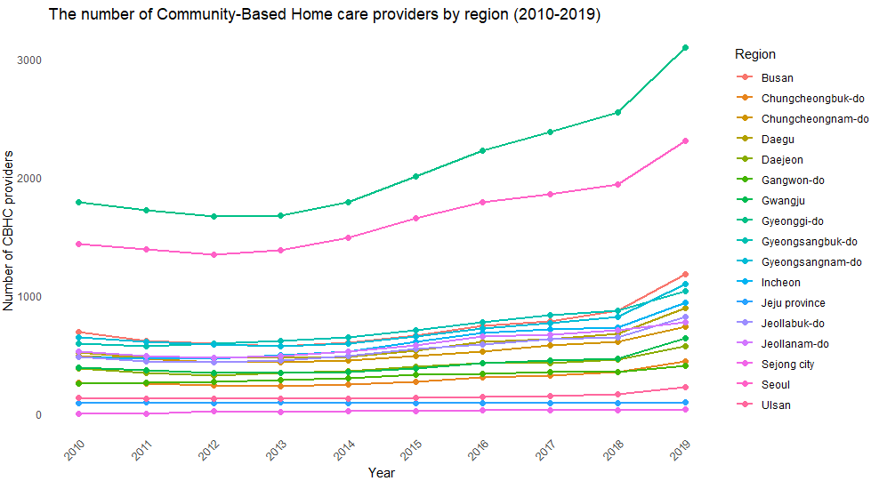
Appendix figure 2. The number of HBC providers by region (2010-2019)

