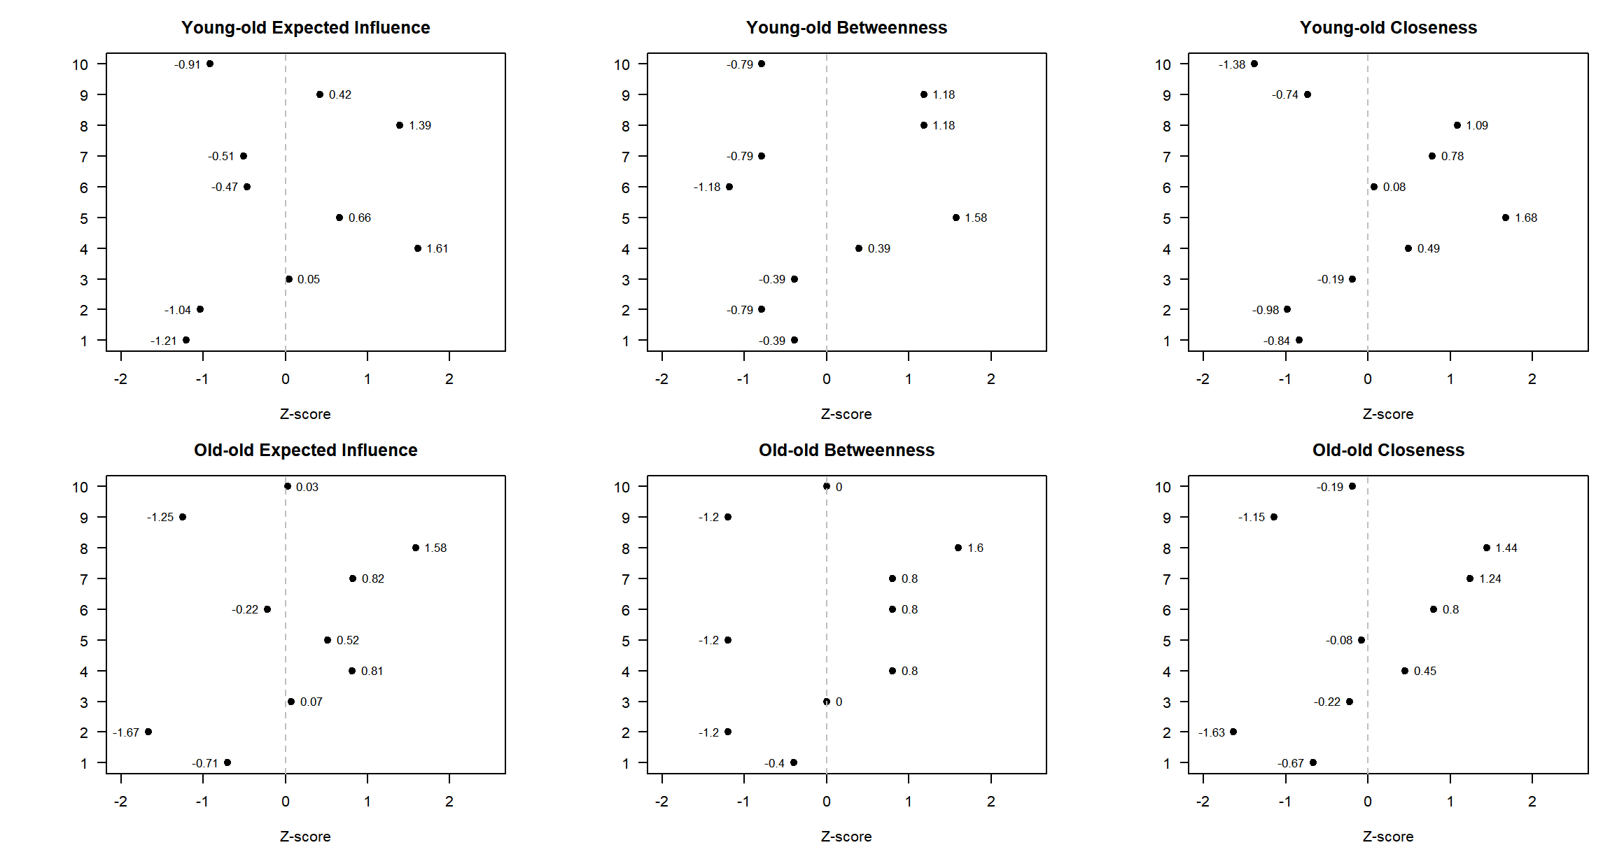
(a) Centrality indices of health literacy networks in young-old and old-old adults
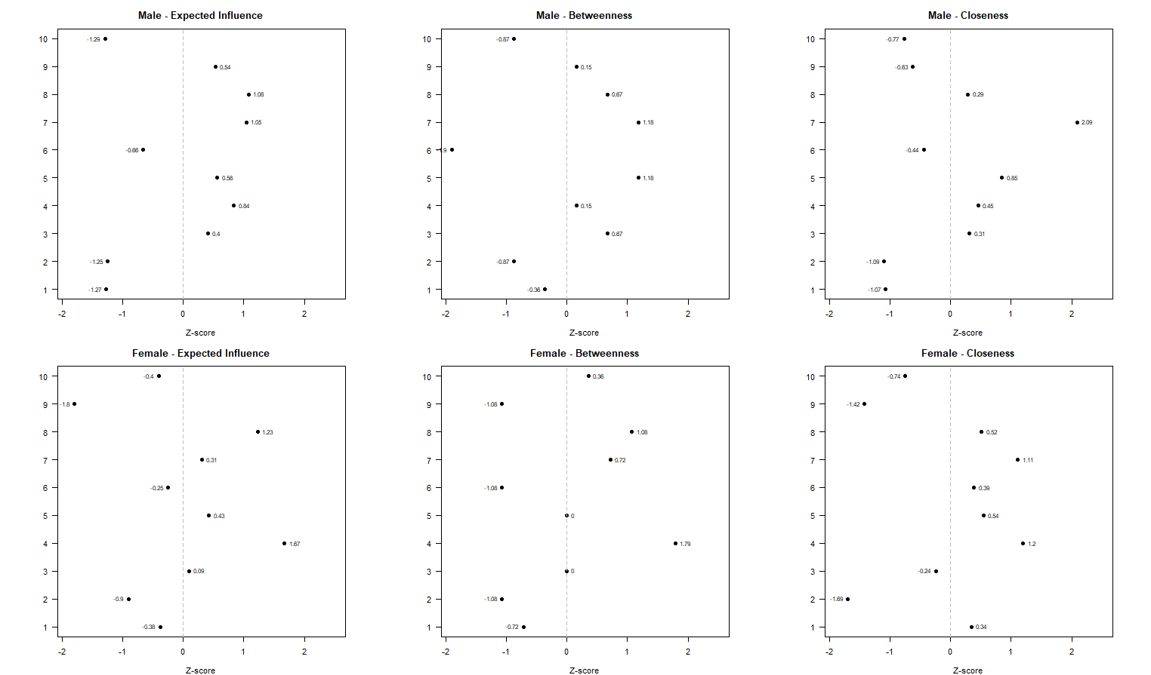
(b) Centrality indices of health literacy networks in male and female older adults
Supplementary Figure 1. Centrality indices of health literacy networks across age groups and sex
Note. Numbers (1–10) represent individual health literacy items (HL1–HL10). HL_1 = judging which vaccinations are needed; HL_2 = understanding mental health risks (e.g., stress, depression); HL_3 = understanding health risks related to behaviours (e.g., drinking, smoking, physical inactivity); HL_4 = judging which everyday behaviours are related to health; HL_5 = understanding a doctor’s explanations during treatment; HL_6 = judging what to do first in a medical emergency; HL_7 = understanding instructions from a doctor or pharmacist on how to take prescribed medication; HL_8 = understanding patient education materials; HL_9 = judging the reliability of health information on the internet or media; HL_10 = using information from the internet or media for health-related decision-making and behaviours.

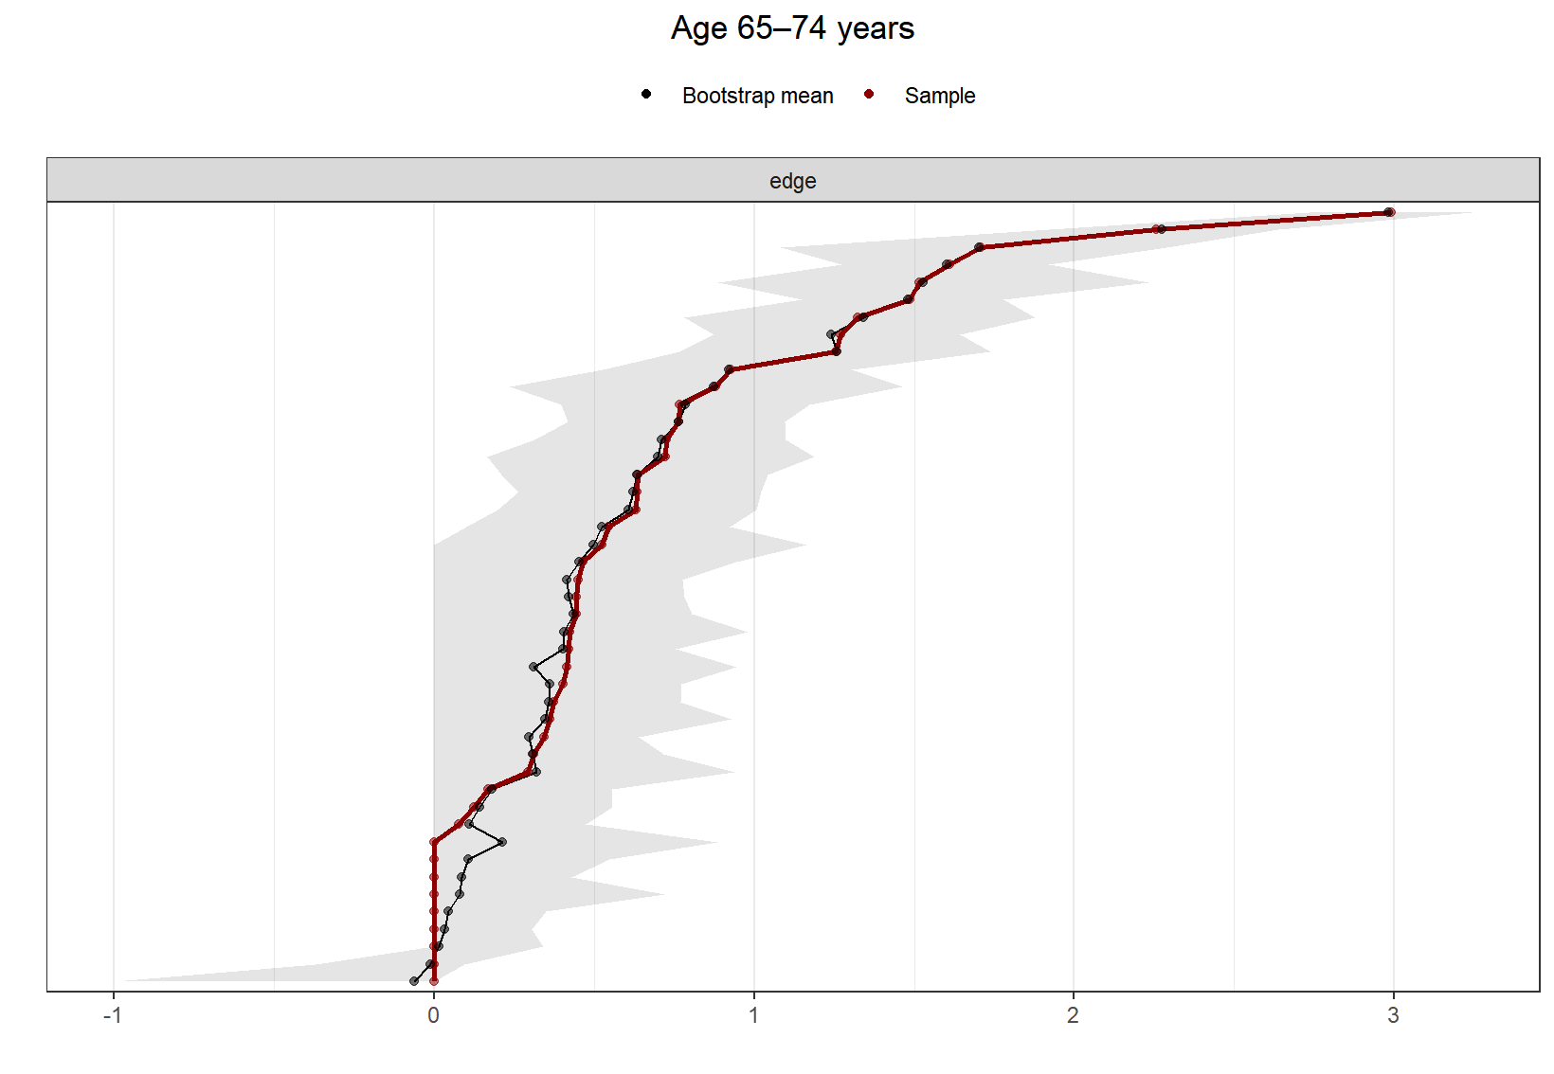
(a) Young-old adults (65–74 years)
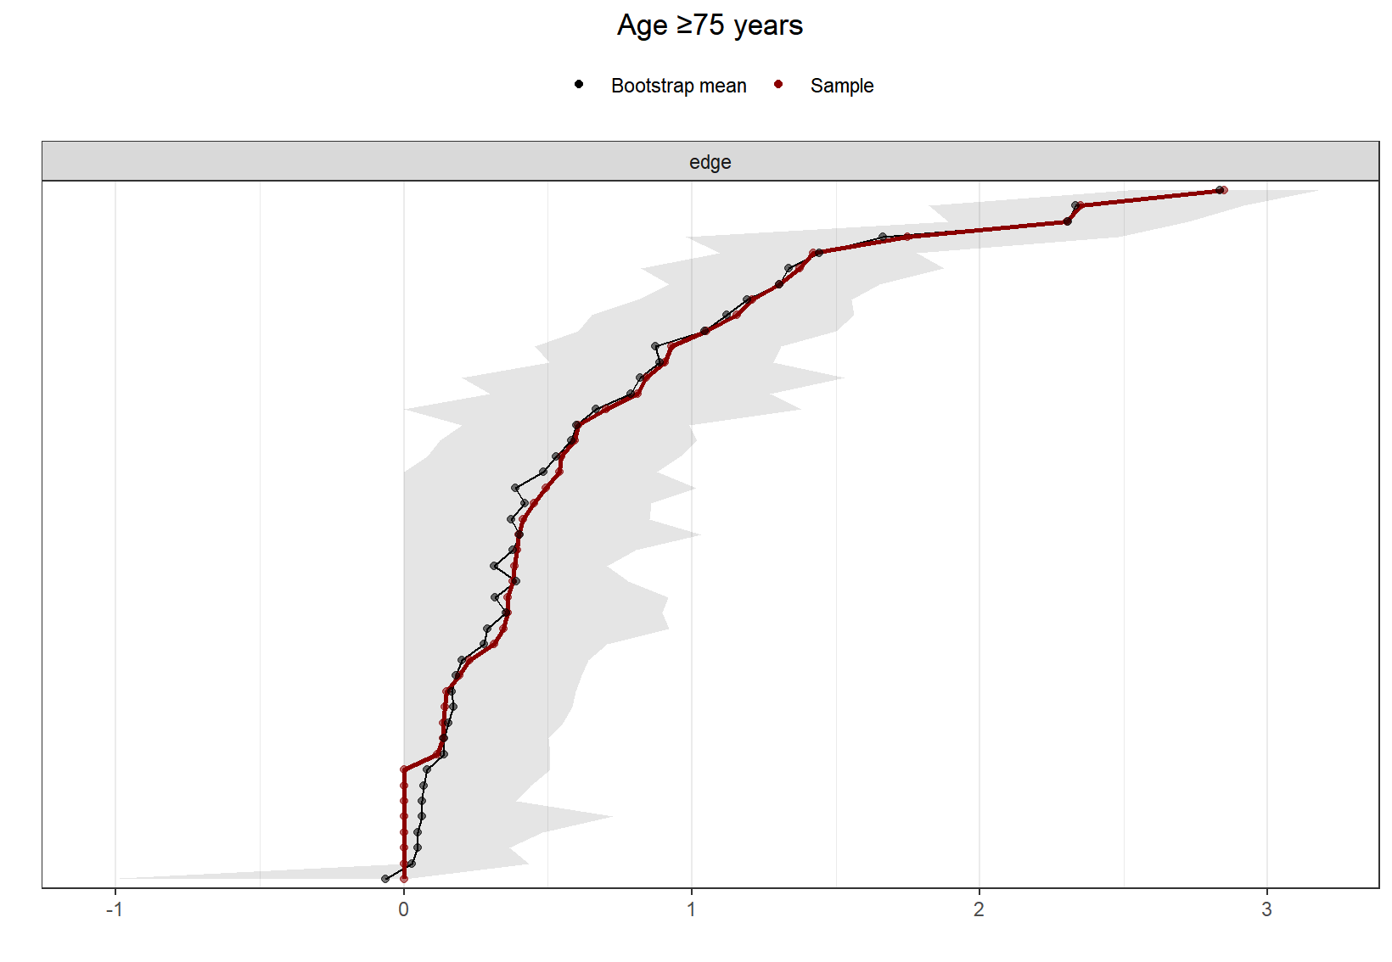
(b) Old-old adults (≥75 years)
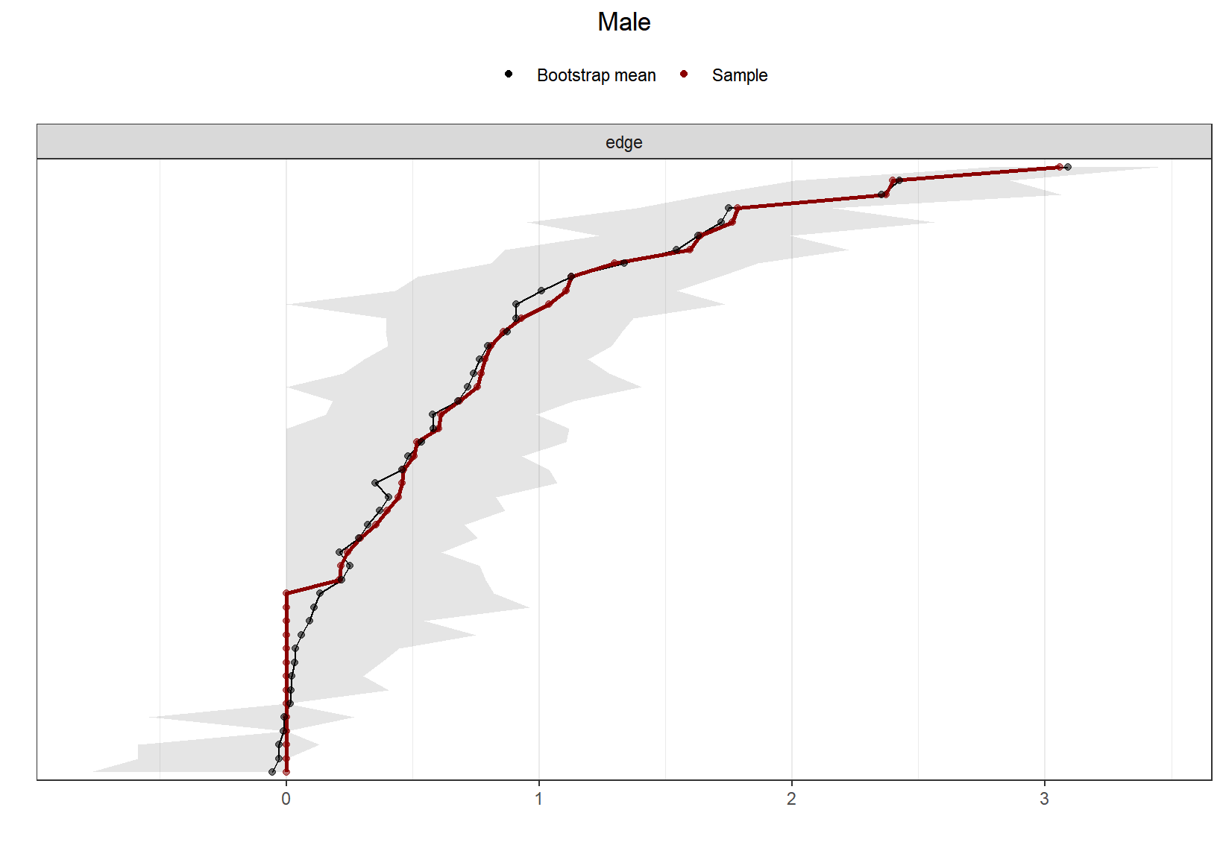
(c) Male older adults
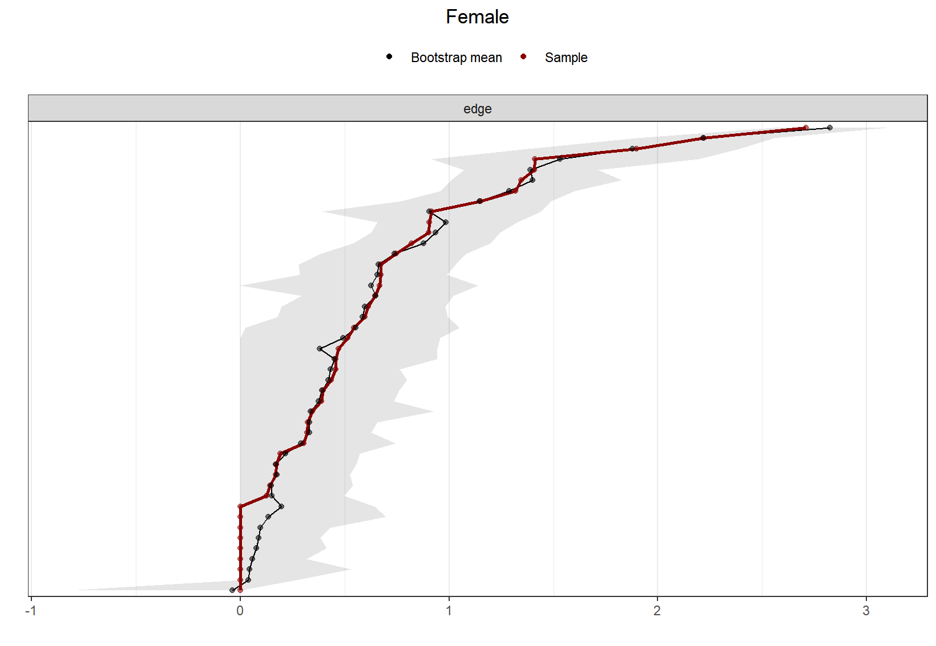
(d) Female older adults
Supplementary Figure 2. Bootstrap edge-weight accuracy plots

