Hip fracture burden and projected incidence among older adults in China to 2035: a GBD 2023 modelling study with exploratory hospital case-mix comparison

Supplementary file Fig. 1. Study design flowchart
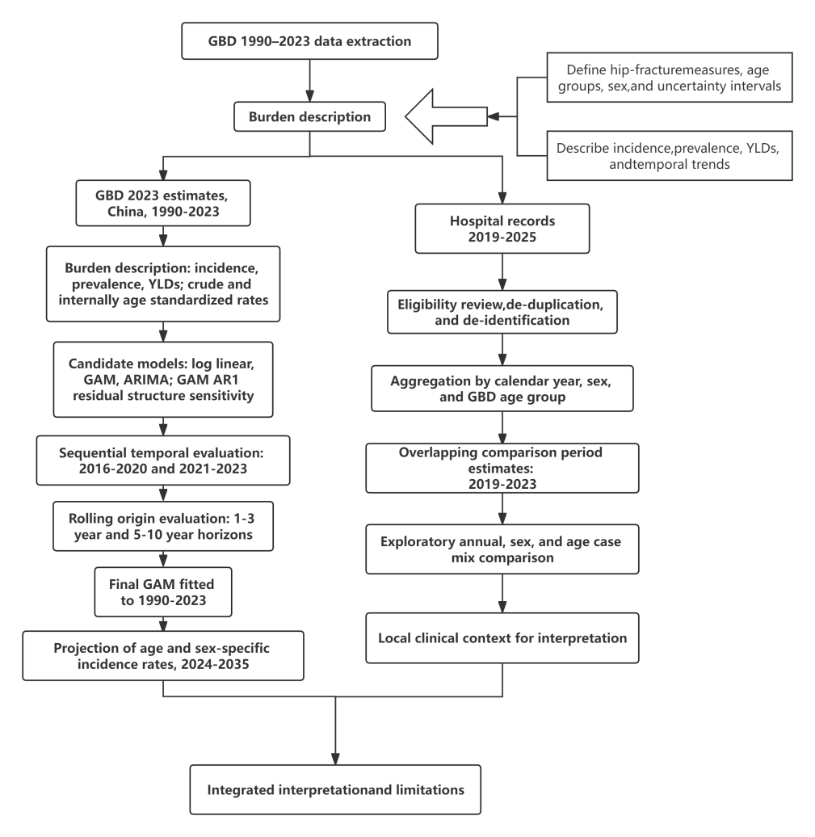
GBD modelling and hospital case-mix analyses were conducted separately and integrated at the interpretation stage; hospital data were not used for model fitting or selection.
Supplementary file Table 1. Clinical correspondence used to align the GBD hip fracture category and hospital case definition.
Component | Clinical/ICD-10 correspondence | Use in this study
Femoral neck fracture | S72.0 | Included
Pertrochanteric/intertrochanteric fracture | S72.1 | Included
Subtrochanteric fracture | S72.2 | Included
Other non proximal or non target fractures | Acetabular/pelvic, femoral shaft/distal femur, pathological/periprosthetic and other prespecified exclusions | Excluded from hospital cohort
Note: ICD-10 labels are provided as clinical coding correspondence for harmonization. GBD estimates were extracted directly from the GBD 2023 Results Tool and were not reconstructed from the hospital ICD-coded records.
Supplementary file Table 2. Candidate model performance across temporal evaluation horizons.
A. held-out GBD temporal evaluation, 2016-2020
Model | MAE | RMSE | MAPE | R²
log-linear model | 755.93 | 1362.89 | 19.90% | 0.671
GAM | 341.90 | 661.64 | 16.51% | 0.923
GAM AR1 | 194.17 | 338.30 | 12.01% | 0.980
ARIMA | 415.43 | 891.82 | 11.47% | 0.859
B.Later held-out GBD temporal evaluation, 2021-2023
Model | MAE | RMSE | MAPE | R²
log-linear model | 599.63 | 1121.57 | 15.78% | 0.831
GAM | 152.20 | 348.36 | 4.06% | 0.984
GAM AR1 | 301.30 | 559.03 | 10.79% | 0.958
ARIMA | 98.62 | 212.70 | 2.77% | 0.994
C.Short horizon rolling-origin evaluation (1-3 years)
Model | MAE | RMSE | MAPE | R²
ARIMA | 108.62 | 276.94 | 3.58% | 0.988
GAM | 202.94 | 415.33 | 8.01% | 0.972
GAM AR1 | 168.23 | 339.52 | 6.94% | 0.981
log-linear model | 675.51 | 1220.51 | 18.21% | 0.760
D.Long horizon rolling-origin evaluation (5-10 years)
Model | MAE | RMSE | MAPE | R²
ARIMA | 775.49 | 1369.17 | 23.48% | 0.691
GAM | 480.14 | 820.30 | 26.39% | 0.889
GAM AR1 | 525.15 | 881.34 | 25.91% | 0.872
log-linear model | 922.31 | 1611.42 | 24.95% | 0.572
E.Long horizon rolling-origin evaluation among adults aged ≥80 years (5-10 years)
Model | MAE | RMSE | MAPE | R²
ARIMA | 1421.53 | 1929.62 | 28.10% | 0.339
GAM | 682.90 | 1118.88 | 12.46% | 0.778
GAM AR1 | 803.04 | 1212.40 | 16.20% | 0.739
log-linear model | 1728.22 | 2274.30 | 34.51% | 0.081
Model selection prioritized long horizon RMSE and then long horizon RMSE in adults aged ≥80 years because projection through 2035 was the principal planning objective. GAM was selected.
Supplementary file Table 3. GAM specification and residual structure sensitivity analyses.
Analysis | Key result
Selected GAM | sex × age + overall year smooth (k=7) + sex-specific sum to zero temporal deviations (k=6) + age-specific sum to zero temporal deviations (k=6); REML, gamma=1.4, select=TRUE
Final GAM k check: overall year smooth | EDF=5.95; k-index=0.261; P<0.001
GAM AR1 sensitivity: estimated rho | 0.924
GAM AR1 sensitivity: median absolute lag 1 residual correlation | Initial 0.924; AR(1) standardized 0.604
GAM-AR1 sensitivity: Ljung-Box summary | Minimum P=2.03e-06; proportion P>0.05=0.125
Basis-dimension sensitivity:
k overall | k deviations | rho | AIC | Deviance explained | Median [lag-1]
8 | 6 | 0.890 | -2605.70 | 99.76% | 0.698
10 | 8 | 0.924 | -2889.22 | 99.82% | 0.604
12 | 8 | 0.924 | -2929.64 | 99.83% | 0.593
Supplementary file Table 4. ARIMA orders and residual diagnostics for the full 1990-2023 age sex series.
Sex | Age, years | p | d | q | AICc | Ljung-Box P
Male | ≥95 | 2 | 1 | 0 | -176.79 | 0.940
Male | 90-94 | 2 | 1 | 0 | -192.38 | 0.842
Male | 85-89 | 2 | 1 | 0 | -203.21 | 0.889
Male | 80-84 | 2 | 1 | 0 | -197.45 | 0.989
Male | 75-79 | 1 | 1 | 2 | -205.14 | 0.917
Male | 70-74 | 2 | 1 | 0 | -205.84 | 0.718
Male | 65-69 | 1 | 1 | 2 | -206.58 | 0.911
Male | 60-64 | 3 | 1 | 0 | -221.51 | 0.870
Female | ≥95 | 2 | 1 | 0 | -144.49 | 0.850
Female | 90-94 | 2 | 1 | 0 | -153.92 | 0.827
Female | 85-89 | 2 | 1 | 0 | -170.43 | 0.623
Female | 80-84 | 2 | 1 | 0 | -201.01 | 0.789
Female | 75-79 | 1 | 1 | 2 | -211.32 | 0.842
Female | 70-74 | 2 | 1 | 0 | -191.59 | 0.826
Female | 65-69 | 2 | 1 | 0 | -179.54 | 0.751
Female | 60-64 | 3 | 1 | 0 | -200.40 | 1.000
All selected ARIMA models were non seasonal and fitted on the log incidence rate scale. Drift was allowed during selection but was not retained in the final full series models.
Supplementary file Table 5. Crude and internally age standardized burden changes and Kitagawa decomposition, 1990-2023.
A.Crude and internally age standardized rates
Measure | Population | Crude 1990 | Crude 2023 | Crude change | Std. change
Incidence | Overall | 556.87 | 1,088.96 | 95.55% | 58.46%
Incidence | Male | 406.77 | 813.70 | 100.04% | 69.63%
Incidence | Female | 693.63 | 1,342.58 | 93.56% | 58.96%
Prevalence | Overall | 1,050.67 | 2,261.09 | 115.21% | 88.40%
Prevalence | Male | 714.67 | 1,519.58 | 112.63% | 97.83%
Prevalence | Female | 1,356.81 | 2,944.29 | 117.00% | 91.76%
YLD | Overall | 198.79 | 200.87 | 1.05% | -10.74%
YLD | Male | 138.18 | 139.59 | 1.02% | -5.47%
YLD | Female | 254.01 | 257.33 | 1.31% | -9.79%
B.Kitagawa decomposition of crude rate change (per 100,000)
Measure | Population | Total change | Rate component | Age composition component | Age composition share
Incidence | Overall | 532.09 | 356.22 | 175.88 | 33.05%
Incidence | Male | 406.93 | 294.13 | 112.80 | 27.72%
Incidence | Female | 648.95 | 442.39 | 206.56 | 31.83%
Prevalence | Overall | 1,210.43 | 948.22 | 262.21 | 21.66%
Prevalence | Male | 804.91 | 681.83 | 123.08 | 15.29%
Prevalence | Female | 1,587.48 | 1,262.32 | 325.15 | 20.48%
YLD | Overall | 2.08 | -27.53 | 29.61 | Offsetting component
YLD | Male | 1.40 | -12.58 | 13.99 | Offsetting component
YLD | Female | 3.32 | -32.60 | 35.91 | Offsetting component
For YLD, percentage shares are not emphasized because the net crude rate change was small and resulted from two larger components with opposite directions. Internally standardized rates use the 2023 age distribution of the corresponding study population aged ≥60 years as the reference.
Supplementary file Table 6. Age and sex-specific YLD burden in 1990 and 2023.
Sex | Age, years | YLD number 1990 | YLD number 2023 | YLD rate 1990 | YLD rate 2023 | Rate change
Male | ≥95 | 52.71 | 1,937.50 | 329.68 | 457.28 | 38.70%
Male | 90-94 | 297.42 | 7,120.46 | 295.57 | 418.26 | 41.51%
Male | 85-89 | 1,679.86 | 18,177.60 | 264.73 | 355.99 | 34.47%
Male | 80-84 | 4,626.07 | 26,868.44 | 221.65 | 267.02 | 20.47%
Male | 75-79 | 8,090.89 | 31,124.61 | 164.67 | 180.64 | 9.70%
Male | 70-74 | 12,098.75 | 39,487.56 | 138.27 | 134.64 | -2.63%
Male | 65-69 | 17,751.41 | 40,117.22 | 131.74 | 106.41 | -19.22%
Male | 60-64 | 22,065.39 | 33,493.43 | 120.80 | 82.64 | -31.59%
Female | ≥95 | 434.25 | 9,422.70 | 877.43 | 1,152.08 | 31.30%
Female | 90-94 | 2,235.00 | 27,585.24 | 809.95 | 976.11 | 20.52%
Female | 85-89 | 9,561.19 | 57,699.17 | 702.25 | 783.31 | 11.54%
Female | 80-84 | 18,839.34 | 69,787.25 | 538.71 | 562.71 | 4.45%
Female | 75-79 | 22,900.29 | 68,086.90 | 351.59 | 348.14 | -0.98%
Female | 70-74 | 26,319.98 | 71,476.32 | 259.90 | 225.29 | -13.32%
Female | 65-69 | 28,356.68 | 55,938.77 | 203.47 | 144.87 | -28.80%
Female | 60-64 | 25,841.73 | 36,824.03 | 150.37 | 90.04 | -40.12%
Supplementary file Table S7. Period specific sensitivity analysis for temporal evaluation observations overlapping the COVID 19 pandemic.
Period | Model | MAE | RMSE | MAPE | R²
Pre pandemic 2016-2019 | log-linear model | 690.07 | 1,231.16 | 18.18% | 0.705
Pre pandemic 2016-2019 | GAM | 302.28 | 591.55 | 14.11% | 0.932
Pre pandemic 2016-2019 | GAM AR1 | 163.73 | 309.49 | 9.81% | 0.981
Pre pandemic 2016-2019 | ARIMA | 325.87 | 707.94 | 9.30% | 0.902
COVID overlap 2020-2022 | log-linear model | 775.48 | 1,431.73 | 20.07% | 0.737
COVID overlap 2020-2022 | GAM | 280.09 | 609.87 | 11.46% | 0.952
COVID overlap 2020-2022 | GAM AR1 | 223.96 | 339.62 | 11.89% | 0.985
COVID overlap 2020-2022 | ARIMA | 306.07 | 823.36 | 8.05% | 0.913
2023 | log-linear model | 491.81 | 921.18 | 13.89% | 0.873
2023 | GAM | 116.71 | 193.34 | 3.88% | 0.994
2023 | GAM AR1 | 547.98 | 883.53 | 17.50% | 0.883
2023 | ARIMA | 151.34 | 272.00 | 4.29% | 0.989
Sensitivity excluding 2020-2022:
Model | MAE | RMSE | MAPE | R²
log-linear model | 650.42 | 1,175.72 | 17.32% | 0.746
GAM | 265.17 | 536.12 | 12.06% | 0.947
GAM-AR1 | 240.58 | 482.44 | 11.35% | 0.957
ARIMA | 290.97 | 644.78 | 8.30% | 0.924
Supplementary Fig. 2. Short horizon rolling-origin RMSE across candidate models (1-3 year forecasts).
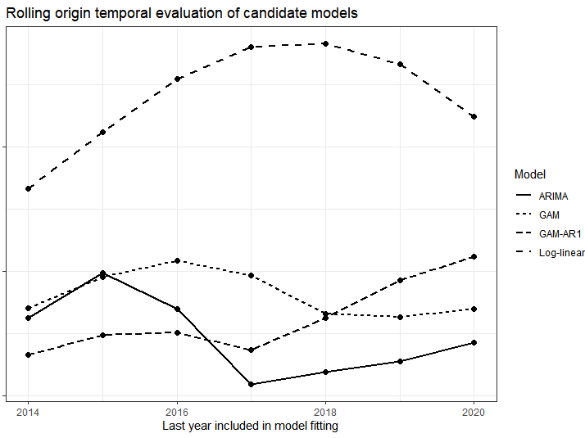

Supplementary file Fig. 3. Long horizon rolling-origin RMSE across candidate models (1-10 year forecasts).
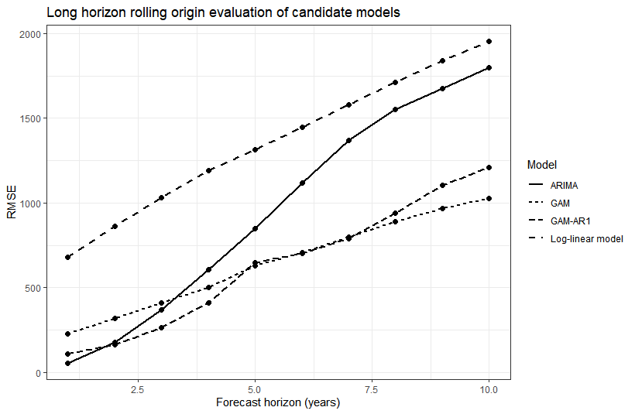
Supplementary file Fig. 4. GBD estimates versus predicted incidence rates in the 2016-2020 held-out GBD temporal evaluation period for the selected GAM.
Supplementary file Fig. 5. Supplementary file Fig. 5. Age- and sex-stratified GBD estimates and GAM-predicted incidence rates in the 2016–2020 held-out GBD temporal evaluation period.

Supplementary file Fig. 6. Crude and internally age standardized hip fracture incidence rates among Chinese adults aged ≥60 years, 1990-2023.
Supplementary file Fig. 7. Crude and internally age standardized YLD rate trends among Chinese adults aged ≥60 years, 1990-2023
Supplementary file Fig. 8. Absolute YLD burden among Chinese adults aged ≥60 years, 1990-2023.

