Supplementary Figure 1. Family pedigree showing three H7N9 affected individuals and their close contacts
Red color noted the death of H7N9; Green color noted survivor with H7N9 infection; Blue color: noted with close contacts; circle shape noted female; square shape noted male.
MP

NP

NS
PA
PB1

PB2
Supplementary Figure 2. Phylogenetic analysis of six segments (MP, NP, NS, PA, PB1, and PB2) from the four H7N9 isolates in three confirmed cases of a family cluster in Hangzhou, Zhejiang Province, China, in January of 2014.
Red color strains noted the isolates from three family cluster cases in 2014, while blue color noted the isolates from the confirmed spondaic cases in Zhejiang Province in 2013.
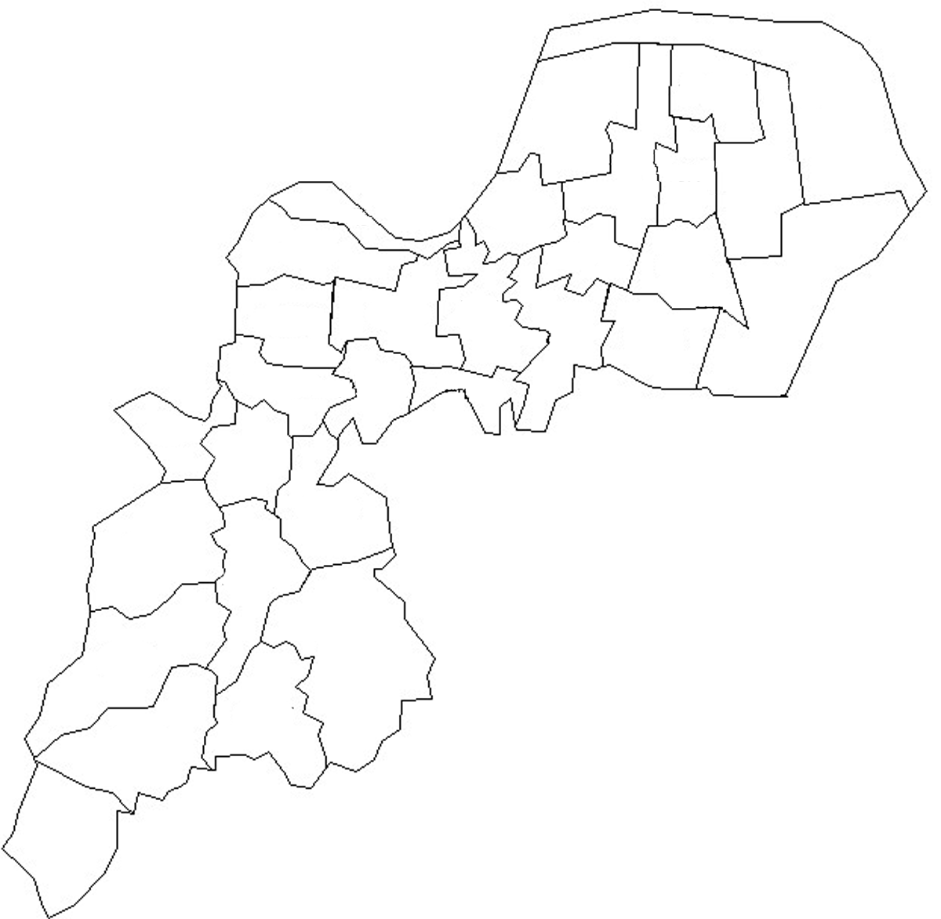
C1 market
B1 market
A1 market
Supplementary Figure 3. The geographical distribution of three H7N9 confirmed cases and related with live bird market in Xiao Shan district, Hangzhou, Zehjiang Province in 2014
H7N9 Positive live bird market; Three confirmed cases
H7N9 Positive countryside under H7N9 surveillance during January of 2014

