Supplementary Data
Table S1. Candidate models. “X” indicates that the covariate was included. The AIC scores are given for each model. Models 1-8 represent weekly incidences whereas Models 9-16 represent monthly incidences. The model with the lowest AIC score is shaded gray
Model | Annual harmonic | Semi-annual harmonic | Dengue | ILI | AIC Score
1 | X | X | X | X | 2653.76
2 |  | X | X | X | 2881.61
3 | X |  | X | X | 2696.42
4 | X | X |  | X | 2687.17
5 |  |  | X | X | 2913.60
6 |  |  |  | X | 3057.65
7 |  | X |  | X | 2988.92
8 | X |  |  | X | 2751.12
9 | X | X | X | X | 1261.51
10 |  | X | X | X | 1523.65
11 | X |  | X | X | 1323.82
12 | X | X |  | X | 1276.50
13 |  |  | X | X | 1587.12
14 |  |  |  | X | 1699.01
15 |  | X |  | X | 1602.28
16 | X |  |  | X | 1360.58

Figure S1.
Incidence = exp{β₀+ β₁_cos(Ø)+ β₂_sin(Ø) + β₃_cos(Φ)+β₄_sin(Φ) + β_{5_}AssociatedV + ε}
Where β₀ represents the intercept or baseline level of ILI; β₁ – β₄ are the coefficients of the harmonic; Ø =2π*month/12 Φ=2π*month/6 (representing annual and biannual monthly epidemics) and β₅ represents the variable being tested for association with the ILI incidence and included: monthly precipitation, monthly median temperature, monthly median relative humidity, and total monthly school days.
Relative risks were estimating by taking the exponent of the coefficient β5. The corresponding confidence intervals for relative risks were similarly transformed.

Figure S2. Sensitivity analysis showing the leave-one-out cross validation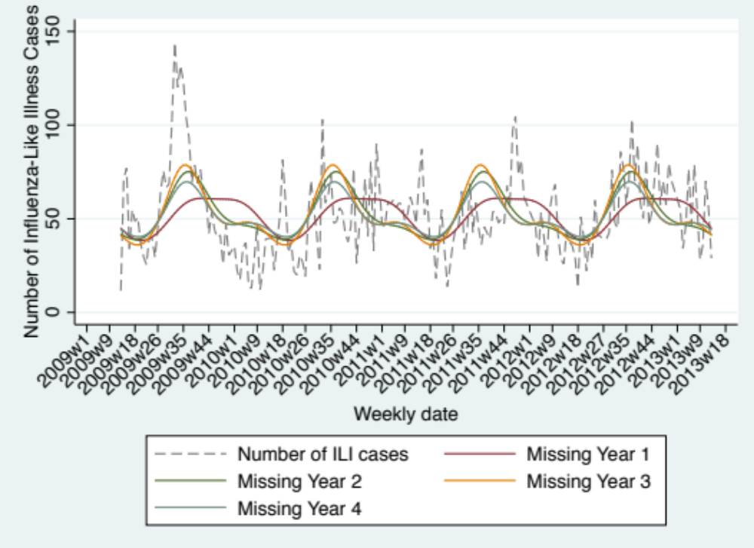

Figure S3. Influenza-like illness cases and monthly days of school.
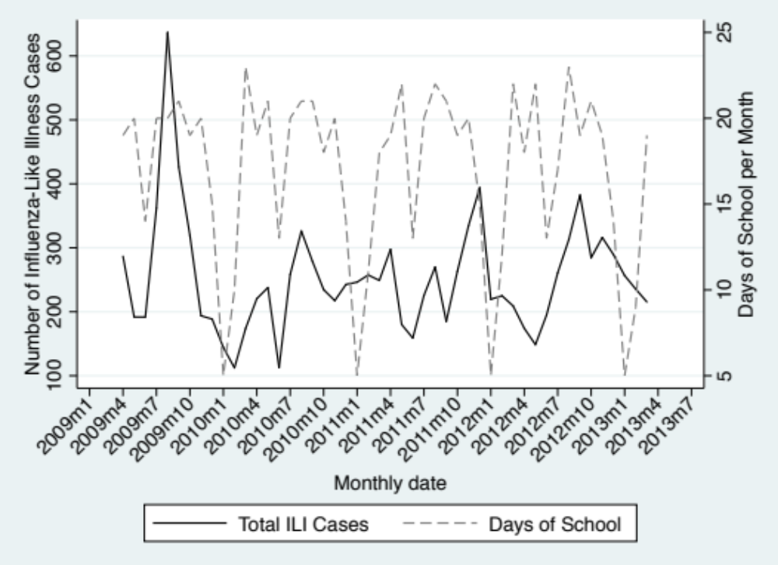

Figure S4. Influenza-like illness cases and total monthly precipitation.
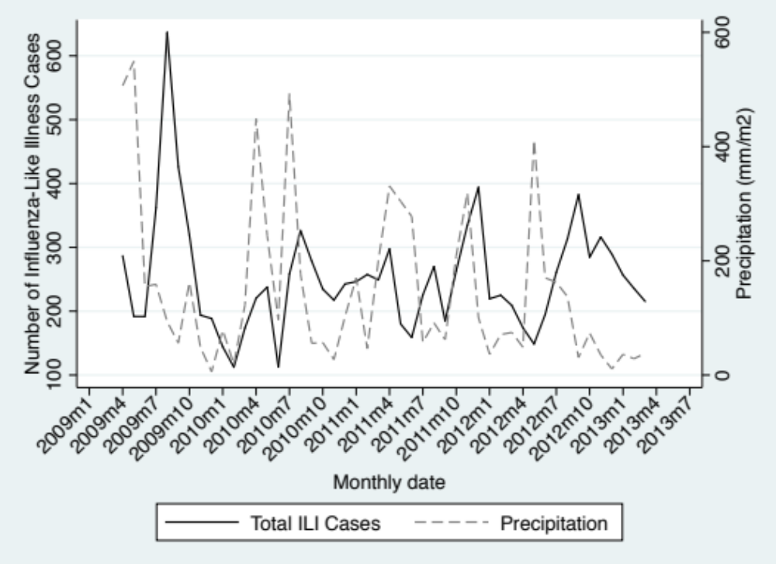

Figure S5. Influenza-like illness cases and monthly median relative humidity.
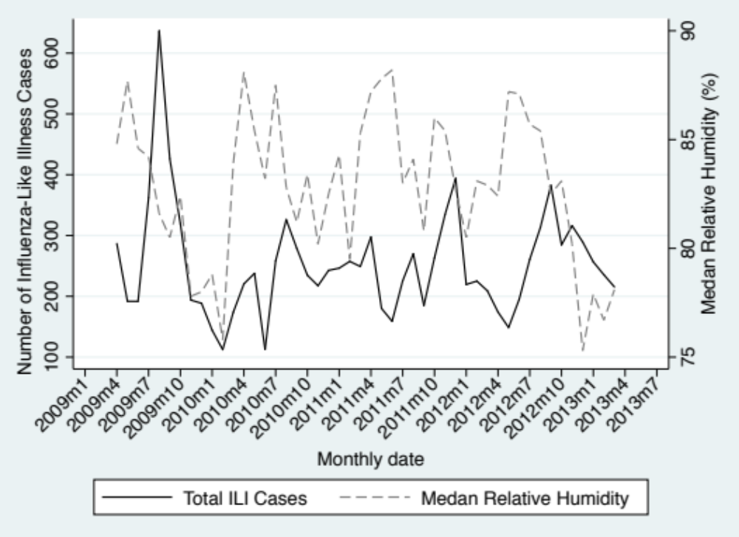

Figure S6. Influenza-like illness cases and monthly median temperature.
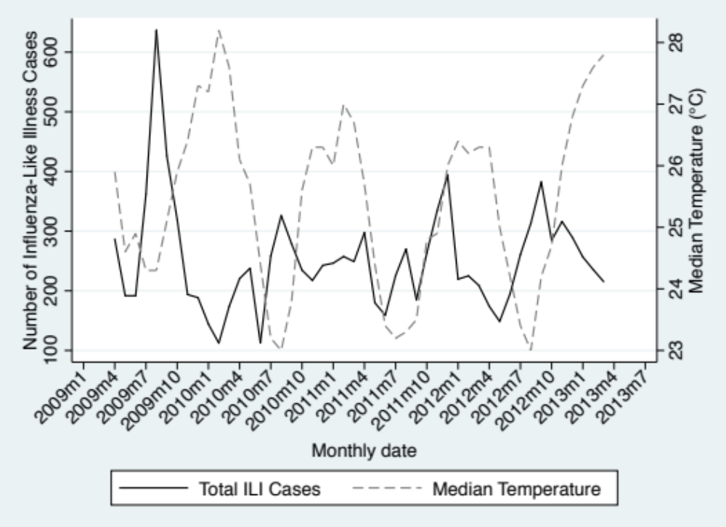

Figure S7. Influenza-like illness and dengue cases.
