Additional file 5 Co-amoxiclav resistance in faecal E. coli isolates from asymptomatic children, by OECD status
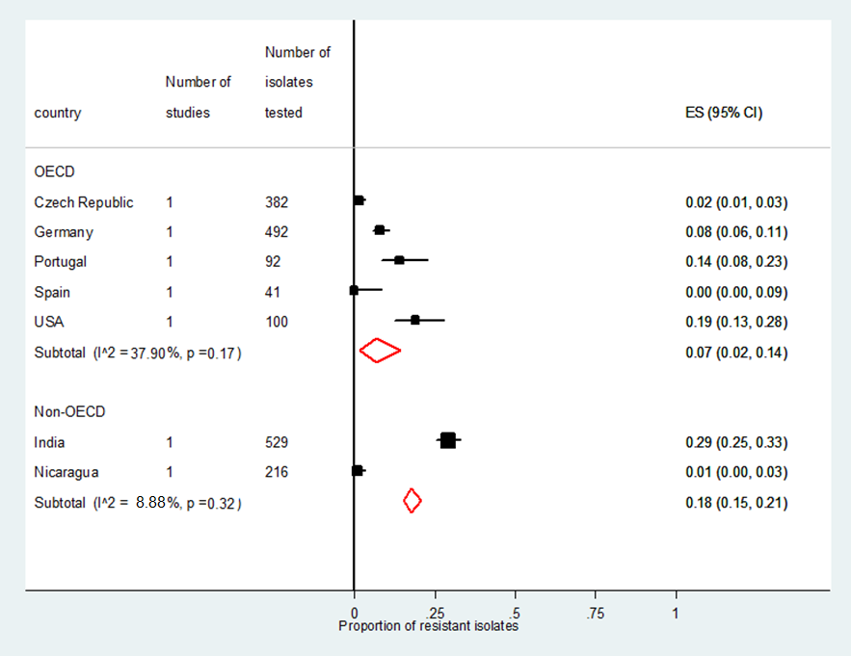 Where ES = effect size

