Additional file 1

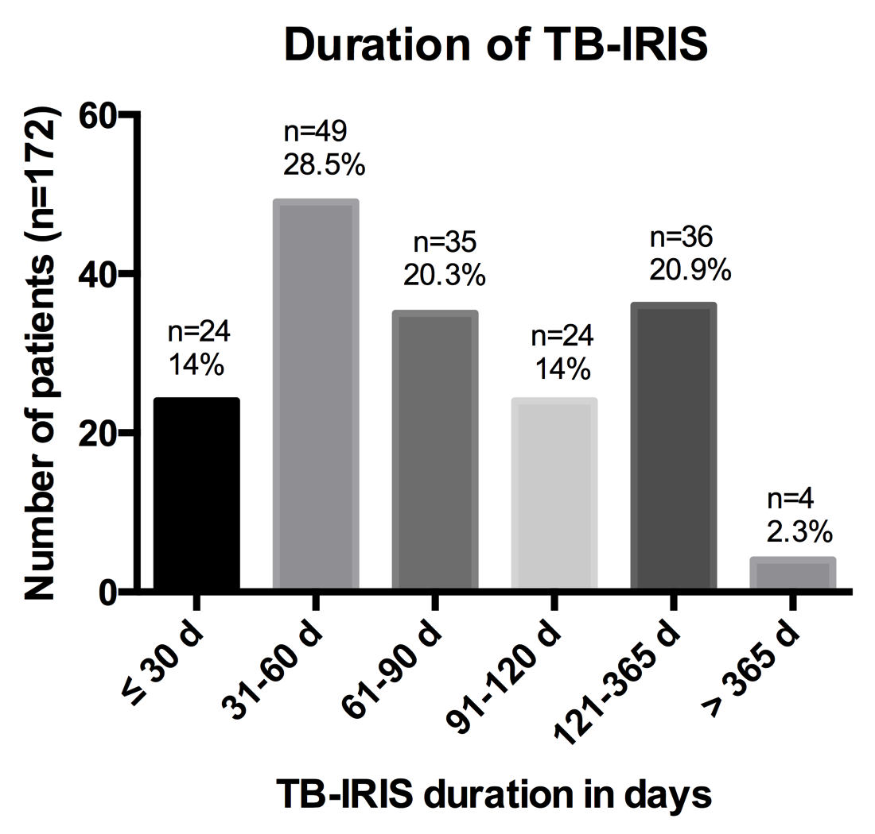

Legend for Additional file 1

Additional file 1: Figure S1: Distribution of TB-IRIS duration
This graph shows the number and proportion of patients who had a duration of TB-IRIS symptoms within each of the specified duration categories (in days) displayed on the x-axis. The graph includes only the 172 patients who had a known TB-IRIS start and end date, and thus excludes 2 patients who had a duration >365 days but in whom IRIS was ongoing at last visit.

