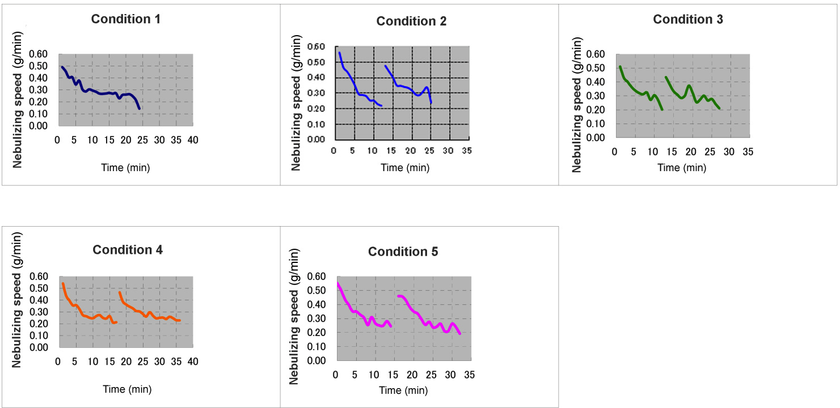
Figure S4 Time course changes of the nebulizing speeds.

