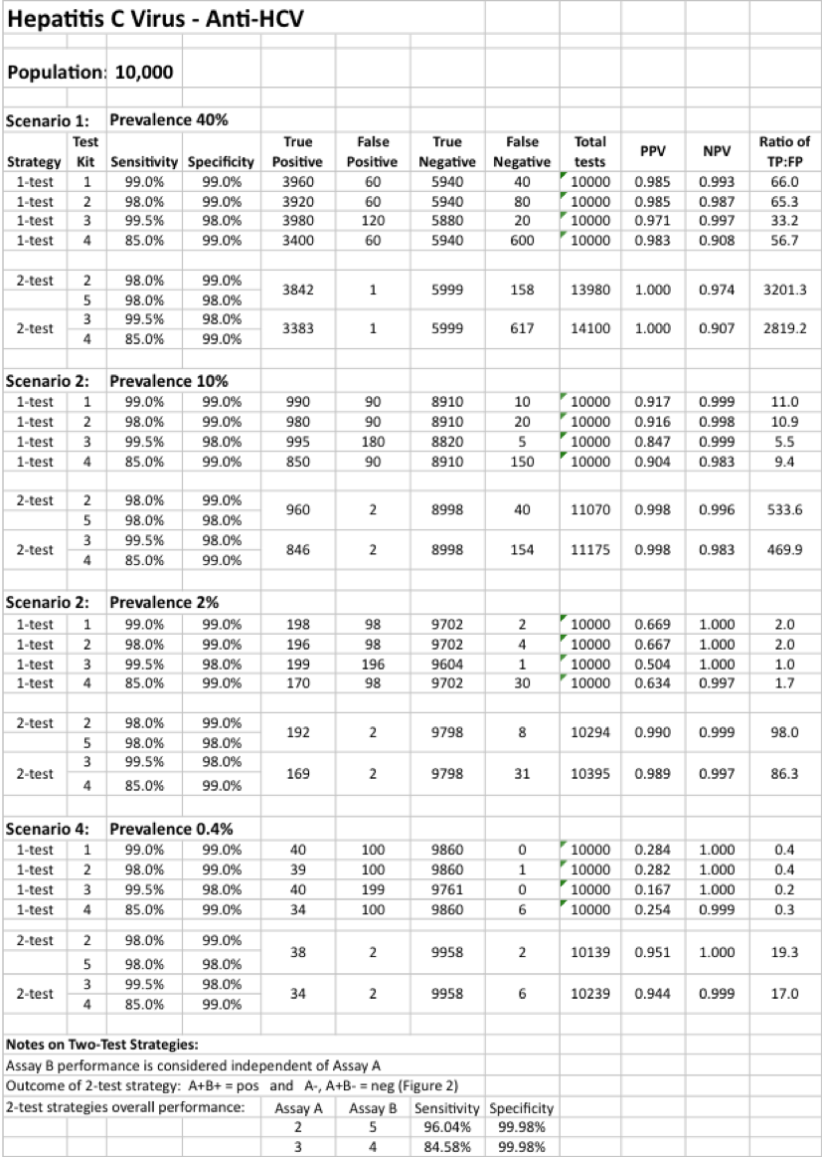
Additional file 2: Outcomes from applying 1- and 2-test diagnostic strategy models to four HCV epidemic scenarios

