Additional File 3.

Title: Full Poisson and Logit Models, with Model fit Indices and Variance Inflation Factors (VIFs) for all Models
Appendix B. Analysis and Model Fit.

Generalized linear models were used to examine the demographic and socioeconomic variables associated with knowledge, correct steps performed, and innovation use. Knowledge items were specified using Poisson models as these variables are counts and their distribution displayed positive skew but did not show evidence of significant overdispersion. Coefficients in Poisson models are incidence rate ratios, here, the rate at which additional knowledge items or correct steps are recalled/performed. Logistic regression was used to determine characteristics associated with innovation use. Coefficients of logit models are presented as odds ratios where ratios above 1 indicate a greater odds of innovation use and below 1 indicating lower odds of innovation use.
Models are first presented as full models and then reduced stepwise models. Model diagnostics include multicollinearity and comparative and global indices of model fit. Multicollinearity was assessed using variance inflation factors with the package collin. Stata 13 (StataCorp 2012) was used for all analyses.

Table S1. Knowledge of Bacteria in Both Genders, Women, and Men. Full Model with all covariates included.
 | Both Genders |  | Women |  | Men
 | B | SE | B | SE | B | SE
Age | 1.021 | 0.991 - 1.051 | 1.062 | 1.008 - 1.118* | 1.016 | 0.955 - 1.080
Sex (0=female, 1=male) | 1.294 | 0.632 - 2.648
Education (0=no, 1=yes) | 0.928 | 0.500 - 1.722 | 0.931 | 0.390 - 2.223 | 1.334 | 0.485 - 3.667
Num Wives or Co-Wives | 0.972 | 0.803 - 1.178 | 0.933 | 0.764 - 1.141 | 1.118 | 0.553 - 2.260
Total children | 0.933 | 0.857 - 1.015 | 0.713 | 0.557 - 0.913** | 0.951 | 0.821 - 1.101
Total cattle | 1.002 | 0.999 - 1.005 | 1.005 | 1.000 - 1.010 | 1.000 | 0.995 - 1.005
Wealth | 1.511 | 1.122 - 2.033** | 1.335 | 0.892 - 1.998 | 1.730 | 0.988 - 3.030
Used Innov. (0=no, 1=yes) | 1.910 | 0.961 - 3.796 | 2.472 | 0.875 - 6.979 | 2.029 | 0.596 - 6.905
AMR Knowledge | 1.377 | 1.015 - 1.868* | 1.256 | 0.839 - 1.880 | 1.500 | 0.822 - 2.738
Pseudo R2 | 0.08 |  | 0.13 |  | 0.11
Prob>chi2 | 0.17 |  | 0.08 |  | 0.56
Log Likelihood | -78.07 |  | -46.39 |  | -27.37
LR chi2 | 12.90 |  | 13.89 |  | 6.76
Obs | 62 |  | 40 |  | 22
* p<0.05; ** p<0.01

Table S2. Knowledge of Bacteria in Both Genders, Women, and Men. Reduced models using stepwise backward regression (0.20 retention factor).
 | Both Genders |  | Women |  | Men
 | B | SE | B | SE | B | SE
Age | 1.018 | 0.992 - 1.045 | 1.056 | 1.006 - 1.108*
Sex (0=female, 1=male)
Education (0=no, 1=yes)
Num Wives or Co-Wives
Total children | 0.955 | 0.889 - 1.024 | 0.707 | 0.555 - 0.899**
Total cattle |  |  | 1.004 | 1.000 - 1.009
Wealth | 1.493 | 1.118 - 1.995** | 1.307 | 0.883 - 1.937 | 1.615 | 1.040 - 2.508*
Used Innov. (0=no, 1=yes) | 1.664 | 0.871 - 3.178 | 2.438 | 0.916 - 6.484
AMR Knowledge | 1.387 | 1.058 - 1.819*
Pseudo R2 | 0.06 |  | 0.12 |  | 0.06
Prob>chi2 | 0.05 |  | 0.03 |  | 0.05
Log Likelihood | -79.06 |  | -47.07 |  | -28.80
LR chi2 | 10.93 |  | 12.54 |  | 3.90
Obs | 62 |  | 40 |  | 22
* p<0.05; ** p<0.01

Figure 1. Fit Statistics Comparing Full and Reduced Models for Knowledge of Bacteria in Both Genders. Reduced model indices are in “Current” column and Full in “Saved” column.
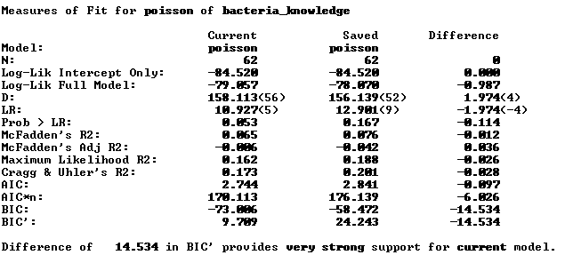

Figure 2. Collinearity Measures for Knowledge of Bacteria in Both Genders.
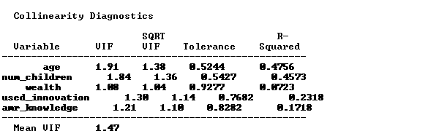

Figure 3. Fit Statistics Comparing Full and Reduced Models for Knowledge of Bacteria in Women. Reduced model indices are in “Current” column and Full in “Saved” column.
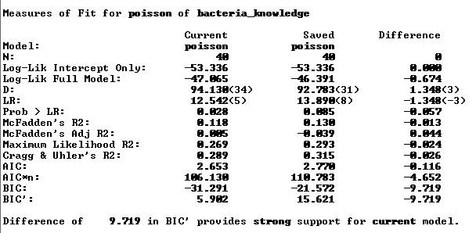

Figure 4. Collinearity Measures for Knowledge of Bacteria in Women.
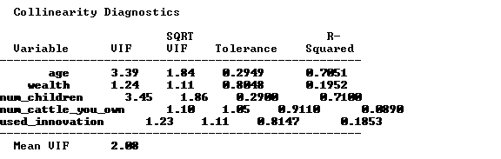

Figure 5. Fit Statistics Comparing Full and Reduced Models for Knowledge of Bacteria in Men. Reduced model indices are in “Current” column and Full in “Saved” column.
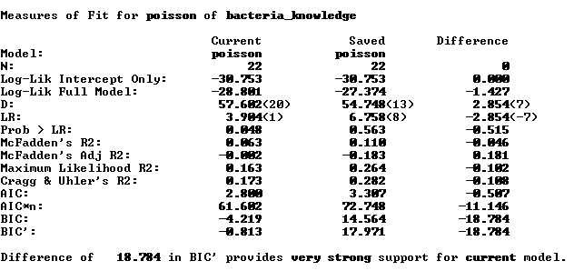

Note: No VIF information for men given only one variable was retained.

Table S3. Knowledge of Antimicrobial Resistance in Both Genders, Women, and Men. Full Model with all covariates included.
 | Both Genders |  | Women |  | Men
 | B | SE | B | SE | B | SE
Age | 0.963 | 0.929 - 0.999* | 0.972 | 0.911 - 1.038 | 0.956 | 0.901 - 1.014
Sex (0=female, 1=male) | 2.719 | 1.340 - 5.520**
Education (0=no, 1=yes) | 1.041 | 0.582 - 1.862 | 1.123 | 0.449 - 2.808 | 1.144 | 0.489 - 2.674
Num Wives or Co-Wives | 1.149 | 0.947 - 1.393 | 1.247 | 0.977 - 1.590 | 1.062 | 0.621 - 1.815
Total children | 1.037 | 0.961 - 1.119 | 0.954 | 0.722 - 1.261 | 1.062 | 0.943 - 1.196
Total cattle | 0.999 | 0.996 - 1.002 | 0.991 | 0.975 - 1.008 | 0.999 | 0.996 - 1.002
Wealth | 0.772 | 0.515 - 1.158 | 0.782 | 0.447 - 1.368 | 0.920 | 0.461 - 1.838
Used Innov. (0=no, 1=yes) | 0.500 | 0.259 - 0.966* | 0.832 | 0.280 - 2.471 | 0.355 | 0.135 - 0.933*
Bacteria Knowledge | 1.218 | 0.962 - 1.541 | 1.183 | 0.831 - 1.685 | 1.162 | 0.811 - 1.665
Pseudo R2 | 0.15 |  | 0.08 |  | 0.12
Prob>chi2 | 0.00 |  | 0.53 |  | 0.47
Log Likelihood | -70.44 |  | -40.06 |  | -28.63
LR chi2 | 25.03 |  | 7.08 |  | 7.62
Obs | 62 |  | 40 |  | 22

Table S4. Knowledge of Antimicrobial Resistance in Both Genders, Women, and Men. Reduced models using stepwise backward regression (0.20 retention factor).
 | Both Genders |  | Women |  | Men
 | B | SE | B | SE | B | SE
Age | 0.975 | 0.950 - 1.001 | 0.970 | 0.931 - 1.009
Sex (0=female, 1=male) | 3.131 | 1.632 - 6.008**
Used Innov. (0=no, 1=yes) | 0.635 | 0.369 - 1.095 |  |  | 0.500 | 0.234 - 1.067
Num Wives or Co-Wives | 1.136 | 0.952 - 1.355 | 1.186 | 0.953 - 1.476
Pseudo R2 | 0.13 |  | 0.04 |  | 0.05
Prob>chi2 | 0.00 |  | 0.19 |  | 0.06
Log Likelihood | -72.32 |  | -41.95 |  | -30.67
LR chi2 | 21.27 |  | 3.29 |  | 3.54
Obs | 62 |  | 40 |  | 22

Figure 6. Fit Statistics Comparing Full and Reduced Models for Knowledge of Antimicrobial Resistance in Both Genders. Reduced model indices are in “Current” column and Full in “Saved” column.
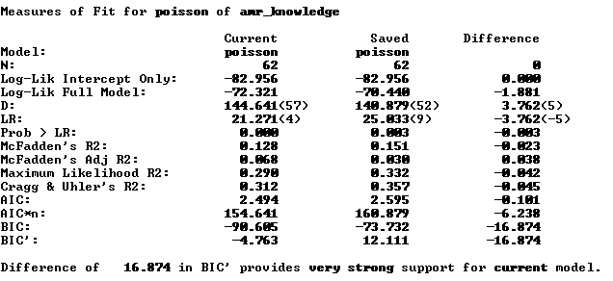
Figure 7. Collinearity Statistics for Knowledge of Antimicrobial Resistance in Both Genders.
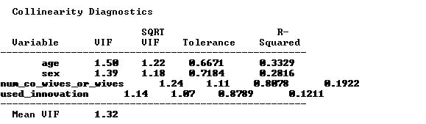

Figure 8. Fit Statistics Comparing Full and Reduced Models of Knowledge of Antimicrobial Resistance for Women. Reduced model indices are in “Current” column and Full in “Saved” column.
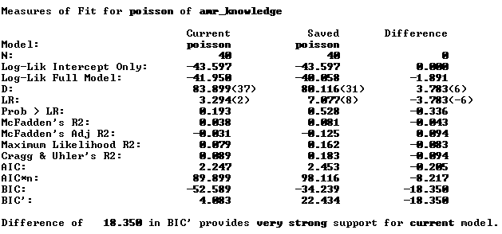

Figure 9. Collinearity Statistics for Knowledge of Antimicrobial Resistance in Women.
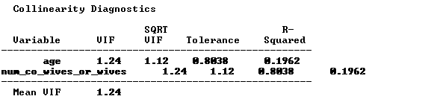
Figure 10. Fit Statistics Comparing Full and Reduced Models for Knowledge of Antimicrobial Resistance in Men. Reduced model indices are in “Current” column and Full in “Saved” column.
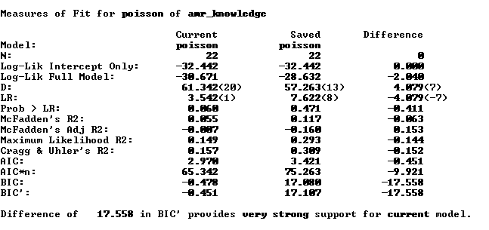
Table S5. Number of Recalled Health Benefits of Innovations in Women and Men. Full model with all covariates included.
 | Women |  | Men
 | B | CI | B | CI
Age | 1.039 | 1.003 - 1.077* | 1.021 | 0.980 - 1.063
Education (0=no, 1=yes) | 1.096 | 0.631 - 1.904 | 1.234 | 0.554 - 2.748
Num Wives or Co-Wives | 0.967 | 0.833 - 1.122 | 0.836 | 0.457 - 1.531
Total children | 0.899 | 0.764 - 1.057 | 0.961 | 0.852 - 1.083
Total cattle | 1.001 | 0.996 - 1.006 | 1.002 | 0.999 - 1.005
Wealth | 1.053 | 0.758 - 1.463 | 1.212 | 0.677 - 2.170
Used Innov. (0=no, 1=yes) | 2.164 | 1.008 - 4.646* | 1.577 | 0.580 - 4.284
Bacteria Knowledge | 0.977 | 0.773 - 1.235 | 1.083 | 0.771 - 1.521
AMR Knowledge | 1.278 | 0.972 - 1.680 | 1.203 | 0.731 - 1.981
Pseudo R2 | 0.08 |  | 0.07
Prob>chi2 | 0.33 |  | 0.90
Log Likelihood | -55.35 |  | -28.29
LR chi2 | 10.24 |  | 4.15
Obs | 40 |  | 22

Table S6. Number of Recalled Health Benefits of Innovations in Women and Men. Reduced models using stepwise backward regression (0.20 retention factor).
 | Women |  | Men
 | B | CI | B | CI
Age | 1.017 | 1.000 - 1.034
Used Innov. (0=no, 1=yes) | 1.745 | 0.913 - 3.337
AMR Knowledge | 1.262 | 0.978 - 1.630
Pseudo R2 | 0.07
Prob>chi2 | 0.04
Log Likelihood | -56.31 |  | -38.36
LR chi2 | 8.32 |  | 0.0
Obs | 40 |  | 22

Figure 11. Fit Statistics Comparing Full and Reduced Models for Number of Recalled Health Benefits of Innovation in Women. Reduced model indices are in “Current” column and Full in “Saved” column.
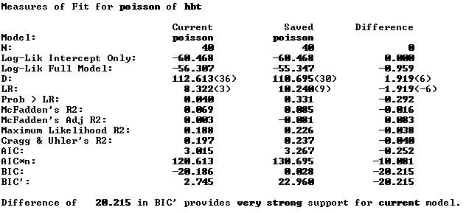
Figure 12. Collinearity Statistics for Number of Recalled Health Benefits of Innovation in Women.
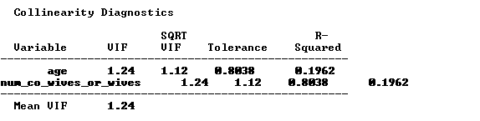
Figure 13. Fit Statistics Comparing Full and Reduced Models for Number of Recalled Health Benefits of Innovation in Men. Reduced model indices are in “Current” column and Full in “Saved” column.
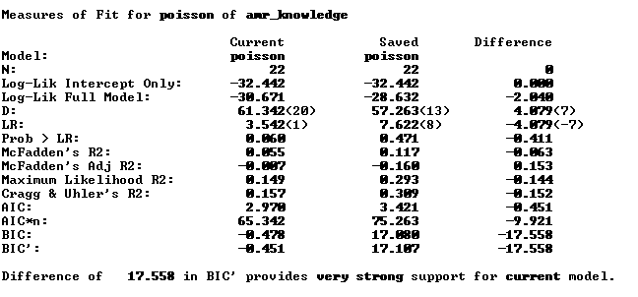
Note: No VIF information for men given no variable was retained.

Table 7S. Number of Steps Performed Correctly for Innovations in Women and Men. Full model with all covariates included.
 | Women |  | Men
 | B | CI | B | CI
Age | 0.993 | 0.961 - 1.027 | 0.994 | 0.934 - 1.057
Education (0=no, 1=yes) | 0.890 | 0.543 - 1.459 | 4.148 | 1.299 - 13.248*
Num Wives or Co-Wives | 1.026 | 0.887 - 1.188 | 1.221 | 0.590 - 2.524
Total children | 1.049 | 0.904 - 1.218 | 0.965 | 0.804 - 1.158
Total cattle | 0.994 | 0.987 - 1.001 | 0.999 | 0.993 - 1.006
Wealth | 1.021 | 0.772 - 1.350 | 1.577 | 0.775 - 3.211
Used Innov. (0=no, 1=yes) | 0.998 | 0.549 - 1.814 | 0.916 | 0.228 - 3.678
Bacteria Knowledge | 1.096 | 0.888 - 1.354 | 1.326 | 0.868 - 2.024
AMR Knowledge | 0.998 | 0.777 - 1.282 | 0.858 | 0.436 - 1.690
Pseudo R2 | 0.04 |  | 0.23
Prob>chi2 | 0.85 |  | 0.11
Log Likelihood | -55.34 |  | -23.60
LR chi2 | 4.79 |  | 14.30
Obs | 40 |  | 22
Obs | 40 |  | 22

Table 8S. Number of Steps Performed Correctly for Innovations in Women and Men. Reduced models using stepwise backward regression (0.20 retention factor).
 | Women |  | Men
 | B | CI | B | CI
Total cattle | 0.995 | 0.989 - 1.001
Wealth |  |  | 1.638 | 0.816 - 3.287
Education (0=no, 1=yes) |  |  | 4.356 | 1.552 - 12.228**
Bacteria Knowledge |  |  | 1.271 | 0.882 - 1.832
Pseudo R2 | 0.03 |  | 0.21
Prob>chi2 | 0.07 |  | 0.00
Log Likelihood | -56.07 |  | -24.16
LR chi2 | 3.32 |  | 13.19
Obs | 40 |  | 22

Figure 14. Fit Statistics Comparing Full and Reduced Models for Number of Steps Performed Correctly in Women. Reduced model indices are in “Current” column and Full in “Saved” column.
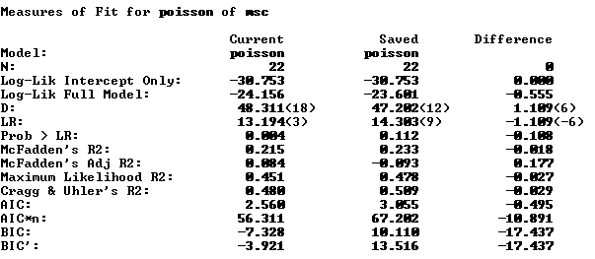
Figure 15. Collinearity Statistics for Number of Steps Performed Correctly in Women.
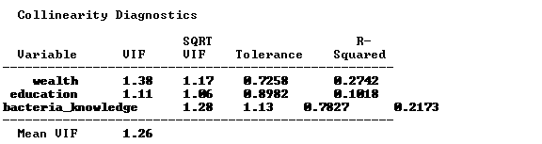

Figure 16. Fit Statistics Comparing Full and Reduced Models for Number of Steps Performed Correctly in Men. Reduced model indices are in “Current” column and Full in “Saved” column.
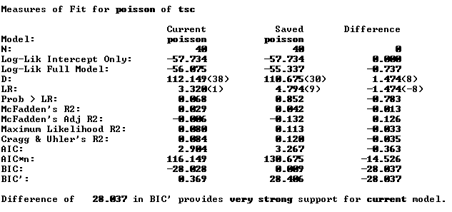
Note: No VIF information for men given no variable was retained.

Table S9. Correlates of Innovation Use in Women and Men. Full model with all covariates included.

 | Women |  | Men
 | B | SE | B | SE
Age | 0.790 | 0.627 - 0.996* | 0.554 | 0.236 - 1.301
Education (0=no, 1=yes) | 0.368 | 0.044 - 3.076 | 7.064 | 0.062 - 798.641
Num Wives or Co-Wives | 0.586 | 0.263 - 1.303 | 0.263 | 0.008 - 8.715
Total children | 5.099 | 1.010 - 25.757* | 3.923 | 0.743 - 20.712
Total cattle | 0.986 | 0.963 - 1.009 | 0.978 | 0.952 - 1.005
Wealth | 0.452 | 0.158 - 1.294 | 1.797 | 0.032 - 100.035
AMR Knowledge | 1.017 | 0.310 - 3.335 | 0.028 | 0.001 - 0.748*
Bacteria Knowledge | 2.685 | 0.847 - 8.510 | 1.460 | 0.208 - 10.247
Pseudo R2 | 0.32 |  | 0.65
Prob>chi2 | 0.08 |  | 0.01
Log Likelihood | -15.38 |  | -5.16
LR chi2 | 14.24 |  | 19.45
Obs | 40 |  | 22

Table S10. Correlates of Innovation Use in Women and Men. Reduced models using stepwise backward regression (0.20 retention factor).
 | Women |  | Men
 | B | SE | B | SE
Age | 0.864 | 0.755 - 0.989* | 0.856 | 0.692 - 1.058
Bacteria Knowledge | 1.882 | 0.795 - 4.455
Wealth | 0.441 | 0.165 - 1.174
Total children | 2.332 | 1.115 - 4.877* | 1.247 | 0.985 - 1.578
AMR Knowledge |  |  | 0.089 | 0.009 - 0.901*
Pseudo R2 | 0.24 |  | 0.43
Prob>chi2 | 0.03 |  | 0.01
Log Likelihood | -17.16 |  | -8.54
LR chi2 | 10.66 |  | 12.68
Obs | 40 |  | 22

Figure 17. Fit Statistics Comparing Full and Reduced Models for Correlates of Innovation Use in Women. Reduced model indices are in “Current” column and Full in “Saved” column.
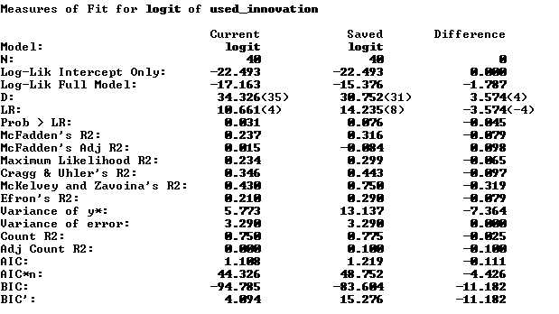

Figure 18. Collinearity Statistics for Number of Steps Performed Correctly in Women.
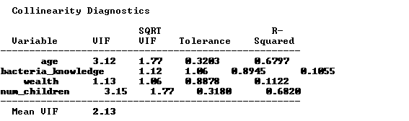
Figure 19. Fit Statistics Comparing Full and Reduced Models for Correlates of Innovation Use in Men. Reduced model indices are in “Current” column and Full in “Saved” column.
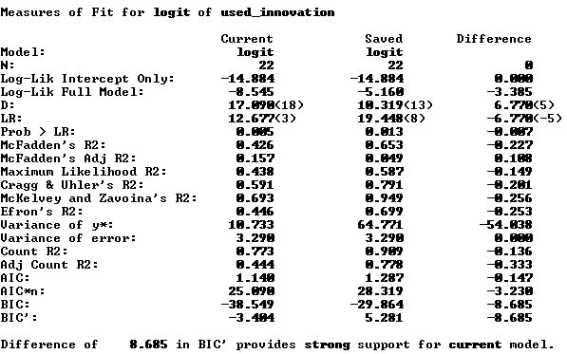
Figure 20. Collinearity Statistics for Number of Steps Performed Correctly in Women.

