Supplementary Material
Supplementary Table 1 Serum LPB concentration according to patient group (µg/ml)
 | Co-infected | HBV mono | HIV mono | Control | p
n | 42 | 38 | 38 | 37
Median (IQR) | 12.4 (10.2-15.6) | 10.8 (8.4-13.4) | 9.9 (7.8-16.0) | 9.6 (8.2-13.3) | 0.1

Supplementary Table 2: Proportions of fibrosis scores according to the HBV genotype.
 | <7.0 kPa | 7-13 kPa | >13 kPa
Genotype A, n=21 | 7 (33%) | 9 (43%) | 5 (24%)
Genotype D, n=11 | 7 (64%) | 3 (27%) | 1 (9%)
Genotype E, n=4 | 2 (50%) | 2 (50%) | 0

Supplementary Table 3 Multiple correlation analysis of all patients ungrouped. Statistically significant correlations appear in red font.
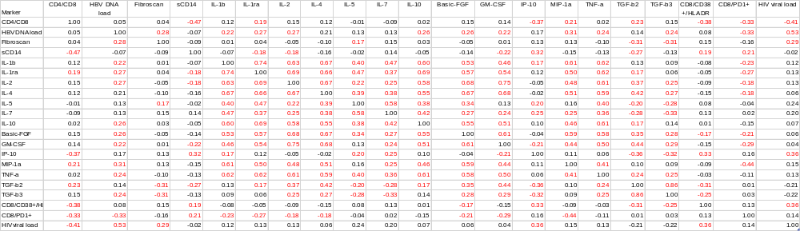

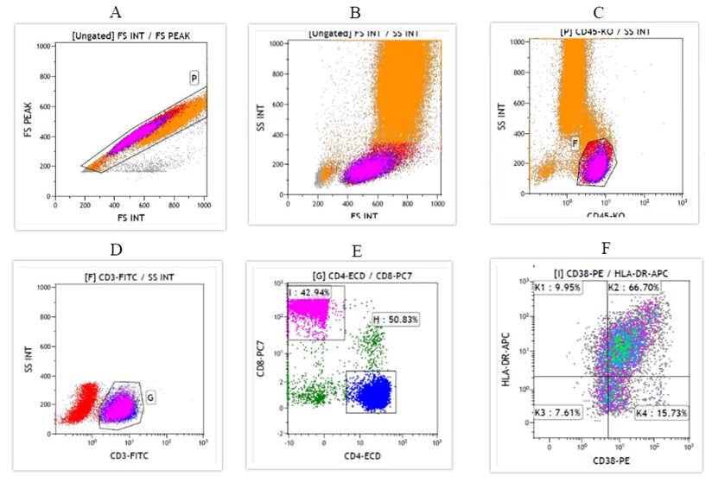
Supplementary Figure 1: Gating strategy for Immune Activation panel. Plot A shows the singlet population gating while Plot B represents the SSC against FSC plot indicating the position of the singlet cells of the lymphocyte population. Plot C shows the lymphocyte population as shown by less complexity (SS) and intense staining for CD45-KO in a plot of side scatter against CD45-KO. Plot D shows the CD3+ population (Gate G) as gated from Gate F shown in Plot C. Using colour precedence and back gating, Plot D also shows the non-lymphocyte population (red colour) that is included within gate F based on use of complexity (SS INT) and staining for CD45. Picture E shows the CD4+ in the blue colour (gate H) and the CD8+ lymphocytes in the magenta colour (gate I). Plot F shows the CD8+ population staining for CD38-PE and HLA-DR-APC gated from gate I. The gate placement was based on defined fluorescence minus one (FMO) settings.

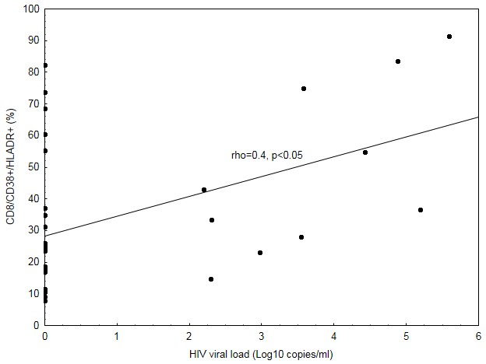
Supplementary Figure 1 Scatter plot of % CD8/CD38+/HLA-DR+ in the co-infected group. The plot only includes HBV/HIV co-infected patients. All patients with undetectable HIV viral load are assigned values of zero and appear on the y-axis as dots corresponding with the percentage expression CD8/CD38+/HLA-DR.

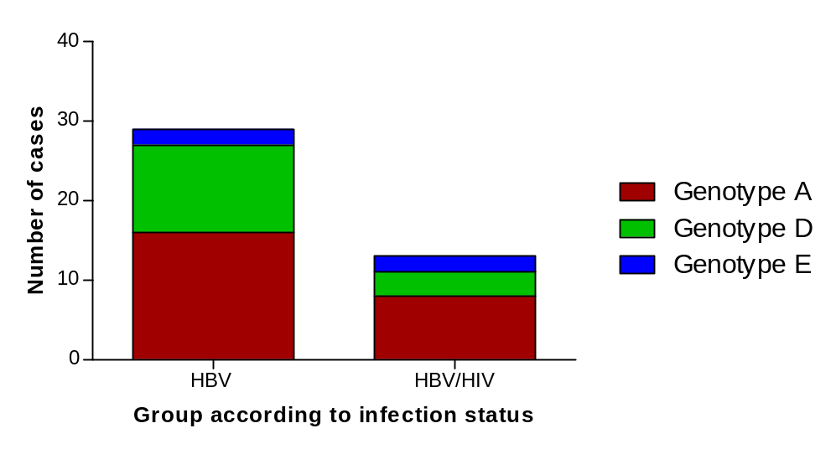
Supplementary Figure 2 Frequency of HBV genotypes according to HBV and HIV infection status. Among the 13 co-infected patients whose HBV was successfully sequenced, 8 (62%) were infected with HBV genotype A, 3 (23%) with D and 2 had HBV genotype E (15%). The distribution of genotypes among the HBV mono-infected patients was- 16/29 (55%) A, 11/29 (38%) D and 2/29 (7%) E. The red columns represent HBV genotype A, green is for genotype D and the blue corresponds to genotype E. Genotyping was frequently more successful in the HBV mono-infected group compared to the co-infected group.

