Supporting information
Restriction of in vivo infection by antifouling coating on urinary catheter with controllable and sustained silver release: A proof of concept study
Kedar D. Mandakhalikar, Rong Wang, Juwita N. Rahmat, Edmund Chiong,
Koon Gee Neoh, Paul A. Tambyah

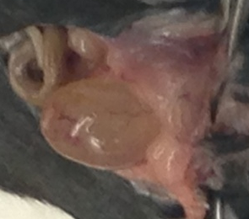
Figure S1 Bladder enlarged due to blockage in urine flow

Figure S2 Average IL-6 levels in urine of E. coli inoculated mice implanted with uncoated catheters and P3 coated catheters. Error bars indicate SD.

Figure S3 Amounts of calcium and magnesium deposition in urinary bladder of all micropigs with DoverTM and P3 catheter.

Figure S4 Daily weight measurements to assess general health of the mice. Error bars indicate SD.

