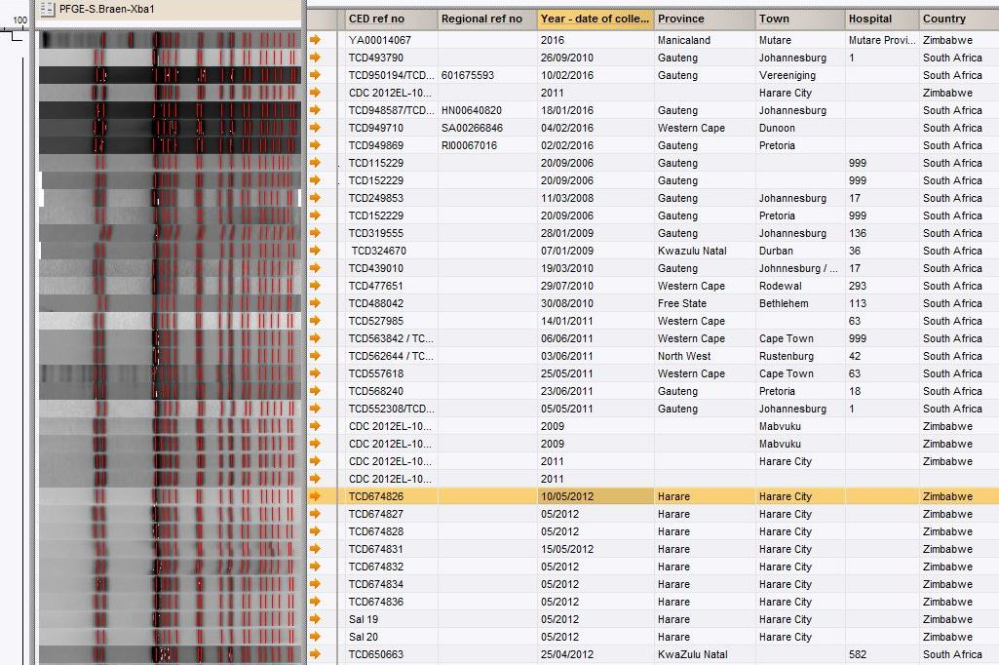
Additional file 1: Figure S1: PFGE analysis of the Zimbabwe (2009) with South Africa (2006, 2008, 2009, 2010, 2011, and 2012) S. Typhi isolates

