Additional file 1
Figure S1: Forest plot of the Effect of PCV against IPD among HIV-infected Children based on Pre-post studies
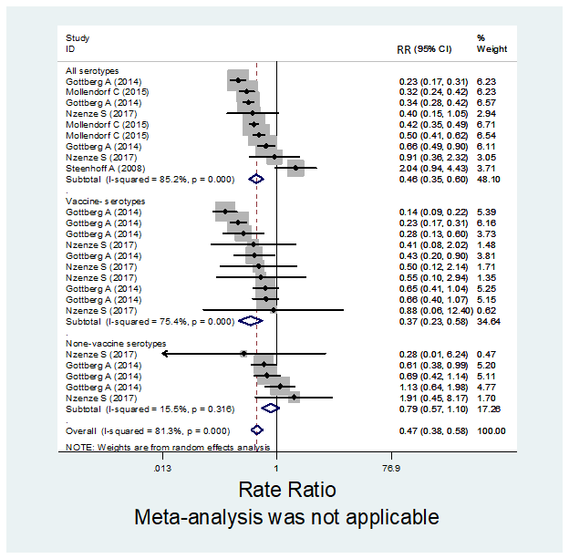

Figure S2: Forest plot of the Effect of PCV against IPD among HIV-uninfected Children based on Pre-post studies
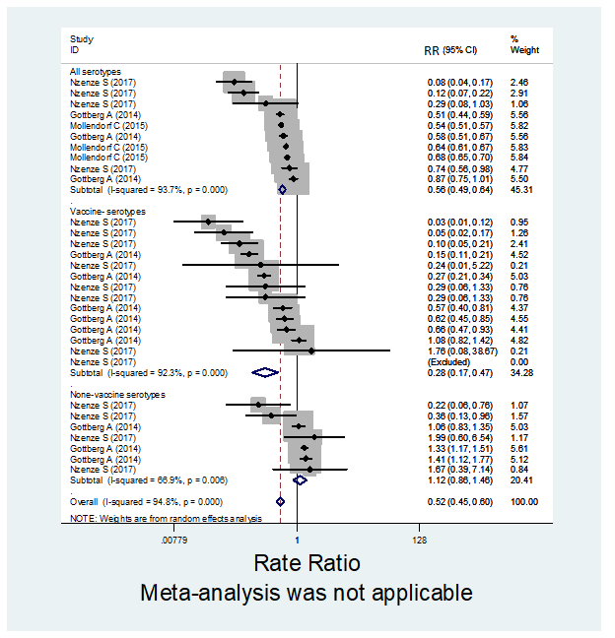

Figure S3: Forest plot of the Effect of PCV against IPD among HIV-infected Children in pre-post studies according to age groups

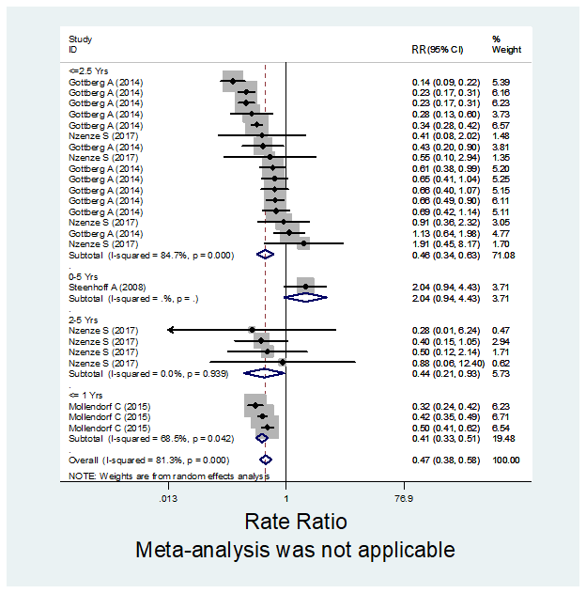

Figure S4: Forest plot of the Effect of PCV against IPD among HIV-uninfected Children in pre-post studies according to age groups
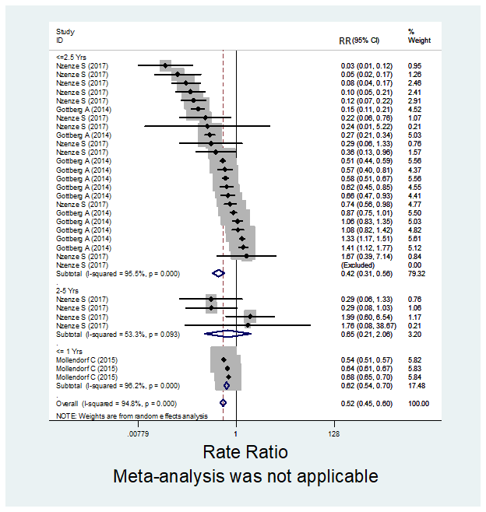

Figure S5: Forest plot of the Effect of PCV against IPD among HIV-infected Children in case-control studies according to age groups
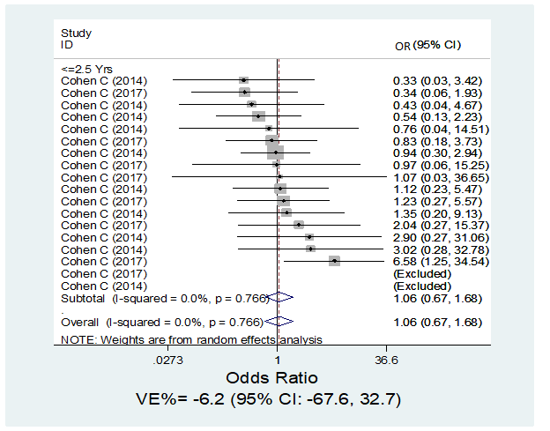

Figure S6: Forest plot of the Effect of PCV against IPD among HIV-uninfected Children in case-control studies according to age groups
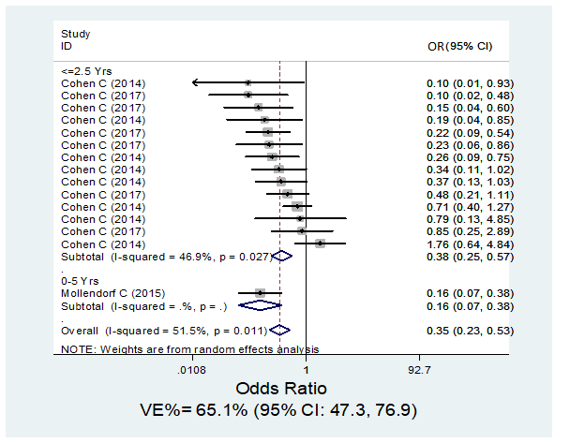
Figure S7: Forest plot of the Effect of PCV against IPD among HIV-infected Children in randomized trials according to age groups
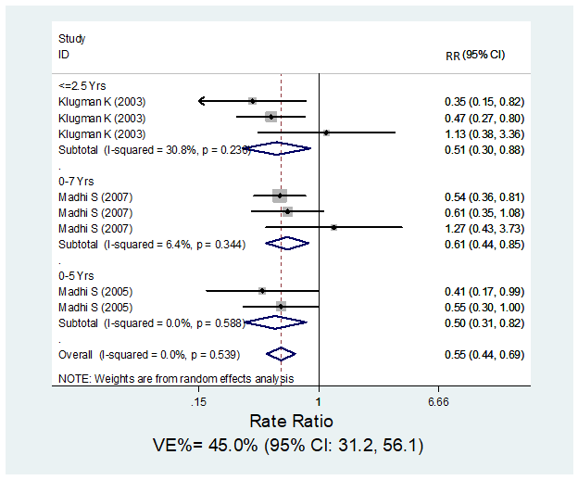

Figure S8: Forest plot of the Effect of PCV against IPD among HIV-uninfected Children in randomized trials according to age groups
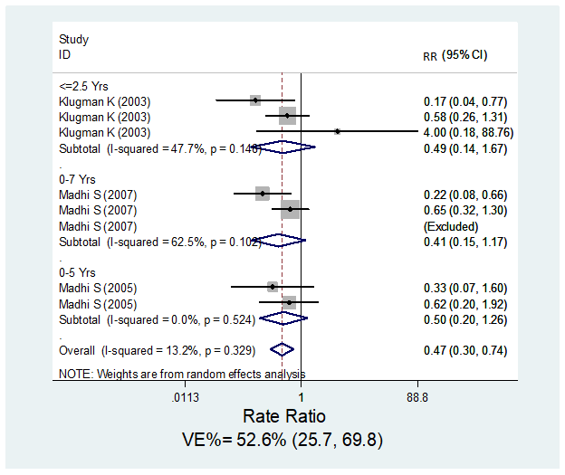

Figure S9: Forest plot of the Effect of PCV against IPD among HIV-infected Children in pre-post studies according to vaccine valency
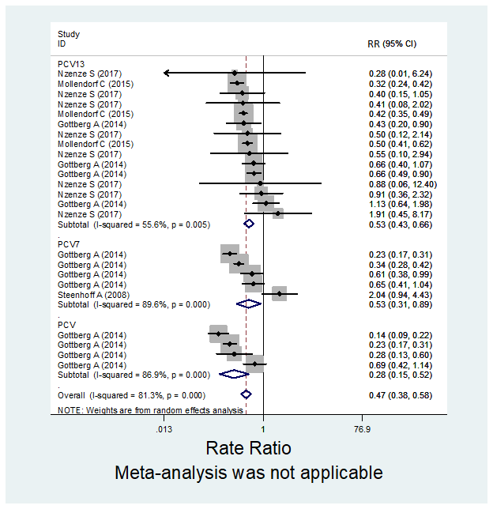

Figure S10: Forest plot of the Effect of PCV against IPD among HIV-uninfected Children in pre-post studies according to vaccine valency
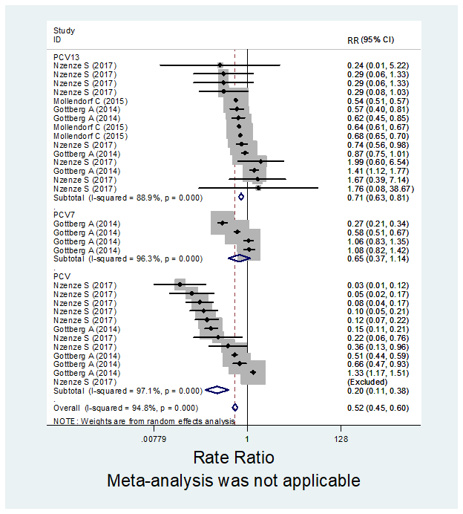

Figure S11: Forest plot of the Effect of PCV against IPD among HIV-infected Children in case-control studies according to vaccine valency
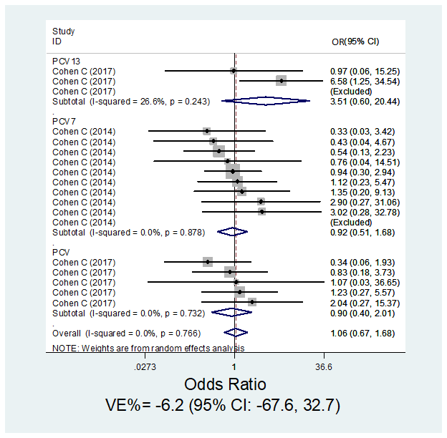

Figure S12: Forest plot of the Vaccine effectiveness among HIV-uninfected Children in Case-Control studies according to vaccine valency
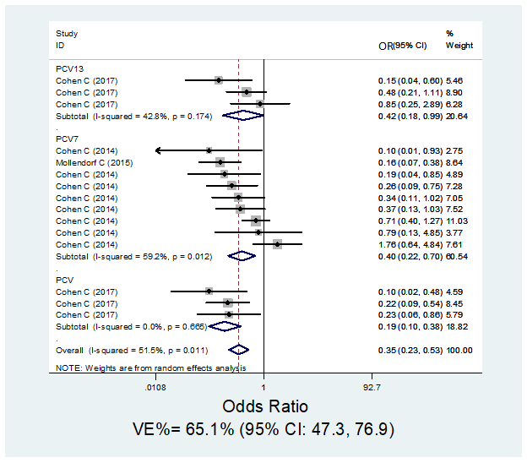

Figure S13: Influential observation analysis (HIV-infected Children, pre-post studies)
Figure S14: Influential observation analysis (HIV-uninfected Children, pre=post studies)

Figure S15: Influential observation analysis (HIV-infected Children, case-control studies)
Figure S16: Influential observation analysis (HIV-uninfected Children, case-control studies)

Figure S17: Influential observation analysis (HIV-infected Children, randomized trials)
Figure S18: Influential observation analysis (HIV-uninfected Children, randomized trials)

Figure S19: Assessment of Publication Bias in Clinical Trial Studies in HIV-infected Children
Figure S20: Assessment of Publication Bias in Clinical Trial Studies in HIV-uninfected Children

Figure S21: Assessment of Publication Bias in Case-Control Studies in HIV-uninfected Children
Figure S22: Assessment of Publication Bias in Case-Control Studies in HIV-infected Children

Figure S23: Assessment of Publication Bias in Pre-post Studies in HIV-uninfected Children

Figure S24: Assessment of Publication Bias in Pre-post Studies in HIV-infected Children

