Additional file 6: Original images for results of Sanger sequencing detection of VZV from CSF specimen.
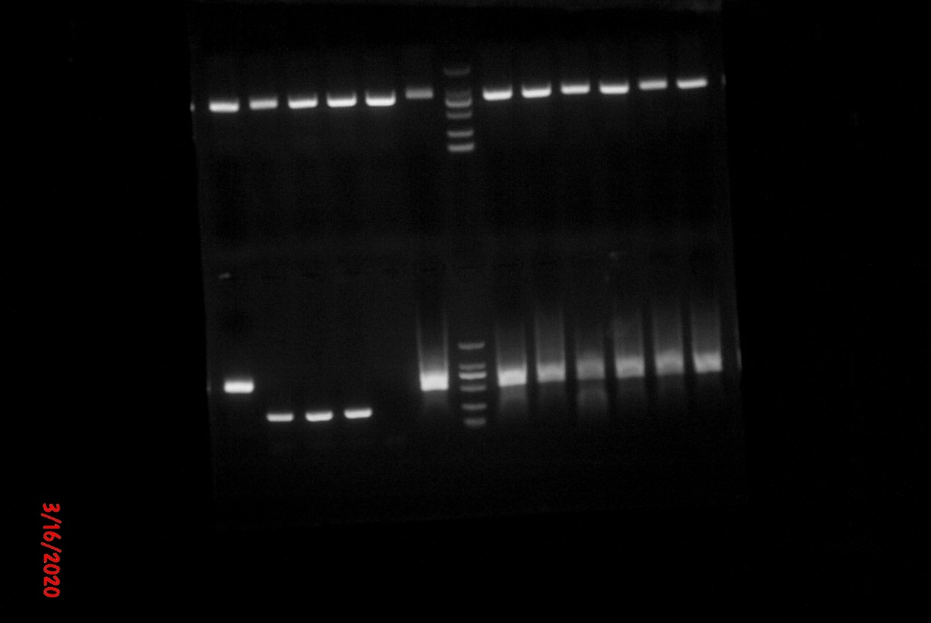
277
277
M
N
Case 2
Case 1
-500bp
-250bp
-100bp
a

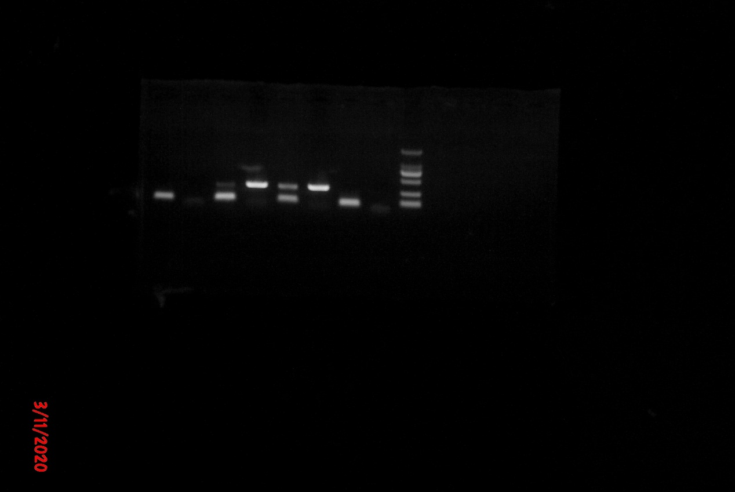
Case 3
Case 4
277
277
N
M
-500bp
-250bp
-100bp
b

Fig. 2 Sanger sequencing detection of VZV from CSF specimen.
M: DNA markers of DL2000 or Trans 2K Plus. N: negative control. The number 277bp represent the sample code.

