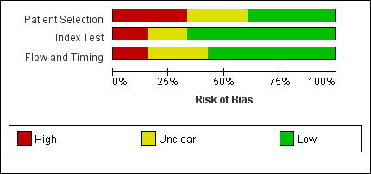
Fig. S1 Methodological quality assessment using the QUADAS-2 tool showing the proportion of included studies with different risk of bias.

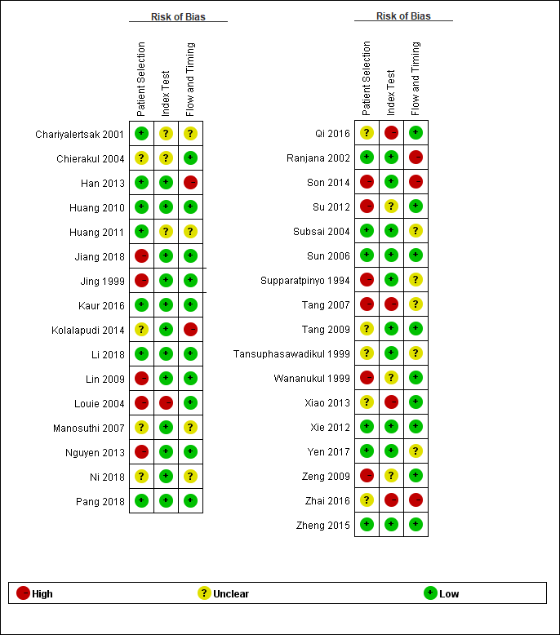
Fig. S2 Methodological quality summary of studies included in the meta-analysis.

