Supplementary Tables and Figures
Gaps in the Care Cascade for Screening and Treatment of Refugees with Tuberculosis Infection in Middle Tennessee: A Retrospective Cohort Study
Supplementary Table 1A: Matching Rules and Algorithms for Identifying Participants across Study Datasets
Matching Methods | Variables | Matching Algorithm | Command (Software) | Threshold
Exact | Full Name  Date of Birth  Sex | Exact
Fuzzy | Full Name  First Name  Last Name | Soundex  Generalized Edit Distance  Levenshtein Edit Distance  Last Name, First Initial  Inverted First and Last Name | SOUNDEX function (SAS) & Soundex() code (Stata)  COMPGED function (SAS)  COMPLEV function (SAS) & STRDIST module (Stata) | <750  <7
Fuzzy | Date of Birth | DOB +/- 365 days  YOB +/- 10 years

Supplementary Table 1B: Breakdown of Participants by Matching Conditions
Matching Conditions | Total | Cum Total | Cum %
Exact Full Name, Exact Date of Birth, Exact Sex | 1111 | 1111 | 66.1
Exact Full Name, Exact Sex, Fuzzy Date of Birth | 32 | 1143 | 67.9
Exact Date of Birth, Exact Sex, Fuzzy Full Name | 128 | 1271 | 75.6
Exact Date of Birth, Exact Sex, Fuzzy Last Name | 10 | 1281 | 76.2
Exact Last Name, Exact First Initial, Exact Date of Birth, Exact Sex | 70 | 1351 | 80.3
Exact Last Name, Exact First Initial, Exact Sex, Fuzzy Year of Birth | 9 | 1360 | 80.9
Exact Date of Birth, Fuzzy Full Name | 17 | 1377 | 81.9
 | Overall Totals
Total who screened positive for tuberculosis | 1681 | 1681 | 100.00
Matched to Metro Public Health Department visits | 1377 | 1377 | 81.9
Included in analyses¹ | 1293 | 1293 | 76.9

¹84 individuals who matched at Metro Public Health Department were later excluded based on study inclusion/exclusion criteria

Supplementary Table 2: Distribution of Elixhauser Comorbidity Groups within Study Population (n=1208). Individuals could have multiple comorbidities.
Elixhauser Comorbidity Group | Freq | %
None | 797 | 65.98
Hypertension, Uncomplicated | 151 | 12.50
Obesity | 150 | 12.42
Liver Disease | 77 | 6.37
Diabetes, Uncomplicated | 47 | 3.89
Depression | 35 | 2.90
Weight Loss | 22 | 1.82
Chronic Pulmonary Disease | 20 | 1.66
Coagulopathy | 19 | 1.57
Hypothyroidism | 17 | 1.41
Alcohol Abuse | 15 | 1.24
HIV/AIDS | 14 | 1.16
Cardiac Arrhythmias | 10 | 0.83
Fluid and Electrolyte Disorders | 5 | 0.41
Valvular Disease | 5 | 0.41
Other Neurological Disorders | 4 | 0.33
Peptic Ulcer Disease Excluding Bleeding | 3 | 0.25
Psychoses | 3 | 0.25
Renal Disease | 3 | 0.25
Rheumatoid Arthritis/ Collagen Vascular | 3 | 0.25
Paralysis | 2 | 0.17
Pulmonary Circulation Disorders | 2 | 0.17
Congestive Heart Failure | 1 | 0.08
Metastatic Cancer | 1 | 0.08
Peripheral Vascular Disorders | 1 | 0.08
Solid Tumour without Metastasis | 1 | 0.08
Blood Loss Anaemia | 0 | 0.00
Deficiency Anaemia | 0 | 0.00
Diabetes, Complicated | 0 | 0.00
Drug Abuse | 0 | 0.00
Hypertension, Complicated | 0 | 0.00
Lymphoma | 0 | 0.00

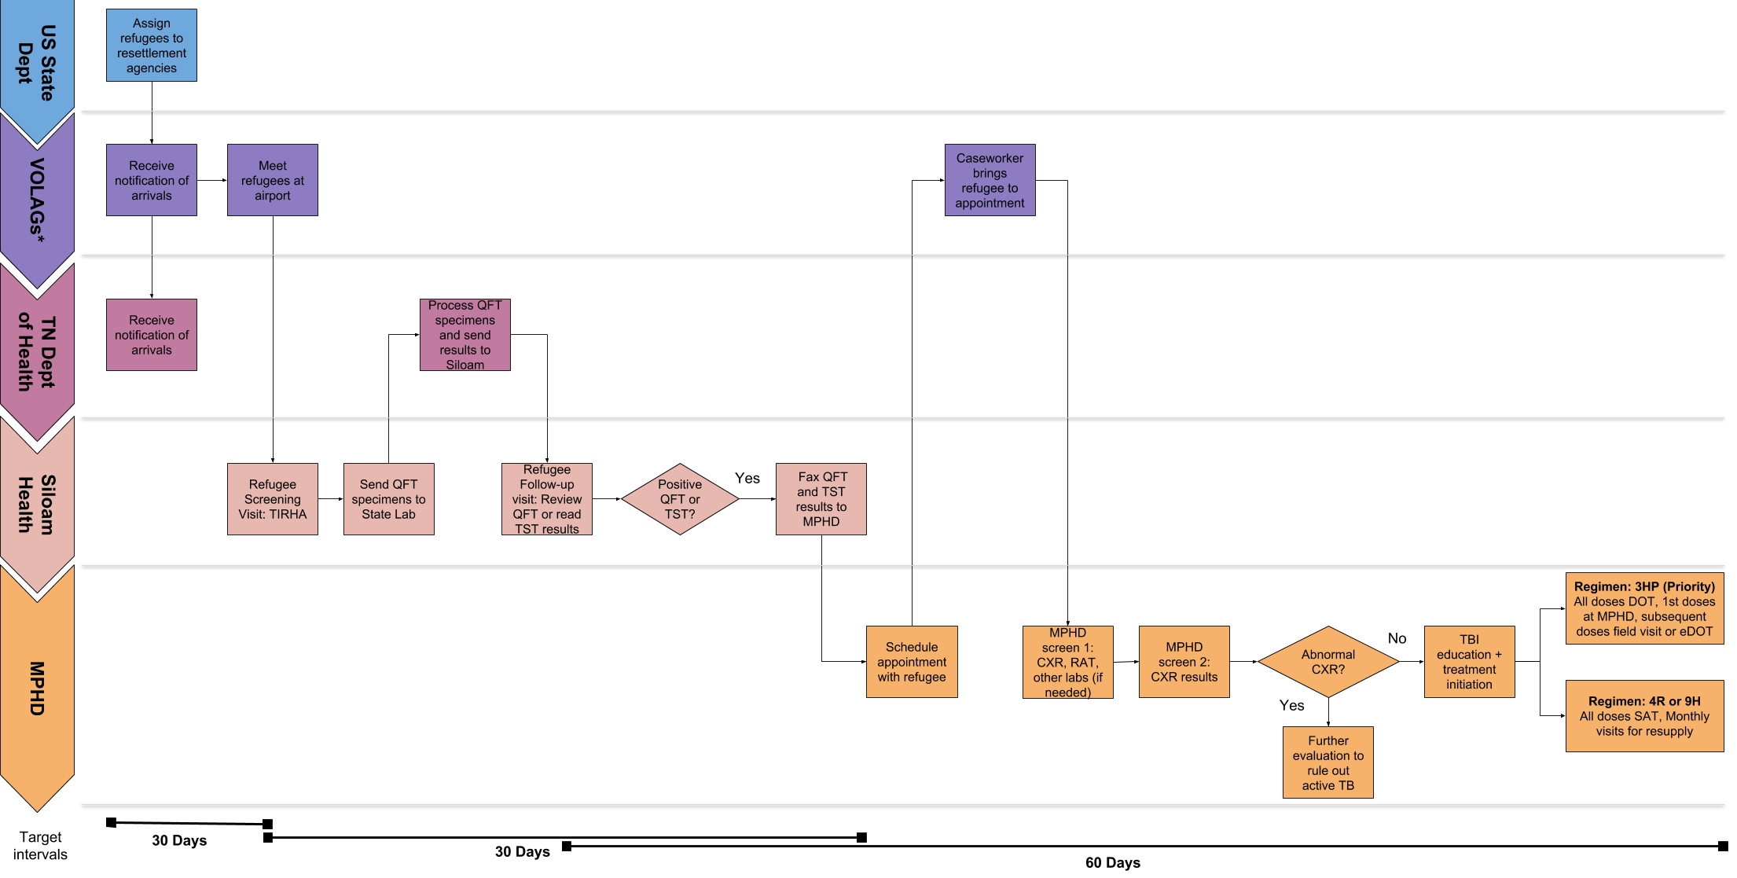
Supplementary Figure 1: TB infection screening workflow in Middle Tennessee.
VOLAG = Volunteer Agency; TN Dept of Health = Tennessee Department of Health; MPHD = Metro Public Health Department; QFT = QuantiFERON TB test; TIRHA = Tennessee Initial Refugee Health Assessment; TST = Tuberculin Skin Test; CXR = Chest X-ray; RAT = TB Risk Assessment Tool; DOT = Directly Observed Therapy; SAT = Self-Administered Therapy; 3HP = 12 week, once-weekly isoniazid and rifapentine regimen; 4R = 4 month, once-daily rifampin regimen; 9H = 9 month, once-daily isoniazid regimen
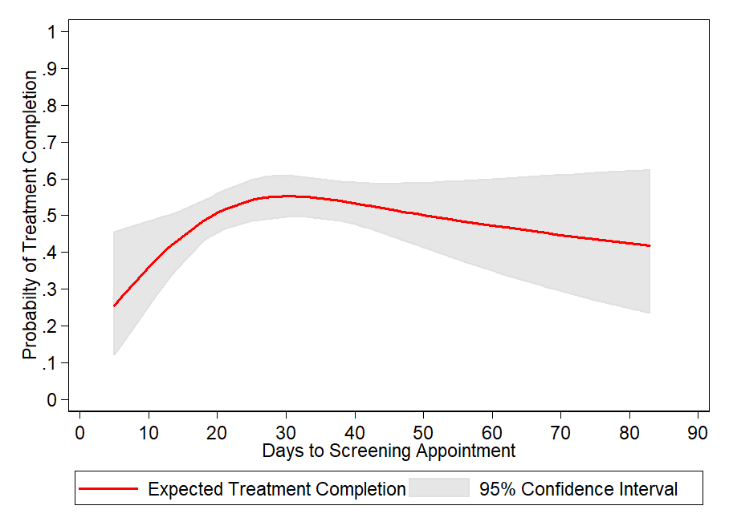
Supplementary Figure 2: Association between days from US arrival to initial screening appointment and TBI treatment completion. Days to screening appointment is modeled as a continuous variable using restricted cubic splines with 3 knots. In the final logistic model, covariates are adjusted using the following levels: sex (female), Elixhauser comorbidity index (score < 1), receipt of influenza vaccine (yes), country of origin (not Asian); regimen (isoniazid only [9H]).

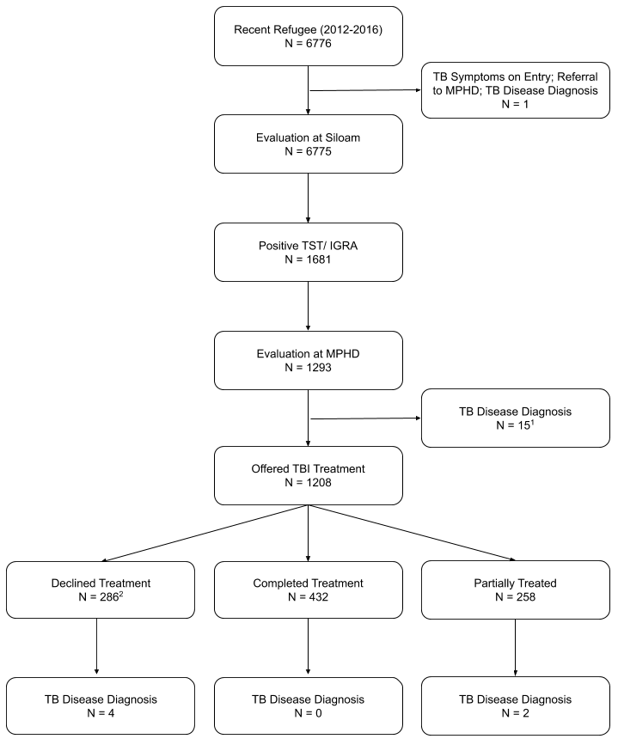
Supplementary Figure 3: Diagnosis of Tuberculosis Disease (N=22) among Refugees in Middle Tennessee

MPHD = Metro Public Health Department; TST = Tuberculin Skin Test; IGRA = Interferon Gamma Release Assay; TBI = Tuberculosis Infection

¹ In addition to the 15 individuals diagnosed with TB disease, 70 others were ineligible to start treatment due to a false positive test, prior treatment or provider decision

² In addition to the 286 individuals who declined treatment, 232 others did not start treatment for other reasons such as loss to follow-up and patient relocation.

