Additional file 2:
1.- OR and theirs 95% CI estimations for the period effect in comparison with the average of the whole period.
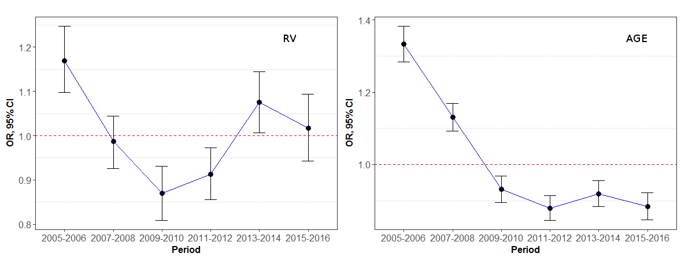

2.- OR and theirs 95% CI estimations for the health department effect in comparison with the average of all of them.

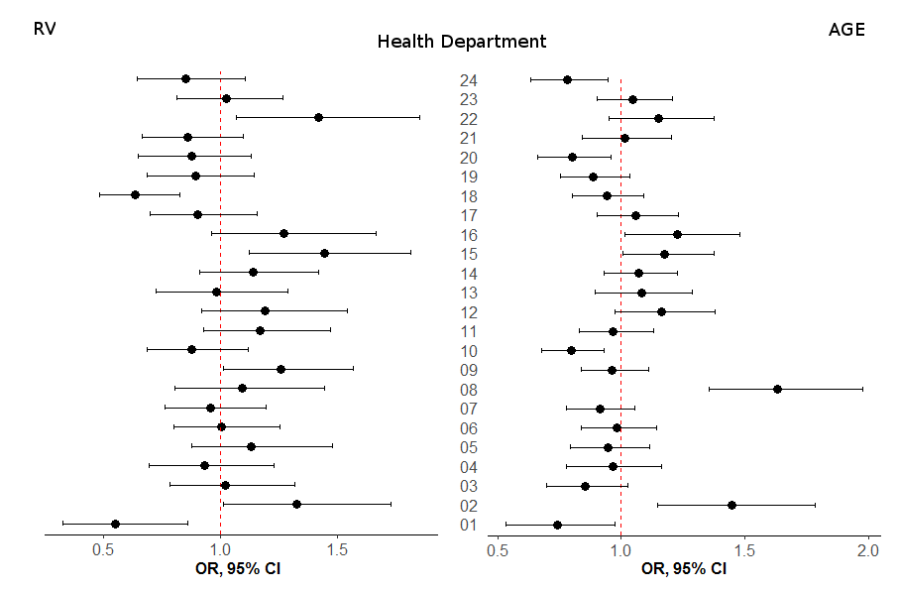

3.- Spatio-temporal risk of RV and AGE-Hospitalisation in comparison with the average of the Valencia R. 