Supplementary File 2. Supplementary figures

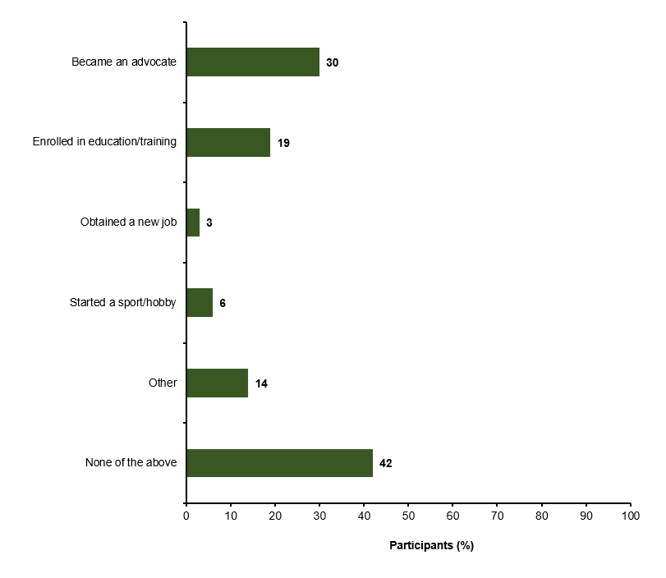
Supplementary Figure 1. Impact of HCV treatment on participants' ability to engage in wider society (N=124)

Supplementary Figure 2. Participants’ living situation at the start of HCV treatment and during the survey (N=124)
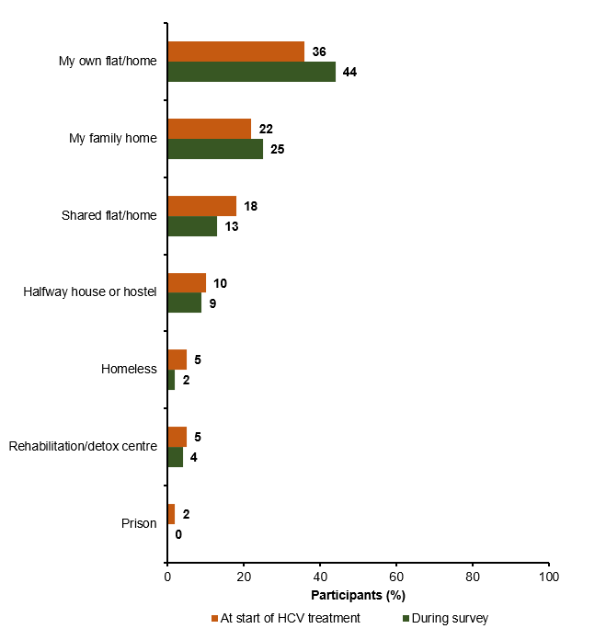

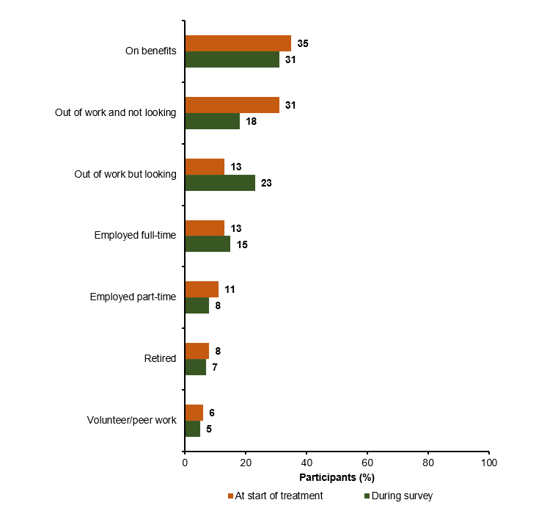
Supplementary Figure 3. Participants’ employment status at the start of HCV treatment and during the survey (N=124)

