Supplement
Figure S1: Missingness patterns in predictor variables for regression model.
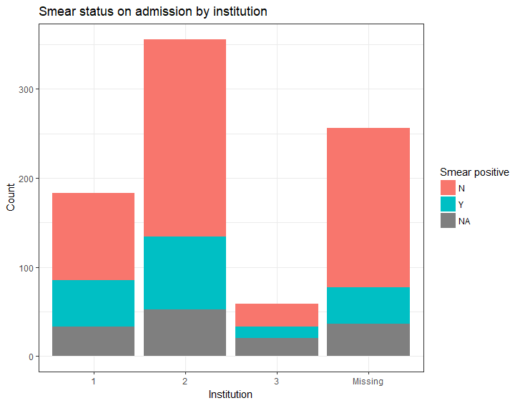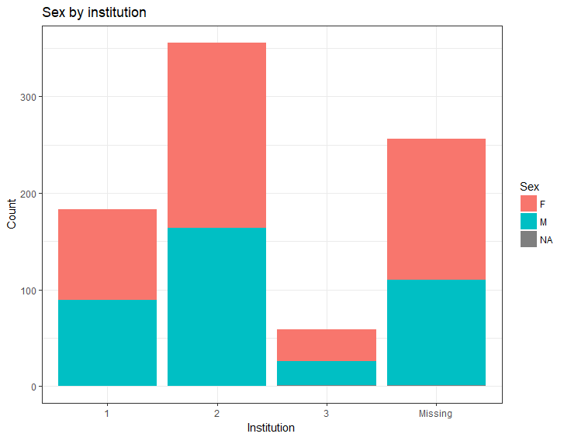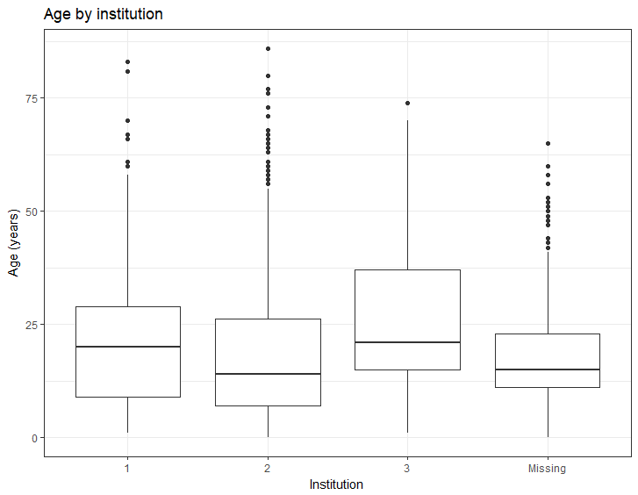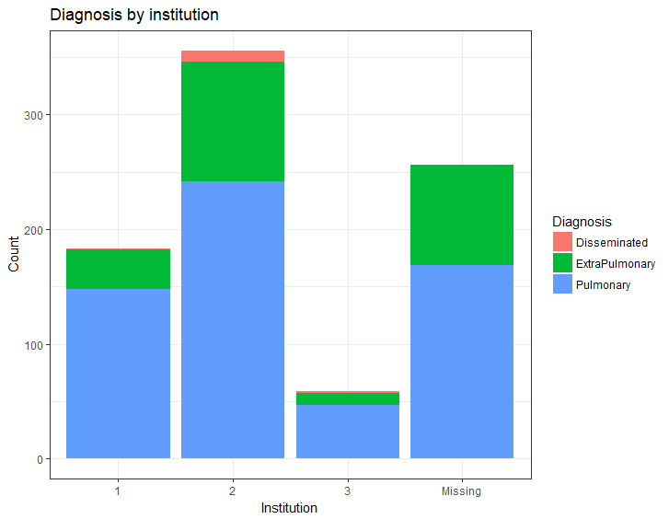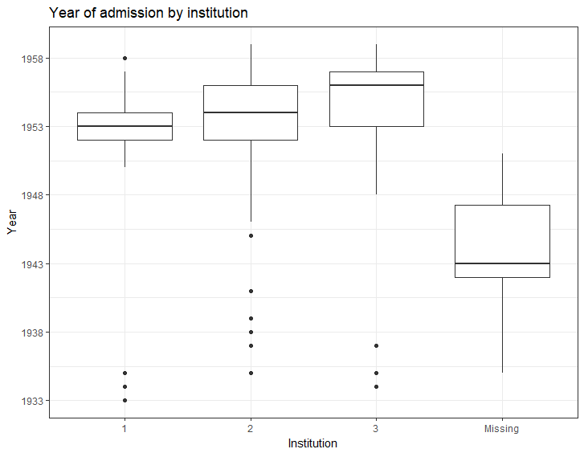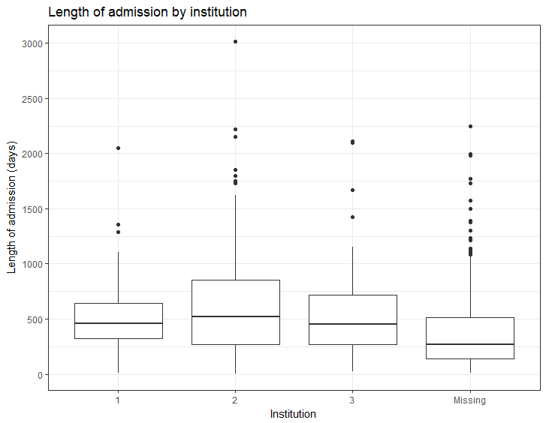

Table S1: Rhat values for imputed variables that were missing data in original dataset.
Variable | Rhat for parameter means | Rhat for parameter standard deviations
Institution | 0.998 | 0.998
Age | 1.002 | 1.001
Sex | 0.999 | 0.999
Marital status | 1.003 | 1.003
Open at admission | 1.001 | 1.000

Table S2: Parameter estimates from pooled generalized linear regression model.
Variable | Estimate | SE | p-value
Intercept  (ref = Female, Pulmonary, Institution 2, smear negative) | 6.59 | 0.19 | 0.00
Admission year (1933-1946) | 0.01 | 0.17 | 0.94
Admission year (1946-1952) | -0.33 | 0.15 | 0.03
Admission year (1952-1955) | -1.36 | 0.46 | 0.003
Admission year (1955-1959) | -0.05 | 0.19 | 0.80
Smear positive on admission | 0.35 | 0.06 | 0.00
Smear positive on discharge | -0.21 | 0.20 | 0.31
Age (centered at mean = 19.2 years) | -0.0006 | 0.002 | 0.78
Sex (male) | -0.01 | 0.05 | 0.83
Interaction age*sex (male) | -0.008 | 0.003 | 0.02
Diagnosis (disseminated) | 0.12 | 0.19 | 0.52
Diagnosis (extrapulmonary | 0.06 | 0.06 | 0.35
Institution 1 | -0.23 | 0.07 | 0.002
Institution 3 | -0.09 | 0.08 | 0.27
Note: outcome was log-transformed and the main predictor, year of admission, is nonlinear so variable estimates are not directly interpretable. The values above are useful in terms of directionality (positive = longer stay, negative = shorter stay) and relative to their standard error.

