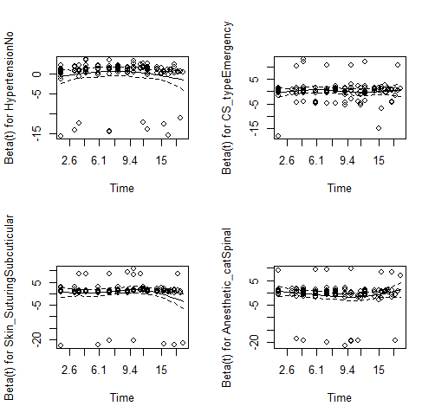
Fig 1: Plots of scaled Schoenfeld residuals against transformed time for variables in a model
fit to the data

