Additional file: The relationship between COVID-19 risk and the socioeconomic risk factors
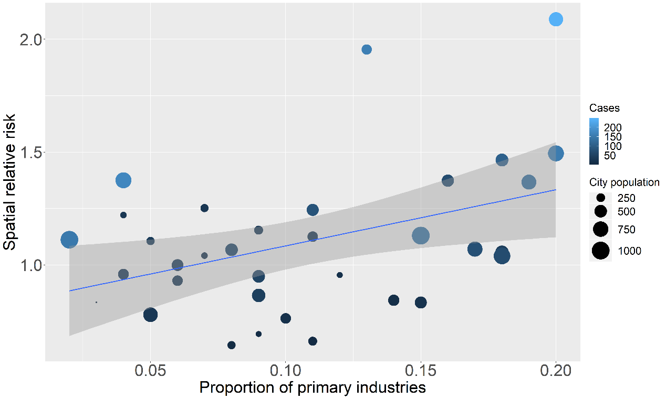
Fig S1. The relationship between COVID-19 risk and proportion of primary industry GDP

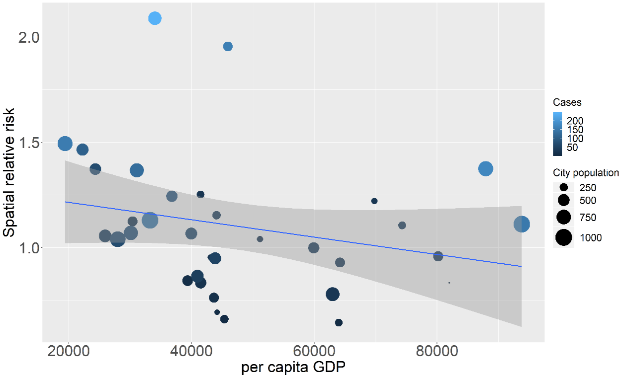
Fig S2. The relationship between COVID-19 risk and per capita GDP

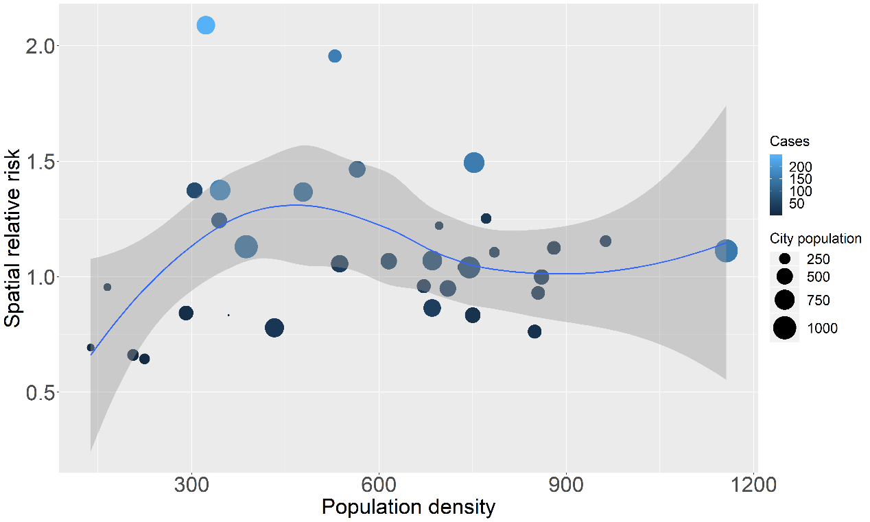
Fig S3. The relationship between COVID-19 risk and population density

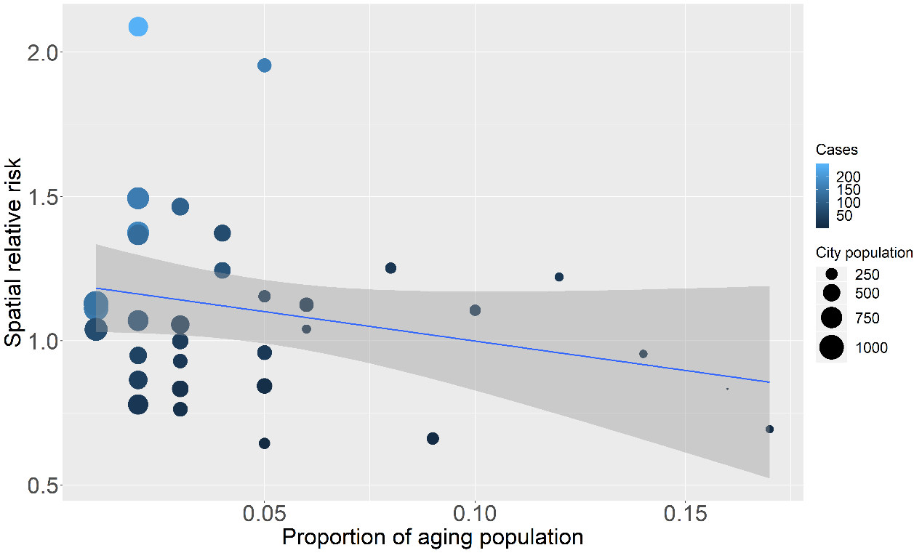
Fig S4. The relationship between COVID-19 risk and proportion of aging population

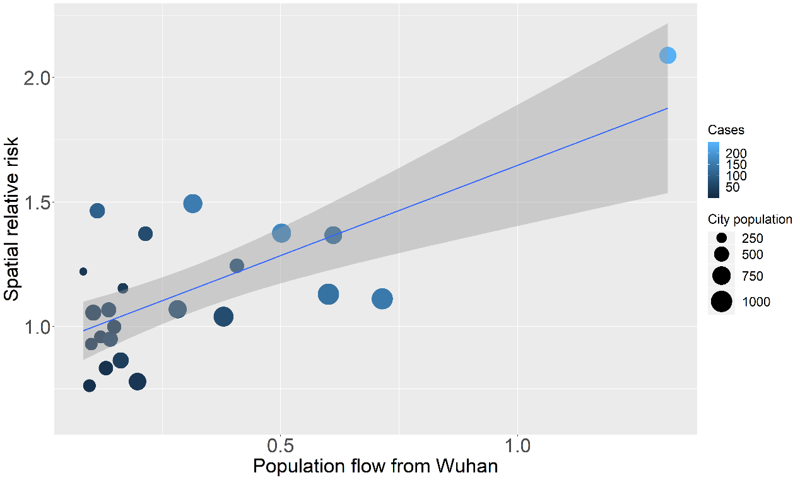 Fig S5. The relationship between COVID-19 risk and population flow from Wuhan

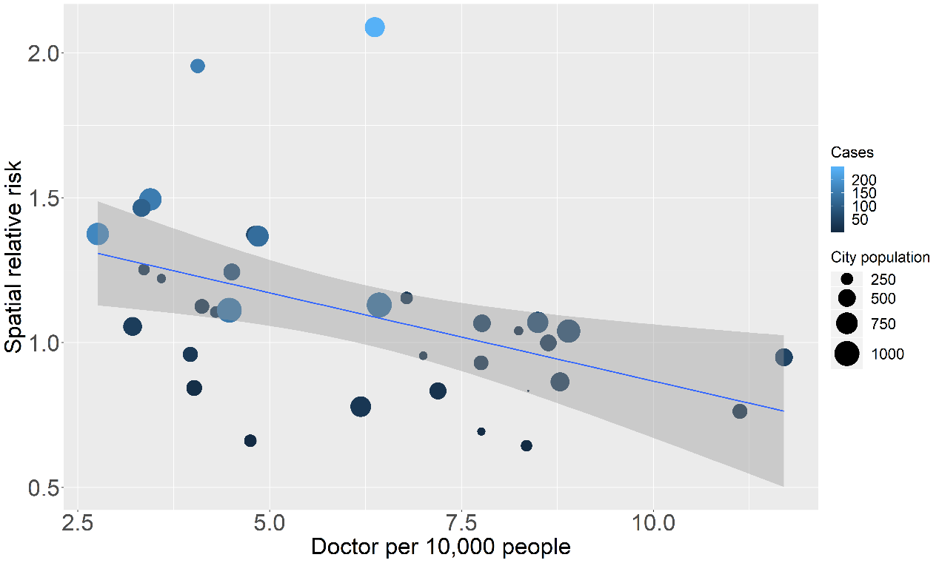
Fig S6. The relationship between COVID-19 risk and doctor per 1000 people

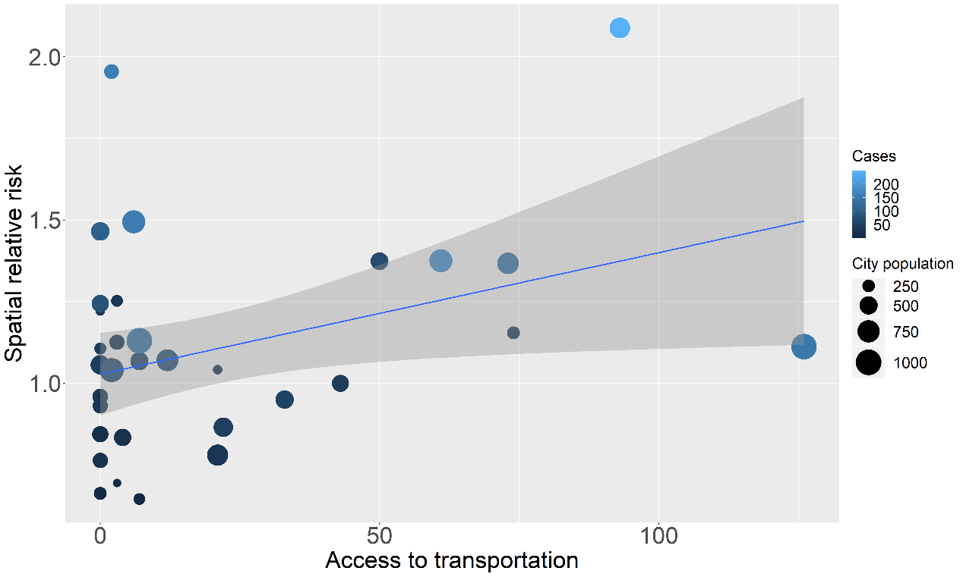 Fig S7. The relationship between COVID-19 risk and access to transportation

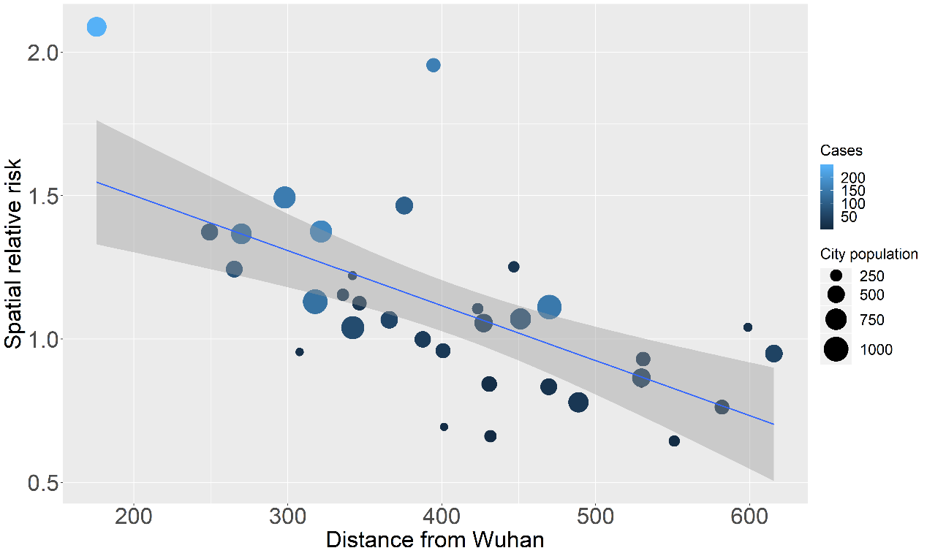

Fig S8. The relationship between COVID-19 risk and distance from Wuhan

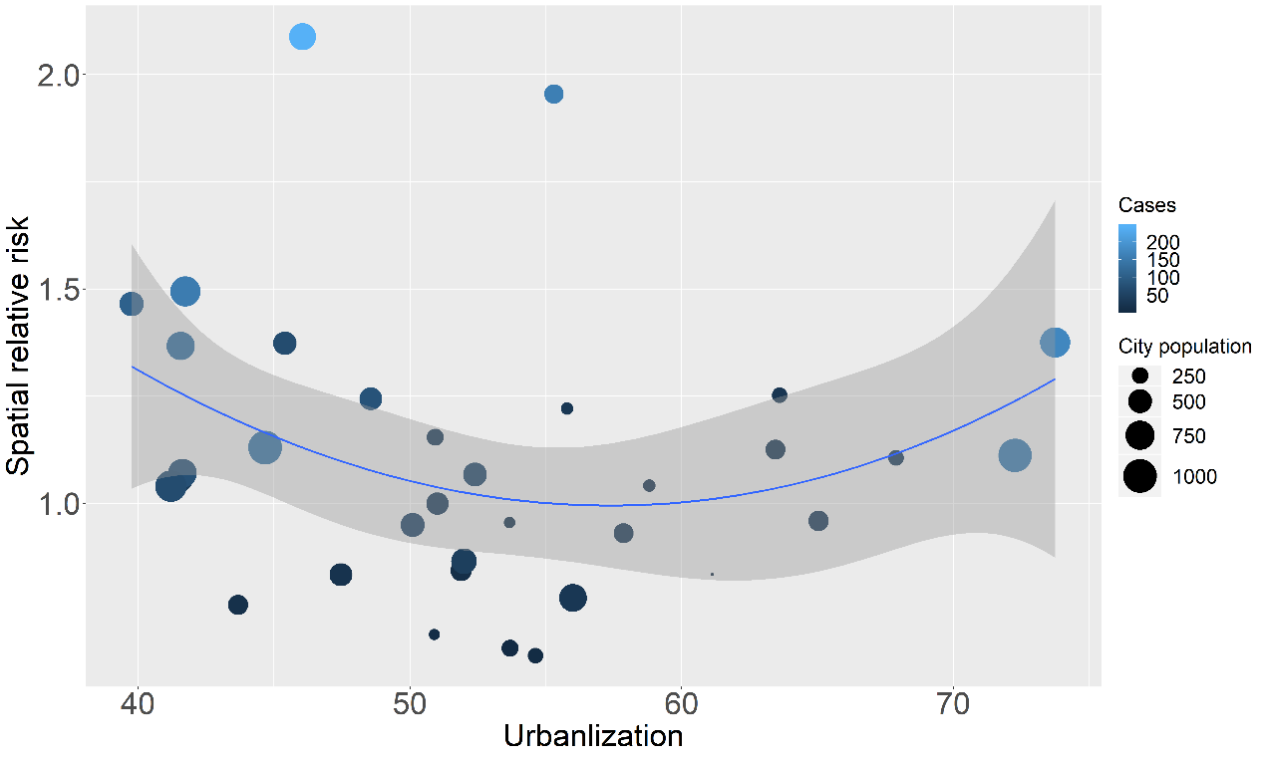
Fig S9. The relationship between COVID-19 risk and urbanization

