Mask Number | Picture | Manufacturer and model | Mask type | Shape | Approval Standard | Regulatory Status | Exhalation Valve | Tethering Devices | Number of masks measured for weight and thickness* | Average Thickness (mm) | Average Weight (g/m²)
1 | 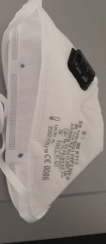 | 3M K112 | FFP2 | duckbill | EN149-2001 | Not on Appendix A | Yes | Headband straps | 1 | 1.05 | 223
2 | 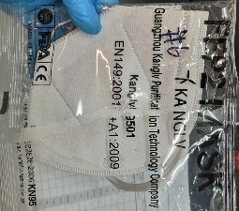 | Guangzhou Kanglv 9501 | FFP2 | flatfold | EN149-2001 | Not on Appendix A | No | Earloop straps | 1 | 0.51 | 111
3 | 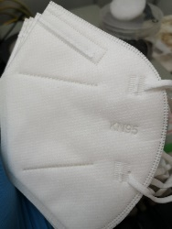 | Aoxing KN95 | KN95 | flatfold | GB2626-2006 | Appendix A  (FDA Authorized) | No | Earloop straps | 1 | 0.85 | 174
4 | 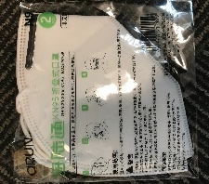 | aRUN Industrial Co N9 | KN95 | flatfold | GB2626-2006 | Appendix A  (FDA Authorized) | No | Earloop straps | 1 | 0.58 | 127
5 | 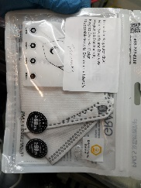 | Graphene SNN70370B | KN95 | flatfold | GB2626-2006 | Not on Appendix A | Yes | Earloop straps | 2 | 0.7 ± 0.03 | 162 ± 4
6 | 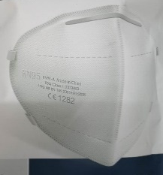 | HuaGang Communication Disposable Face Mask | KN95 | flatfold | GB2626-2006 | Formerly on Appendix A | No | Earloop straps | 1 | 0.67 | 166
7 | 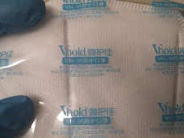 | Jinan Vhold Co. VH95 | KN95 | flatfold | GB2626-2006 | Formerly on Appendix A | No | Earloop straps | 5 | 1.04 ± 0.07 | 233 ± 12
8 | 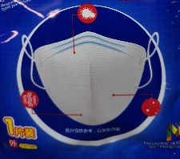 | SNIPPET SNB9501 | KN95 | flatfold | GB2626-2006 | Not on Appendix A | No | Earloop straps | 2 | 0.82 ± 0.03 | 198 ± 6
9 | 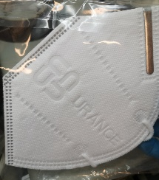 | Urance KN95 | KN95 | flatfold | GB2626-2006 | Not on Appendix A | No | Earloop straps | 1 | 0.56 | 126
10 | 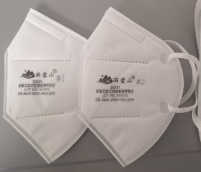 | Yimengshan 9201 | KN95 | flatfold | GB2626-2006 | Not on Appendix A | No | Earloop straps | 2 | 0.83 ± 0.02 | 200 ± 1
11 | 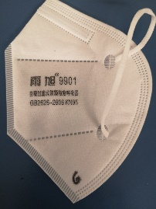 | Yuxu 9901 | KN95 | flatfold | GB2626-2006 | Not on Appendix A | No | Earloop straps | 1 | 0.85 | 189
12 | 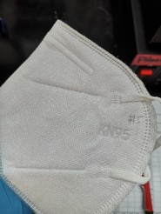 | Unmarked batch #1 | KN95 | flatfold | GB2626-2006 | Not on Appendix A | No | Earloop straps | 1 | 0.75 | 177
13 | 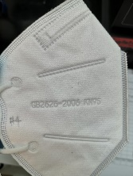 | Unmarked batch #2 | KN95 | flatfold | GB2626-2006 | Not on Appendix A | No | Earloop straps | 1 | 0.74 | 170
14 | 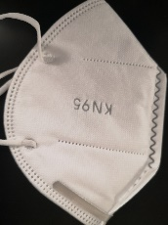 | Unmarked batch #3 | KN95 | flatfold | GB2626-2006 | Not on Appendix A | No | Earloop straps | 2 | 0.81 ± 0.02 | 174 ± 2
15 | 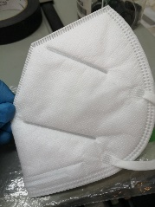 | Unmarked batch #4 | KN95 | flatfold | GB2626-2006 | Not on Appendix A | No | Earloop straps | 1 | 1.04 | 234
16 | 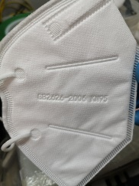 | Unmarked batch #5 | KN95 | flatfold | GB2626-2006 | Not on Appendix A | No | Earloop straps | 1 | 0.73 | 163
17 | 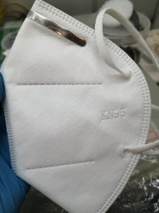 | Unmarked batch #6 | KN95 | flatfold | GB2626-2006 | Not on Appendix A | No | Earloop straps | 1 | 0.72 | 164
18 | 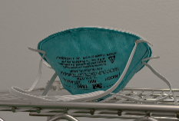 | 3M 1860/1860S | N95 | round | NIOSH-42CFR84 | NIOSH N95 (FDA cleared) | No | Headband straps | 3 | 1.43 ± 0.03 | 316 ± 20
19 | 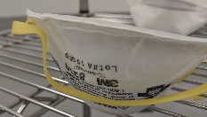 | 3M 8210 | N95 | round | NIOSH-42CFR84 | NIOSH N95 (FDA authorized) | No | Headband straps | 1 | 1.43 | 317
20 | 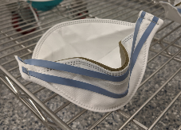 | 3M 9210 | N95 | 3 panel flatfold | NIOSH-42CFR84 | NIOSH N95 (FDA authorized) | No | Headband straps | 1 | 0.85 | 168
21 | 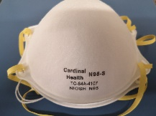 | Cardinal Health ML/S | N95 | round | NIOSH-42CFR84 | NIOSH N95 (FDA cleared) | No | Headband straps | 5 | 1.08 ± 0.12 | 365 ± 28
22 | 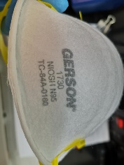 | Gerson 1730 | N95 | round | NIOSH-42CFR84 | NIOSH N95 (FDA cleared) | No | Headband straps | 1 | 1.45 | 328
23 | 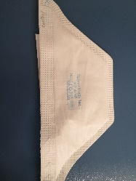 | Kimberly-Clark 46767 (duckbill) | N95 | duckbill | NIOSH-42CFR84 | NIOSH N95 (FDA cleared) | No | Headband straps | 1 | 0.66 | 154
24 | 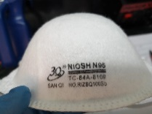 | Rizhao 3Q SanQi RIZSQ100Sb | N95 | round | NIOSH-42CFR84 | NIOSH N95 (FDA authorized) | No | Headband straps | 1 | 1.18 | 306
25 | 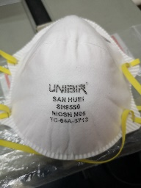 | San Huei SH9550 | N95 | round | NIOSH-42CFR84 | NIOSH N95 (FDA authorized) | No | Headband straps | 1 | 1.02 | 306

