Figure S1: Individual questionnaire items (Perception to COVID-19):
Figure S1 shows the details of responses (Mean score) to different questionnaire items as regards perception to COVID-19
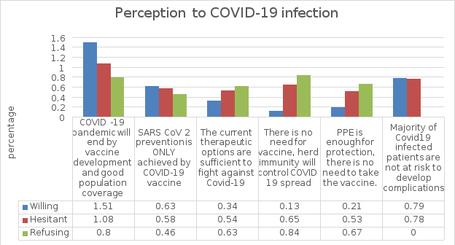
Mean score

Figure S2: Individual questionnaire items (Perception to COVID-19 vaccine):
Figure S2 shows the details of responses to different questionnaire items as regards perception to COVID-19 vaccine.
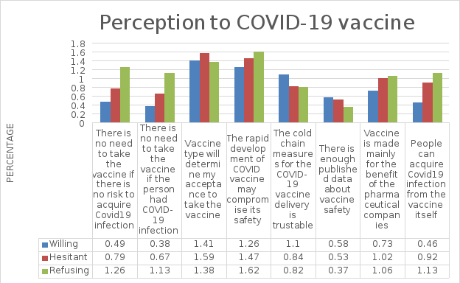
Mean score

Figure S3: Individual questionnaire items (Attitude to vaccine and vaccination):
Figure S3 shows the details of responses to different questionnaire items as regards attitude to vaccine and vaccination in general
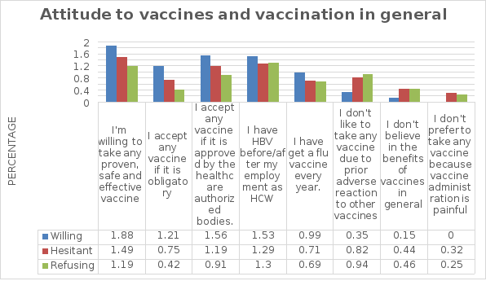
Mean score

Figure S4: Individual questionnaire items (Attitude to COVID-19 vaccines):
Figure S4 shows the details of responses to different questionnaire items as regards attitude to COVID-19 vaccines.

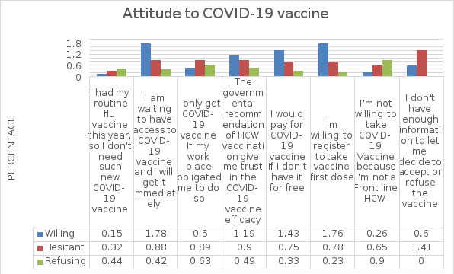
Mean score

