Additional Materials for

Modeling analysis reveals the transmission trend of COVID-19 and control efficiency of human intervention
Chaoyuan Cheng^{1,3}, Xinru Wan¹, and Zhibin Zhang^{1,2}†.

Correspondence to: zhangzb@ioz.ac.cn

This file includes:

Figs. S1 to S2
Tables S1
Captions for Data S1

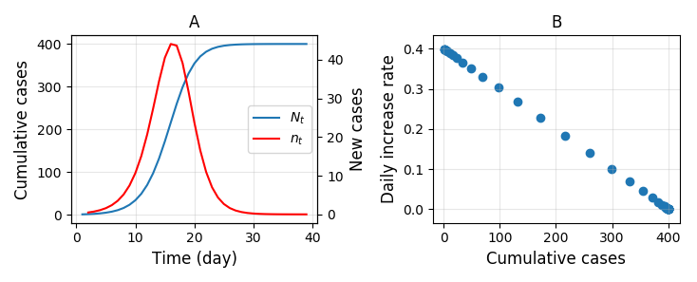
Fig. S1. An illustration on the change of number of cumulative cases (N_{t}) and the number of new cases (n_{t}) (A) and the relationship between daily increase rate (r) and number of cumulative cases of COVID-19 as described in the logistic model (modified from Zhang et al 2004). r_{t} = a - bN_{t} (a, b are constants, a represents the maximum daily increase rate r_{m}). Here, a = 0.4, b = 0.001, N₀ = 1.

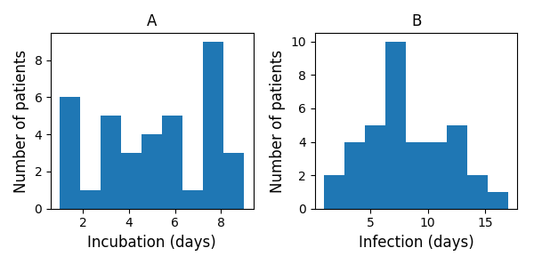
Fig. S2. The estimated incubation time (A) and infection time (B) of COVID-19 infected patients based on Table S1.

Table S1 Epidemiological data of some cases of Wuhan residents and non-residents who travelled to Wuhan. Only data of non-residents was used for estimating the incubation time (IBT) and infection time (IFT). For source of the original data, see methods section.
Location | Date of showing symptoms | Date of being hospitalized | Arrival in Wuhan | Wuhan resident | IBT | IFT
Shenzhen | 2020/1/4 | 2020/1/10 | 2019/12/29 | no | 6 | 12
Shanghai | 2020/1/16 | 2020/1/16 | 2020/1/8 | no | 8 | 8
Xicheng District | 2020/1/16 | 2020/1/20 | 2020/1/8 | no | 8 | 12
Shenzhen | 2020/1/2 | 2020/1/11 | 2019/12/29 | no | 4 | 13
Shenzhen | 2020/1/3 | 2020/1/10 | 2019/12/29 | no | 5 | 12
Zhuhai | 2020/1/13 | 2020/1/19 | 2020/1/12 | no | 1 | 7
Tongzhou District | 2020/1/19 | 2020/1/20 | 2020/1/12 | no | 7 | 8
Haidian District | 2020/1/17 | 2020/1/20 | 2020/1/13 | no | 4 | 7
Fengtai District | 2020/1/14 | 2020/1/20 | 2020/1/11 | no | 3 | 9
Haidian District | 2020/1/9 | 2020/1/14 | 2020/1/3 | no | 6 | 11
Shenzhen | 2020/1/1 | 2020/1/11 | 2019/12/29 | no | 3 | 13
Pingxiang | 2020/1/10 | 2020/1/10 | 2020/1/2 | no | 8 | 8
Wenzhou | 2020/1/4 | 2020/1/4 | 2020/1/3 | yes
Wenzhou | 2020/1/4 | 2020/1/17 | 2020/1/3 | yes
Fuyang | 2020/1/21 | 2020/1/21 | 2020/1/19 | no | 2 | 2
Beihai | 2020/1/16 | 2020/1/17 | 2020/1/12 | yes
Chengdu | 2020/1/19 | 2020/1/19 | 2020/1/17 | unknown
Lingao County | 2020/1/16 | 2020/1/20 | 2020/1/14 | unknown
Xicheng District | 2020/1/20 | 2020/1/20 | 2020/1/11 | no | 9 | 9
Shijingshan District | 2020/1/19 | 2020/1/21 | 2020/1/11 | no | 8 | 10
Hong Kong | 2020/1/18 | 2020/1/21 | 2020/1/10 | no | 8 | 11
Chaohu, Hefei | 2020/1/18 | 2020/1/20 | 2020/1/17 | yes
Shenyang | 2020/1/16 | 2020/1/22 | 2020/1/15 | no | 1 | 7
Hefei | 2020/1/10 | 2020/1/21 | 2020/1/7 | no | 3 | 14
Chizhou | 2020/1/22 | 2020/1/22 | 2020/1/19 | yes
Xianyang | 2020/1/20 | 2020/1/21 | 2020/1/12 | no | 8 | 9
Xi'an | 2020/1/20 | 2020/1/21 | 2020/1/15 | no | 5 | 6
Zhongwei | 2020/1/21 | 2020/1/21 | 2020/1/12 | no | 9 | 9
Dazhou | 2020/1/18 | 2020/1/20 | 2020/1/17 | no | 1 | 3
Chaoyang | 2020/1/19 | 2020/1/22 | 2020/1/18 | no | 1 | 4
Lanzhou | 2020/1/18 | 2020/1/21 | 2020/1/17 | no | 1 | 4
Shijingshan District | 2020/1/19 | 2020/1/21 | 2020/1/11 | no | 8 | 10
Chengdu | 2020/1/18 | 2020/1/18 | 2020/1/10 | no | 8 | 8
Chengdu | 2020/1/18 | 2020/1/18 | 2020/1/13 | no | 5 | 5
Urumqi | 2020/1/20 | 2020/1/20 | 2020/1/15 | no | 5 | 5
Shijiazhuang | 2020/1/19 | 2020/1/19 | 2020/1/18 | yes
Hechi | 2020/1/22 | 2020/1/23 | 2020/1/21 | yes
Beihai | 2020/1/22 | 2020/1/22 | 2020/1/21 | yes
Fuyang | 2020/1/22 | 2020/1/22 | 2020/1/19 | yes
Ganzhou | 2020/1/22 | 2020/1/22 | 2020/1/21 | yes
Hechi | 2020/1/21 | 2020/1/22 | 2020/1/15 | yes
Beihai | 2020/1/19 | 2020/1/19 | 2020/1/18 | yes
Tianjin | 2020/1/24 | 2020/1/24 | 2020/1/23 | unknown
Hechi | 2020/1/19 | 2020/1/21 | 2020/1/13 | no | 6 | 8
Fuyang | 2020/1/22 | 2020/1/22 | 2020/1/16 | no | 6 | 6
Ganzhou | 2020/1/21 | 2020/1/21 | 2020/1/17 | yes
Beihai | 2020/1/22 | 2020/1/22 | 2020/1/21 | yes
Yulin | 2020/1/21 | 2020/1/22 | 2020/1/15 | yes
Bozhou | 2020/1/21 | 2020/1/23 | 2020/1/19 | yes
Ma'anshan | 2020/1/18 | 2020/1/22 | 2020/1/16 | yes
Hefei | 2020/1/19 | 2020/1/22 | 2020/1/15 | no | 4 | 7
Ankang | 2020/1/14 | 2020/1/23 | 2020/1/6 | no | 8 | 17
Ankang | 2020/1/21 | 2020/1/23 | 2020/1/20 | yes
Bozhou | 2020/1/20 | 2020/1/22 | 2020/1/19 | yes
Hefei | 2020/1/23 | 2020/1/24 | 2020/1/22 | yes
Ma'anshan | 2020/1/22 | 2020/1/22 | 2020/1/20 | yes
Ma'anshan | 2020/1/22 | 2020/1/23 | 2020/1/18 | yes
Bozhou | 2020/1/19 | 2020/1/21 | 2020/1/17 | yes
Bozhou | 2020/1/18 | 2020/1/22 | 2020/1/16 | yes
Ma'anshan | 2020/1/19 | 2020/1/22 | 2020/1/16 | yes
Ma'anshan | 2020/1/22 | 2020/1/24 | 2020/1/16 | yes
Ma'anshan | 2020/1/18 | 2020/1/24 | 2020/1/9 | no | 9 | 15
Huainan | 2020/1/22 | 2020/1/25 | 2020/1/19 | yes
Ankang | 2020/1/22 | 2020/1/22 | 2020/1/18 | yes
Bengbu | 2020/1/24 | 2020/1/24 | 2020/1/19 | yes
Macau | 2020/1/26 | 2020/1/27 | 2020/1/23 | unknown
Ankang | 2020/1/23 | 2020/1/23 | 2020/1/22 | no | 1 | 1
Ankang | 2020/1/22 | 2020/1/24 | 2020/1/18 | yes
Bengbu | 2020/1/21 | 2020/1/21 | 2020/1/19 | yes
Hefei | 2020/1/23 | 2020/1/26 | 2020/1/22 | yes
Hefei | 2020/1/23 | 2020/1/26 | 2020/1/20 | yes
Hong Kong | 2020/1/25 | 2020/1/29 | 2020/1/22 | yes
Hefei | 2020/1/22 | 2020/1/23 | 2020/1/19 | no | 3 | 4
Xi'an | 2020/1/21 | 2020/1/22 | 2020/1/18 | yes
Xi'an | 2020/1/25 | 2020/1/25 | 2020/1/20 | yes
Hong Kong | 2020/1/25 | 2020/1/29 | 2020/1/22 | yes
Hefei | 2020/1/25 | 2020/1/25 | 2020/1/20 | unknown
Yan'an | 2020/1/27 | 2020/1/27 | 2020/1/21 | no | 6 | 6
Hefei | 2020/1/21 | 2020/1/26 | 2020/1/20 | unknown
Hefei | 2020/1/24 | 2020/1/27 | 2020/1/21 | unknown
Ankang | 2020/1/20 | 2020/1/20 | 2020/1/18 | yes
Ankang | 2020/1/24 | 2020/1/26 | 2020/1/19 | yes
Baoji | 2020/1/21 | 2020/1/22 | 2020/1/13 | yes
Hefei | 2020/1/30 | 2020/1/30 | 2020/1/23 | unknown
Hefei | 2020/1/24 | 2020/1/29 | 2020/1/21 | unknown
Hefei | 2020/1/30 | 2020/1/30 | 2020/1/23 | unknown
Hefei | 2020/1/24 | 2020/1/28 | 2020/1/22 | unknown
Tianshui | 2020/1/30 | 2020/1/30 | 2020/1/18 | yes
Xi'an | 2020/1/26 | 2020/1/28 | 2020/1/21 | yes
Ningxian, Qingyang | 2020/1/24 | 2020/1/28 | 2020/1/20 | yes
Tianshui | 2020/1/24 | 2020/1/30 | 2020/1/20 | yes
Tianjin | 2020/1/31 | 2020/2/2 | 2020/1/16 | unknown
Tianjin | 2020/1/25 | 2020/1/25 | 2020/1/5 | unknown
Quijing | 2020/1/26 | 2020/1/31 | 2020/1/23 | no | 3 | 8

Data S1. (separate file)
Data on the number of cumulative cases of COVID-19 in seven countries.

