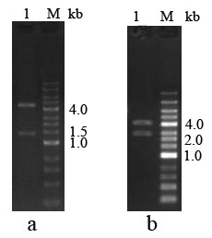
Fig. 3 Digestion verification of the pET28a-SARS-2-N and pET30a-SARS-2-S1 plasmids. a Plasmid pET28a-SARS-CoV-2-N digested with BamH І and Xho І. M: DNA marker. 1: Plasmid pET28a-SARS-CoV-2-N. b Plasmid pET30a-SARS-CoV-2-S1 digested with BamH І and Apa І M: DNA marker. 1: Plasmid pET30a-SARS-CoV-2-S1.
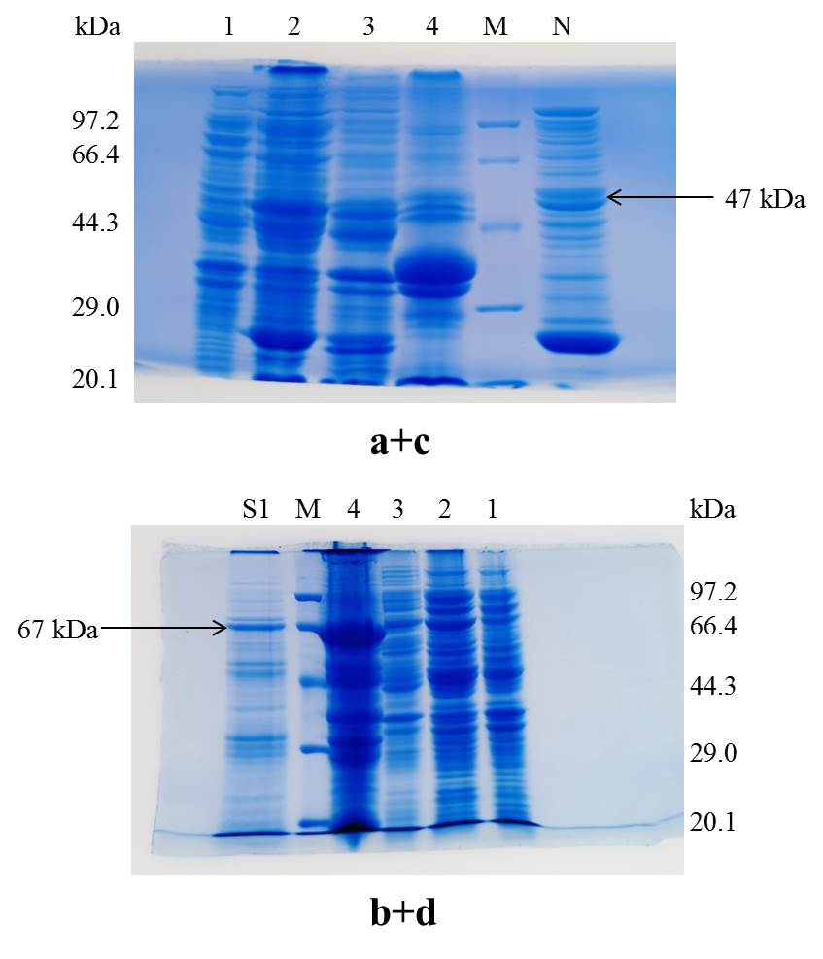
Fig. 4 Expression and purification of N protein and S1 protein of SARS-CoV-2. a SDS-PAGE analysis of N protein showing its expression in E. coli. M: premixed protein marker. 1: protein extracts of uninduced E. Coli. 2: supernatant after sonication. 3: supernatant after washing pellets with 2 M urea. 4: 8 M urea solution of the pellet. b SDS-PAGE analysis of S1 protein showing its expression in E. coli. M: premixed protein marker. 1: protein extracts of uninduced E. coli. 2: supernatant after sonication. 3: supernatant after washing inclusion bodies with 2 M urea. 4: S1 protein dissolved in 8 M urea. c SDS-PAGE analysis of N protein after purification on the Ni-NTA column. M: premixed protein marker. N: N protein purified on the Ni-NTA column. d SDS-PAGE analysis of purified S1 protein. M: premixed protein marker. S1: purified S1 protein after re-folding.

