Additional File 5. Age-distribution of all inpatients, inpatients with acute respiratory illness, and inpatient study participants.

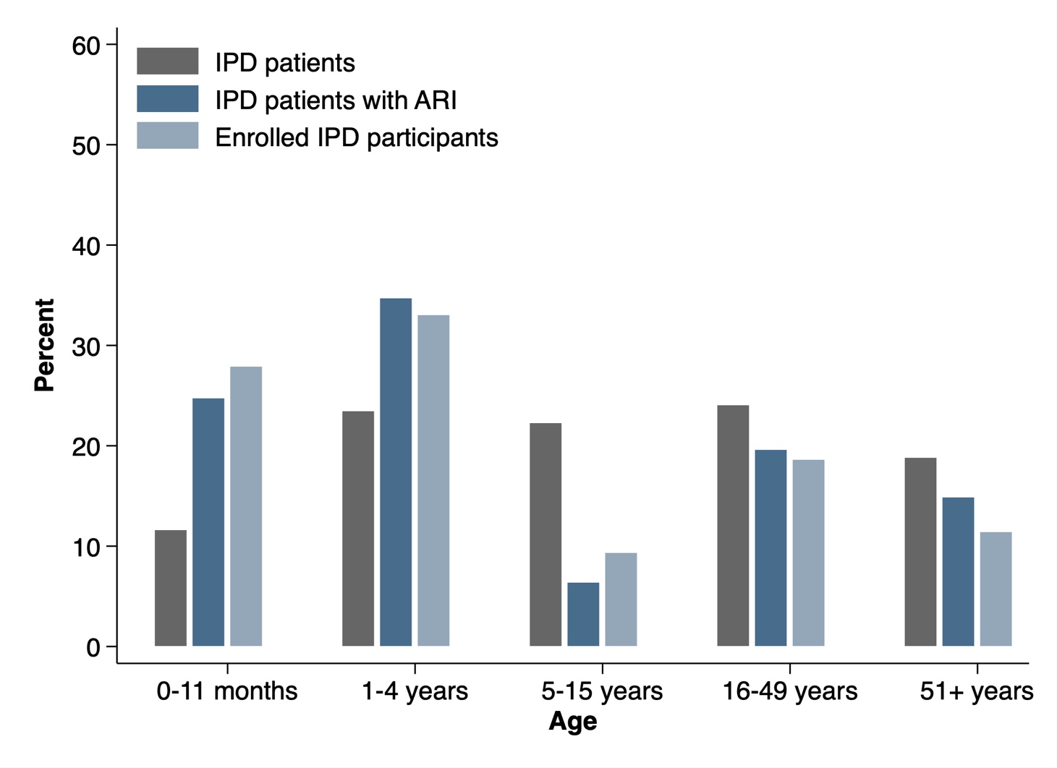
IPD: inpatient department; ARI: acute respiratory illness. Denominator for each proportion is all newly admitted patients (gray bar); newly admitted patients with ARI (dark blue bar); and IPD participants (gray-blue bar).

