A. No Malignancy
B. Malignancy
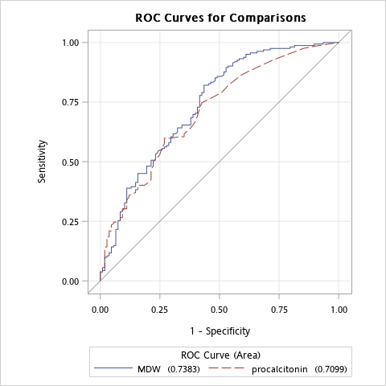
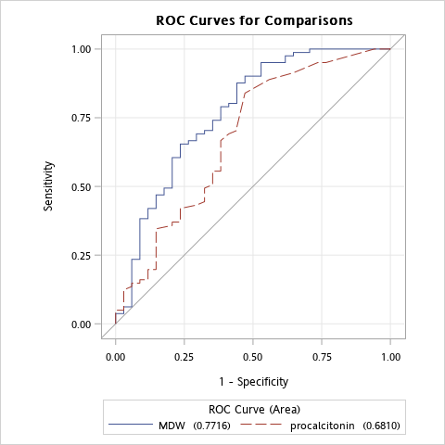
MDW vs procalicitonin p-value=0.2238
MDW vs procalicitonin p-value=0.6549

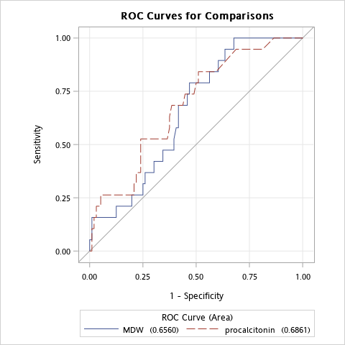
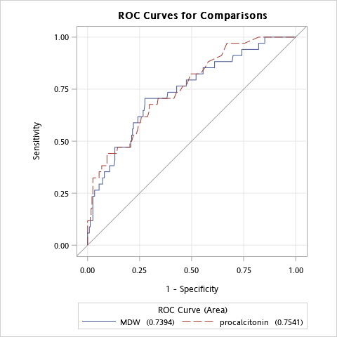
MDW vs procalicitonin p-value=0.7576
MDW vs procalicitonin p-value=0.9368
D. Malignancy
C. Non Malignancy

