Supplementary material

Bacterial co-infections in community-acquired pneumonia caused by SARS-CoV-2, Influenza virus and Respiratory Syncytial virus.
Pontus Hedberg, Niclas Johansson, Anders Ternhag, Lina Abdel-Halim, Jonas Hedlund, Pontus Nauclér

Table of Contents

Figure S1. Flowchart of health care episodes included in the study. 2
Table S1. ICD-10 codes for specific comorbidities 3
Table S2. Definition of positive microbiological tests 4
Figure S2. Bacterial co-infection testing practices over time in SARS-CoV-2 patients 5
Figure S3. Detected bacterial co-pathogens in LRT and blood cultures in SARS-CoV-2, influenza and RSV 6

Figure S1. Flowchart of health care episodes included in the study.

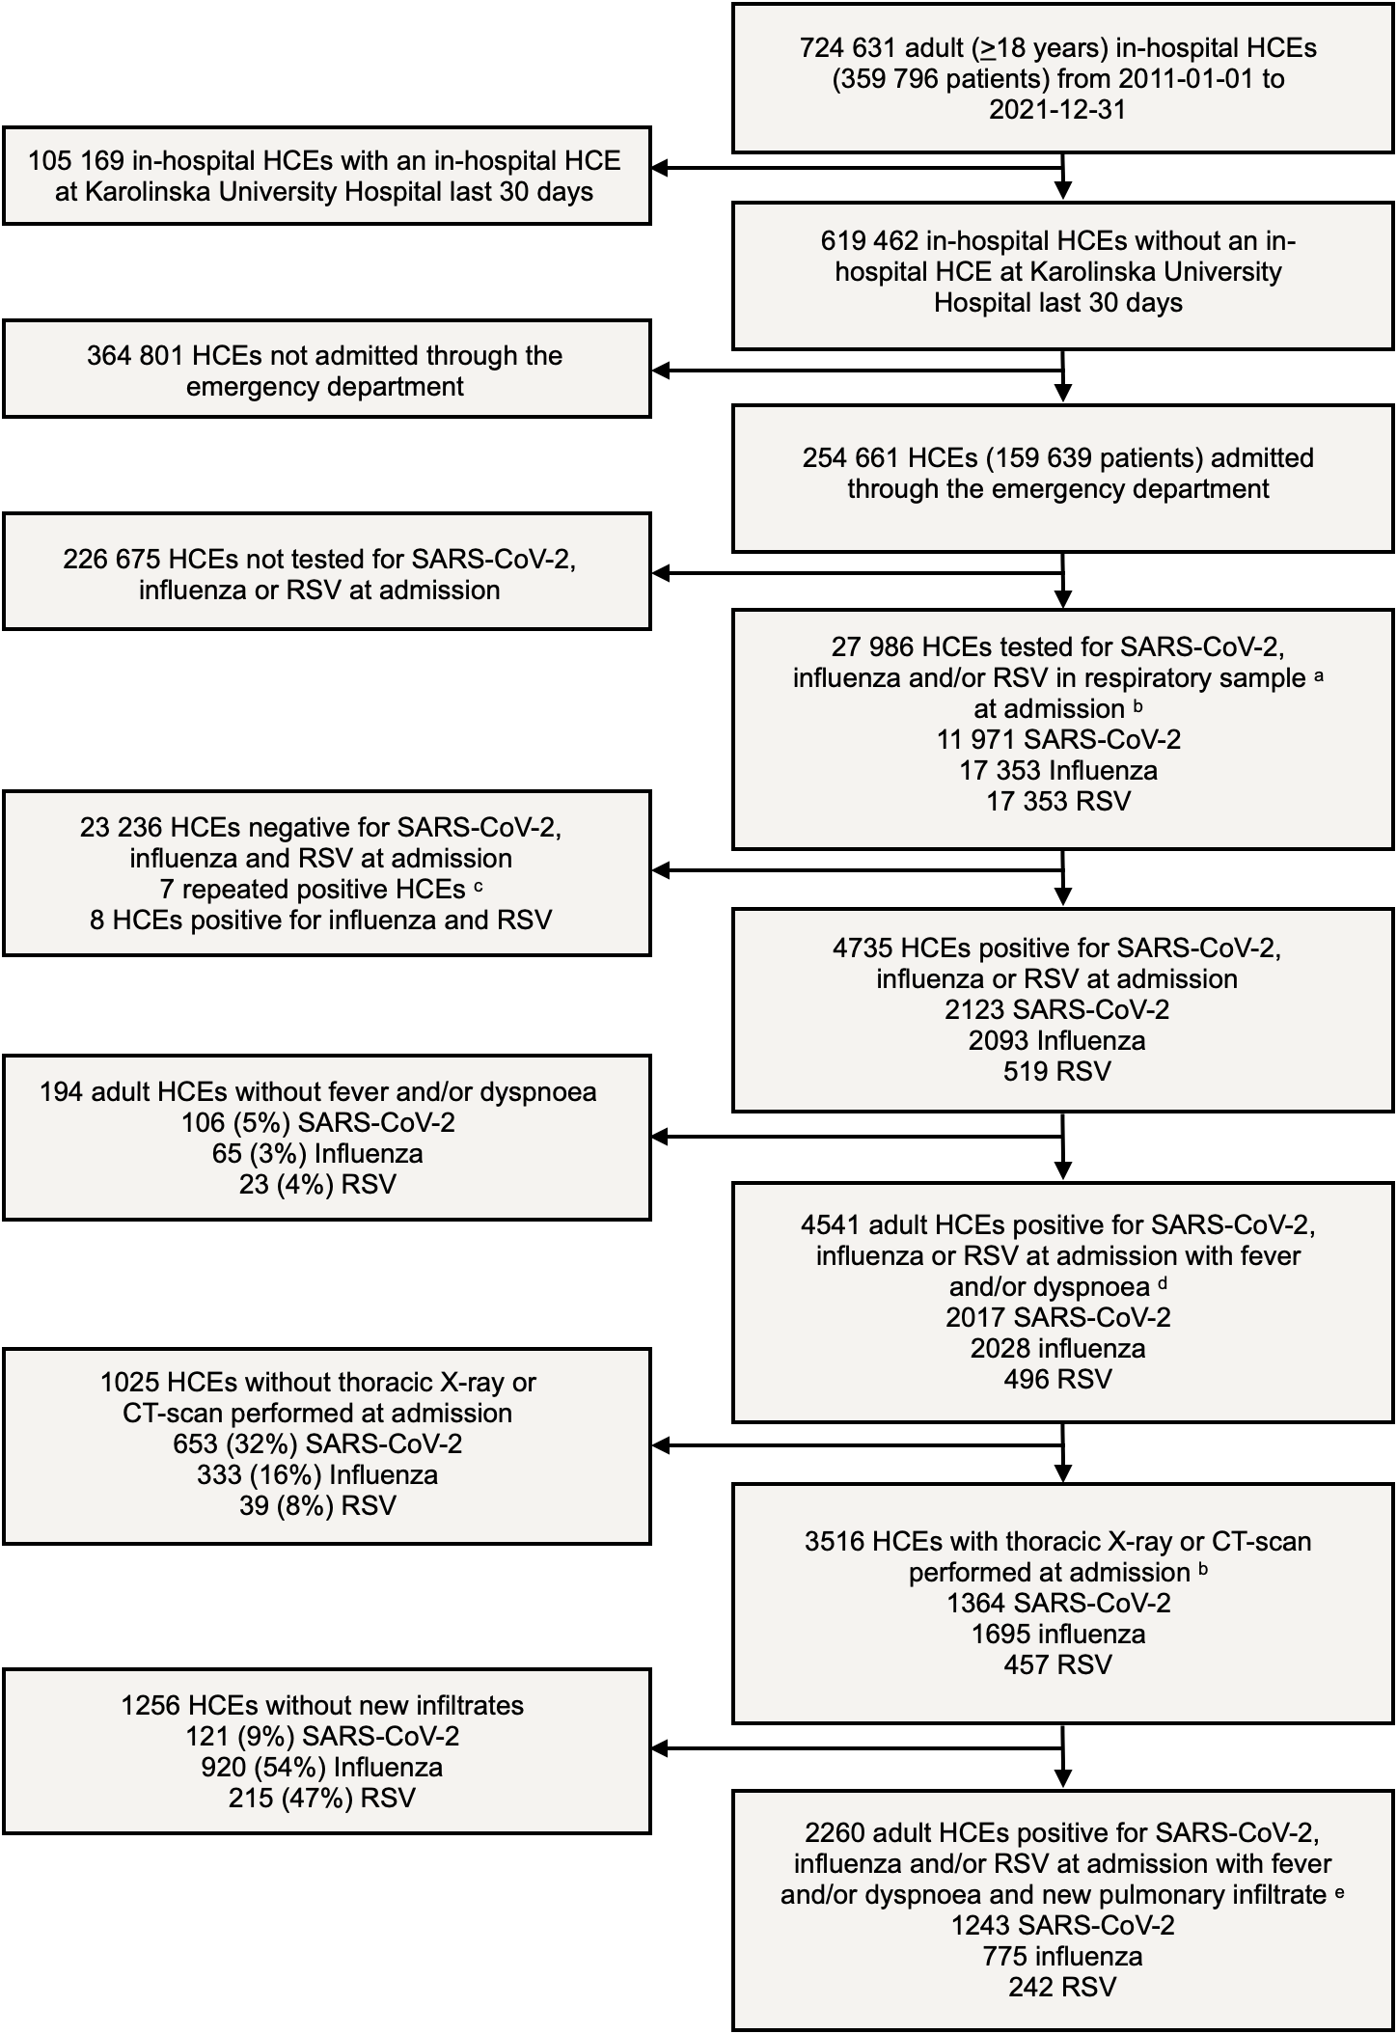

ª Nasopharynx, throat, sputum, tracheal secretion or bronchoalveolar lavage
^{b} Minus one day to plus two days from admission date
^{c} Tested positive for same pathogen within previous 90 days
^{d} Body temperature ≥38°C, oxygen saturation <95% or respiratory rate >20
^{e} New infiltrates that were not assessed as non-infectious or of uncertain significance according to radiologist.

Abbreviations: CT = Computed tomography, HCE = Health care episode, RSV = Respiratory syncytial virus, SARS-CoV-2 = Severe acute respiratory syndrome coronavirus 2

Table S1. ICD-10 codes for specific comorbidities

Comorbidity category | ICD-10 codes ª
Diabetes mellitus | E10-E14
Hypertension | I10-I15
Cardiac disease | I05-I08, I20-I22, I24-I28, I34-I37, I42, I44 -I50
Chronic respiratory disease | J43-J47, J6-J7, J80-J84, J92-J96, J98-J99
Chronic kidney failure | N18-N19
Malignancy | C
Immunosuppression | B2, C0-C2, C30-C34, C37-C39, C4-C8, C90-C96, D70-D73, D80-D84, N18, Z21, Z51.0, Z51.1, Z94.0, Z94.1, Z94.2, Z94.3, Z94.4, Z94.6, Z94.8, Z94.9
ª The shortest text-pattern for identification of included ICD-10 codes are listed

Table S2. Definition of positive microbiological tests
Test | Definition of positive test | Definition of negative test/Identified organisms considered non-significant/contaminants
SARS-CoV-2 | Confirmed positive for SARS-CoV-2 RNA | Negative or suspected positive for SARS-CoV-2 RNA
Influenza ª | Confirmed positive for influenza A (H3N2 or H1N1) or influenza B (FluB) | Negative for influenza A or B RNA
RSV ª | Confirmed positive for respiratory syncytial virus RNA | Negative for respiratory syncytial virus RNA
NPH bacterial culture | Growth of S. pneumoniae | Beta-hemolytic Streptococci, Citrobacter spp., E. coli, Enterobacter spp., H. influenza, Klebsiella spp., Moraxella spp., Neisseria spp., Proteus spp., Pseudomonas spp., S. agalactiae, S. aureus, S. mitis, S. pyogenes, Serratia spp., Stenotrophomonas spp., Yeast
LRT culture | Brush specimens: >10³ CFU/mL  Bronchoalveolar lavage: >10⁴ CFU/mL  Sputum and tracheal secretions: >10⁵ CFU/ml | Non-quantitative cultures  Quantitative cultures lower than CFU threshold  Growth of Fungi
Blood culture | Growth of Actinomyces spp., Actinotignum spp., Aerococcus spp., Bacteroides spp., Brevibacterium spp., C. perfringens, Citrobacter spp., E. Coli, Enterobacter spp., Enterococcus spp., Globicatella spp., Haemophilus spp., Klebsiella spp., Moraxella spp., Pseudomonas spp., Rothia spp., S. aureus, Streptococci spp. | Coagulase-negative Staphylococci, Corynebacterium spp., Micrococcus spp., Propionibacterium spp.
Urinary bacterial antigen | Positive for L. pneumophila or S. pneumoniae | Negative for L. pneumophila and S. pneumoniae
Bacterial DNA tests | Positive for Chlamydophila DNA, Mycoplasma DNA or Legionella DNA | Negative for Chlamydophila DNA, Mycoplasma DNA and Legionella DNA

a Diagnostics for a narrow respiratory virus panel including influenza A virus (IAV), influenza B virus (IBV), and respiratory syncytial virus (RSV) were performed using in-house realtime PCR assays until 14 September 2014 when they were replaced by the Simplexa Flu A/B \& RSV Kit (Focus Diagnostics Inc., Cypress (CA, USA)), which were in turn replaced by the Xpert Flu/RSV ((Cepheid, Solna, Sweden) from 15 May 2019 (Tiveljung-Lindell A, Rotzén-Ostlund M, Gupta S, et al. Development and implementation of a molecular diagnostic platform for daily rapid detection of 15 respiratory viruses. J Med Virol. 2009;81(1):167-175. doi:10.1002/jmv.21368).
Abbreviations: CFU = Colony-forming units, LRT = Lower respiratory tract, NPH = Nasopharyngeal

Figure S2. Bacterial co-infection testing practices over time in SARS-CoV-2 patients

Note: Proportion of SARS-CoV-2 patients with test performed at admission per test modality. The first wave included all admissions before October 1, 2020 and the second wave included all admissions from October 1, 2020 and onwards.

Abbreviations: SARS-COV-2,severe acute respiratory syndrome coronavirus 2; NPH, nasopharyngeal; LRT, lower respiratory tract

Figure S3. Detected bacterial co-pathogens in LRT and blood cultures in SARS-CoV-2, influenza and RSV
Note: Bacterial etiologies in positive blood cultures (upper panel) and lower respiratory tract samples (lower panel) by virus group. The proportion represents the proportion of all positive tests per virus category.
Abbreviations: SARS-COV-2, severe acute respiratory syndrome coronavirus 2; RSV, respiratory syncytial virus; LRT, lower respiratory tract

