Table S1. Number of samples included in microbiome analysis by time point.

 | BL | 7D | 30D | 60D | 6M | 12M | 24M | RBX2660
Responders | 90 | 74 | 67 | 75 | 63 | 54 | 41 | 155
Non-responders | 21 | 11 | 2

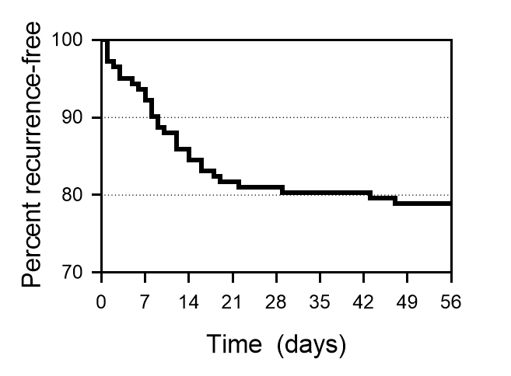

Figure S1. Kaplan-Meier analysis plot of recurrence-free participants over time after last received RBX2660 treatment.
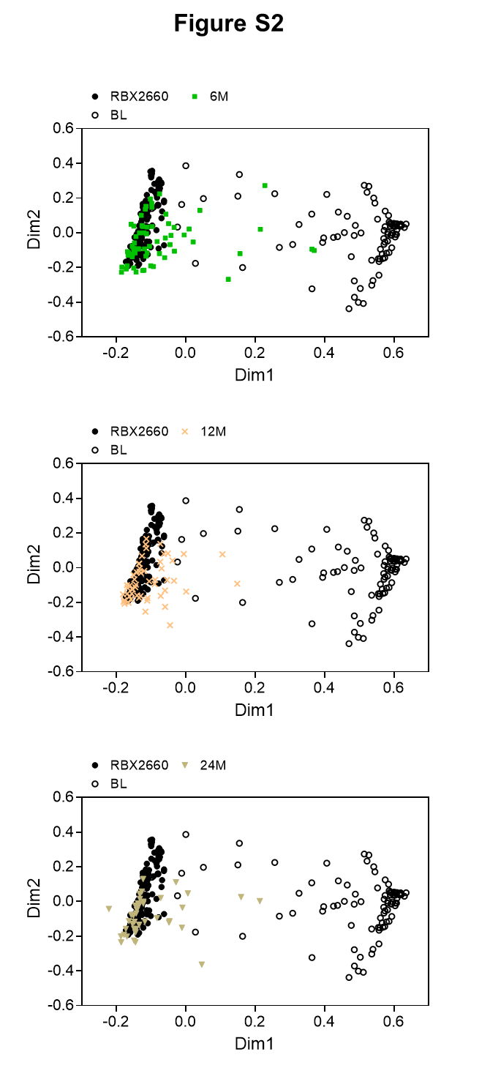
Figure S2. Non-parametric multidimensional similarity analysis (NMDS) based on Bray-Curtis dissimilarity for microbiome compositions of RBX2660 and responder microbiome compositions before treatment (BL) and 6, 12, and 24 months (top, middle, and bottom panels, respectively) after last received RBX2660 treatment.
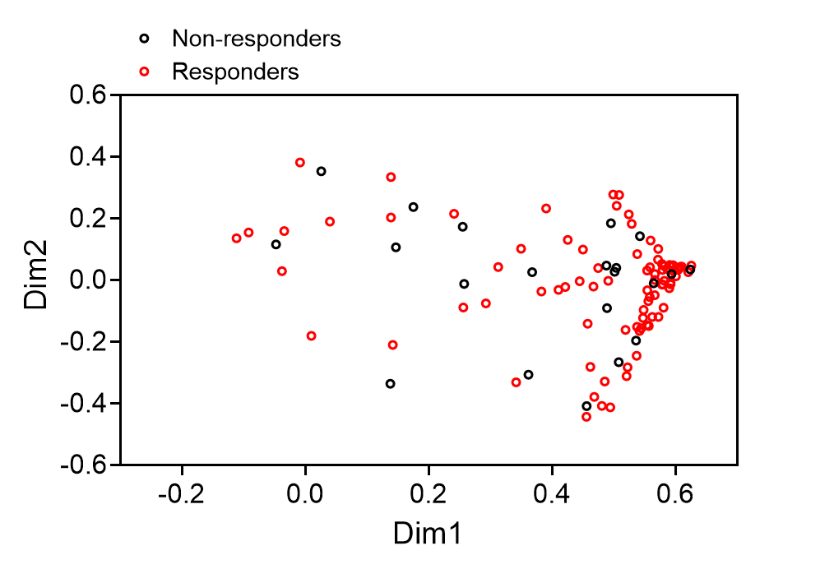

Figure S3. Non-parametric multidimensional similarity analysis (NMDS) based on Bray-Curtis dissimilarity for microbiome compositions of responder and nonresponder microbiome compositions before treatment (BL). There was no signficant difference (p > .05, parametric t-test).

