APPENDICES EXPRESSIVE LANGUAGE TEST

Appendix A :Adapted Developmental Language Test Illustrations PHASE 2
Picture A Picture B
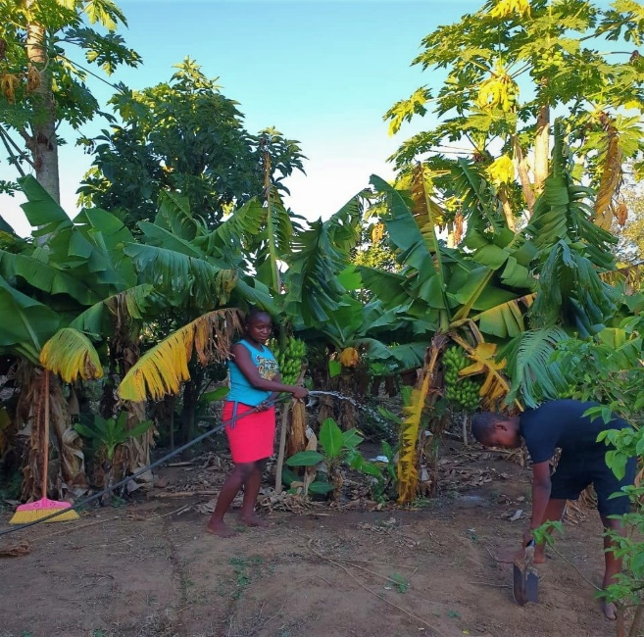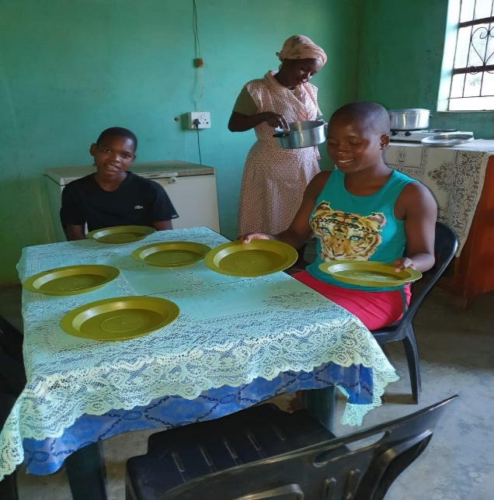
Picture C Picture D
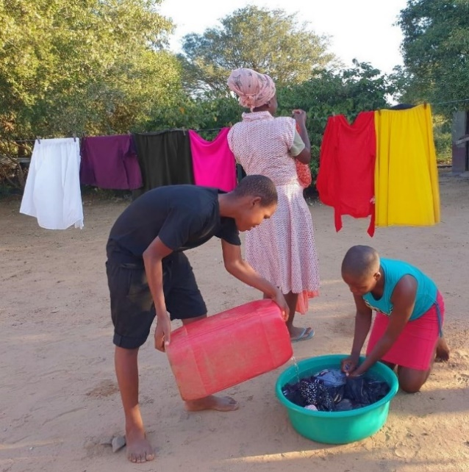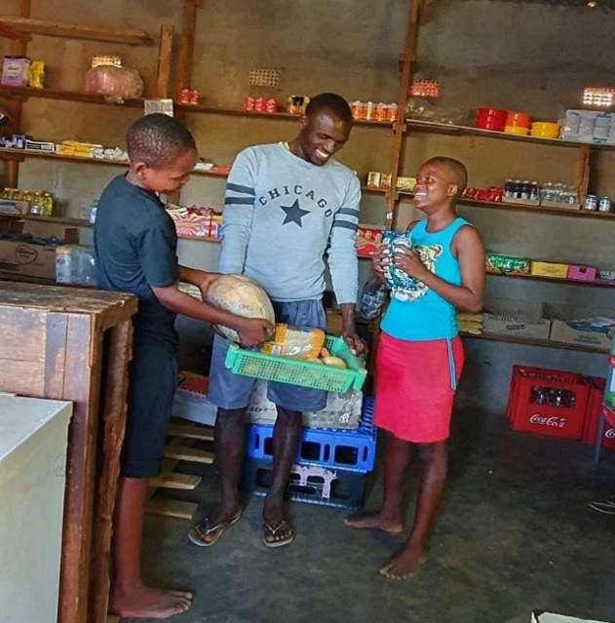

APPENDIX B Developmental Language test (Adapted for Ingwavuma)
SECTION A
Purpose: Establish rapport &introduce the narrative
- Instruction:
Unalo iculo olithandayo esingalicula ndawonye noma umlolozelo esingawusho sobabili?
1  Song | Song or rhyme production. | 2 | 1 | 0
1  Song | Song or rhyme production. | song or rhyme clear with enjoyment | sings but lacks clarity | unable to perform
- Instruction:
Show all pictures to the child then proceed with questions: Akubuke lezizithombe. Lona umndeni wakwa Mthembu. Kukhona ubaba Kanye nomama, kuthiwa umama nonkosikazi Mthembu nomfana obizwa ngokuthi uThemba nentombazane ebizwa ngokuthi uNosipho.

2. Names/ story characters | Ungasho ukuthi bangobani labantu?  nokuthi bangobani amagama abo? | 3 | 2 | 1 | 0
2. Names/ story characters |  | All characters & their names correct | all people correct, some names correct | some people, and some names correct | No response

SECTION B
Picture 1:
Description:
Izithombe zisitshela indaba yokuthi umndeni wenzani undawonye ngomunye uMgqibelo ekuseni. Buka isithombe sokuqala. Unkosikazi Mthembu washeshe wavuka ukuywasha izingubo. UThemba noNosipho bayamsiza umama wabo.

3.1  Follows 2- and 3- part commands | Ngikhombisa umama Mthembu, bese ungikhombisa uNosipho, ugcine ngokungikhombisa uThemba. | 3 | 2 | 1 | 0
3.1  Follows 2- and 3- part commands |  | all correct | all shown, but order incorrect | Two people shown in correct order

3.2  WH Q | Bakuphi? (where) | 1 | 0
3.2  WH Q | Benzani? (what) | 1 | 0
3.2  WH Q | Bakwenzelani lokho? (why) | 1 | 0
 | Ubani owasha/ oshuka izingubo? (who) | 1 | 0
 | Uzineka kuphi unkosikazi Ndaba izingubo? (where) | 1 | 0
 | Ukwenzelani lokho? (why) | 1 | 0

3.3  Recognizes  colors | Ungangikhombisa into emnyama (black) esithombeni? | 1 | 0
3.3  Recognizes  colors | Ungangikhombisa into e orange? | 1 | 0
3.3  Recognizes  colors | Ungangikhombisa into emhlophe (white) | 1 | 0
 | Bumbala muni utshani? | 1 | 0
 | Uwumbala onjani lamaplate? | 1 | 0

Ngizobala amaphekisi. Ngisize ukuwabala?
(count to 5 and wait for the child to copy this. If s/he can do this continue counting to 10 and wait for the child. If s/he can do this, count the remaining pegs).
3.4 Counting 1-15 | Counting to 15. | 3 | 2 | 1 | 0
3.4 Counting 1-15 | Counting to 15. | counts to 15 | counts to 10 | counts to 5 | less than 5/ NR

SECTION C

Picture 2
Sebeqedile ngokuwasha izingubo oThemba no Nosipho bayakosiza umnumzane Ndaba ngesikhathi esebenza etshala izimbali engadini

4.1 Identify object by name | Ngikhombisa ifosholo |  | 1 | 0
4.1 Identify object by name | Yini enye onganisela ngayo engadini? |  | 1 | 0
4.1 Identify object by name | Ngikhombisa umshanelo |  | 1 | 0
4.1 Identify object by name | Ngikhombisa amahlamvu/ amacembe |  | 1 | 0
4.2 Understand object function | Ubambeni/uphetheni uNosipho? |  | 1 | 0
4.2 Understand object function | Eyokwenzani? |  | 1 | 0
4.2 Understand object function | uyasiza yini umshanelo ensimini? |  | 1 | 0
4.2 Understand object function | Yini enye onganisela ngayo engadini? |  | 1 | 0
4.2 Understand object function | Elokwenzani ifosholo? |  | 1 | 0
4.3 Understands differences in meaning OPPOSITES |  | Ubani omile ubani obheke phansi? | 1 | 0
4.3 Understands differences in meaning OPPOSITES |  | ungikhombise isibhakabhaka. | 1 | 0
4.3 Understands differences in meaning OPPOSITES |  | Ngikhombise isihlahla esifishane. | 1 | 0
4.3 Understands differences in meaning OPPOSITES |  | Ngikhombise isihlahla eside. | 1 | 0
4.3 Understands differences in meaning OPPOSITES |  | Sinaziphi isithelo isihlahla esiseduze kuka Nosipho. | 1 | 0
4.3 Understands differences in meaning OPPOSITES |  | Ngikhombise inhlabathi. | 1 | 0

SECTION D

Picture 3
Okulandelayo umnumzane Mthembu baya kothenga noThemba Kanye noNosipho

5.1  Fruit & vegetables Naming | Can you tell me all the names of fruit you know? | 3 | 2 | 1 | 0
5.1  Fruit & vegetables Naming | Can you tell me all the names of fruit you know? | more than 4 correct | more than 2 correct | 1 correct | None offered
5.2  Fruit/ Vegetable Differentiation | Nhloboni yokudla abakuthengile (prompt: ingabe amafruits noma ama vege?) Yimaphi amanye ama veji owaziyo noma akhona ensimini ekhaya? | 3 | 2 | 1 | 0
5.2  Fruit/ Vegetable Differentiation |  | more than 4 correct | more than 2 correct | 1 correct | None offered
5.3  Narratives | Uke waya esitolo kothenga?  Ngitshele/ngixoxele ngako.  (Prompts if necessary: Uye kuphi? Waya nobani? Nafika kanjani esetolo? Nathengani? | 3 | 2 | 1 | 0
5.3  Narratives |  | Unprompted, 3 details | Prompted 3 details | Prompted less than 3 details | No response/ cannot relate

SECTION E

Picture 4
Ekugcineni baqeda ukuthenga. Uma befika ekhaya uThemba no Nosipho bathola ukuthi umama wabo esebalungisele isidlo sabo sasemini base bemsiza ukudeka itafula.
6.1. Counting OBJECTS | Zingakhi izitsha ozibonayo etafuleni? | 1 |  |  |  | 0
6.1. Counting OBJECTS | Zingakhi izitsha ozibonayo etafuleni? | Correct |  |  |  | Incorrect
6.2. Associating  Colours | Awumbala onjani amapuleti futhi kukhona yini omunye enye into ewumbala ofana nawo? | 2 |  | 1 |  |  |  | 0
6.2. Associating  Colours |  | Both answers correct |  | 1 answer correct |  |  |  | Both answers wrong
6.3.  Inferencing | Ucabanga ukuthi lomndeni uzokwenzani manje? | 2 |  | 1 |  |  |  | 0
6.3.  Inferencing | Ucabanga ukuthi lomndeni uzokwenzani manje? | Answer makes sense, future tense |  | Answer correct tense incorrect |  |  |  | Answer incorrect
6.4.  Narratives | Accurately relays a whole story Ungangixoxela indaba yonke ngabakwenzile abakwa Mthembu ngomgqibelo ekuseni? | 4 | 3 |  | 2 |  | 1 |  | 0
6.4.  Narratives |  | 4 events | 3 events |  | 2 events |  | 1 event |  | Could not tell the story

APPENDIX C: PHASE 2 Size Of Effect Analysis Of Infection On Language Tests

Measurement description  t -tests | Cohen’s d  ( d=m1-m2/sd) | Interpretation  (.8=large;  .5 moderate; .2 small)
SCHISTOSOMIASIS POSITIVE
Z score (sum vocab 1) & Schistosomiasis | d= -.671 | Medium Negative effect
Z score (Sum Vocabulary 2) & Schistosomiasis | d= -.188 | Minimal significance
Z SCORE (sum colours) & Schistosomiasis | d= -.532 | Medium Negative effect
Z score (sum WH- questions) & schistosomiasis | d= -.255 | Small negative effect
Z score (Sum Narratives) & Schisto | d= -.99 | High negative effect
SOIL TRANSMITTED HELMINTHS POSITIVE
Z score ( Sum Vocab 1) & STH | d= -1.84 | Minimal significance
Z score (Sum Vocab 2) & STH | d=.28 | Small effect
Z score (Sum WH questions ) & STH | d= -.62 | Minimal significance
Z score (Colours) & STH | d= -1.41 | No effect
Z score (Sum Narratives) & STH | d= -2.16 | Minimal significance
*P<0.05)

