SUPPLEMENTARY MATERIALS
Venous Thromboembolism in COVID-19 Patients and Prediction Model: A Multicenter Cohort Study

Yi Lee, Qasim Jehangir, Pin Li, Deepthi Gudimella, Pooja Mahale, Chun-Hui Lin, Dinesh R. Apala, Geetha Krishnamoorthy, Abdul R. Halabi, Kiritkumar Patel, Laila Poisson, Venugopal Balijepally, Anupam A. Sule, Girish B. Nair

Table of Contents

Page 2 – 5: Table S1: Dictionary of variables in Southeastern Michigan Consortium
Registry Database
Page 6: Table S2: ICD-10 and Consortium Sheet codes for in-hospital venous
thromboembolic events, including acute deep vein thrombosis and acute
pulmonary embolism
Page 7 – 12: Table S3: Univarate Analysis for predictors of acute venous thromboembolic events
Page 13: Table S4: Functions and Packages Used in the analysis
Page 14 – 15: Table S5A: Correlation of variables
Page 16: Table S5B: Predictors that were excluded
Page 17 – 18: Figure S1A: Scree plot of principal components analysis
Page 19 Figure S1B: Biplot of the Principal Components Analysis
Page 20: Figure S2: Decision tree of VTE model in COVID-19 patients

Supplementary Table 1. Dictionary of variables in Southeastern Michigan Consortium Registry Database.
Category | Predictor variables | Description | Values
Personal Information | Patient Study ID | Unique alphanumeric value for each patient
Personal Information | AdmissionNumber | Determines if the patient is admitted the first time in the hospital or is a revisitor | 1 = New Patient  2 = Revisitor  3 = Revisitor
Personal Information | Gender | Gender of the patient | Male=0, Female=1
Personal Information | Race/ethnicity | Race/ethnicity of the patient | 1 = American Indian or Alaskan Native  2 = Asian or Pacific Islander  3 = Black  4 = White  5 = Hispanic  6 = Others  7 = Unknown
Personal Information | AgeAtFirstAdmission | Age of the patient at first admission | Number>0
Personal Information | BMICat | Body mass index of the patient | <18.5 = 1  18.5-24.9 = 2  25-29 = 3  >30 = 4
Hospital Summary | HadCOVIDDx | Was a COVID-19 diagnosis made/treated in this inpatient episode? | 1=yes, 0=no
Hospital Summary | HospitalLOS | Days from ED to Discharge | Number>0
Hospital Summary | TotalICULOS | Days spent in the intensive care unit | Number>0
Hospital Summary | CovidVentDays | The number of days on mechanical ventilation | Number>=0
Hospital Summary | CPR | Was cardiopulmonary resuscitation performed? | 1=yes, 0=no
Hospital Summary | PresentingO2Sat | Patients’ oxygen saturation on admission | Numeric, 0-100
Hospital Summary | O2device | Patients require oxygen support on admission | Nasal cannula/Non-rebreather mask  Ventilator  High-flow nasal cannula  None = breathing on room air  Other
Hospital Summary | SOFAScore | Sequential Organ Failure Assessment (SOFA) score at the time of presentation to the hospital for this episode of care
Lab Values | WBC | White blood cell count of the patient | Numeric>0
Lab Values | Neutrophil-lymphocyte ratio | Neutrophil-lymphocyte ratio of the patient | Numeric>0
Lab Values | BNP | B-type natriuretic peptide content of the patient | Numeric>0
Lab Values | CRP | C-reactive protein content of the patient | Numeric>0
Lab Values | D-dimer | D-dimer content of the patient | Numeric>0
Lab Values | Ferritin | Ferritin content of the patient | Numeric>0
Lab Values | LDH | Lactate dehydrogenase content of the patient | Numeric>0
Lab Values | ALT | Alanine transaminase content of the patient | Numeric>0
Lab Values | AST | Aspartate aminotransferase content of the patient | Numeric>0
Lab Values | BUN | Blood urea nitrogen content of the patient | Numeric>0
Lab Values | Creatinine | Creatinine content of the patient | Numeric>0
Lab Values | Potassium | Potassium content of the patient | Numeric>0
Lab Values | T.bilirubin | Total bilirubin content of the patient | Numeric>0
Lab Values | PlateletCount | Platelet count of the patient | Numeric>0
Past medical history of the patient | Surgery | If patient had any previous surgeries | Coronary artery bypass graft  Cardiac stent  Lung transplant  Pulmory lobectomy  No = had no surgery
Past medical history of the patient | AtrialFibrillation | Atrial fibrillation, a type of cardiac medical history | 1=yes, 0=no
Past medical history of the patient | CAD | Coronary Artery Disease, a type of cardiac medical history | 1=yes, 0=no
Past medical history of the patient | HeartFailure | Heart failure, a type of cardiac medical history | 1=yes, 0=no
Past medical history of the patient | Hyperlipidemia | A type of cardiac medical history | 1=yes, 0=no
Past medical history of the patient | Hypertension | A type of cardiac medical history | 1=yes, 0=no
Past medical history of the patient | MI | Myocardial Infraction, a type of cardiac medical history | 1=yes, 0=no
Past medical history of the patient | PriorPercutaneousCororyInterventions | Prior cardiac catheterization, a type of cardiac medical history | 1=yes, 0=no
Past medical history of the patient | ValvularHeartDisease | Valvular heart disease, a type of cardiac medical history | 1=yes, 0=no
Past medical history of the patient | VentricularTachycardia | Ventricular tachycardia, a type of cardiac medical history | 1=yes, 0=no
Past medical history of the patient | Diabetes | A type of medical history | 1=yes, 0=no
Past medical history of the patient | Cancer | Other medical history | 1=yes, 0=no
Past medical history of the patient | Autoimmune | Other medical history | 1=yes, 0=no
Past medical history of the patient | COPD | Pulmonary medical history | 1=yes, 0=no
Past medical history of the patient | InterstitialLungDisease | Interstitial lung disase, a type of pulmonary medical history | 1=yes, 0=no
Past medical history of the patient | PulmoryFibrosis | Pulmonary fibrosis, a type of pulmonary medical history | 1=yes, 0=no
Past medical history of the patient | PulmoryHypertension | Pulmonary hypertension, a type of pulmonary medical history | 1=yes, 0=no
Past medical history of the patient | VenousThromboembolism | Priot medical history of venous thromboembolism | 1=yes, 0=no
Past medical history of the patient | CKD | Chronic kidney disease, a type of renal medical history | 1=yes, 0=no
Past medical history of the patient | Thyroid_merge | Thryoid disease, a type of endocrine medical history | 1=yes, 0=no
Past medical history of the patient | Leukemia | Hematological history | 1=yes, 0=no
Past medical history of the patient | SickleCellDisease | Sickle cell disease, a type of hematological history | 1=yes, 0=no
Past medical history of the patient | Cirrhosis | Liver medical history | 1=yes, 0=no
Past medical history of the patient | HepatocellularCarcimoma | Hepatocellular carcinoma, a type of liver medical history | 1=yes, 0=no
Past medical history of the patient | MultipleSclerosis | Neurological medical history | 1=yes, 0=no
Past medical history of the patient | TIA.Stroke | Cerebrovascular accident including transient ischemic attack and stroke, a type of neurological medical history | 1=yes, 0=no
This dictionary shows the categories of variables of (1). Personal history, (2). Hospital summary with presenting vitals, oxygen devices, length of stay in intensive care unit, etc (3). Laboratroy values, (4). Past medical history.

Supplementary Table 2. International Classification of Diseases–Tenth Revision and Consortium Sheet codes for in-hospital venous thromboembolic events, including acute deep vein thrombosis and acute pulmonary embolism.

 | International Classification of Diseases–Tenth Revision & Consortium Sheet Codes
Acute pulmonary embolism | Discharge Diagnosis: Acute Pulmonary embolism  I26.0 I26.01 I26.02 I26.09 I26.9 I26.90 I26.92 I26.93 I26.94 I26.99
Other acute venous thrombosis and embolism | Discharge Diagnosis: Acute venous thrombosis and embolism  I81 I82.2 I82.21 I82.210 I82.22 I82.220 I82.29 I82.290 I82.4 I82.40I82.401 I82.402 I82.403 I82.409 I82.41 I82.411 I82.412 I82.413 I82.419 I82.42 I82.421 I82.422 I82.423 I82.429 I82.43 I82.431 I82.432 I82.433 I82.439 I82.44 I82.441 I82.442 I82.443 I82.449 I82.45 I82.451 I82.452 I82.453 I82.459 I82.46 I82.461 I82.462 I82.463 I82.469 I82.49 I82.491 I82.492 I82.493 I82.499 I82.4Y I82.4Y1 I82.4Y2 I82.4Y3 I82.4Y9 I82.4Z I82.4Z1 I82.4Z2 I82.4Z3 I82.4Z9 I82.6 I82.60 I82.601 I82.602 I82.603 I82.609 I82.61 I82.611 I82.612 I82.613 I82.619 I82.62 I82.621 I82.622 I82.623 I82.629 I82.A I82.A1 I82.A11 I82.A12 I82.A13 I82.A19 I82.C1 I82.C11 I82.C12 I82.C13 I82.C19 I82.8 I82.81 I82.811 I82.812 I82.813 I82.819 I82.89 I82.890 I82.9 I82.90

Supplementary Table 3. Univarate Analysis for predictors acute venous thromboembolic events.
 | Variable |  | Odds Ratio¥ (95% CI, p value)
 | Gender | Male | 0.98 (0.77-1.25, p=0.865)
 | Race/ethnicity | American Indian or Alaskan Native | -
 |  | Asian or Pacific Islander | 0.11 (0.00-3.05, p=0.137)
 |  | Black | 0.56 (0.09-10.57, p=0.590)
 |  | White | 0.51 (0.09-9.60, p=0.530)
 |  | Hispanic | 0.11 (0.00-3.05, p=0.137)
 |  | Others | 0.26 (0.03-5.52, p=0.261)
 |  | Unknown | 0.64 (0.09-12.85, p=0.697)
 | Age (years) | [19.0,101.0] | 1.00 (1.00-1.01, p=0.242)
 | Body mass index (kg/m²), mean | <18.5 | -
 |  | 18.5-24.9 | 0.98 (0.46-2.43, p=0.955)
 |  | 25-29 | 0.75 (0.35-1.84, p=0.482)
 |  | >30 | 0.72 (0.35-1.77, p=0.430)
 | Readmission | 1 | 0.32 (0.19-0.58, p<0.001) *
 | Hospital length of stay (days) | [1.0,51.0] | 1.06 (1.05-1.07, p<0.001)*
 | Total intensive care unit length of stay (days) | [0.0,46.0] | 1.05 (1.04-1.07, p<0.001)*
 | Mechanical ventilation (days) | [0.0,45.0] | 1.06 (1.04-1.08, p<0.001)*
 | Cardiopulmonary resuscitation |  | 0.95 (0.69-1.35, p=0.778)
 | Oxygen device | None | -
 |  | Nasal cannula/non-rebreather mask | 1.48 (1.10-1.96, p=0.008)*
 |  | Ventilator | 3.14 (1.62-5.66, p<0.001)*
 |  | Other | 2.54 (0.95-5.74, p=0.038)*
 |  | High-flow nasal cannula | 12.59 (4.94-31.64, p<0.001)*
Vitals on presentation | Oxygen Saturation (%) | [2.0,100.0] | 0.99 (0.97-1.01, p=0.259)
 | Heart rate (beats/minute) | [11.0,209.0] | 1.01 (1.01-1.02, p<0.001)*
 | Respiratory rate (breaths/minute) | [1.0,135.0] | 1.01 (0.99-1.03, p=0.208)
 | Diastolic blood Pressure (mmHg) | [0.0,235.0] | 1.00 (1.00-1.01, p=0.370)
 | Systolic blood pressure (mmHg) | [45.0,266.0] | 1.00 (0.99-1.00, p=0.164)
Labs on presentation | White blood cell count (K/uL) | [0.2,85.9] | 1.06 (1.04-1.08, p<0.001)*
 | Lymphocytes (K/uL) | [0.0,89.0] | 0.98 (0.97-1.00, p=0.012)*
 | Neutrophils (K/uL) | [0.0,98.0] | 1.00 (0.99-1.00, p=0.761)
 | Hemoglobin A1c (%) | [4.5,17.1] | 0.89 (0.77-1.02, p=0.114)
 | B-type natriuretic peptide (pg/mL) | [5.0,3924.0] | 1.00 (1.00-1.00, p=0.957)
 | Ferritin (ng/mL) | [4.0,48174.0] | 1.00 (1.00-1.00, p=0.688)
 | Fibrinogen (mg/dL) | [98.0,1155.0] | 1.00 (1.00-1.00, p=0.212)
 | C-reactive protein (mg/dL) | [0.1,47.6] | 1.04 (1.02-1.05, p<0.001)*
 | D-dimer (μg/mL) | [0.2,26.8] | 1.19 (1.15-1.23, p<0.001)*
 | Interleukin-6 (pg/mL) | [2.5,918.5] | 1.00 (1.00-1.00, p=0.002)*
 | Lactate dehydrogenase (U/L) | [69.0,14007.0] | 1.00 (1.00-1.00, p=0.062)
 | Alanine transaminase (U/L) | [3.0,8518.0] | 1.00 (1.00-1.00, p=0.537)
 | Aspartate aminotransferase (U/L) | [7.0,9251.0] | 1.00 (1.00-1.00, p=0.025)*
 | Procalcitonin (ng/mL) | [0.1,100.0] | 0.99 (0.96-1.01, p=0.514)
 | Blood urea nitrogen (mg/dL) | [3.0,241.0] | 1.01 (1.00-1.01, p=0.003)*
 | Creatinine (mg/dL) | [0.2,21.5] | 1.03 (0.96-1.08, p=0.394)
 | Potassium (meq/L) | [1.3,9.5] | 1.28 (1.08-1.51, p=0.003)*
 | Total bilirubin (mg/dL) | [0.1,37.7] | 1.12 (1.03-1.23, p=0.007)*
 | Hemoglobin (gm/dL) | [6.4,16.0] | 1.28 (0.81-2.26, p=0.311)
 | Lactate (mmol/L) | [0.4,29.1] | 1.02 (0.90-1.12, p=0.714)
 | Platelet Count (K/uL) | [18.0,1115.0] | 1.00 (1.00-1.00, p<0.001)*
Social history |  |  | -
 | Smoker |  | 0.94 (0.57-1.47, p=0.789)
 | Alcohol Use |  | 1.55 (0.64-3.21, p=0.284)
 | Marijuana Use |  | 1.88 (0.44-5.55, p=0.314)
¥Odds ratio was calculated as [Probability of VTE, given Variable/Probability of VTE given not Variable)]/[Probability of not VTE given variable)/Probability of not VTE given not Variable)]

Supplementary Table 3. (Continued)
 | Variable |  | Odds Ratio (95% CI, p value)
In-hospital medications  Home medications | Inpatient anticoagulation therapeutic dose |  | 5.59 (4.27-7.32, p<0.001) *
In-hospital medications  Home medications | Inpatient anticoagulation prophylactic dose |  | 0.25 (0.19-0.35, p<0.001) *
In-hospital medications  Home medications | Non-steroidal anti-inflammatory drugs |  | 1.85 (0.59-4.88, p=0.242)
In-hospital medications  Home medications | Azithromycin |  | 2.10 (0.58-6.07, p=0.203)
In-hospital medications  Home medications | Hydroxychloroquine |  | 2.09 (0.11-13.54, p=0.509)
In-hospital medications  Home medications | Angiotensin-converting enzyme inhibitors |  | 1.36 (0.57-3.03, p=0.472)
In-hospital medications  Home medications | Angiotensin receptor blockers |  | 1.17 (0.38-2.99, p=0.766)
In-hospital medications  Home medications | Beta blockers |  | 0.55 (0.21-1.27, p=0.183)
In-hospital medications  Home medications | Diuretics |  | 0.94 (0.40-2.09, p=0.887)
In-hospital medications  Home medications | Statins |  | 0.56 (0.24-1.24, p=0.169)
In-hospital medications  Home medications | Warfarin |  | 1.62 (0.24-6.27, p=0.540)
In-hospital medications  Home medications | Aspirin |  | 0.64 (0.24-1.47, p=0.316)
In-hospital medications  Home medications | P2Y12 inhibitors |  | 1.76 (0.27-6.90, p=0.474)
In-hospital medications  Home medications | Direct oral anticoagulants |  | NA
In-hospital medications  Home medications | Other anticoagulants |  | NA
In-hospital medications  Home medications | Corticosteroids |  | 1.48 (0.41-4.15, p=0.495)
In-hospital medications  Home medications | Proton pump inhibitors |  | 1.75 (0.77-3.81, p=0.169)
Lab values (Maximum and Minimum) | White blood cell count Max |  | 1.03 (1.02-1.05, p<0.001)*
Lab values (Maximum and Minimum) | Lymphocytes Min |  | 0.97 (0.95-0.99, p=0.001)*
Lab values (Maximum and Minimum) | Neutrophils Max |  | 1.03 (1.01-1.04, p=0.001)*
Lab values (Maximum and Minimum) | Hemoglobin A1c Min |  | 0.90 (0.77-1.02, p=0.118)
Lab values (Maximum and Minimum) | B-type natriuretic peptide Max |  | 1.00 (1.00-1.00, p=0.928)
Lab values (Maximum and Minimum) | Ferritin Max |  | 1.00 (1.00-1.00, p=0.734)
Lab values (Maximum and Minimum) | Lactate Max |  | 1.08 (0.99-1.17, p=0.073)
Lab values (Maximum and Minimum) | C-reactive protein Max |  | 1.04 (1.03-1.06, p<0.001)*
Lab values (Maximum and Minimum) | D-dimer Max |  | 1.21 (1.16-1.26, p<0.001)*
Lab values (Maximum and Minimum) | Interleukin-6 Max |  | 1.00 (1.00-1.00, p=0.002)*

Supplementary Table 3. (Continued)
 | Variable | Odds Ratio (95% CI, p value)
Prior Medical History | Atrial fibrillation | 0.66 (0.40-1.03, p=0.086)
Prior Medical History | Coronary artery disease | 0.74 (0.51-1.03, p=0.088)
Prior Medical History | Deep vein thrombosis | 2.67 (1.81-3.86, p<0.001)*
Prior Medical History | Heart failure | 0.80 (0.53-1.17, p=0.267)
Prior Medical History | Hyperlipidemia | 0.85 (0.65-1.10, p=0.212)
Prior Medical History | Hypertension | 0.85 (0.63-1.17, p=0.312)
Prior Medical History | Myocardial infarction | 1.21 (0.79-1.79, p=0.363)
Prior Medical History | Valvular heart disease | 1.08 (0.59-1.83, p=0.790)
Prior Medical History | Ventricular tachycardia | 0.85 (0.05-4.29, p=0.876)
Prior Medical History | Diabetes mellitus | 0.90 (0.69-1.17, p=0.446)
Prior Medical History | Malignancy | 1.24 (0.91-1.68, p=0.169)
Prior Medical History | Autoimmune disease | 1.24 (0.69-2.08, p=0.432)
Prior Medical History | Chronic obstructive pulmonary disease | 0.65 (0.43-0.95, p=0.034)*
Prior Medical History | Interstitial lung disease | 1.38 (0.07-7.59, p=0.760)
Prior Medical History | Pulmonary embolism | 3.40 (2.15-5.21, p<0.001)*
Prior Medical History | Pulmonary fibrosis | 0.79 (0.04-3.95, p=0.819)
Prior Medical History | Pulmonary hypertension | 0.70 (0.17-1.93, p=0.555)
Prior Medical History | Other venous thromboembolism | 3.34 (2.39-4.61, p<0.001)*
Prior Medical History | Chronic kidney disease | 1.26 (0.86-1.80, p=0.222)
Prior Medical History | End-stage renal disease | 1.16 (0.51-2.29, p=0.694)
Prior Medical History | Thyroid disease | 1.01 (0.69-1.44, p=0.948)
Prior Medical History | Sickle cell disease | 1.01 (0.05-5.20, p=0.996)
Prior Medical History | Ascites | 8.38 (1.64-38.24, p=0.006)*
Prior Medical History | Liver cirrhosis | 1.01 (0.16-3.44, p=0.994)
Prior Medical History | Hepatocellular carcinoma | 3.70 (0.18-29.00, p=0.258)
Prior Medical History | Non-alcoholic steatosis hepatitis | 3.70 (0.18-29.00, p=0.258)
Prior Medical History | Multiple sclerosis | 0.61 (0.03-2.99, p=0.634)
Prior Medical History | Transient ischemic attack or stroke | 0.81 (0.53-1.20, p=0.314)
Supplemenatry Table 3 (Continued). Univariate Analysis for venous thromboembolic events including baseline characteristics, initial vital signs on presentation, laboratory on presentation, social history, medication history prior to admission, and past medical history, anticoagulation during hospitalization. *p<0.05. Abbreviations: Max, maximum; min, minimum.

Supplemenatry Table 4. Functions and Packages Used in the analysis.

JMP Pro functions

## Correlations for continuous variables:
Analyze > Multivariate Methods > Multivariate.
Select Nonparametric Correlation
Select Spearman’s Rho (r)

## Random sampling:
Tables > Subset, random split ratio: 30:70

## LR, MLR model:
Analyze > Fit Model

## Decision trees and random forest:
Analyze > Predictive Modeling > Partition

UVA and PCA R packages

##library(finalfit)
forfit1 = forfit %>% filter(Event == 'Venous' | Event == 'No Event')
## summary table 1
tab1 = forfit1 %>%
summary_factorlist()

## univariate analysis
uva1 = forfit1 %>%
finalfit()

##pca
library(factoextra)
cov.pca2.res <- prcomp(cov.pca2, scale = TRUE)
fviz_eig(cov.pca2.res) #scree plot
fviz_pca_biplot(cov.pca2.res, repel = TRUE, col.var = "navyblue", col.ind = "grey70") #biplot

Supplementary Table 5A. Correlation of variables.
Variable 1 | Variable 2 | Spearman's rho | Significance Value
AST | ALT | 0.7 | <0.0001
Creatinine | BUN | 0.74 | <0.0001
BNPMax | BNP | 0.9765 | <0.0001
CRPMax | CRP | 0.6695 | <0.0001
FerritinMax | Ferritin | 0.9061 | <0.0001
D-dimerMax | D-dimer | 0.8465 | <0.0001
LDHMax | LDH | 0.8394 | <0.0001
WBCMax | WBC | 0.5576 | <0.001
HadCOVIDDx | AdmissionNumber | -0.8551 | <0.0001
CovidVentDays | TotalICUDays | 0.7819 | <0.0001
Neutrophil-lymphocyte ratio Max | LymphocytesMin | -0.9791 | <0.0001
Neutrophil-lymphocyte ratio Max | NeutrophilsMax | 0.7606 | <0.0001
Neutrophil-lymphocyte ratio Max | Lymphocytes | -0.6516 | <0.0001
Neutrophil-lymphocyte ratio | Lymphocytes | -0.7956 | <0.0001
Neutrophil-lymphocyte ratio | Neutrophils | 0.96 | <0.0001
Neutrophil-lymphocyte ratio | Lymphocytes | -0.7956 | <0.0001
Neutrophil | Lymphocytes | -0.7281 | <0.0001
NeutrophilsMax | LymphocytesMin | -0.6639 | <0.0001
LymphocytesMin | Lymphocytes | 0.635 | <0.0001
VenousThromboembolism | DeepVeinThrombosis | 0.7952 | <0.0001
VenousThromboembolism | PulmoryEmbolism | 0.6593 | <0.0001
SystolicBP | DiastolicBP | 0.5585 | <0.0001
ip_AC_prophylatic | ip_AC_therapeutic | -0.7434 | <0.0001

23 groups of variables that are highly correlated based on Spearman’s coefficient. The variables are explained in the dictionary of variables in Supplementary Table 1.

Supplementary Table 5B. Predictors that were excluded.
Predictor
BNPMax
CRPMax
FerritinMax
D-dimerMax
LDHMax
WBCMax
TotalICUDays
LymphocytesMin
NeutrophilsMax
N/L ratio Max
Neutrophils
Lymphocytes
DeepVeinThrombosis
PulmoryEmbolism

The variables are explained in Supplementary Table 1.

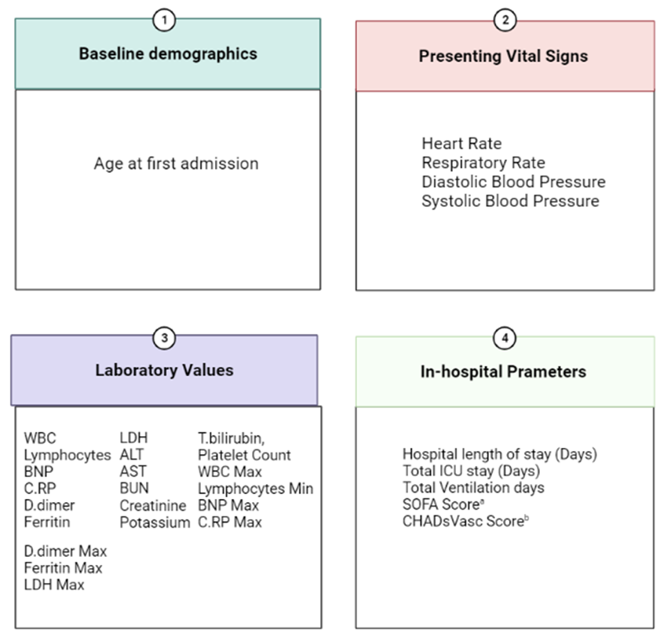
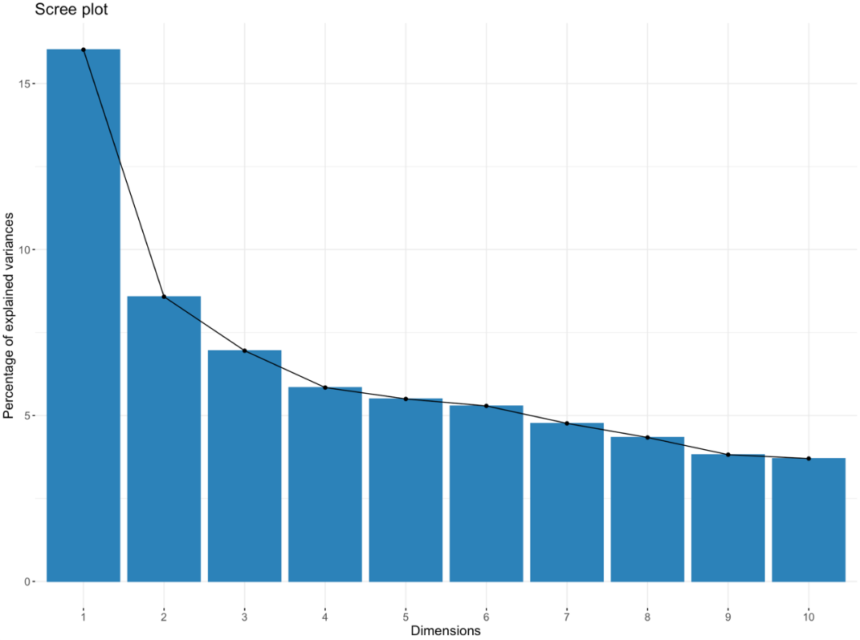

Supplementary Figure 1A. Scree plot of principal components analysis (PCA). Patient without missing data (N=1443) from the cohort were included in the PCA. 32 continuous variables were included in PCA. In the scree plot, the 1st component explains only about 16% variations of the data and 24.6% of the variations can be explained by the first 2 components. The variables are explained in Supplementary Table 1.

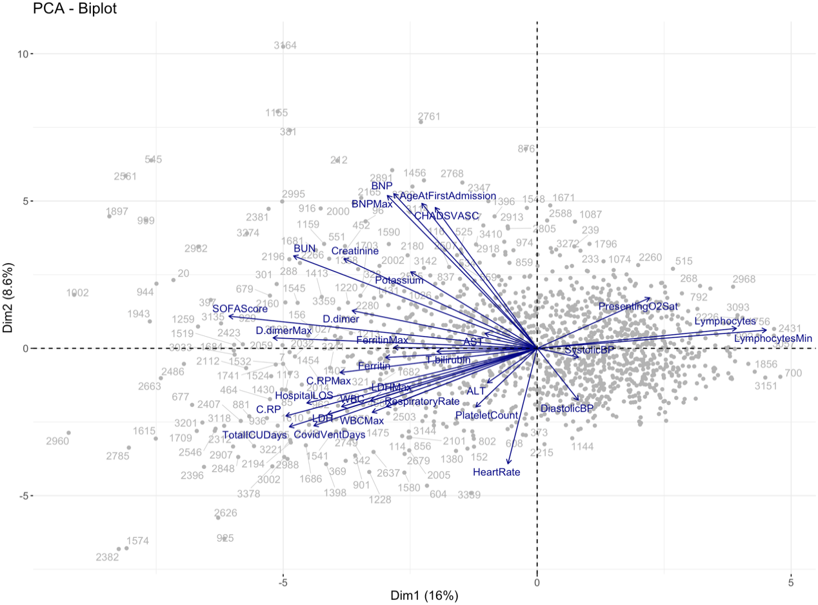

Supplemenatry Figure 1B. Biplot of the Principal Components Analysis. The top 2 components are the x and y axis and the k vectors (blue arrows) show how strongly each characteristic influence a principal component. PC1 explained 16% of the total variation and PC2 explained 8.6%. Most of the vectors are horizontal, and they strongly influence PC1. Many of them are positive correlated as they are close to each other. Among which, presenting heart rate (HR) and blood pressure (BP) strongly influence PC2. Other variables are explained in Supplementary Table 1.

Supplemenatry Figure 2. Decision tree of VTE model in COVID-19 patients. This diagram delienated the nodes of our decision tree model. The first split was on the node of therapeutic anticoagulation in hospitalized patients into yes or no. Each one of this splits further on BUN, hospital length of stay, D-dimer and history of VTE.
Abbreviations: BUN, blood urea nitrogen; VTE, venous thromboembolism

