Additional table S1. Information on HBV and HDV sequences from Yakutia that were used for Skyline analysis
Virus | Year of isolation | Number of sequences | GenBank accession number
HBV | 2018 | 13¹ | OK143470, OK143474, OK143477, OK143478, OK143480, OK143482, OK143485, OK143489, OK143490, OK143494-OK143496, OK143498
HBV | 2014 | 35 | KM212957, KP143742-KP143745, KP165597-KP165605, KP184495-KP184495, KP202936-KP202945, KP230541, KT962021-KT962025
HBV | 2008 | 8 | OL771254-OL771261
HBV | 2004-2006 | 16 | OM025238-OM025253
HBV | 1997 | 14 | AY653781, AY653782, AY653787-AY653789, AY653796, AY653799, EU594390-EU594395, EU594433
HDV | 2018-2019 | 73¹ | OK142820–OK142858, OK142920–OK142929, OK142938, OK142939, OL875352-OL875373
HDV | 2016 | 1 | LT604953
HDV | 2001 | 2 | AJ309879, AJ309880
HDV | 2001 | 12 | AJ309868-AJ309878, AJ309881
¹ Sequences obtained in this study

Additional table S2. Comparison of HBV genotyping results obtained using Sanger sequencing and ELISA kit for HBsAg serotyping
HBV genotype determined by sequencing | Number of tested samples | HBV serotype and deduced genotype by ELISA | Number of correctly identified samples | Concordance, %
HBV-A | 46 | adw2, HBV-A | 46 | 100%
HBV-D | 32 | ayw2 or ayw3, HBV-D | 32 | 100%
HBV-C | 4 | adrq+, HDV-C – in 3 samples;  adw2, HBV-A –  in 1 sample | 3 | 75%
All HBV genotypes combined | 82 | - | 81 | 98.8%

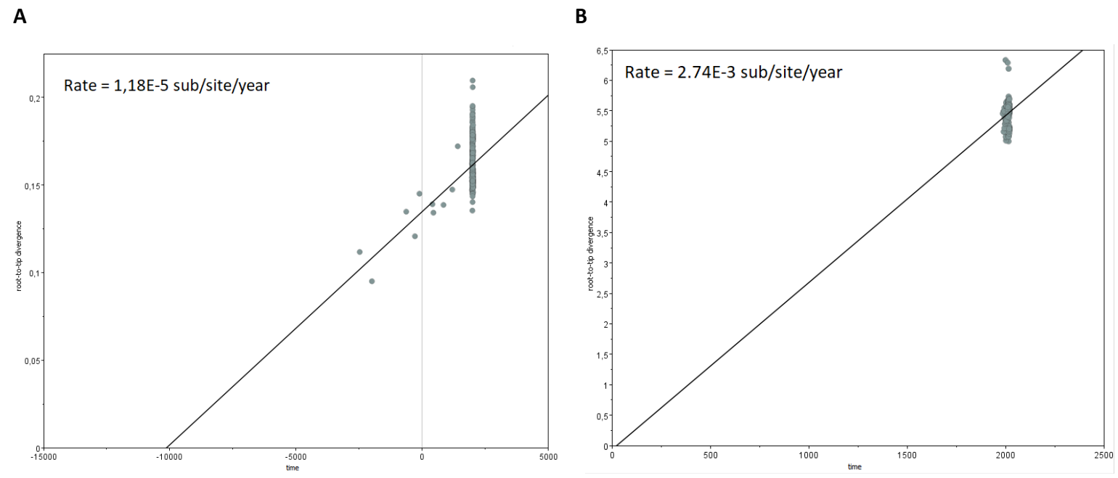
(a) | (b)
Additional figure S1. Temporal signal linear regression graphs for HBV (a) and HDV (b) complete genomic sequences. The X-axis shows time in years.
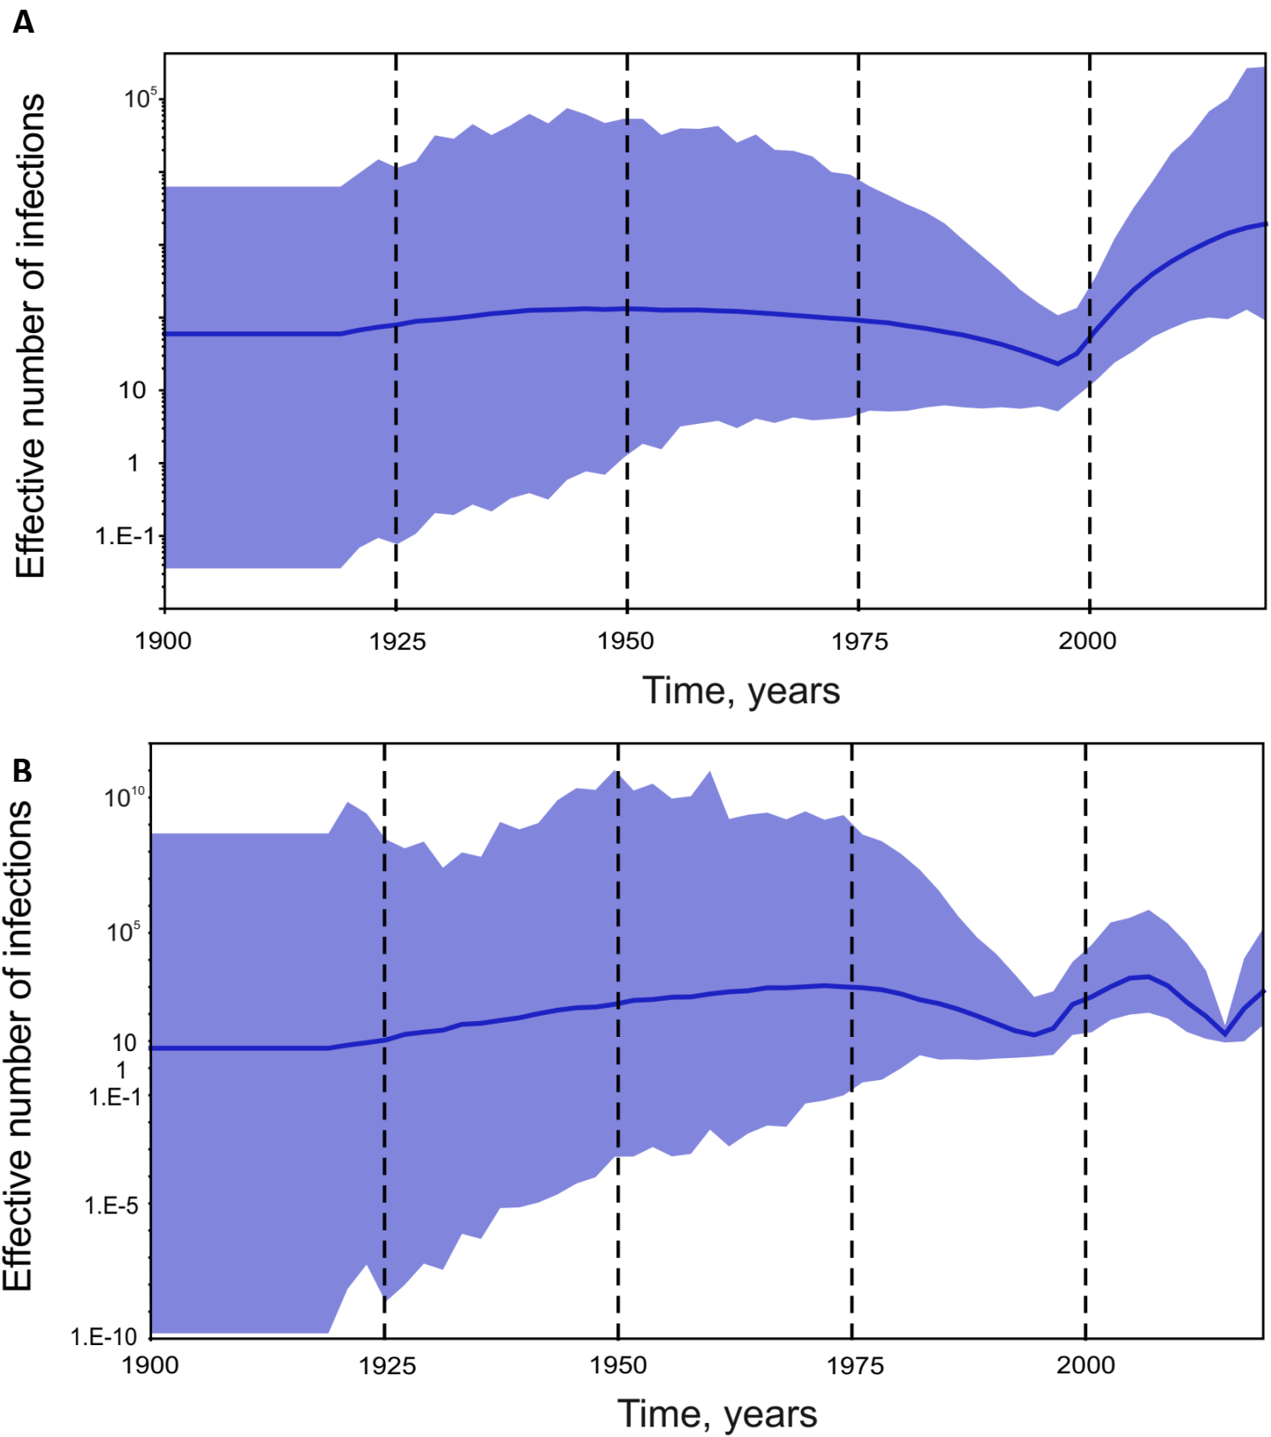
Additional figure S2. SkyGrid reconstruction for HBV complete genome (a) and HBV S-gene 650 nt fragment (b) datasets. The graphs show the relationship between the effective number of infections (y-axis) and the chronological time expressed in years (x-axis). The blue curve indicates the mean, and the 95% HPD interval shown in lilac filling.
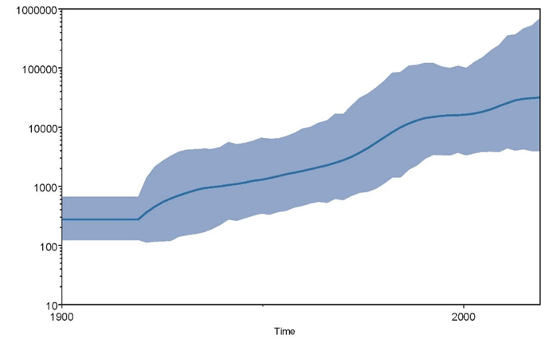 | 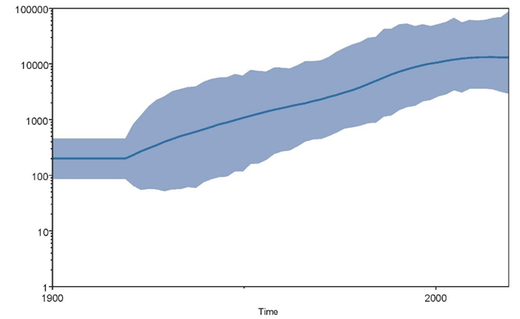
(a) | (b)
Additional figure S3. SkyGrid reconstruction for HDV complete genome (a) and 379 nt fragment of HDV R0 region (b) datasets. The graphs show the relationship between the effective number of infections (y-axis) and the chronological time expressed in years (x-axis). The blue curve indicates the mean, and the 95% HPD interval shown in blue filling.
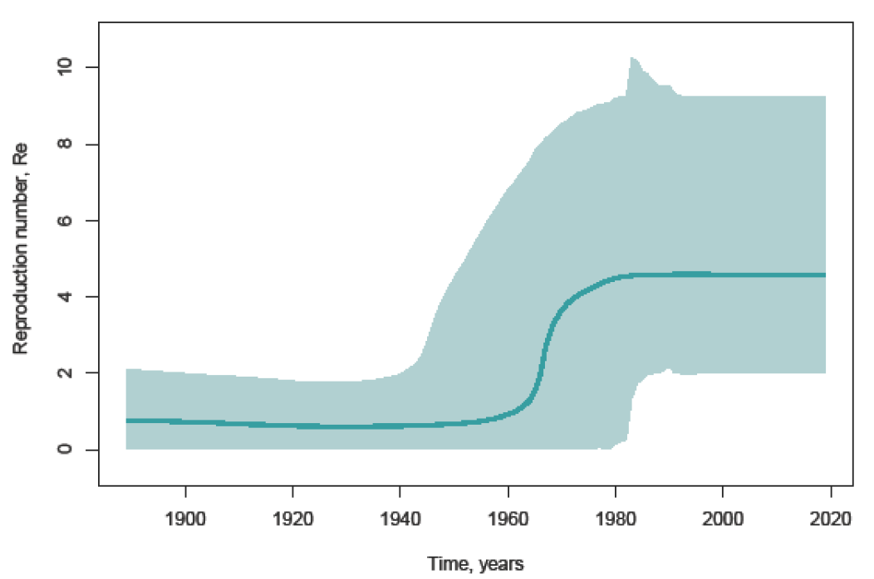 | 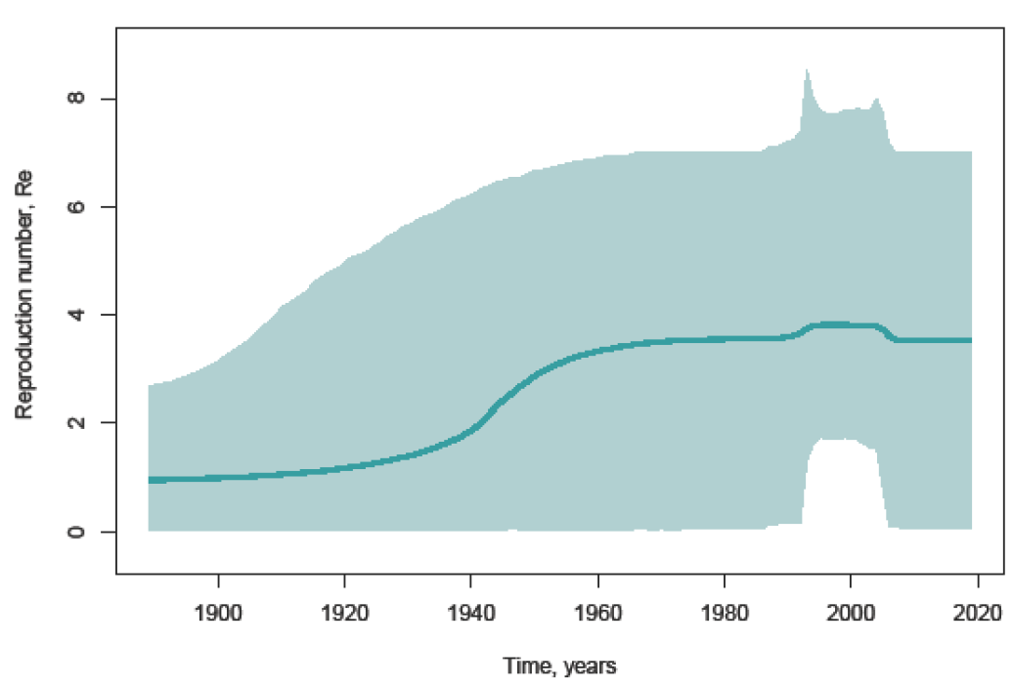
(a) | (b)
Additional figure S4. SkyGrid reconstruction for HBV subgenotypes D2 (a) and D3 (b). The graphs show the relationship between the effective number of infections (y-axis) and the chronological time expressed in years (x-axis). The green curve indicates the mean, and the 95% HPD interval shown in green filling.

