Appendix A

Table S1. Parameters regulating COVID-19 burden.
Description | Age (years) | Value (%) |  | Reference
Probability of developing respiratory symptoms and/or fever given infection | 0-19  20-39  40-59  60-79  80+ | 18.1  22.4  30.5  35.5  64.6 |  | Poletti et al. [1]
Proportion of laboratory-confirmed symptomatic individuals requiring hospitalization | 0-19  20-39  40-59  60+ | 40.0  29.2  33.3  33.8 |  | Yang et al. [2]
Fatality ratio among laboratory-confirmed symptomatic individuals | 0-19  20-39  40-59  60+ |  | 0.51  0.65  2.38  10.52 | Yang et al. [2]

Table S2. Transmission Parameters for all simulations.
Scenario | Parameters | Model 1 | Model 2 | Model 3
Baseline | $$R_{0}$$ | 1.3 | 1.3 | 1.3
Baseline | $$β$$ | 0.0052775 | 0.0030013 | 0.0038085
Baseline | $$γ$$ | 1/5.1 | 1/5.1 | 1/5.1
Baseline | Initial seeds | 1 | 1 | 1
Baseline | Cumulative infections reached to interrupt simulation | 1,000 | 1,000 | 1,000
Baseline | Population size | 758,529,559 | 758,529,559 | 758,529,559
Sensitivity analysis on the initial number of seeds | Initial seeds | - | - | 5, 20
Sensitivity analysis on the reproduction number | $$R_{0}$$ | - | - | 2.0
Sensitivity analysis on the reproduction number | $$β$$ | - | - | 0.0058425
Sensitivity analysis on the cumulative number of infections reached to interrupt the simulation | Cumulative infections reached to interrupt simulation | - | - | 500, 2,000
Parameters that are not listed in sensitivity analyses are kept as in the baseline analysis.

Table S3. Data completeness.
Province | Total Number of  Participants | Number of Participants with Missing Information | Number of Participants with Complete Information
Sichuan | 360 | 160 | 200
Chongqing | 34 | 14 | 20
Shandong | 33 | 14 | 19
Hebei | 23 | 6 | 17
Henan | 25 | 9 | 16
Zhejiang | 21 | 7 | 14
Fujian | 18 | 5 | 13
Yunnan | 23 | 10 | 13
Hunan | 19 | 7 | 12
Guangdong | 19 | 9 | 10
Jiangxi | 17 | 7 | 10
Shanxi | 21 | 11 | 10
Total | 613 | 259 | 354
One participant was not a Chinese resident and one responded to the survey outside of the 20-day study period; as such, they were excluded from the study.

Figure S1. Age distribution.
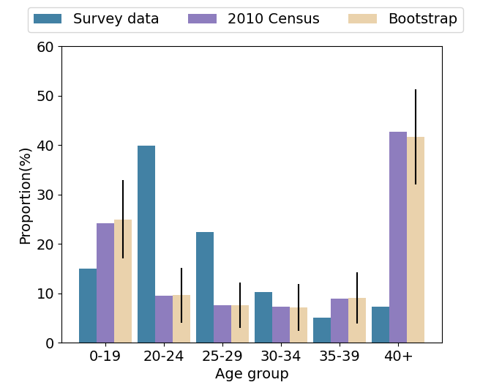
Figure S1: Age distributions of study participants, the 12 analyzed provinces from the 2010 Chinese census (2010 census [3]) and the bootstrap sample. Note that standard errors are given for the bootstrapped data.

Figure S2. Sensitivity analysis on the initial number of seeds
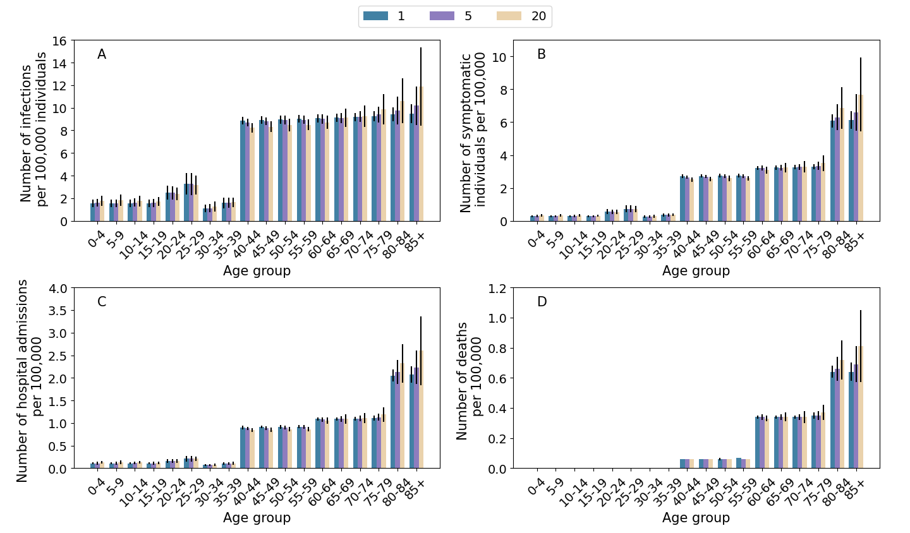
Figure S2: Sensitivity analysis on the initial number of seeds for Model 3. A Number of infections by age group for Model 3 when varying the number of initial seeds; $R_{0}$ is fixed to 1.3 and the simulation is interrupted when cumulative 1,000 infections are reached. B As A, but for symptomatic individuals. C As A, but for hospital admissions. D As A, but for deaths.

Figure S3. Sensitivity analysis on the reproduction number
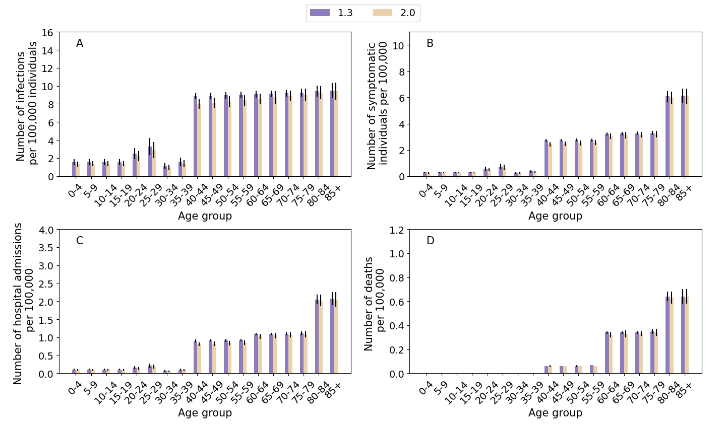
Figure S3: Sensitivity analysis on the reproduction number for Model 3. A Number of infections by age group for Model 3 when varying the reproduction number. The initial number of seeds is set to 1 and the simulation is interrupted when cumulative 1,000 infections are reached. B As A, but for symptomatic individuals. C As A, but for hospital admissions. D As A, but for deaths.

Figure S4. Sensitivity analysis on the cumulative number of infections reached to interrupt the simulation
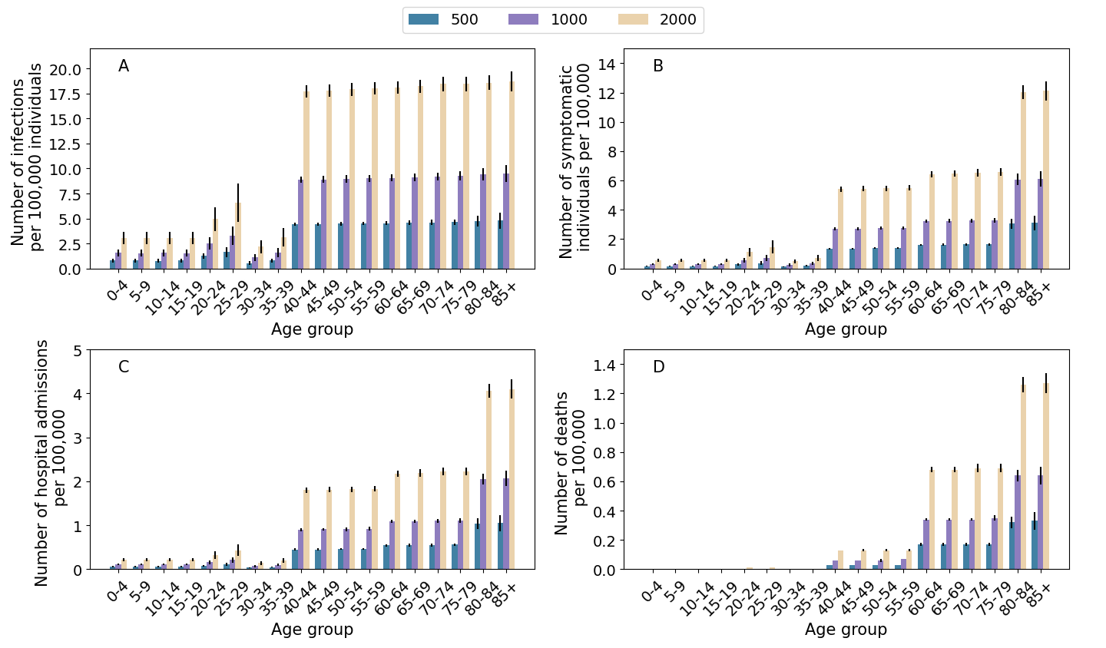
Figure S4: Sensitivity analysis on the cumulative number of infections reached to interrupt simulation for Model 3. A Number of infections by age group for Model 3 when varying the cumulative number of infections reached to interrupt the simulation; $R_{0}$ is fixed to 1.3 and the initial number of seeds is set to 1. B As A, but for symptomatic individuals. C As A, but for hospital admissions. D As A, but for deaths.

References
- Poletti P, Tirani M, Cereda D, et al. Association of age with likelihood of developing symptoms and critical disease among close contacts exposed to patients with confirmed sars-cov-2 infection in italy. JAMA Network Open, 2021, 4(3): e211085-e211085.
- Yang J, Chen X, Deng X, et al. Disease burden and clinical severity of the first pandemic wave of COVID-19 in Wuhan, China. Nature Communications, 2020, 11(1): 1-10.
- National Bureau of Statistics of the People's Republic of China. China Statistical Yearbook 2010. Available in Chinese at http://www.stats.gov.cn/tjsj/ndsj/2010/indexch.htm. (Accessed on Nov. 25, 2021).

