Additional Results

Table S1: Unadjusted and adjusted analysis of factors associated with COVID-19 severity by Day 29 using a stratified logistic regression model on each matched pair

 |  |  |  | Univariate analysis | Multivariate analysis
 |  | N of patients | N of event (%) | Odds Ratio (95% CI) | Odds Ratio (95% CI)
Covid Variant
 | Historical lineages | 650 | 250 (38.5) | 1 | 1
 | VOC Alpha | 650 | 271 (41.7) | 1.15 (0.91 - 1.45) | 1.33 (1.03 - 1.72)
Age, years
 | <60 | 333 | 89 (26.7) | 1 | 1
 | (60 - 64) | 157 | 63 (40.1) | 1.07 (0.37 - 3.07) | 0.94 (0.27 - 3.02)
 | (65 - 69) | 138 | 61 (44.2) | 1.16 (0.27 - 4.99) | 1.33 (0.28 - 6.33)
 | (70 - 74) | 184 | 96 (52.2) | 1.66 (0.33 - 8.17) | 1.77 (0.32 - 9.58)
 | 75+ | 488 | 212 (43.4) | 1.59 (0.25 - 10.17) | 1.78 (0.25 - 12.59)
Body Mass Index (BMI, kg/m²)
 | <18.5 | 42 | 14 (33.3) | 1 | 1
 | (18.5 - 25) | 516 | 179 (34.7) | 1.44 (0 .52 -4.01) | 1.79 (0 .78 -5.61)
 | (25.01 -29.99) | 369 | 143 (38.8) | 1.45 (0.49 -4.23) | 1.93 (0.57 -6.44)
 | 30+ | 373 | 185 (49.6) | 2.65 (0.94 -7.47) | 3.57 (1.10 -11.61)
Heart disease
 | No | 489 | 166 (33.9) | 1 | 1
 | Yes | 811 | 355 (43.8) | 1.23 (0.84 -1.79) | 0.91 (0.59 -1.41)
Chronic lung disease
 | No | 1124 | 433 (38.5) | 1 | 1
 | Yes | 176 | 88 (50) | 1.14 (0.72 -1.81) | 0.79 (0.46 -1.38)
Asthma
 | No | 1232 | 496 (40.3) | 1 | 1
 | Yes | 68 | 25 (36.8) | 1.03 (0.51 -2.06) | 1.07 (0.50 -2.30)
Chronic kidney disease
 | No | 1143 | 442 (38.7) | 1 | 1
 | Yes | 157 | 79 (50.3) | 1.25 (0.78 -2.0) | 0.99 (0.56 -1.74)
Chronic liver disease
 | No | 1267 | 506 (39.9) | 1 | 1
 | Yes | 33 | 15 (45.5) | 1.96 (0.72 -5.36) | 0.67 (0.22 -2.08)
Chronic neurological disease
 | No | 1097 | 430 (39.2) | 1 | 1
 | Yes | 203 | 91 (44.8) | 1.57 (0.99 -2.49) | 0.47 (0.28 -0.80)
Active cancer
 | No | 1167 | 451 (38.6) | 1 | 1
 | Yes | 133 | 70 (52.6) | 1.82 (1.04 -3.16) | 0.44 (0.24 -0.84)
Solid organ or hematopoietic cell transplant
 | No | 1256 | 505 (40.2) | 1 | 1
 | Yes | 44 | 16 (36.4) | 1.11 (0.45 -2.73) | 0.57 (0.20 -1.64)
Autoimmune disease
 | No | 1253 | 499 (39.8) | 1 | 1
 | Yes | 47 | 22 (46.8) | 1.00 (0.40 -2.48) | 1.08 (0.41 -2.85)
HIV Infection
 | No | 1290 | 519 (40.2) | 1 | 1
 | Yes | 10 | 2 (20) | 2.0 (0.18 -22) | 0.41 (0.03 -4.76)
Diabetes
 | No | 921 | 338 (36.7) | 1 | 1
 | Yes | 379 | 183 (48.3) | 1.63 (1.11 -2.39) | 0.70 (0.46 -1.09)
Tabacco
 | No | 994 | 384 (38.6) | 1 | 1
 | Yes | 305 | 137 (44.9) | 1.20 (0.82 -1.77) | 0.83 (0.53 -1.30)
Dexamethasone or other corticosroids
 | No | 252 | 40 (15.9) | 1 | 1
 | Yes | 1048 | 481 (45.9) | 5.22 (2.98 -9.14) | 6.30 (3.37 -11.80)

Table S2: Multivariable analysis of factors associated with mortality by Day 29 using a stratified Cox regression model on each matched pair

 |  |  |  | Multivariate analysis
 |  | N of patients | N of Event | Hazard ratio (95% CI)
Covid Variant
 | Historical lineages | 650 | 112 | 1
 | VOC Alpha | 650 | 130 | 1.21 (0.93 -1.58)
Sex
 | Female | 502 | 91 | 1
 | Male | 798 | 151 | 1.21 (0.92 -1.61)
Age, years
 | <60 | 333 | 20 | 1
 | (60 - 64) | 157 | 15 | 1.17 (0.59 -2.32)
 | (65 - 69) | 138 | 17 | 1.45 (0.75 -2.82)
 | (70 - 74) | 184 | 28 | 1.59 (0.87 -2.89)
 | 75+ | 488 | 162 | 4.85 (2.91 -8.06)
BMI, kg/m²
 | <18.5 | 42 | 11 | 1
 | (18.5 - 25) | 516 | 107 | 0.94 (0.50 - 1.76)
 | (25.01 -29.99) | 369 | 50 | 0.68 (0.35 -1.32)
 | 30+ | 373 | 74 | 1.29 (0.67 -2.48)
Heart disease
 | No | 489 | 50 | 1
 | Yes | 811 | 192 | 1.35 (0.96 -1.89)
Chronic lung disease
 | No | 1124 | 188 | 1
 | Yes | 176 | 54 | 1.72 (1.23 -2.40)
Asthma
 | No | 1232 | 232 | 1
 | Yes | 68 | 10 | 0.55 (0.28 -1.06)
Chronic kidney disease
 | No | 1143 | 187 | 1
 | Yes | 157 | 55 | 1.60 (1.14 -2.24)
Chronic liver disease
 | No | 1267 | 235 | 1
 | Yes | 33 | 7 | 1.04 (0.48 -2.25)
Chronic neurological disease
 | No | 1097 | 176 | 1
 | Yes | 203 | 66 | 1.59 (1.16 -2.16)
Active cancer
 | No | 1167 | 199 | 1
 | Yes | 133 | 43 | 2.1 (1.50 -3.07)
Solid organ or hematopoietic cell transplant
 | No | 1256 | 236 | 1
 | Yes | 44 | 6 | 0.70 (0.30 -1.66)
Autoimmune disease
 | No | 1253 | 232 | 1
 | Yes | 47 | 10 | 1.22 (0.63 -2.36)
HIV Infection
 | No | 1290 | 240 | 1
 | Yes | 10 | 2 | 1.75(0.42 -7.21)
Diabetes
 | No | 921 | 152 | 1
 | Yes | 379 | 90 | 1.13 (0.85 -1.50)
Tabacco
 | No | 994 | 182 | 1
 | Yes | 305 | 60 | 0.94 (0.68 -1.31)

Table S3: Multivariable analysis of factors associated with WHO scale >5 by Day 29 using a stratified Cox regression model on each matched pair

 |  |  |  | Multivariate analysis
 |  | N of patients | N of Event | Hazard ratio (95% CI)
Covid Variant
 | Historical lineages | 650 | 164 | 1
 | VOC Alpha | 650 | 179 | 1.24 (1.00 -1.55)
Sex
 | Female | 502 | 197 | 1
 | Male | 798 | 379 | 1.37 (1.08 -1.74)
Age, years
 | <60 | 333 | 47 | 1
 | (60 - 64) | 157 | 37 | 1.38 (0.88 - 2.15)
 | (65 - 69) | 138 | 33 | 1.23 (0.78 -1.95)
 | (70 - 74) | 184 | 54 | 1.49 (0.98 -2.25)
 | 75+ | 488 | 171 | 2.95(2.05 -4.25)
BMI, kg/m2
 | <18.5 | 42 | 11 | 1
 | (18.5 - 25) | 516 | 122 | 1.11 (0.59 - 2.07)
 | (25.01 -29.99) | 369 | 84 | 1.03 (0.54 -1.95)
 | 30+ | 373 | 246 | 1.69 (0.89 -3.18)
Heart disease
 | No | 489 | 91 | 1
 | Yes | 811 | 251 | 1.16 (0.89 -1.51)
Chronic lung disease
 | No | 1124 | 254 | 1
 | Yes | 176 | 88 | 1.55 (1.15 -2.08)
Asthma
 | No | 1232 | 325 | 1
 | Yes | 68 | 17 | 0.67 (0.40 -1.11)
Chronic kidney disease
 | No | 1143 | 277 | 1
 | Yes | 157 | 65 | 1.27 (0.94 -1.73)
Chronic liver disease
 | No | 1267 | 333 | 1
 | Yes | 33 | 9 | 0.81 (0.41 -1.60)
Chronic neurological disease
 | No | 1097 | 273 | 1
 | Yes | 203 | 69 | 1.45 (1.08 -1.94)
Active cancer
 | No | 1167 | 292 | 1
 | Yes | 133 | 50 | 1.75 (1.27 -2.42)
Solid organ or hematopoietic cell transplant
 | No | 1256 | 328 | 1
 | Yes | 44 | 14 | 1.17 (0.65 -2.10)
Autoimmune disease
 | No | 1253 | 328 | 1
 | Yes | 47 | 14 | 1.08 (0.61 -1.89)
HIV Infection
 | No | 1290 | 340 | 1
 | Yes | 10 | 2 | 1.22 (0.30 -50)
Diabetes
 | No | 921 | 212 | 1
 | Yes | 379 | 130 | 1.18 (0.93 -1.50)
Tabacco
 | No | 994 | 251 | 1
 | Yes | 305 | 91 | 1.05 (0.81 -1.38)

Table S4: Multivariable analysis of factors associated with non-rebreather mask by Day 29 using a stratified Cox regression model on each matched pair

 |  |  |  | Multivariate analysis
 |  | N of patients | N of event | Hazard ratio (95% CI)
Covid Variant
 | Historical lineages | 650 | 177 | 1
 | VOC Alpha | 650 | 208 | 1.20 (0.98 -1.47)
Sex
 | Female | 502 | 149 | 1
 | Male | 798 | 236 | 0.95 (0.76 - 1.17)
Age, years
 | <60 | 333 | 67 | 1
 | (60 - 64) | 157 | 44 | 1.35 (0.91 -1.99)
 | (65 - 69) | 138 | 44 | 1.53 (1.04 -2.26)
 | (70 - 74) | 184 | 73 | 2.07 (1.42 -2.87)
 | 75+ | 488 | 157 | 1.87 (1.35 -2.60)
BMI, kg/m²
 | <18.5 | 42 | 10
 | (18.5 - 25) | 516 | 127 | 1.18 (0.61 -2.27)
 | (25.01 -29.99) | 369 | 109 | 1.57(0.81 -3.05)
 | 30+ | 373 | 139 | 2.19(1.13 -4.24)
Heart disease
 | No | 489 | 126 | 1
 | Yes | 811 | 259 | 1.02(0.80 -1.30)
Chronic lung disease
 | No | 1124 | 327 | 1
 | Yes | 176 | 58 | 1.06 (0.79 -1.43)
Asthma
 | No | 1232 | 496 | 1
 | Yes | 68 | 25 | 0.92 (0.59 -1.45)
Chronic kidney disease
 | No | 1143 | 330 | 1
 | Yes | 157 | 55 | 1.18 (0.86 -1.60)
Chronic liver disease
 | No | 1267 | 376 | 1
 | Yes | 33 | 9 | 0.80 (0.41 -1.57)
Chronic neurological disease
 | No | 1097 | 321 | 1
 | Yes | 203 | 64 | 1.15 (0.86 -1.53)
Active cancer
 | No | 1167 | 333 | 1
 | Yes | 133 | 52 | 1.47 (1.08 -2.00)
Solid organ or hematopoietic cell transplant
 | No | 1256 | 378 | 1
 | Yes | 44 | 7 | 0.54 (0.25 -1.17)
Autoimmune disease
 | No | 1253 | 369 | 1
 | Yes | 47 | 16 | 1.16 (0.69 -1.95)
HIV Infection
 | No | 1290 | 384 | 1
 | Yes | 10 | 1 | 0.42 (0.05 -3.02)
Diabetes
 | No | 921 | 263 | 1
 | Yes | 379 | 122 | 1.04(0.83 -1.31)
Tabacco
 | No | 994 | 286 | 1
 | Yes | 305 | 99 | 1.08 (0.84 -1.38)

Table S5: Multivariable analysis of factors associated with high flow oxygen therapy by day 29 using a stratified Cox regression model on each matched pair

 |  |  |  | Multivariate analysis
 |  | N of patients | N of Event | Hazard ratio (95% CI)
Covid Variant
 | Historical lineages | 650 | 201 | 1
 | VOC Alpha | 650 | 240 | 1.18 (0.98 – 1.40)
Sex
 | Female | 502 | 393 | 1
 | Male | 798 | 658 | 1.12 (0.98 - 1.28)
Age, years
 | <60 | 333 | 269 | 1
 | (60 - 64) | 157 | 128 | 0.87 (0.70 - 1.09)
 | (65 - 69) | 138 | 112 | 0.78 (0.62 -0.98)
 | (70 - 74) | 184 | 145 | 0.79 (0.64 -0.98)
 | 75+ | 488 | 397 | 1.10 (0.92 -1.32)
BMI, kg/m2
 | <18.5 | 42 | 31 | 1
 | (18.5 - 25) | 516 | 414 | 1.14 (0.78 - 1.65)
 | (25.01 -29.99) | 369 | 303 | 1.08 (0.74 -1.58)
 | 30+ | 373 | 303 | 1.01 (0.69 -1.48)
Heart disease
 | No | 489 | 385 | 1
 | Yes | 811 | 666 | 1.07 (0.93 -1.27)
Chronic lung disease
 | No | 1124 | 908 | 1
 | Yes | 176 | 143 | 1.16(0.96 -1.40)
Asthma
 | No | 1232 | 997 | 1
 | Yes | 68 | 54 | 0.94(0.71 -1.24)
Chronic kidney disease
 | No | 1143 | 933 | 1
 | Yes | 157 | 118 | 0.95(0.77 -1.18)
Chronic liver disease
 | No | 1267 | 1024 | 1
 | Yes | 33 | 27 | 0.97(0.66 -1.44)
Chronic neurological disease
 | No | 1097 | 887 | 1
 | Yes | 203 | 164 | 1.09 (0.91 -1.31)
Active cancer
 | No | 1167 | 956 | 1
 | Yes | 133 | 95 | 0.86 (0.69 -1.07)
Solid organ or hematopoietic cell transplant
 | No | 1256 | 1021 | 1
 | Yes | 44 | 30 | 0.64 (0.43 -0.95)
Autoimmune disease
 | No | 1253 | 1014 | 1
 | Yes | 47 | 37 | 0.85 (0.61 -1.19)
HIV Infection
 | No | 1290 | 1043 | 1
 | Yes | 10 | 8 | 0.84 (0.41 -1.70)
Diabetes
 | No | 921 | 743 | 1
 | Yes | 379 | 308 | 0.94 (0.82 -1.09)
Tabacco
 | No | 994 | 800 | 1
 | Yes | 305 | 251 | 0.99 (0.85 -1.16)

Table S6: Multivariable analysis of factors associated with ICU admission by day 29 using a stratified Cox regression model on each matched pair

 |  |  |  | Multivariate analysis
 |  | N of patients | N of Event | Hazard ratio (95% CI)
Covid Variant
 | Historical lineages | 650 | 207 | 1
 | VOC Alpha | 650 | 240 | 1.12 (0.93 -1.36)
Sex
 | Female | 502 | 140 | 1
 | Male | 798 | 300 | 1.48 (1.20 -1.83)
Age, years
 | <60 | 333 | 119 | 1
 | (60 - 64) | 157 | 70 | 1.25 (0.91 - 1.68 )
 | (65 - 69) | 138 | 55 | 1.02 (0.76 -1.49)
 | (70 - 74) | 184 | 87 | 1.49 (1.10 -2.01)
 | 75+ | 488 | 111 | 0.82 (0.61 -1.10)
BMI; kg/m²
 | <18.5 | 42 | 5 | 1
 | (18.5 - 25) | 516 | 121 | 1.57(1.07 - 2.31)
 | (25.01 -29.99) | 369 | 150 | 2.33 (1.62 -3.34)
 | 30+ | 373 | 164 | 2.59 (1.80 -3.72)
Heart disease
 | No | 489 | 165 | 1
 | Yes | 811 | 275 | 1.07 (0.86 -1.34)
Chronic lung disease
 | No | 1124 | 374 | 1
 | Yes | 176 | 66 | 1.38 (1.04 -1.83)
Asthma
 | No | 1232 | 416 | 1
 | Yes | 68 | 24 | 1.00 (0.66 -1.52)
Chronic kidney disease
 | No | 1143 | 397 | 1
 | Yes | 157 | 43 | 0.75 (0.53 -1.06)
Chronic liver disease
 | No | 1267 | 425 | 1
 | Yes | 33 | 15 | 1.21 (0.71 -2.05)
Chronic neurological disease
 | No | 1097 | 406 | 1
 | Yes | 203 | 34 | 0.50 (0.35 -0.73)
Active cancer
 | No | 1167 | 394 | 1
 | Yes | 133 | 46 | 0.92 (0.66 -1.27)
Solid organ or hematopoietic cell transplant
 | No | 1256 | 428 | 1
 | Yes | 44 | 12 | 0.78 (0.42 -1.44)
Autoimmune disease
 | No | 1253 | 414 | 1
 | Yes | 47 | 22 | 1.66 (1.07 -2.57)
HIV Infection
 | No | 1290 | 435 | 1
 | Yes | 10 | 5 | 2(0.91 -5.52)
Diabetes
 | No | 921 | 301 | 1
 | Yes | 379 | 139 | 1.17(0.94 -1.45)
Tabacco
 | No | 994 | 334 | 1
 | Yes | 305 | 106 | 0.80 (0.63 -1.01)

Table S7: Multivariable analysis of factors associated with Mechanical ventilation or ECMO by day 29 using a stratified Cox regression model on each matched pair

 |  |  |  | Multivariate analysis
 |  | N of patients | N of Event | Hazard ratio (95% CI)
Covid Variant
 | Historical lineages | 650 | 108 | 1
 | VOC Alpha | 650 | 107 | 0.96 (0.73 -1.27)
Sex
 | Female | 502 | 145 | 1
 | Male | 798 | 300 | 1.34 (1.09 -1.66)
Age, years
 | <60 | 333 | 133 | 1
 | (60 - 64) | 157 | 77 | 1.23 (0.92 -1.65)
 | (65 - 69) | 138 | 58 | 0.98 (0.71 -1 .35)
 | (70 - 74) | 184 | 86 | 1.36 (1.01 -1.82)
 | 75+ | 488 | 91 | 0.60 (0.44 -0.81)
BMI, kg/m2
 | <18.5 | 42 | 4 | 1
 | (18.5 - 25) | 516 | 122 | 2.77 (1.01 - 7.61)
 | (25.01 -29.99) | 369 | 139 | 3.93 (1.43 -10.80)
 | 30+ | 373 | 180 | 5.27 (1.92 -14.46)
Heart disease
 | No | 489 | 171 | 1
 | Yes | 811 | 274 | 1.09 (0.88 -1.36)
Chronic lung disease
 | No | 1124 | 392 | 1
 | Yes | 176 | 53 | 0.88 (0.65 -1.20)
Asthma
 | No | 1232 | 422 | 1
 | Yes | 68 | 23 | 0.90 (0.58 -1.38)
Chronic kidney disease
 | No | 1143 | 401 | 1
 | Yes | 157 | 44 | 0.90 (0.64 -1.26)
Chronic liver disease
 | No | 1267 | 430 | 1
 | Yes | 33 | 15 | 1.21 (0.71 -2.05)
Chronic neurological disease
 | No | 1097 | 415 | 1
 | Yes | 203 | 30 | 0.47 (0.32 -0.70)
Active cancer
 | No | 1167 | 405 | 1
 | Yes | 133 | 40 | 0.85 (0.61 -1.20)
Solid organ or hematopoietic cell transplant
 | No | 1256 | 433 | 1
 | Yes | 44 | 12 | 0.69 (0.37 -1.30)
Autoimmune disease
 | No | 1253 | 418 | 1
 | Yes | 47 | 27 | 2.00 (1.33 -3.00)
HIV Infection
 | No | 1290 | 441 | 1
 | Yes | 10 | 5 | 1.46 (0.53 -4.00)
Diabetes
 | No | 921 | 305 | 1
 | Yes | 379 | 140 | 1.16 (0.93 -1.40)
Tabacco
 | No | 994 | 322 | 1
 | Yes | 305 | 123 | 1.17 (0.89 -1.39)

Table S8: Multivariable analysis of factors associated with time from symptoms onset to hospitalization using a stratified Cox regression model on each matched pair

 |  |  |  | Multivariate analysis
 |  | N of patients | N of events | Hazard Ratio (95% CI)
Covid Variant
 | Historical lineages | 650 | 650 | 1
Hazard Ratio (95% CI) | VOC Alpha | 650 | 650 | 0.96 (0.96 -1.08)
Sex
 | Female | 502 | 502 | 1
Hazard Ratio (95% CI) | Male | 798 | 798 | 1.01 (0.89-1.13)
Age, years
 | <60 | 333 | 333 | 1
 | (60 - 64) | 157 | 157 | 1.13 (0.93- 1.38)
 | (65 - 69) | 138 | 138 | 0.93 (0.75-1.14)
 | (70 - 74) | 184 | 184 | 1.09 (0.89-1.32)
 | 75+ | 488 | 488 | 1.44 (1.22-1.70)
BMI, kg/m2
 | <18.5 | 42 | 42 | 1
 | (18.5 - 25) | 516 | 516 | 0.67 (0.49- 0.93)
 | (25.01 -29.99) | 369 | 369 | 0.67 (0.48-0.93)
 | 30+ | 373 | 373 | 0.76 (0.55-1.07)
Heart disease
 | No | 489 | 489 | 1
 | Yes | 811 | 811 | 0.98 (0.86-1.12)
Chronic lung disease
 | No | 1124 | 1124 | 1
 | Yes | 176 | 176 | 1.23 (1.03-1.45)
Asthma
 | No | 1232 | 1232 | 1
 | Yes | 68 | 62 | 0.87 (0.68-1.12)
Chronic kidney disease
 | No | 1143 | 1143 | 1
 | Yes | 157 | 157 | 1.35 (1.12-1.63)
Chronic liver disease
 | No | 1267 | 1267 | 1
 | Yes | 33 | 33 | 0.78 (0.55-1.12)
Chronic neurological disease
 | No | 1097 | 1097 | 1
 | Yes | 203 | 203 | 1.44 (1.22-1.70)
Active cancer
 | No | 1167 | 1167 | 1
 | Yes | 133 | 133 | 1.18 (0.82-1.43)
Solid organ or hematopoietic cell transplant
 | No | 1256 | 1256 | 1
 | Yes | 44 | 44 | 1.15 (0.82-1.61)
Autoimmune disease
 | No | 1253 | 1253 | 1
 | Yes | 47 | 47 | 0.85 (0.62-1.15)
HIV Infection
 | No | 1290 | 1290 | 1
 | Yes | 10 | 10 | 0.96 (0.48-1.88)
Diabetes
 | No | 921 | 921 | 1
 | Yes | 379 | 379 | 1.00 (0.87-1.14)
Tabacco
 | No | 994 | 994 | 1
 | Yes | 305 | 305 | 1.04 (0.91-1.20)

Table S9: Multivariable analysis of factors associated with duration on hospitalization using a stratified Cox regression model on each matched pair

 |  |  |  | Multivariate analysis
Variable |  | N of patients | N of events | Hazard ratio (95% CI)
Covid Variant
 | Historical lineages | 649 | 349 | 1
 | VOC Alpha | 649 | 354 | 0.95 (0.81-1.10)
Sex
 | Female | 501 | 373 | 1
 | Male | 797 | 425 | 0.88 (0.75-1.03)
Age, years
 | <60 | 332 | 119 | 1
 | (60 - 64) | 157 | 70 | 0.64 (0.50- 0.82)
 | (65 - 69) | 138 | 55 | 0.59 (0.46-0.77)
 | (70 - 74) | 184 | 87 | 0.45 (0.35-0.59)
 | 75+ | 487 | 111 | 0.42 (0.34-0.53)
BMI, kg/m3
 | <18.5 | 41 | 16 | 1
 | (18.5 - 25) | 516 | 281 | 1.50 (0.90- 2.50)
 | (25.01 -29.99) | 369 | 224 | 1.52 (0.90-2.55)
 | 30+ | 372 | 182 | 0.97 (0.57-1.64)
Heart disease
 | No | 488 | 310 | 1
 | Yes | 810 | 393 | 1.06 (0.89-1.27)
Chronic lung disease
 | No | 1123 | 628 | 1
 | Yes | 175 | 75 | 0.95 (0.74-1.23)
Asthma
 | No | 1230 | 664 | 1
 | Yes | 68 | 39 | 1.01 (0.72-1.41)
Chronic kidney disease
 | No | 1143 | 645 | 1
 | Yes | 155 | 58 | 0.71 (0.52-0.96)
Chronic liver disease
 | No | 1265 | 685 | 1
 | Yes | 33 | 18 | 0.93 (0.57-1.50)
Chronic neurological disease
 | No | 1097 | 623 | 1
 | Yes | 203 | 80 | 0.76 (0.59-0.97)
Active cancer
 | No | 1165 | 653 | 1
 | Yes | 133 | 50 | 0.65 (0.48-0.88)
Solid organ or hematopoietic cell transplant
 | No | 1254 | 677 | 1
 | Yes | 44 | 26 | 0.85 (0.55-1.31)
Autoimmune disease
 | No | 1253 | 687 | 1
 | Yes | 45 | 16 | 0.43 (0.26-0.71)
HIV Infection
 | No | 1288 | 698 | 1
 | Yes | 10 | 5 | 0.63 (0.26-1.55)
Diabetes
 | No | 920 | 527 | 1
 | Yes | 379 | 176 | 0.81 (0.67-0.97)
Tabacco
 | No | 994 | 553 | 1
 | Yes | 304 | 150 | 0.80 (0.66-0.97)

Table S10: Multivariable analysis of factors associated with readmission using a stratified Cox regression model on each matched pair

 |  |  |  | Multivariate analysis
 |  | N of patients | N of events | Hazard Ratio (95% CI)
Covid Variant
 | Historical lineages | 428 | 28 | 1
 | VOC Alpha | 428 | 19 | 0.78 (0.42 -1.42)
Sex
 | Female | 336 | 22 | 1
Hazard Ratio (95% CI) | Male | 520 | 25 | 0.54 (0.27-1.06)
Age, years
 | <60 | 268 | 14 | 1
 | (60 - 64) | 103 | 6 | 1.07 (0.38- 2.99)
 | (65 - 69) | 89 | 4 | 0.91 (0.27-2.98)
 | (70 - 74) | 108 | 6 | 1.29 (0.44-3.76)
 | 75+ | 288 | 17 | 1.06 (0.41-2.74)
BMI, kg/m2
 | <18.5 | 150 | 6 | 1
 | (18.5 - 25) | 243 | 23 | 1.87 (0.67- 5.16)
 | (25.01 -29.99) | 261 | 10 | 0.98 (0.31-3.02)
 | 30+ | 202 | 8 | 1.24 (0.40-3.83)
Heart disease
 | No | 363 | 16 | 1
 | Yes | 490 | 31 | 1.01 (0.46-2.20)
Chronic lung disease
 | No | 755 | 45 | 1
 | Yes | 98 | 2 | 2.38 (1.04-5.43)
Asthma
 | No | 805 | 38 | 1
 | Yes | 48 | 10 | 1.04 (0.24-4.48)
Chronic kidney disease
 | No | 778 | 35 | 1
 | Yes | 75 | 12 | 2.38 (1.04-5.43)
Chronic liver disease
 | No | 833 | 46 | 1
 | Yes | 20 | 1 | 4.13 (1.71-9.97)
Chronic neurological disease
 | No | 738 | 37 | 1
 | Yes | 115 | 10 | 1.92 (0.83-4.40)
Active cancer
 | No | 787 | 44 | 1
 | Yes | 66 | 3 | 0.93 (0.27-3.17)
Solid organ or hematopoietic cell transplant
 | No | 827 | 40 | 1
 | Yes | 26 | 7 | 3.25 (1.28-8.24)
Autoimmune disease
 | No | 829 | 45 | 1
 | Yes | 24 | 2 | 2.11 (0.48-9.18)
HIV Infection
 | No | 848 | 47 | 1
 | Yes | 5 | 0 | NA
Diabetes
 | No | 636 | 35 | 1
 | Yes | 217 | 11 | 0.59 (0.27-1.30)
Tabacco
 | No | 672 | 38 | 1
 | Yes | 181 | 9 | 0.87 (0.35-2.11)

Figure S1: Kaplan-Meir plot for all cause of mortality

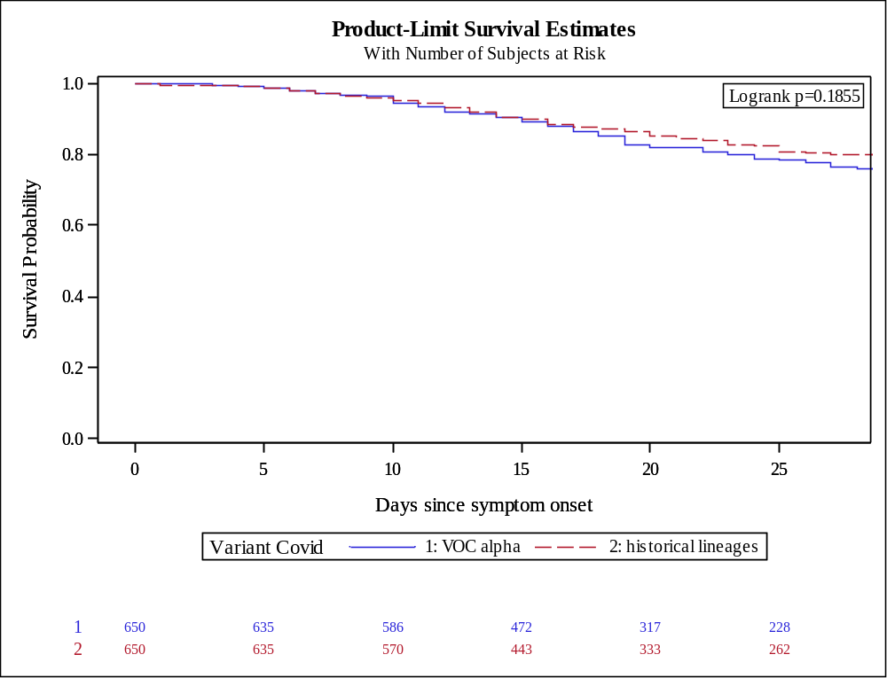

Figure S2: Kaplan-Meir plot for WHO scale >5

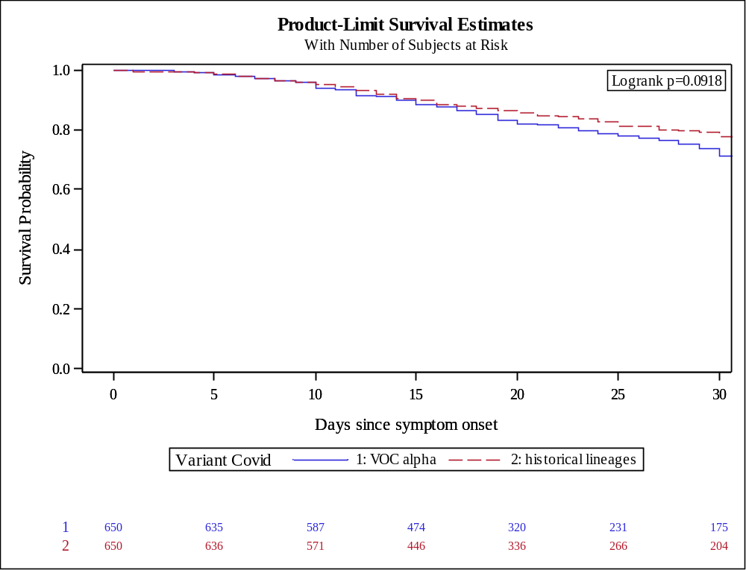

Figure S3: Kaplan-Meir plot for non-rebreather mask

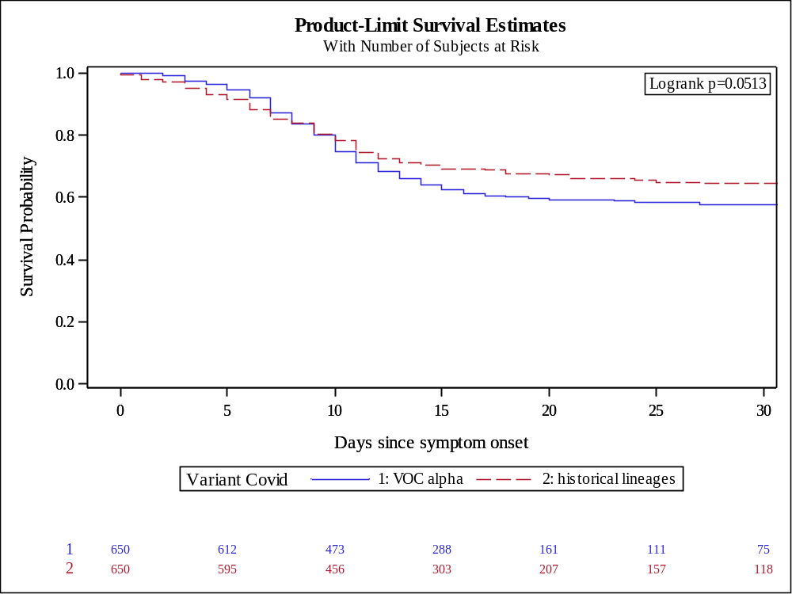

Figure S4: Kaplan-Meir plot for high flow oxygen therapy

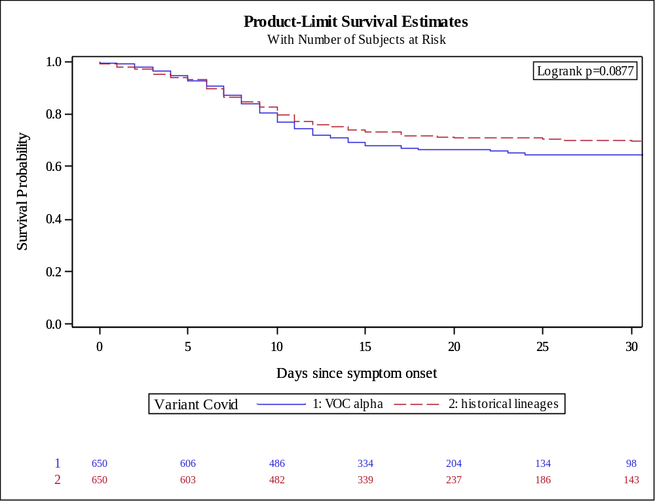

Figure S5: Kaplan-Meir plot for intensive care admission

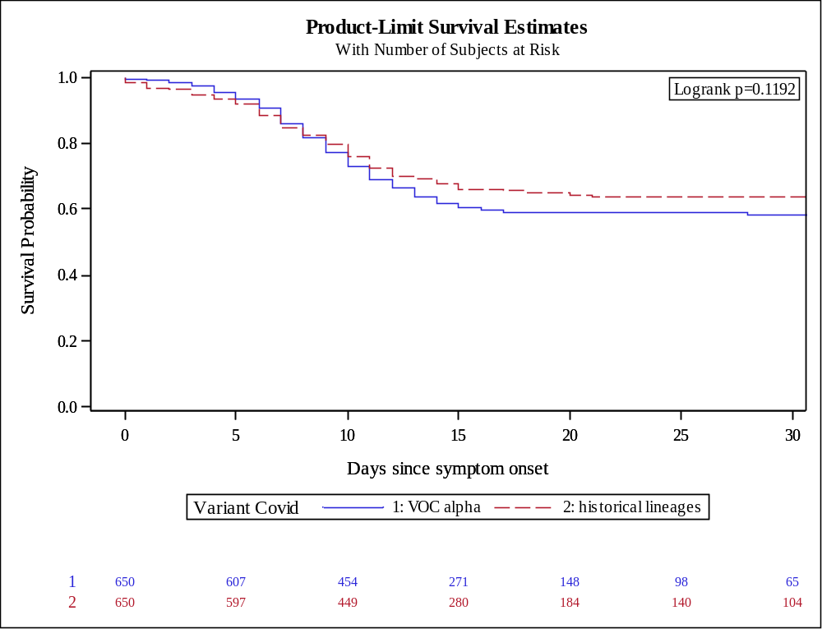

Figure S6: Kaplan-Meir plot for Mechanical ventilation or ECMO

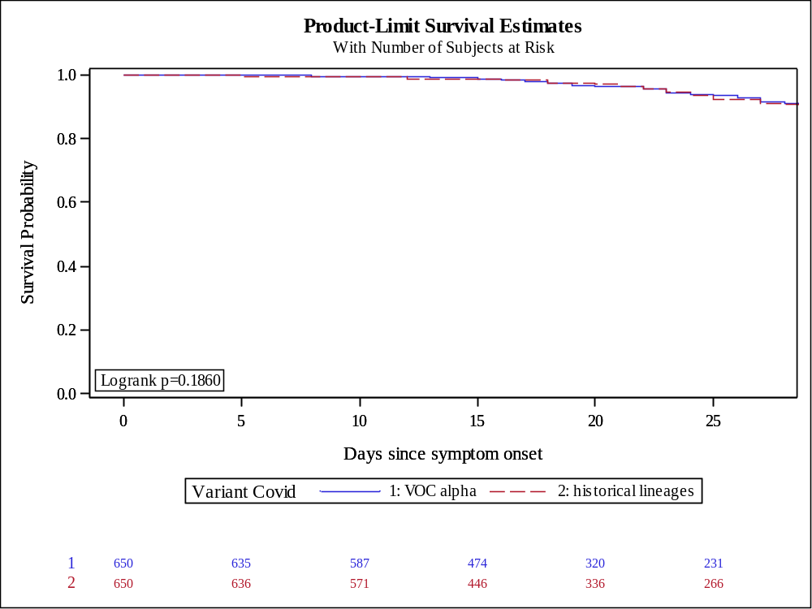

Figure S7: Kaplan-Meir plot for hospitalization (time from symptoms onset to hospitalization)

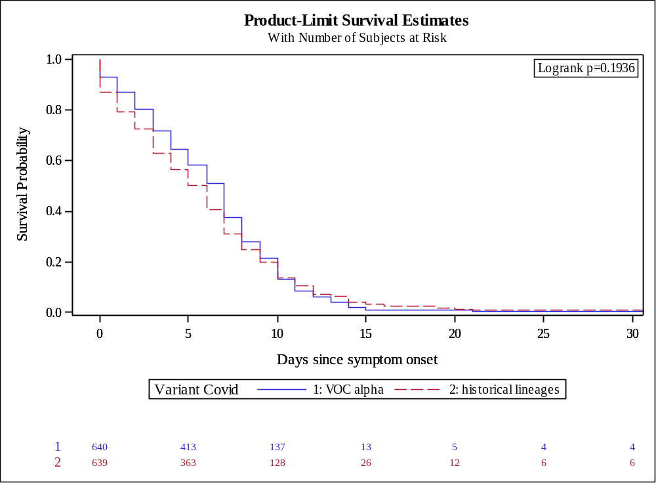

Figure S8: Kaplan-Meir plot for hospital discharge (duration on hospitalization)

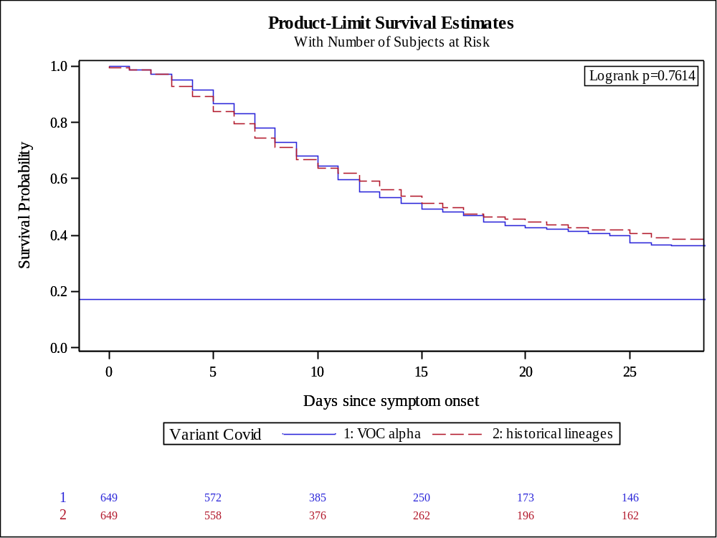

Figure S9: Kaplan-Meir plot for readmission

