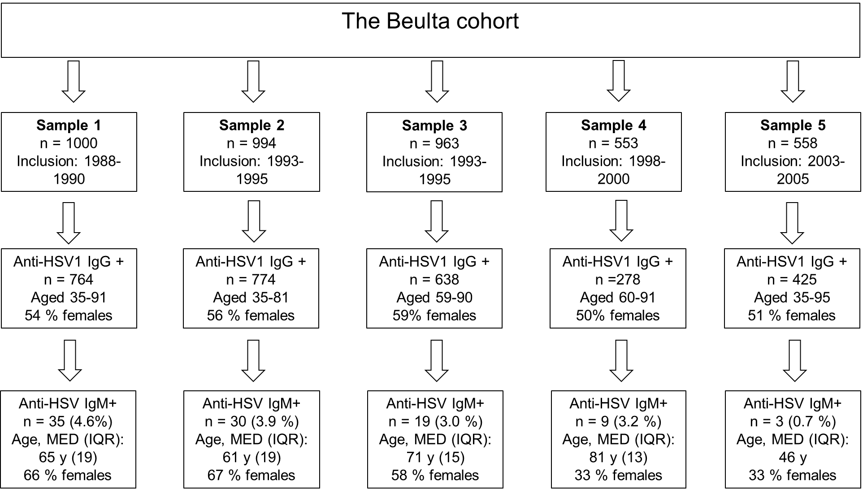
Flow chart of the Betula cohort and anti-HSV IgM seropositivity in the different samples.

MED: median
IQR: interquartile range (IQR)

