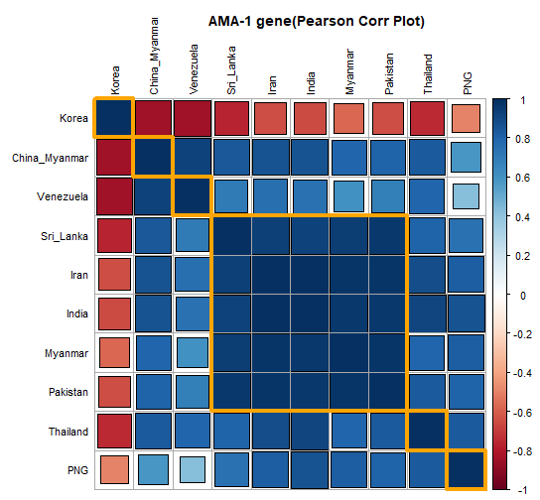
Figure S3: Pearson correlation plot of KP and global pvama-1 samples based on pairwise Fst values. The plot shows clustering and correlation between the groups in hierarchical order. The dark brackets and large sizes depict the minimum genetic distinction and high correlation.

