Additional file 3: Reported COVID-19 Inoculation Deaths and Injuries in Social Circles*
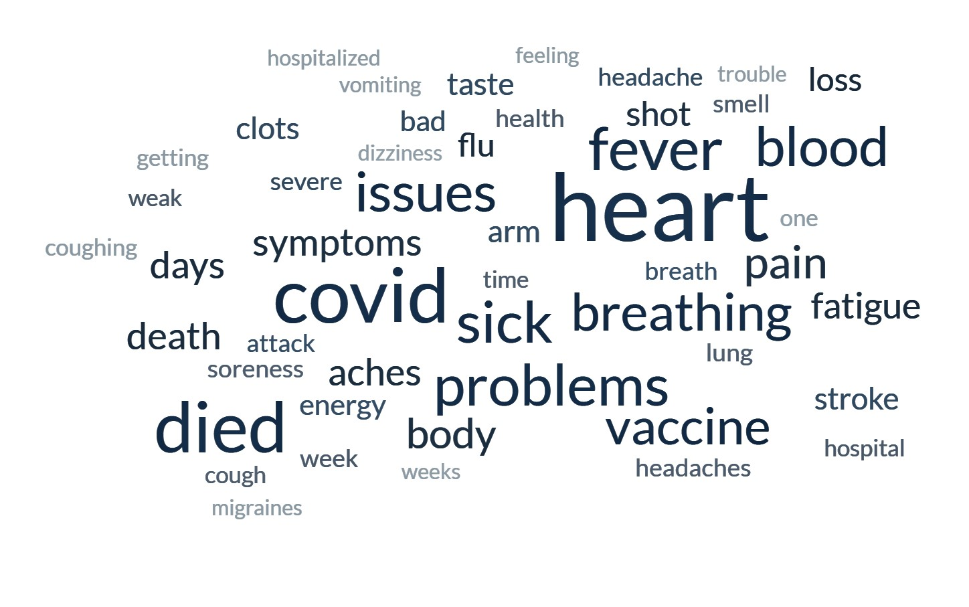

Comments Provided by Respondents for the Following Question: Of the people you know who experienced a health problem after being vaccinated, think about the one you know BEST. Please describe the health condition experienced by that person.

These comments are intended to be provided as a separate linked document in the final published article.

Severe body aches
Heart issues requiring surgery
Our daughter, her whole body shut down after 2nd shot. If her brother were not there she would not have survived
Chills, feeling rough, body aches, no energy, no appetite, weak.
Acute inflammation
High blood pressure.
She died don't know the health issues she had from it
Memory loss
Heart attack when he had no heart problems at all before it. He died from the heart attack.
For the day felt like he had a strong flu
COVID
Heart problems
Got a stroke
My coworker has had to go on disability because she started experiencing continuous migraines the day after receiving the vaccine. She had never had one before.
Headache, cough
Fatigue
They got COVID
Still caught covid and got sick
Covid like symptoms shortness of breath fever body aches, etc.
Comatose after heart attack
Stroke, more heart issues, blood clots,
She had a stroke.
Death
The person got a long rash on her leg that does not go away it looks like shingles but it from the covid vaccine she had introduce in her
Close to hospitalization
My little cousin had Coronavirus
Had to be admitted into the hospital for treatment. Had a temperature and inability to build up oxygen levels until put onto the hospital oxygen system
Sick and lethargic
Arthritis, blood disorder, acne, and heart burn
Died
Fatigue and general malaise
Pain
Lung problem
Covid pneumonia sepsis after booster
Fever chills
Poor energy, achiness
Higher blood pressure, higher pulse, and vertigo.
I guess know they caught COVID-19 again and this time it had them down bad sick
They were vomiting terribly and had awful fever
Heart problems
Fever
Sleepiness, loss of appetite
He died from the shot
Blood clots, circulation problems
They had experienced a blood clot reaction with the third dose.
Fatigue and breathing issues
My grandma's heart stopped 2 days after she got the vaccine.
Flu-like
Breathing problems
Severe symptoms after both shots. Sick for 4 days each time.
Extreme side effects
Hair loss, migraine
Weakened immune system
Cancer retuned in his body spread all over. Died!
They passed away from covid
Decreased lung capacity
Fatigue and 2 of them caught covid within a month of vaccination
Sore muscles
Just like a flu
Stomachache, nausea, fatigue, loss of appetite, loss of smell
Pain arm
Having seizures
Breathing
Lung problems
They got autism
Troubled breathing
My sister started having heavy periods after each covid vaccine
Sepsis
Their arm was sore
Coughing and headaches
Blood clots
Had a shingles like rash all over her face, on both sides not just one. This happened March 2021. The doctors said it was in fact from the vaccine, and to this day it hasn’t been cured. Mind you, she only took the vaccine to return to in person work. She didn’t want to, other than that.
Heart palpitations
Heart issues
Their pre-existing condition was triggered by the vaccine.
Death
This person’s health is going downhill since the shot.
They were in poor health
The only health condition experience was my arm was kind of swollen.
Died
Respiratory
She had a stroke within days of # 2 Moderna vaccine. She has to use a walker and has speech issues. She was in her 40’s. She is a registered nurse.
Hospitalized for three days with breathing and heart issues. He was required to take the shot to participate in the college world series.
Got Covid but only sniffles & cough
Shortness of breath
Alzheimer’s
My friend with no preexisting heart condition died of a heart failure after the second dose.
One was sick in bed a week delirious and unable to get up eat or anything (90). The other had vaccine and that evening experienced chest pain went to ER died with "stroke" (42)
Severe heart issues. 1 hour after injection my 22-year old friend had a massive heart attack and has been hospitalized for 7 months. Was very healthy and athletic before that shot
Heart issues
Heart issues
Blood clotting causing loss of limb
Death
On several medications she didn't take before for heart and breathing problems
COVID-19
They were sick for over 2 months. Weak, could not hardly breathe.
They had headaches
Heart problems
Fever and cough.
Craps
Aching, soreness
They all experienced it before the vaccines had been available.
Breathing issues are the hardest to cope with
Shaking, muscle spasms, and headache
I don't know a lot of details, but fever, achy feeling and dizziness were mentioned as well as sluggishness. Fortunately, none were hospitalized
Arm in pain 3 days
Swollen arms
Memory loss
Contracted cov19 after the vaccine
Body aches running nose loss of appetite
Temporary psychosis that required sedation at a mental hospital.
The shot made it worse. The lose energy and the end result was death. The shot doesn't work if it did then people would not be able to get covid.
The vaccine made them sick for a few months and even after getting better they were still kind of sick
Throwing up. Fever. Headache
Migraine and dizziness
They had nerve problems in their legs and they were weak
Migraines that never seem to go away when they almost never had one before.
Just pain: muscle pain
After getting the vaccine they started having seizures about 2 months after receiving the vaccine and never had any problems until they received the vaccine
They were bed ridden for a week with the biggest problem trying to breath with extreme fatigue
Her immune system attacked her kidneys
Fever chills aches for about 24 hours
Catches
Health problems
They died
Significant pain that was not there before
Blood clots
My great grandmother got sick after she got the shot
Skin issues
Nausea, headache
Felt like they had fever and their arm was very sore.
Pain and swelling in the arm that was injected. Also stomach pains
He had chest problems hard for him to breath and he seems his other skills are slower
Death
My daughter was ill enough to be bedridden after the first and second Moderna vaccine. It only lasted about 12 hours though.
Hospitalized and on a ventilator for 3 days.
In hospital but was out in 3 weeks
They had dizziness. Trouble with vision
Got COVID 19 and had to be hospitalized
Vomiting steady soreness
Got really sick and all most died because it is poison
They had headaches felt feverish their injection was swollen
Experience more body aches
Redness, soreness, lymphadenopathy, myalgias, fever, and headache within hours of getting booster.
Health, confusion is really bad
Getting COVID
Nausea. Heart issues high bp hard to move around
Trouble breathing
They just had a very bad flu like cold
A member of my church died from blood clot surgery less than a week after having a covid vaccine in the hospital during recovery
Vomiting, dizziness, ringing in ears for approximately 3 months
Flu like symptoms and a severe cold
They almost died
They received the vaccine and after they immediately started having health issues with headaches and shortness of breath and their immune system was compromised.
Cousin 47-stroke Cousin- blood clots Friend-death Aunt- death
Loss of taste
Both people got Covid shortly after receiving vaccine.
He died after 5 weeks, he was a diabetic and his kidneys shut down after getting COVID 15 days after vaccine
Two of our children, both nurses, suffered intense flu like symptoms
Heart problems
Got the vaccine shot and it went against the body n he’s died
Death
They experienced a mild heart attack
Bruising and lung
Numbness on side of injection
They couldn't breathe for a minute and was rushed to the hospital
Blood clot
They got covid
Two months of dizziness, vertigo, anxiety, terrible sleep
Death from a heart attack after vaccination by a few weeks.
Lack of taste
Coughing fever
It was severe but so far cannot tell if it’s lasting or not.
ICU. Then a deceased.
Ill
The same person experienced fever and extreme fatigue.
Issues with their heart
Died
No taste or small and some breathing problems
Felt like a case of the flu
Heart attack
Death
Difficulty breaking, constant coughing and trouble and breathing with fever
Soreness, short of breath, fever, body aches
Close friend began having cardiac issues after vaccination.
Anaphylactic shock twice. Nearly killed my mother.
Neurological damage and a spontaneous pneumothorax
Death
Death
Weakens immune system
Stiff neck and sickness flu symptoms and time off work and school
Hemoratic stroke
Not good for health
Sore and body aches
Flu symptoms for up to a full week
It made them really light-headed and passed out
Blood clots.
They started to hemorrhage and almost lost baby
Heart conditions
My father, low energy and a significant change in his health declining. Still has a rough time breathing and now uses a cpap machine.
Went to hospital with pneumonia then blood clots in legs, can walk but not far and weak.
Death
Only vaccine side effects
Scary
My cousin had an allergic reaction to the shot
My brother because he was allergic
Menstrual cycles off drastically, memory loss, post-nasal drip, prone to sinus infections
It was bad, sad and I was so sad for her
They began to have extreme head aches and stomach aches. They were extremely drowsy and weak.
Could not taste or smell things
Depression, anxiety
Loss of limbs due to receiving the original covid Vaccine...
Trouble breathing
Couldn't taste
My mother’s back started hurting and now she has on again off again back problems and she’s young she’s in her late 30s.
They died
Spots on their face and body weakness
They got sick and got covid directly after getting the vaccine.
They still can’t walk without catching their breath
Migraines
Asthma
No illness, just bad coughing
Neurological issues
They was sick for a couple of days with a swollen arm
Joint paint for months
Breathing and constant pain in arm. Constantly getting migraines
Heart and lung issues
Headaches or feeling nauseous
Horrible
They got covid 19
Throwing up
Seizure, hospitalization, life has been altered. Partially paralyzed
Myocarditis
My uncle had lung problems
They were quite gassy
They went into a cardiac arrest and passed away
Very sick
Never got over covid
They had flu like symptoms- fever, nausea, diarrhea. Pain at injection site. Tiredness. Headache
Paralyzed, waist down
She had gotten cold quicker and for three days a runny nose.
Bad breathing
Tired
Long hauler
They had the worst week/month I felt bad for them
Mini stroke
Heart palpitations Tachycardia
Illness
I know nothing more than that of the scaling skin condition
He was as ill for about 10 days
Soreness
It was horrible
Headaches, stomach pain, arms sore
Paralyzed him
It affected their energy and breathing even after they supposedly got better.
Flu like symptoms
They experience body aches, fever severe headaches low energy
Sick
The mother of friend she was vaccinated and the next day she died
She lost her baby
Very bad and sick
His heart was hearting
Healthy
Coughs
Died
One died, one had a heart attack and one had a blood clot
She had migraines and confusion about everyday things like time, if she did something she was supposed to or forgot about it…she still has confusion at times
Extreme fatigue, fever, body aches and pains, respiratory issues
Body aches, no smell or taste
Lung problems or sinuses problem as a detect result of weather changes
Developed COVID-19 sometime after receiving the vaccine
Hospitalized for a week
Death with organ failure
They got covid after taking the vaccine and have had ongoing symptoms
They died
They died
Side effects
Dizziness—vision problems
The person I know vomited and had serious migraines for about a week after both the second and third doses. Mild temperature of about 100.1
Death
She can no longer smell
Chills and fever and lots of pain
Had an allergic reaction.
Bell’s palsy
Sick
Severe cough and hard to breath
Teenagers developed heart problems
Aches and pains as well as lung issues
They had some reactions
Cough trouble breathing
The lack of smell and taste
Not being able to breathe and being extremely sick overall.
They died
Had flu like symptoms for weeks
Lack of energy, and general feeling of something wasn't right
Horrible they died
The person had really bad heart problems
Swollen legs
No vomiting
Elevated heart issues, high blood pressure, previous conditions come back, death.
Throat closed
It was horrible
Numbness in parts of body
A lot of coughing and chest pains
They said they felt weaker and less efficient in working on things
Died from covid
Struggling to get up after you been vaccinated
Breathing problems
Died
Breathe problem
She has not felt the same as she did before the shot. She has most days now not feeling good and don’t have as much energy as she had before.
They died.
They were sick a very long time. They found out they had an allergic reaction
Pneumonia, dehydration
Blood pressure issues and kidney issues and more issues
Caught pneumonia
They were sick for several days with flu like symptoms
No fever, sniffles, or coughing before the shot. Multiple symptoms after.
Chronic headache
Cough
Ended up dying from a reaction to the drug which caused a major heart attack
Experience soreness and pain and fatigue along with migraines for at least three days and she had to rest and was exhausted drained of energy could not continue her door dash delivery
They got pneumonia after the first shot. They got well and got the second shot and got pneumonia again and died.
Enlarged heart
Their asthma got worse. More sinus infections
Enlarged heart
Headaches
Got sick day after shot. Was in coma. Breathing difficulties, racing heart, fatigue
Died
Rash and a case of hives.
Fever
They lost their sense of smell and taste. Also know someone who got extremely sick after receiving the vaccine and they had to be hospitalized.
Hard time breathing
Tired and sleepy after shot
Blood clots
Heart problems breathing problems
One of them lost her life. The other got sick and got over then got sick 2 times after.
She got the Moderna Vaccine, and it gave her COVID-like symptoms for 3 or 4 days before it went away.
Chest pain with cough, sinus problems, Fatigue, sleepy more than 12 hrs a day, body cramps, weak muscles, headache, fever, sores in mouth and throat. Bruised easily. Major body aches and pain, stiffness.
Developed covid and died
They ran a fever. Shaking uncontrollably and jerking. Vomiting and soreness in muscles. Aches and pains
Individual experienced a mild stroke from excessive blood clotting
Heart palpitations
They ended up getting covid right after the vaccinations and lost their sense of taste
The felt weak and fatigue for days and the heartbeat was fast
Got covid
Mostly flu like symptoms and fatigue
Blood clots and suffered a stroke
Harder to breathe, have no energy feverish
Just sick for 2 weeks
Died
Heart condition. New conditions never had previous issues. One passed away
Heart failure
They got it really bad
Soreness, problems breathing sleepiness, etc.
She had shivers after the vaccine
Rash heart problems breathing problem
Had a stroke 3 weeks later
Weak, delirious
Fatigue and headaches
Had a massive heart attack.
They developed covid
Blood clots and heart problems
Blood clots
Chills
High blood pressure seizures
Made us all super sick for days.
We're hospitalized with various issues
Fever
Can’t eat certain things
Vision and death
Depression digestion severe fatigue and asthma
Painful
Drug reaction from change in prescription.
High fever, weakness
High fever, coughing
Blood clots
Soreness in arm, vomiting
He did have the virus he through, he was coughing
Lung and nervous system shut down
Fever and chest pain
All standard covid symptoms
Died
Lost their taste of smell and taste
Their health dropped drastically, and they are still not better.
Heart problems & having to be on a heart monitor for a week.
Headaches.
She got covid and ended up in the hospital for 4 days.
He contracted covid 3 times after his vacations and still experiences major body pain and weakness
My sister had to be rushed to the emergency room
They got sick with all symptoms of COVID 19 eventually recovered
After getting the shot he got sick with covid. He can't walk without assistance.
They have covid
He can still feel the injection in his arm and once in a while his arm goes completely numb. He also gets rapid beating heart beats off and on throughout the week that he has never had before
Whooping cough
Stroke
Severe vomiting, diarrhea, and dizziness
They were sore for about 2 weeks and couldn’t move after lying down for a long time.
Chills and fever
Aching all over
Loss of taste, smell
Extremely sick for almost a month. Caught covid real bad. Has breathing problems and got put on a machine
Breathing trouble and ventilator
COVID 19
Heart
Pain and swelling in arm
Loss of sense of smell
The health was having trouble breathing
Energy
Within after hours of being vaccinations, she became super sick fever etc. It took her days to stop feeling like pneumonia was not in her lungs.
Bell’s palsy
Made them very tired and weak
Smallpox
My mom passed two weeks after receiving the vaccine. (This event was originally reported under the lasting COVID-19 illness issues.)

