Additional File 3. Supplemental Figures

Association of Statin Use with Outcomes of Patients Admitted with COVID-19: An Analysis of Electronic Health Records using Superlearner

Adovich S. Rivera MD*^{1,2}, Omar Al-Heeti MD*³, Lucia C. Petito PhD⁴, Mathew J. Feinstein MD MS^{4,6}, Chad J. Achenbach MD, MPH^{3,4,5}, Janna Williams MD³, Babafemi Taiwo MBBS^{3,5}

¹Institute for Public Health and Management, Feinberg School of Medicine, Chicago, IL, 60611
2Department of Research and Evaluation, Kaiser Permanente Southern California, Pasadena, CA, 91101
³Department of Medicine, Division of Infectious Diseases, Northwestern University Feinberg School of Medicine, Chicago, IL 60611
⁴Department of Preventive Medicine, Division of Biostatistics, Feinberg School of Medicine, Chicago, IL, 60611
⁵Havey Institute for Global Health, Northwestern University Feinberg School of Medicine, Chicago, IL 606011
⁶Department of Medicine, Division of Cardiology, Feinberg School of Medicine, Chicago, IL, 60611
^{*co-first author}

List of Supplemental Figures
Figure S1. Love plots for covariate balance using different weighting methods with baseline variables, Northwestern Medical Group, March 2020-September 2022.
Figure S2. Love plots for covariate balance using different weighting methods with baseline and site variables, Northwestern Medical Group, March 2020-September 2022.
Figure S3. Love plots for covariate balance using different weighting methods with baseline, site and clinical variables, Northwestern Medical Group, March 2020-September 2022.

Figure S1. Love plots for covariate balance using different weighting methods with baseline variables, Northwestern Medical Group, March 2020-September 2022.
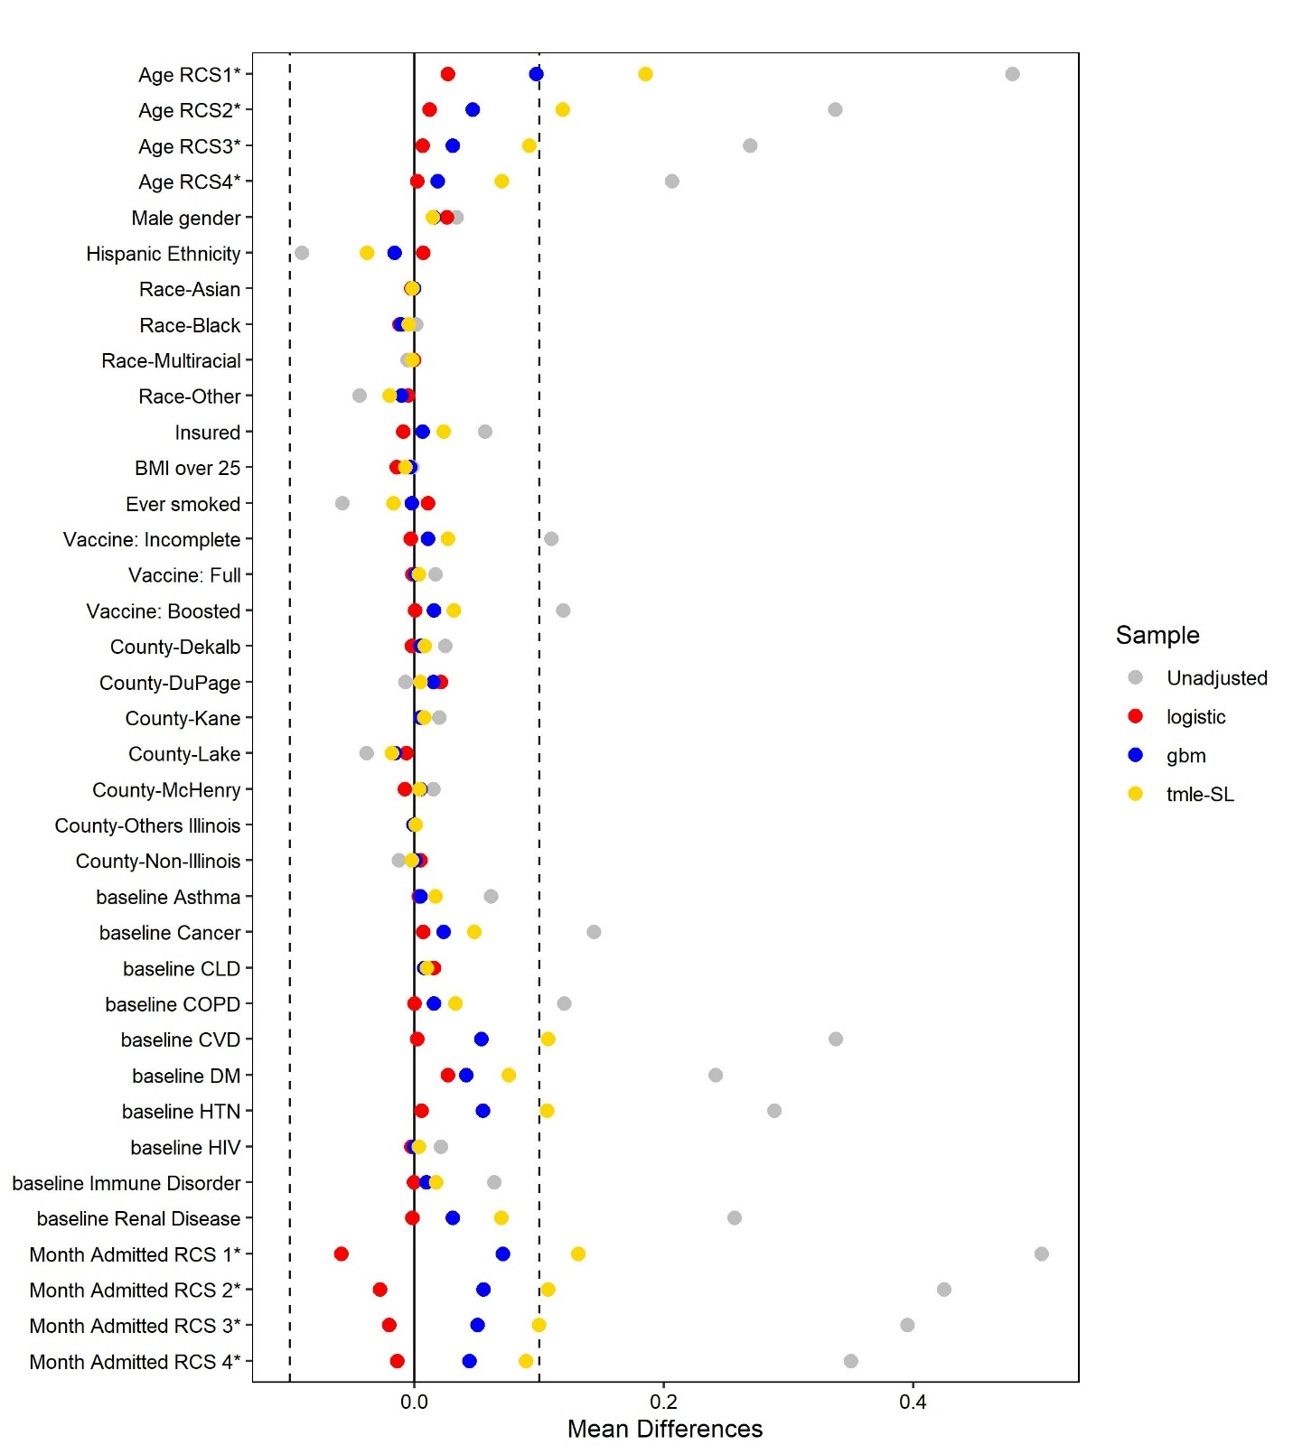
Note: * - standardized mean differences. Unadjusted – no weighting applied to calculated differences. logistic – used weights derived from a logistic regression model. gbm – weights derived from the a gradient boosted model. tmle-SL – weights obtained from the targeted maximum likelihood estimation object with super learner. BMI – body mass index, CLD – chronic liver disease, COPD – chronic obstructive pulmonary disease, CVD – cardiovascular disease, DM – diabetes mellitus, HTN – hypertension, HIV – human immunodeficiency virus, RCS – restricted cubic spline. Multiracial individuals are people who report more than two categories (e.g., Asian and Black), Other races include American Indian, Alaska Native, Native Hawaiian, Pacific-Islander, Guamanian, and Chamorro or chose other or none of the above. Other Illinois counties include all other counties not listed in the figure.

Figure S2. Love plots for covariate balance using different weighting methods with baseline and site variables, Northwestern Medical Group, March 2020-September 2022.
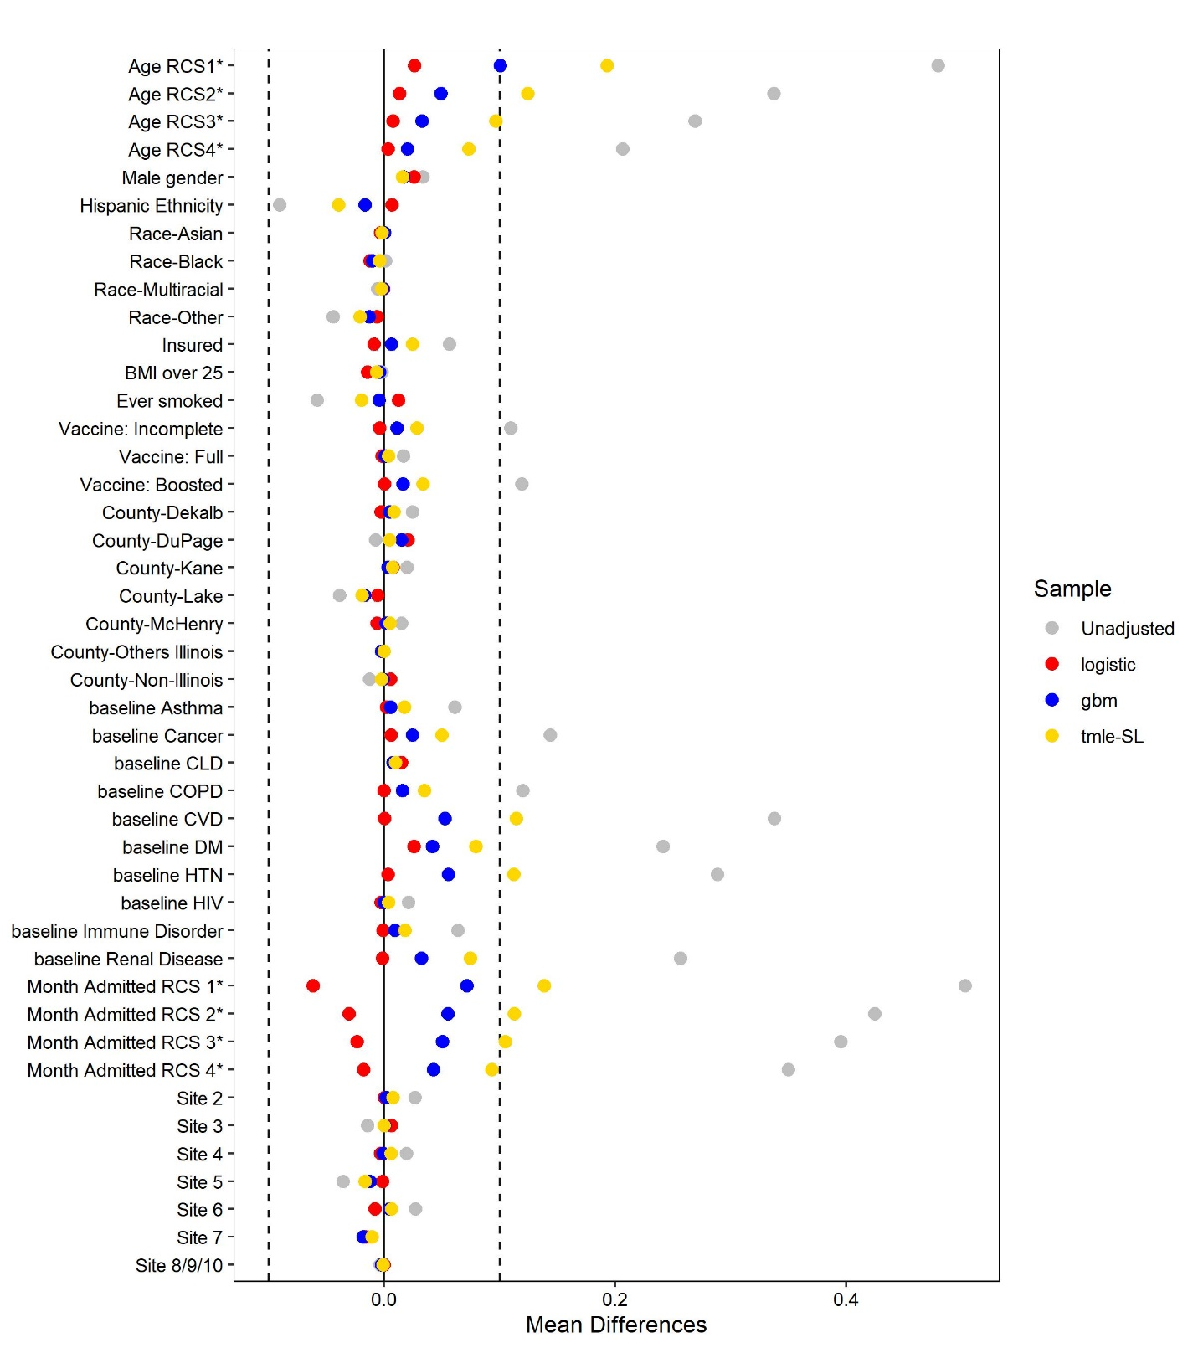 Note: * - standardized mean differences. Unadjusted – no weighting applied to calculated differences. logistic – used weights derived from a logistic regression model. gbm – weights derived from the a gradient boosted model. tmle-SL – weights obtained from the targeted maximum likelihood estimation object with super learner. BMI – body mass index, CLD – chronic liver disease, COPD – chronic obstructive pulmonary disease, CVD – cardiovascular disease, DM – diabetes mellitus, HTN – hypertension, HIV – human immunodeficiency virus, RCS – restricted cubic spline. Multiracial individuals are people who report more than two categories (e.g., Asian and Black), Other races include American Indian, Alaska Native, Native Hawaiian, Pacific-Islander, Guamanian, and Chamorro or chose other or none of the above. Other Illinois counties include all other counties not listed in the figure.

Figure S3. Love plots for covariate balance using different weighting methods with baseline, site and clinical variables, Northwestern Medical Group, March 2020-September 2022.
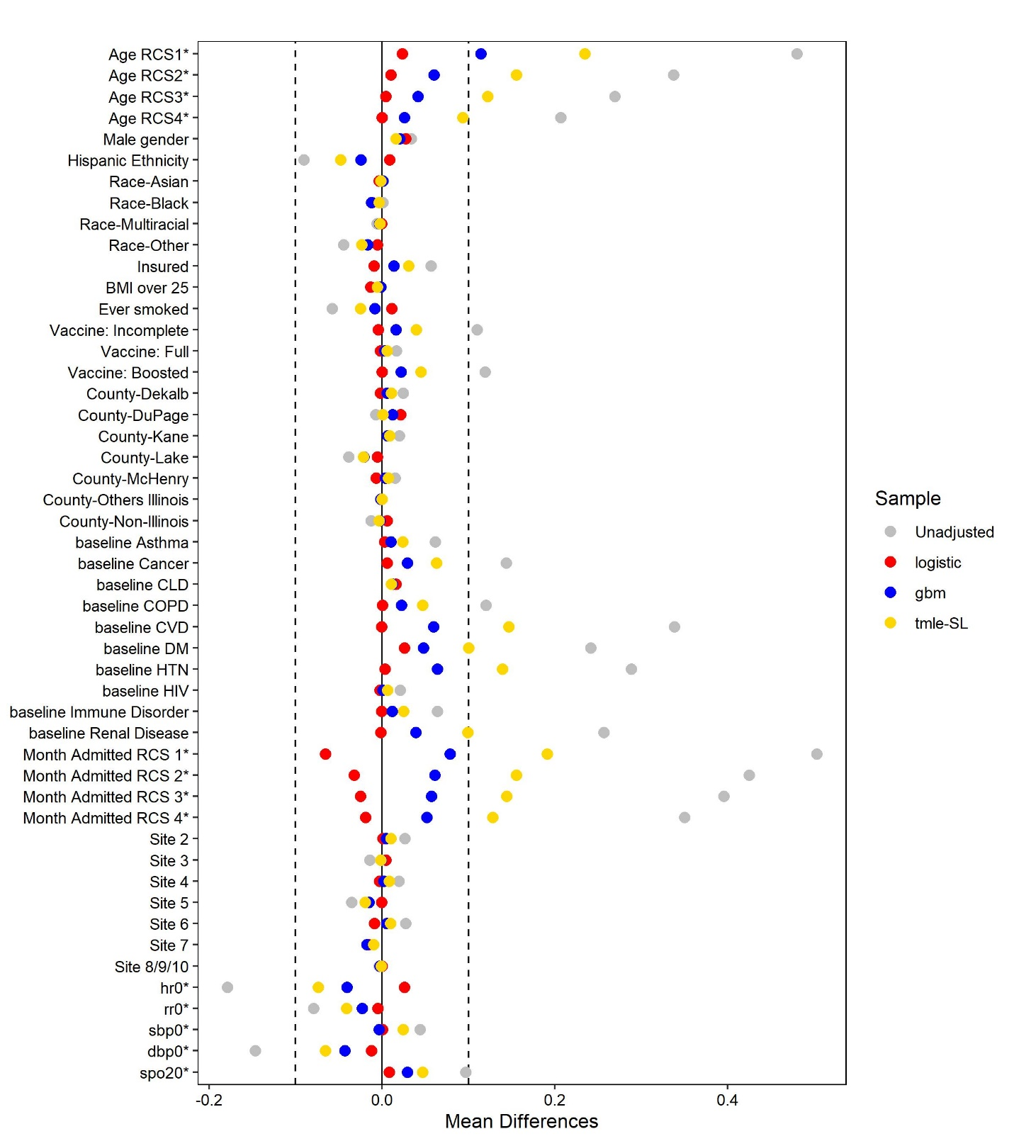
Note: * - standardized mean differences. Unadjusted – no weighting applied to calculated differences. logistic – used weights derived from a logistic regression model. gbm – weights derived from the a gradient boosted model. tmle-SL – weights obtained from the targeted maximum likelihood estimation object with super learner. BMI – body mass index, CLD – chronic liver disease, COPD – chronic obstructive pulmonary disease, CVD – cardiovascular disease, DBP0 – baseline diastolic blood pressure, DM – diabetes mellitus, HTN – hypertension, HIV – human immunodeficiency virus, HR0 – baseline heart rate, RCS – restricted cubic spline. RR0 – baseline respiratory rate, SBP0 – baseline systolic blood pressure, SPO20 – baseline oxygen saturation. Multiracial individuals are people who report more than two categories (e.g., Asian and Black), Other races include American Indian, Alaska Native, Native Hawaiian, Pacific-Islander, Guamanian, and Chamorro or chose other or none of the above. Other Illinois counties include all other counties not listed in the figure.

