eAppendix

Fig 1. Clinical Protocol in Virtual Ward (N: Nurse, Dr: Doctor, TDS: three times daily, BD: twice daily, OM: once daily)
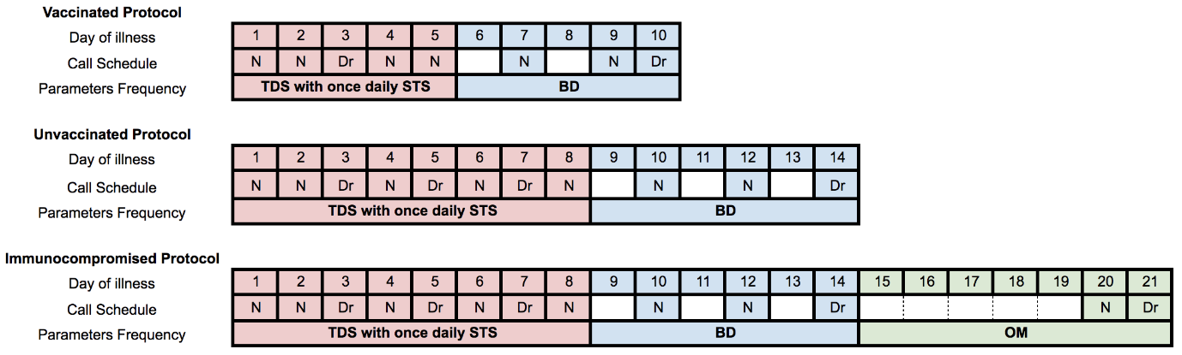

Fig 2. Triaging Protocol for Admission Avoidance Patients
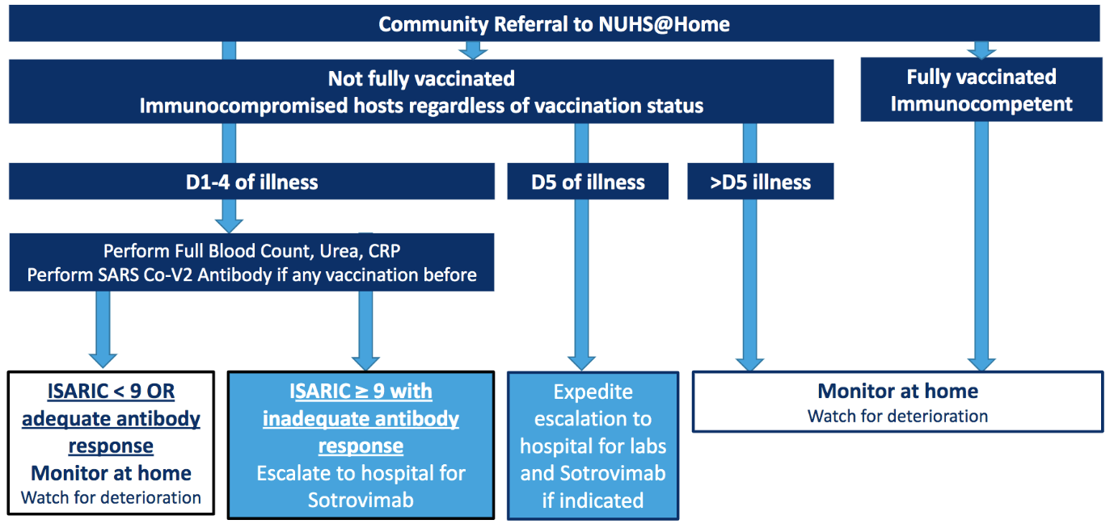

eAppendix Table 1. Patients Escalated to Hospital
^Excludes 2 patients with expected deaths at home

 | Escalated to hospital (n=41) | Did not require escalation to hospital (n=195)^ | P value
Age, mean (SD) | 66.8 (14.7) | 62.8 (19.8) | 0.18
Male, n (%) | 20 (48.7) | 81 (41.5) | 0.49
Race n(%)  Chinese  Malay  Indian  Others | 31 (75.6)  5 (12.2)  2 (4.8)  3 (7.3) | 130 (66.7)  35 (17.9)  14 (7.2)  16 (8.2) | 0.47
Not fully vaccinated, n(%) | 14 (34.1) | 71 (36.4) | 0.17
Immunocompromised, n(%)  Total  Organ transplant  Chemotherapy  Haematological malignancy  Non-cancer immunosuppression | 16 (39.0)  6 (14.6)  4 (9.7)  4 (9.7)  2 (4.9) | 33 (16.9)  6 (3.1)  16 (8.2)  4 (2.1)  7 (3.6) | <0.001
Pregnant, n(%) | 2 (4.8) | 14 (7.1) | 0.74
Comorbidities, n(%)  0  1  ≥2 | 17 (41.5)  15 (36.5)  9 (21.9) | 81 (41.5)  61 (31.3)  53 (27.1) | 0.81
ISARIC 4C Mortality Score,  Median [IQR]  0-3 (low risk), n(%)  4-8 (intermediate risk), n%()  ≥9 (high risk), n(%) | 7 [5,9]  6 (14.6)  22 (53.6)  13 (31.7) | 6 [2,8]  65 (33.3)  97 (49.7)  33 (16.9) | 0.04

