Supplementary Information –Association between Ozone and Influenza Transmissibility in China
Jiao Yang^{1,2,3,#}, Ting Zhang^{1,2,3,#}, Liuyang Yang^{4,1,2,3,#}, Xuan Han^{1,2,3}, Xingxing Zhang^{1,2,3}, Qing Wang^{1,2,3}, Luzhao Feng ^{1,2,3, *}, Weizhong Yang^{1,2,3, *}
¹ School of Population Medicine and Public Health, Chinese Academy of Medical Sciences & Peking Union Medical College, Beijing, China
² State Key Laboratory of Respiratory Health and Multimorbidity, Beijing, China
³ Key Laboratory of Pathogen Infection Prevention and Control (Peking Union Medical College), Ministry of Education
⁴ Department of management science and information system, Faculty of Management and Economics, Kunming university of science and technology, Kunming, Yunnan, China
* Corresponding author at: School of Population Medicine and Public Health, Chinese Academy of Medical Sciences & Peking Union Medical College, Beijing, China.
E-mail address: yangweizhong@cams.cn (W.Yang), fengluzhao@cams.cn (L.Feng).
# These authors contributed equally to the study.

CONTENTS

1. Estimation of Transmissibility
2. Construction of Multivariable Regression Models
3. Derivation of adjusted${ R}_{t}$
4. Supplementary tables or figures
4.1Table S1.
4.2Table S2.
4.3Table S3.
4.4 Fig.S1
5. References

1. Estimation of Transmissibility
Based on the branching process model proposed by Cori et al. within the Bayesian framework[1], the weekly instantaneous reproduction number $R_{t}$ was estimated.This is an extension of Fraser method[2]. Fraser suggested that the renewal estimation equation for the $R_{t}$ of an epidemic could be as
$$R_{t}=\frac{I_{t}}{\sum_{s=0}^{m}{w_{s}I_{t-s}}} (1)$$
where $I_{t}$ refers to the number of reported cases (specifically, the incidence rate multiplied by a constant 10,000) between time $t$and time $t+1$.The term $w_{s}$ denotes the generation time distribution, satisfying $\sum_{s=0}^{m}{w_{s}}=1$. The expected incidence at time $t$ follows a Poisson distribution with a mean (${ R}_{t}\sum_{s=0}^{m}{w_{s}I_{t-s}}$). Transmissibility is assumed constant over the interval [$t-τ, t$] and is quantified by the ${ R}_{[t-τ,t]}$.The likelihood of $I_{t-τ}, ………,I_{t}$ given the reproduction number ${ R}_{\left[t-τ,t\right]}$ and $I_{0}, ………,I_{t-τ-1}$ is as follows:
$${P(I}_{t-τ}, ………,I_{t}\left|I_{0}, ………,I_{t-τ-1}, w,{ R}_{\left[t-τ,t\right]})\right.=\prod_{s=t-τ}^{t}{\frac{{{ e^{-{ R}_{\left[t-τ,t\right]}Λ_{s}} (R}_{\left[t-τ,t\right]}Λ_{s})}^{I_{s}}}{I_{s}!}} (2)$$
where, $Λ_{s}=\sum_{s=0}^{m}{w_{s}I_{t-s}}$. A gamma distribution, characterized by a mean of 2.6 days and a standard deviation of 1.5 days, was assumed to represent the generation time. This assumption remains constant throughout an epidemic. A Bayesian framework was developed using a Gamma-distributed prior with parameters (a, b) for${ R}_{\left[t-τ,t\right]}$. Consequently, the posterior joint distribution of${ R}_{\left[t-τ,t\right]}$ can be derived as proportional to
$${{ { R}_{\left[t-τ,t\right]}(posterior)=R}_{\left[t-τ,t\right]}}^{a+\sum_{s=t-τ}^{t}{I_{s}}-1} e^{-{ R}_{\left[t-τ,t\right]}(\sum_{s=t-τ}^{t}{Λ_{s}}+\frac{1}{b})} \prod_{s=t-τ}^{t}{\frac{{Λ_{s}}^{I_{s}}}{I_{s}!}} (3)$$

Equation (3) indicates that the posterior distribution of ${ R}_{\left[t-τ,t\right]}$is a gamma distribution with the parameters$(a+\sum_{s=t-τ}^{t}{I_{s}},{(\sum_{s=t-τ}^{t}{Λ_{s}}+\frac{1}{b})}^{-1})$.
2. Construction of Multivariable Regression Models
As described by Ali et al[3], the transmissibility of influenza is generally influenced by the depletion of susceptibles and inter-epidemic effects as intrinsic drivers, along with the potential effects of the extrinsic drivers (e.g. O₃ and meteorological drivers). Therefore, general multivariable nonlinear regression models were developed to examine the underlying association between influenza transmissibility and different various drivers.
Drawing to the previous research[3, 4], we found that the exponential, represented by $R_{t}=e^{φ(f_{k})}$, where, $φ\left(f_{k}\right)=β_{2}{f_{k}}^{2}+β_{1}f_{k}+β_{0}$, to be a superior fit for capturing associations across all drivers of influenza transmissibility (Table S2). Here, $β_{i}$ denotes the corresponding coefficients, $f_{k}$ indicates the $k$-th drivers.
Accordingly, the instantaneous reproduction number $R_{ij}$ can be expressed as,
$$R_{ij}={ R}_{0}{ S}_{ij}\prod_{k}{e^{φ({ a}_{ijk} )}} (2.1)$$
Here, ${ R}_{ij}$ denotes time-varying instantaneous reproduction number on the $i-$th day of the$j-th epidemic$; ${ S}_{ij}$ represents the fraction of susceptibles at the commencement of the $i$th day/weeks of $j$th epidemic. While ${ R}_{0}$ signifies the basic reproduction number. The impact of the k-th driving variables is symbolized by${ a}_{ijk}$. The values of $S_{ij}$ is derived subtracting the cumulative number of infections from the fraction of the population initially susceptible at the onset of the influenza season ($S_{0j}$).
Let ${ h}_{ij}$ represent the observed cumulative incidence up to the (i-1)-th day of the j-th epidemic. This can be expressed as:
$h_{ij}=\sum_{x}^{i-1}{{ I}_{xj}}$, where ${ I}_{xj}$ denotes the incidence on day $x$ of epidemic $j$.
Consequently, the relationship for${ S}_{ij} is$:
${ S}_{ij}={ S}_{0j}-{h_{ij}= S}_{0j}\left(1+{ z}_{j} h_{ij}\right)$
where ${ z}_{j} is defined as:$
$${ z}_{j} ={-c_{i}/S}_{0j}$$
and for the given context, the constant${ c}_{i}$ equals 1
Using the Taylor series expansion, we can represent ${ S}_{ij} as:$
$${ S}_{ij}≈{ S}_{0j}{ e}^{{ z}_{j} h_{ij}}$$
From this, we derive:

$$R_{ij}={ R}_{0}{ S}_{0j}{ e}^{{ z}_{j} h_{ij}} \prod_{k}{e^{φ({ a}_{ijk} )}} （2.2）$$
When we take the logarithm and approximate the logarithm of the effective reproduction number, we get:
$$ln\left(R_{ij}\right)=\ln\left({ R}_{0}{ S}_{0j}\right)+{ z}_{j} h_{ij}+\sum_{k}{φ(a_{ijk})}{+ ϵ}_{ij}$$
Here, we treat the parameters $\ln\left({ R}_{0}{ S}_{0j}\right)$ and ${ z}_{j}$ as nuisance parameters, indicative of inter-seasonal factors and not immediately pertinent. The error term is given by $ϵ_{ij}\sim N(0,σ^{2})$.
By suitably substituting the terms, the regression equation is formulated as:
$$ln\left(R_{ij}\right)=α_{j}s_{j}+η_{j}h_{ij} +\sum_{k}{φ(a_{ijk})}+ϵ_{ij} (2.3)$$
In this equation, $s_{j}$ denotes the epidemic$j$, a categorical variable with regression coefficient $α_{j}. Meanwhile,$ $η_{j}$ represents the regression coefficients that describe the rate at which susceptibles are reduced in the population.
A basic model is defined based on intrinsic factors only. i.e. $ln\left(R_{ij}\right)=α_{j}s_{j}+η_{j}h_{ij}+ϵ_{ij}$. The $∆R^{2}$ measures which compare the R-square values of these models, highlight the variance in transmissibility explained by respective drivers.
3. Derivation of adjusted${ R}_{t}$
The adjusted $R_{t}$ by removing the impact of the depletion of susceptibles from${ R}_{t}$ using the approach outlined by Ali et al[3]. It's important to note that $R_{t}$ is influenced by both the basic reproduction number ($R_{0}$) and the depletion of susceptibles (${ S}_{t}$), with its trend declining as the epidemic progresses. We initiated our process by fitting a model: $ln\left(R_{t}\right)=\ln\left({ R}_{0}{ S}_{0}\right)+ξ h_{t}$ to the estimated${ R}_{t}$ for each epidemic individually. Here,${ R}_{0}$ denotes the basic reproduction number. ${ S}_{0j}$ represents the initial susceptible proportion for epidemic $j$. ${ h}_{ij}$ signifies the observed cumulative incidence up to $(i-1)$th day of $j$th epidemic. Furthermore, $ξ is givent by{-c_{i}/S}_{0j}$, with a constant${ c}_{i}$, and in this context, $c_{i}=1$. The adjusted $R_{t}$ was then defined as the residual of the fit. Hence, our measures of adjusted $R_{t}$ is devoid of the effects of depletion of susceptibles and assumed to be driven by both inter-epidemic effects and the extrinsic drivers.

Table S1 $ΔAIC$ values for two different forms of univariate regression models to identify the best model representing the association between instantaneous reproduction number ($R_{t}$) for drivers of influenza.
 |  | Forms of Association | Relative humidity | Absolute humidity | O₃
Northern China | Beijing | Exponential | 0 | 0 | 0
Northern China | Beijing | Power | 3.50 | 14.82 | 30.60
Northern China | Tianjin | Exponential | 0 | 0 | 0
Northern China | Tianjin | Power | 1.52 | 14.45 | 24.74
Northern China | Liaoning | Exponential | 0 | 0 | 0
Northern China | Liaoning | Power | 6.48 | 8.24 | 6.91
Northern China | Gansu | Exponential | 0 | 0 | 0
Northern China | Gansu | Power | 8.56 | 10.61 | 18.56
Southern China | Shanghai | Exponential | 0 | 0 | 0
Southern China | Shanghai | Power | 1.57 | 29.63 | 47.79
Southern China | Jiangsu | Exponential | 0 | 0 | 0
Southern China | Jiangsu | Power | 2.85 | 52.40 | 24.75
Southern China | Guangdong | Exponential | 0 | 0 | 0
Southern China | Guangdong | Power | 26.26 | 6.98 | 0.06
Southern China | Hunan | Exponential | 0 | 0 | 0
Southern China | Hunan | Power | 2.96 | 0.25 | 0.81

Note：${ΔAIC}_{i}={AIC}_{i}-{AIC}_{min}$, $i=$exponential and power. Temperature may less than 0, and the school holiday is 0 or 1 to represent whether a certain day is a holiday. Therefore, temperature and school holidays do not have power-form results
Table S2 Percentage of the variance of the instantaneous reproduction number ($R_{t}$) explained by O₃, compared with1000 null/dummy time series, based on a univariate regression model
Provinces |  | With unadjusted $R_{t}$ |  |  |  | With adjusted $R_{t}$
 |  | $$R^{2}$$ | Permutation analysis  $$R^{2}$$ | $P$† |  | $$R^{2}$$ | Permutation analysis  $$R^{2}$$ | $P$†
Northern China | Beijing | 14.18 | 0.13 | <0.05 |  | 22.27 | 0.13 | <0.05
Northern China | Tianjin | 5.09 | 0.14 | <0.05 |  | 22.02 | 0.15 | <0.05
Northern China | Gansu | 18.07 | 0.20 | <0.05 |  | 33.94 | 0.19 | <0.05
Northern China | Liaoning | 15.04 | 0.16 | <0.05 |  | 35.26 | 0.16 | <0.05
Southern  China | Shanghai | 6.53 | 0.12 | <0.05 |  | 7.82 | 0.12 | <0.05
Southern  China | Jiangsu | 7.99 | 0.10 | <0.05 |  | 2.46 | 0.11 | <0.05
Southern  China | Guangdong | 2.47 | 0.13 | <0.05 |  | 3.85 | 0.11 | <0.05
Southern  China | Hunan | 1.32 | 0.12 | <0.05 |  | 1.91 | 0.12 | <0.05
† indicating a significant difference between $R^{2}$and Permutation analysis $R^{2}$.

Table S3 Percentage of the variance in the instantaneous reproduction number ($R_{t}$) explained by the drivers, across respective provinces from 2013 to 2018. The results are based on the best lag regression models (with the lag lying highest $R^{2}$-value) using lags ranging from 0 to 2 weeks

Provinces |  | Models | With unadjusted $R_{t}$ |  |  |  | With adjusted $R_{t}$
 |  | Models | $$R^{2}$$ | %△$R^{2}$ | df |  | $$R^{2}$$ | %△$R^{2}$ | %△$R^{2}$
Northern China | Beijing | Model1† | 0.36 | - | 719.00 |  | 0.11 | - | 719
Northern China | Beijing | Model2‡ | 0.37 | 1 | 711.00 |  | 0.35 | 24 | 711
Northern China | Beijing | Model3* | 0.41 | 5 | 677.00 |  | 0.41 | 29 | 677
Northern China | Tianjin | Model1† | 0.37 | - | 663.00 |  | 0.09 | - | 663
Northern China | Tianjin | Model2‡ | 0.35 | 2 | 655.00 |  | 0.43 | 34 | 655
Northern China | Tianjin | Model3* | 0.33 | 4 | 621.00 |  | 0.46 | 37 | 621
Northern China | Gansu | Model1† | 0.35 | - | 488.00 |  | 0.04 | - | 488
Northern China | Gansu | Model2‡ | 0.37 | 2 | 484.00 |  | 0.42 | 38 | 484
Northern China | Gansu | Model3* | 0.39 | 4 | 450.00 |  | 0.51 | 47 | 450
Northern China | Liaoning | Model1† | 0.23 | - | 623.00 |  | 0.02 | - | 623
Northern China | Liaoning | Model2‡ | 0.24 | 1 | 615.00 |  | 0.72 | 70 | 615
Northern China | Liaoning | Model3* | 0.25 | 2 | 587.00 |  | 0.63 | 61 | 587
Southern China
Southern China | Shanghai | Model1† | 0.35 | - | 828.00 |  | 0.09 | - | 828
Southern China | Shanghai | Model2‡ | 0.35 | 0 | 820.00 |  | 0.37 | 26 | 820
Southern China | Shanghai | Model3* | 0.36 | 1 | 800.00 |  | 0.39 | 30 | 800
Southern China | Jiangsu | Model1† | 0.39 | - | 831.00 |  | 0.03 | - | 831
Southern China | Jiangsu | Model2‡ | 0.43 | 4 | 824.00 |  | 0.47 | 44 | 824
Southern China | Jiangsu | Model3* | 0.44 | 5 | 818.00 |  | 0.43 | 40 | 818
Southern China | Guangdong | Model1† | 0.27 | - | 800.00 |  | 0.05 | - | 800
Southern China | Guangdong | Model2‡ | 0.29 | 2 | 792.00 |  | 0.27 | 22 | 792
Southern China | Guangdong | Model3* | 0.29 | 2 | 768.00 |  | 0.52 | 47 | 768
Southern China | Hunan | Model1† | 0.19 | - | 814.00 |  | 0.33 | - | 814
Southern China | Hunan | Model2‡ | 0.18 | 1 | 806.00 |  | 0.52 | 19 | 806
Southern China | Hunan | Model3* | 0.18 | 1 | 778.00 |  | 0.51 | 18 | 778
† Model1: factors affecting $R_{t}$ (or adjusted$R_{t}$) include depletion of susceptibles, and /or inter-epidemic factors.
‡ Model2: model 1 for $R_{t}$plus O₃.
* Model3: model 1 for $R_{t}$plus O₃ and other drivers.
$R^{2}$ and $df$ are measures of R-square and degree of freedom from the regression model respectively.
${\%∆R}^{2}$ measured the change in the explained variance (i.e., variance explained by either model 2 or model 3) in comparison to the model 1. For model 2, the equation is: $\% {ΔR}^{2}=|(R_{model2}^{2}-R_{model1}^{2})|×100$. For model 3, the equation is: $\% {ΔR}^{2}=|(R_{model3}^{2}-R_{model1}^{2})|×100$.

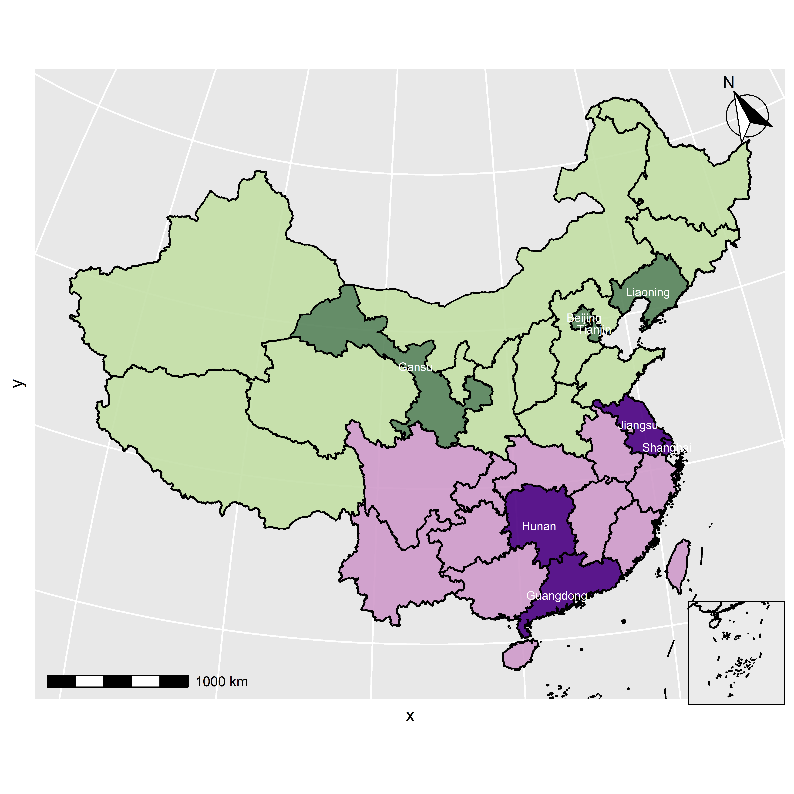
Fig. S1. The map indicating 8 provinces studied in northern China (dark green) and southern China (dark purple).

5. References
1. Cori A, Ferguson NM, Fraser C, Cauchemez S: A new framework and software to estimate time-varying reproduction numbers during epidemics. Am J Epidemiol 2013, 178(9):1505-1512.
2. Fraser C: Estimating individual and household reproduction numbers in an emerging epidemic. PLoS One 2007, 2(8):e758.
3. Ali ST, Cowling BJ, Wong JY, Chen D, Shan S, Lau EHY, He D, Tian L, Li Z, Wu P: Influenza seasonality and its environmental driving factors in mainland China and Hong Kong. Sci Total Environ 2022, 818:151724.
4. te Beest DE, van Boven M, Hooiveld M, van den Dool C, Wallinga J: Driving factors of influenza transmission in the Netherlands. Am J Epidemiol 2013, 178(9):1469-1477.

