Supplementary file

The command used in Stata Software:

ssc install midas

ssc install mylabels

midas tp fp fn tn, res(sum)

midas tp fp fn tn, id(author year) ms(0.75) ford fors bfor(dss)

midas tp fp fn tn, plot sroc(both)

midas tp fp fn tn, pubbias

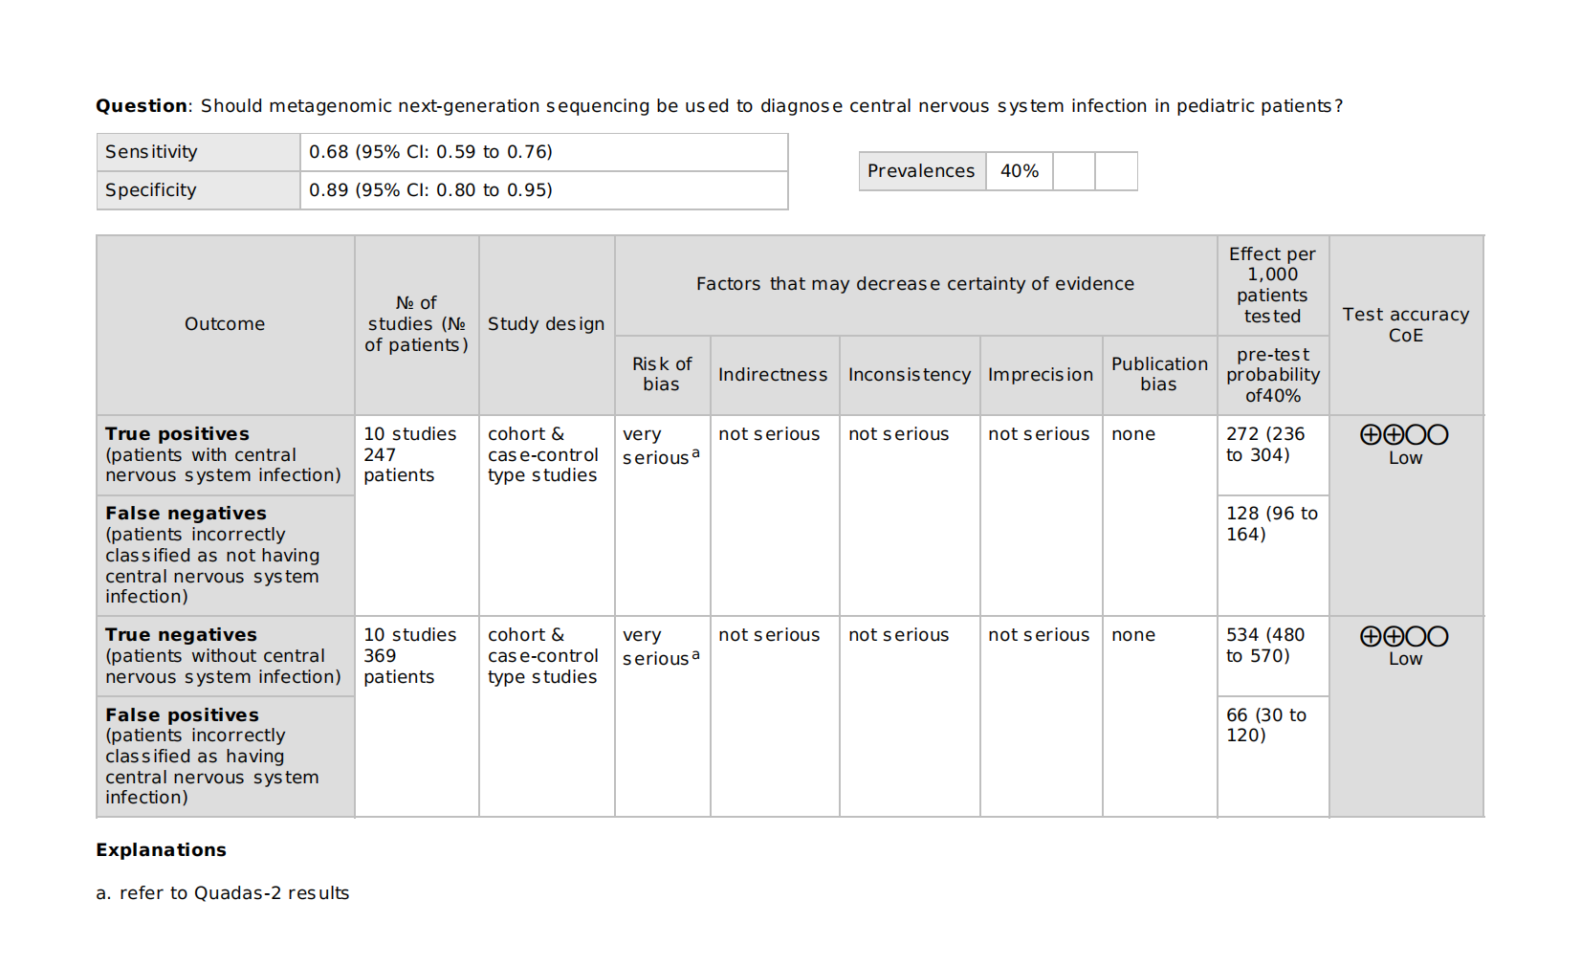
Supplementary Figure 1: The certainty of evidence measure by GRADE score system

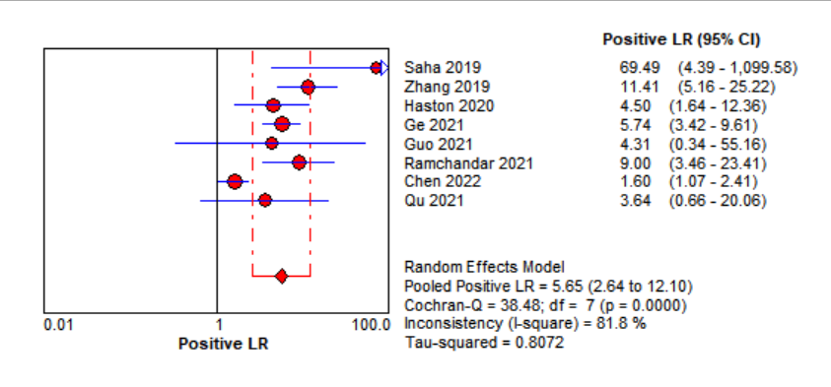
Supplementary Figure 2: Forest plot for the positive likelihood ratio (PLR) of mNGS for the diagnosis of pediatric CNSI.

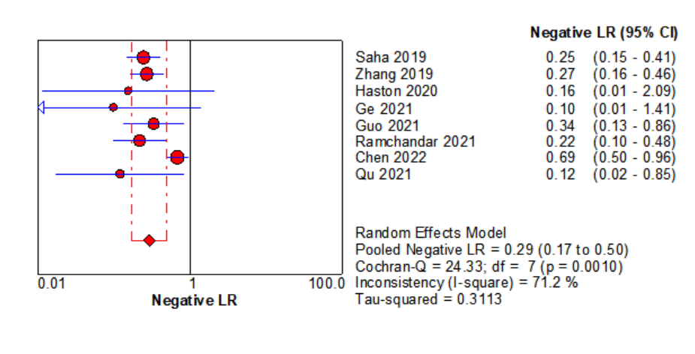
Supplementary Figure 3: Forest plot for the negative likelihood ratio (NLR) of mNGS for the diagnosis of pediatric CNSI.

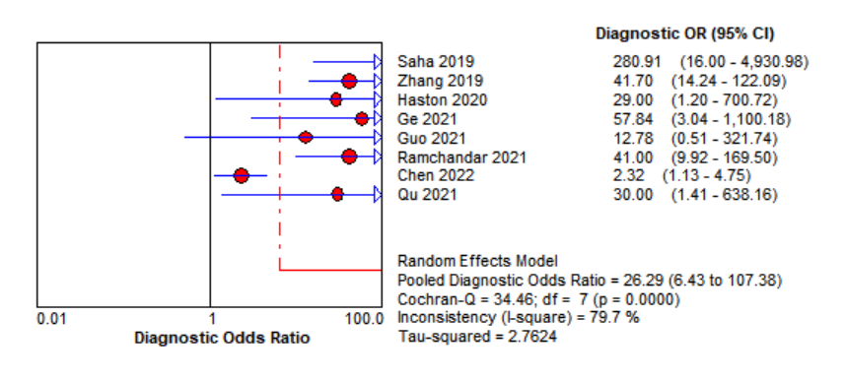
Supplementary Figure 4: Forest plot for the Diagnostic Odd’s Ratio (DOR)

Supplementary Table 1: Leave-one-out analysis depicting the pooled sensitivity and specificity
Sensitivity |  |  | Specificity
 | Estimate (95% CI) | I² value |  | Estimate (95% CI) | I² value
Overall | 0.68 (0.59, 0.76%) | 66.8% | Overall | 0.89 (0.80, 0.95) | 83.3%
Omitted Study |  |  | Omitted Study
(Qu, 2022) | 0.66 (0.60, 0.72) | 67.1% | (Qu, 2022) | 0.86 (0.82, 0.89) | 84.1%
(Chen, 2022) | 0.71 (0.64, 0.78) | 64.0% | (Chen, 2022) | 0.90 (0.86, 0.93) | 62.3%
(Ramchandar, 2021) | 0.66 (0.59, 0.72) | 68.8% | (Ramchandar, 2021) | 0.85 (0.81, 0.89) | 83.7%
(Guo, 2021) | 0.67 (0.60, 0.73) | 71.0% | (Guo, 2021) | 0.86 (0.82, 0.89) | 84.0%
(Ge, 2021) | 0.67 (0.60, 0.72) | 66.5% | (Ge, 2021) | 0.86 (0.82, 0.90) | 84.2%
(Leon, 2020) | 0.70 (0.63, 0.76) | 62.1% | (Haston, 2020) | 0.86 (0.82, 0.90) | 84.2%
(Haston, 2020) | 0.67 (0.61, 0.73) | 68.6% | (Zhang, 2019) | 0.83 (0.79, 0.88) | 81.0%
(Zhang, 2019) | 0.66 (0.59, 0.72) | 70.0% | (Saha, 2019) | 0.84 (0.80, 0.88) | 74.5%
(Saha, 2019) | 0.65 (0.58, 0.72) | 69.0%
(Leon, 2018) | 0.69 (0.62, 0.75) | 68.2%

