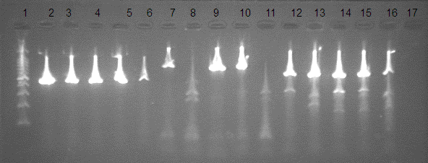
lane: 2,3,4,5,6: are bla_{TEM} positive samples.
lane 7,9,10: are bla_{SHV} positive samples, lane 8,11: are bla_{SHV} negative samples.
lane 12,13,14,15,16: are bla_{CTX-M} positive samples.
lane 17: Negative control.

Supplementary 4: Agarose gel result of bla_{TEM}, bla_{SHV}, and bla_{CTX-M} genes.

