Additional File 3
Figure S1. Panel A- American Association of Population Outcomes Research (AAPOR) 2016 Response Rate 1 by age-category and gender for the National Sample; Panel B - AAPOR 2016 Response Rate 1 by age-category and gender for the Non-Western Migrant Sample

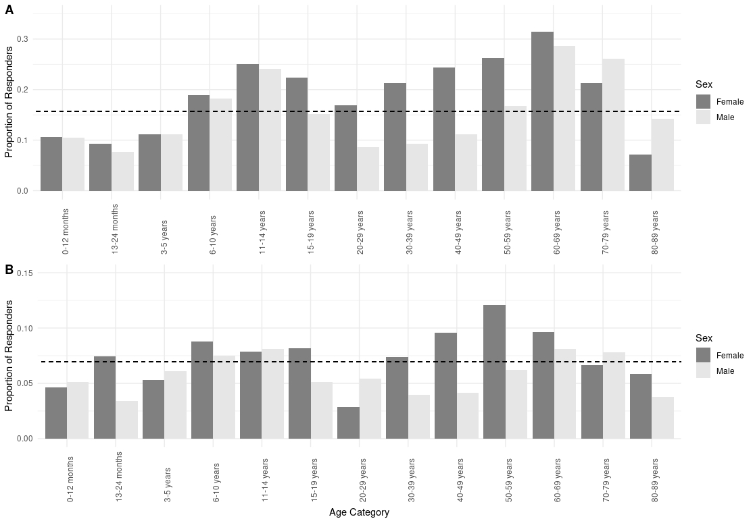

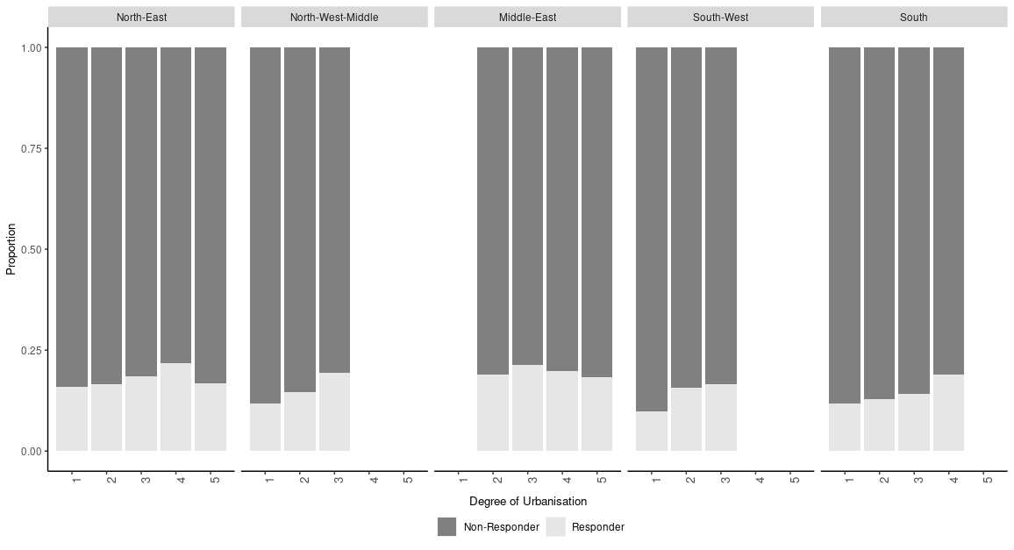
Figure S2. AAPOR 2016 Response Rate 1 in each of the 5 regions, by degree of urbanisation. Denoted as; 1– Very heavily urbanised (> 2000 persons per km²) , 2– Heavily urbanised (1000 to 2000 pp km²), 3– Medium urbanisation (500 to 1000 pp km²), 4– Low urbanisation (250 to 500 pp km²) , 5– No urbanisation/Rural (<250 pp km²).

