Blots used in the paper:
NCM460 Actin (42 KDa)：
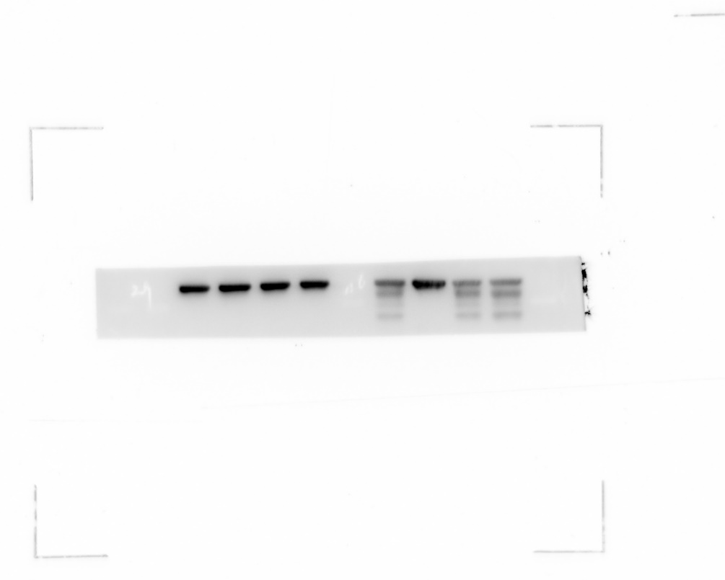
40KDa
HT-29 Actin (42 KDa)：
40KDa
HCT116 Actin (42 KDa)：
40KDa
HT-29 AKT (60 KDa):
55KDa
NCM460+HCT116 AKT (60 KDa):
55KDa
HCT 116+HT-29 mTOR (289 KDa):
180 KDa
180 KDa
NCM460 mTOR (289 KDa):
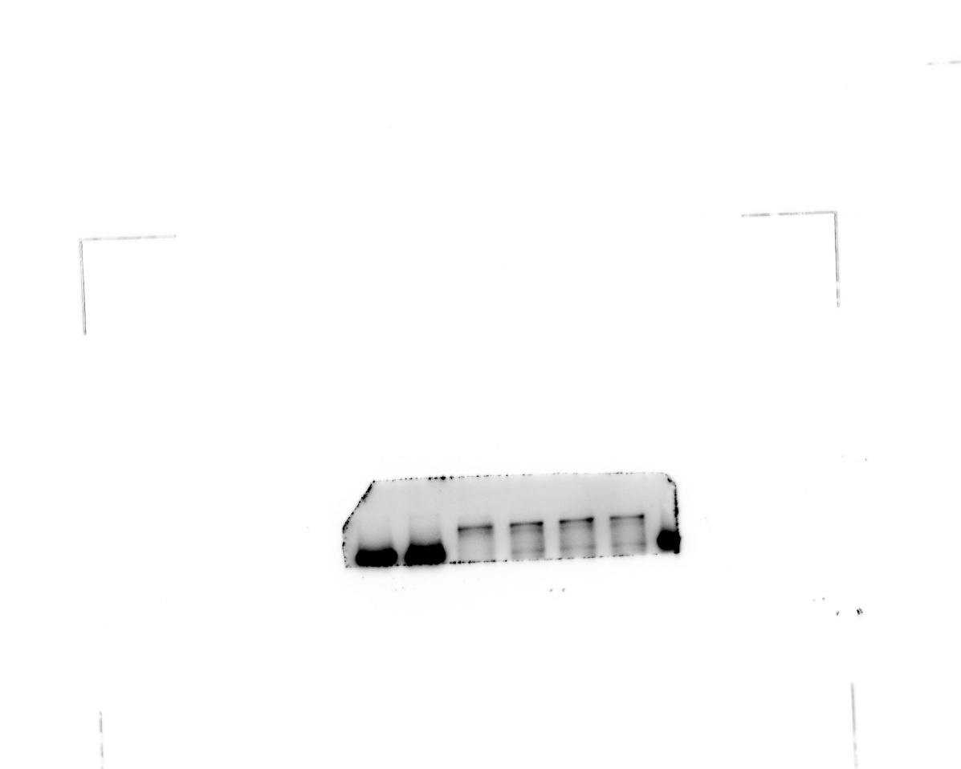
180 KDa
HCT116 p-AKT (62 KDa):
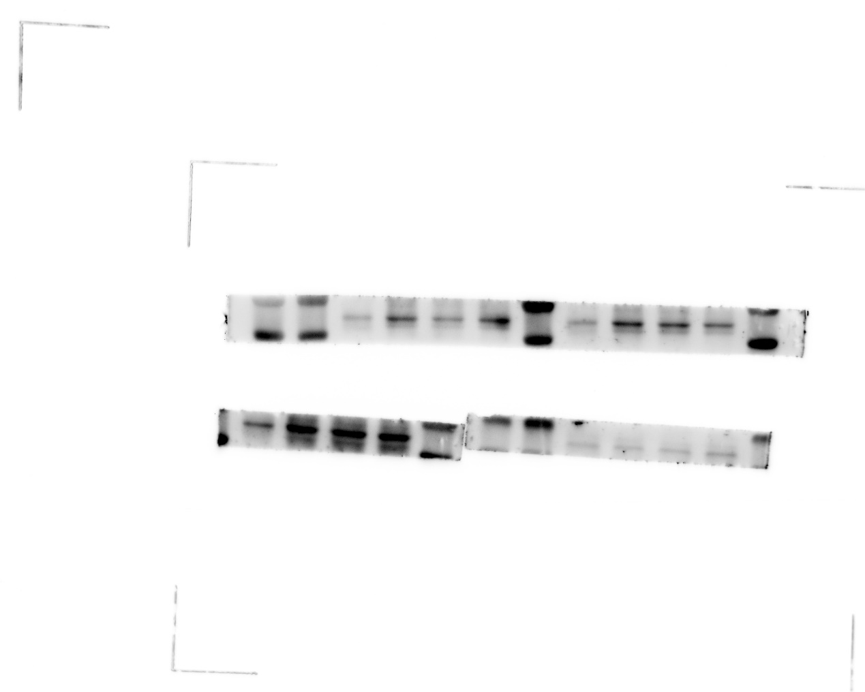
55 KDa
70 KDa
NCM460+HT-29 p-AKT (62 KDa):
70 KDa
55 KDa
HT-29 PI3K (85 KDa):
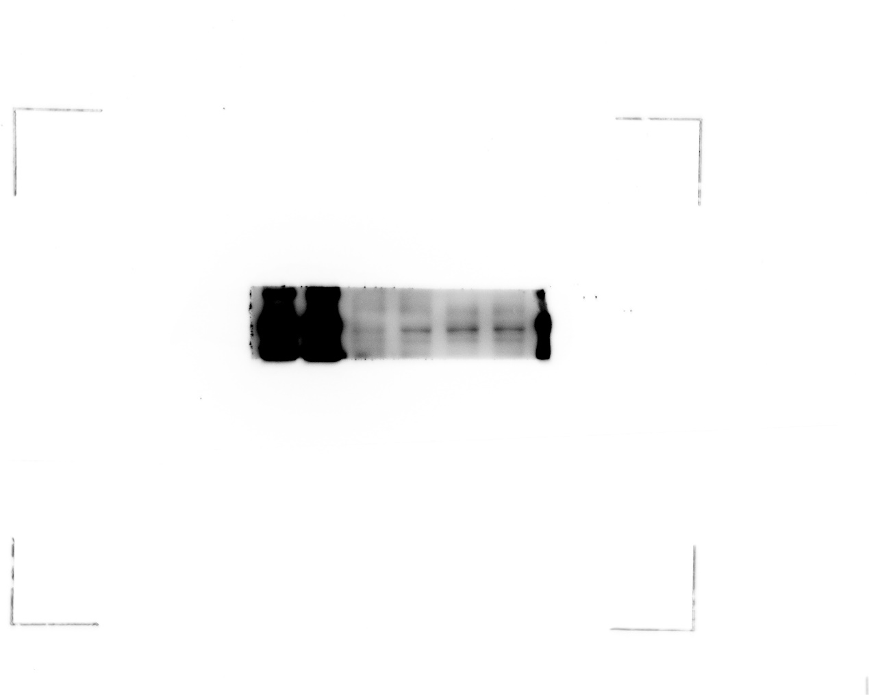
100 KDa
70 KDa
HCT116 PI3K (85 KDa):
130 KDa
100 KDa
70 KDa
NCM460 PI3K (85 KDa):
100 KDa
70 KDa
NCM460 +HCT 116 p-mTOR (289 KDa):
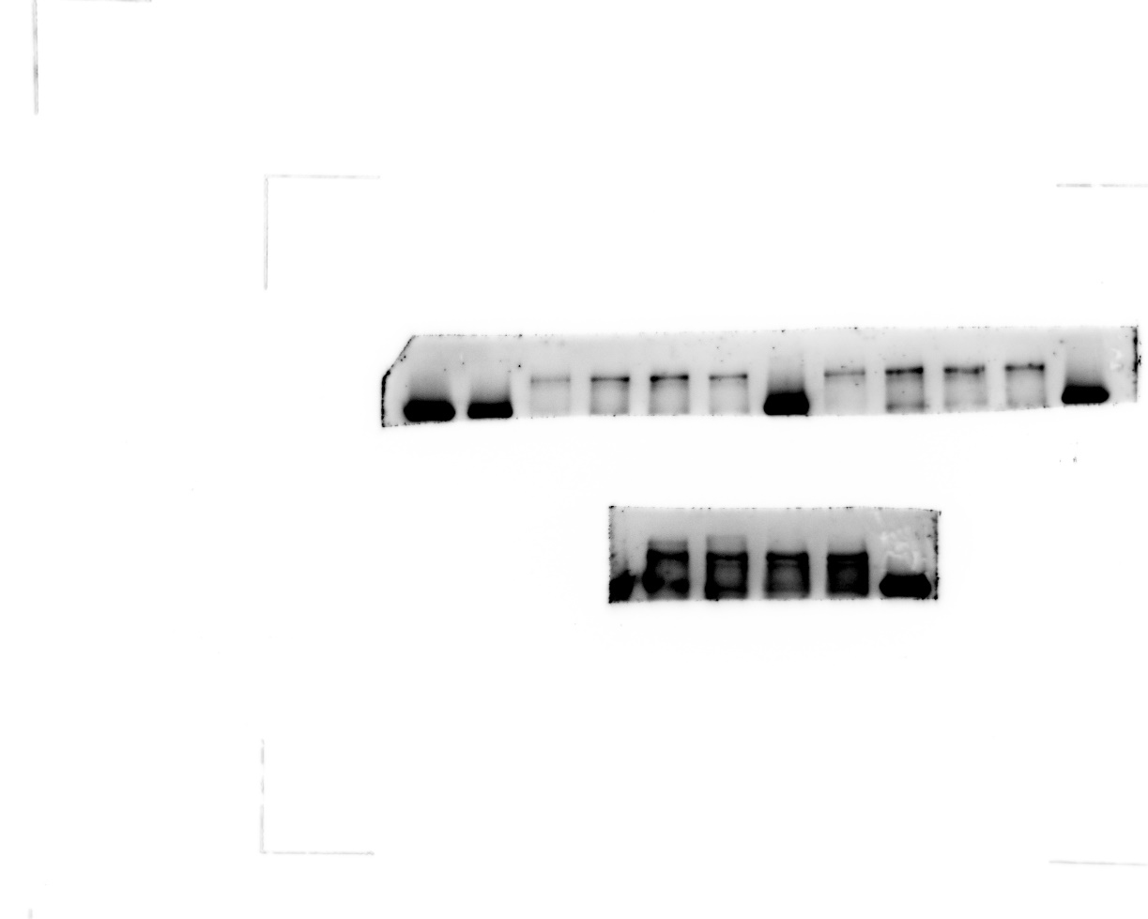
180 KDa
HT-29 p-mTOR (289 KDa):
180 KDa
p-PI3K (85 KDa):
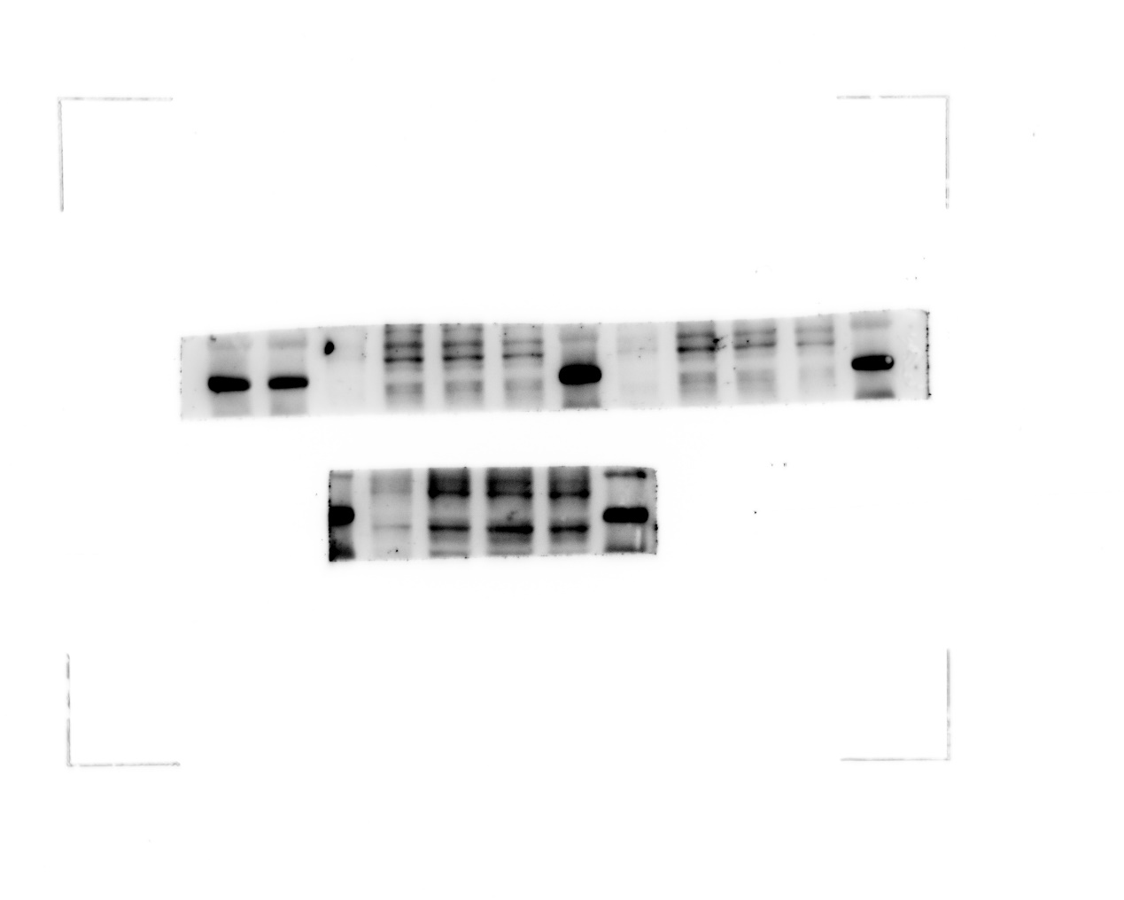
100 KDa
70 KDa
100 KDa
70 KDa

Replicates Blots
Actin-1:
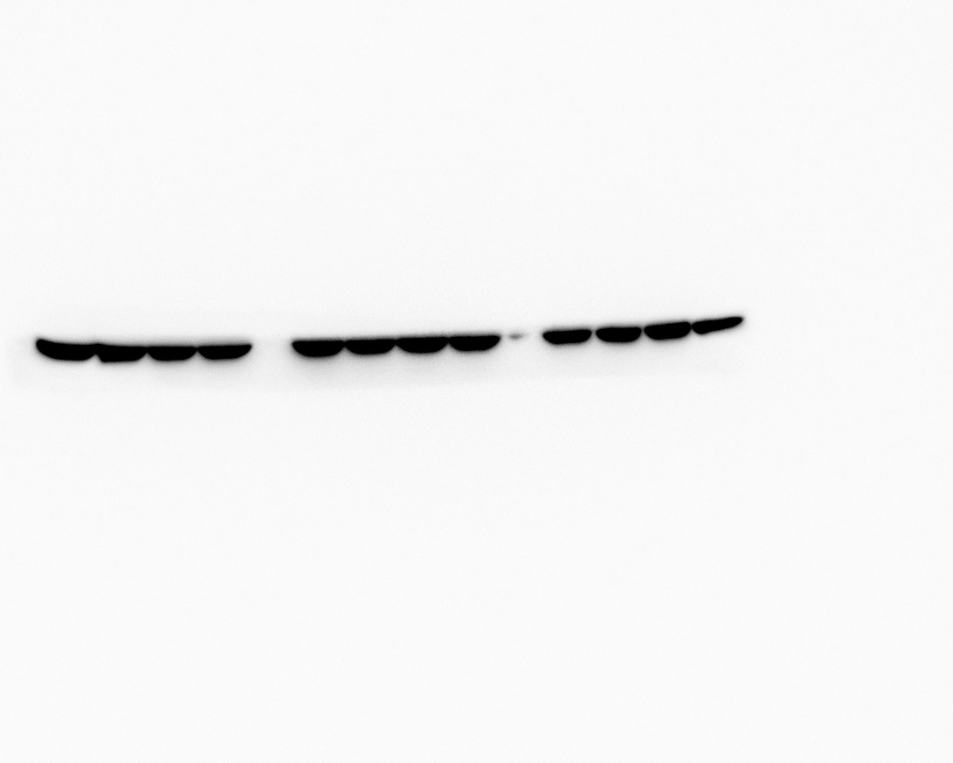
Actin-2:
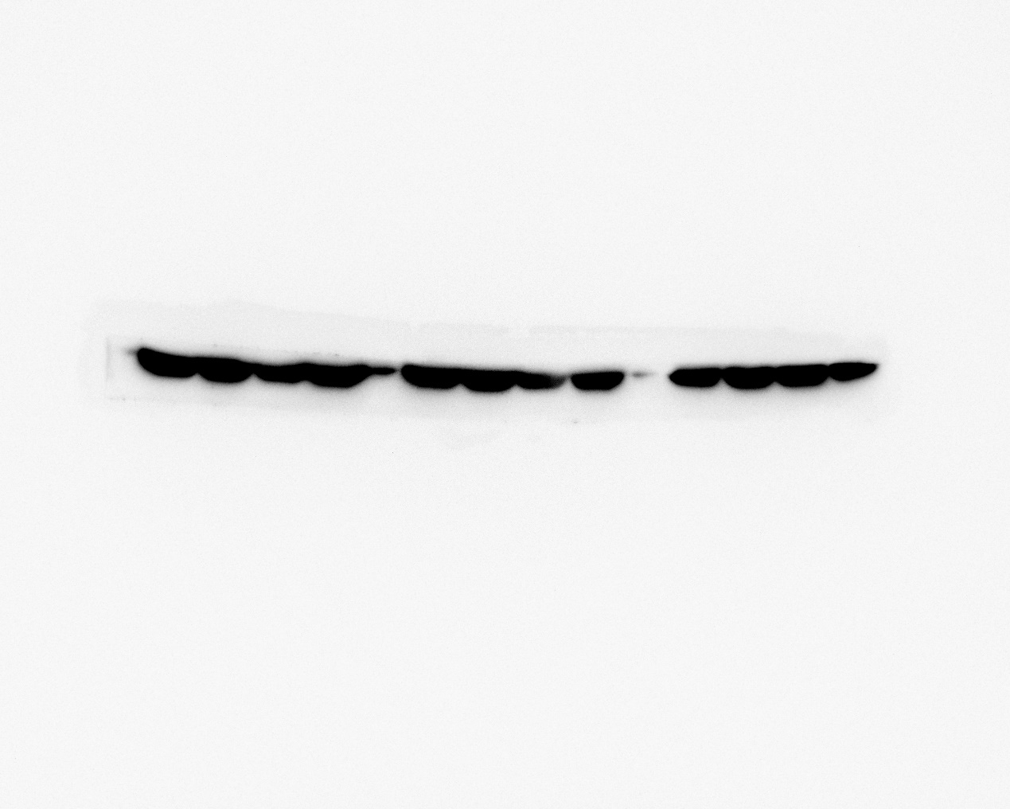
PI3K-1：
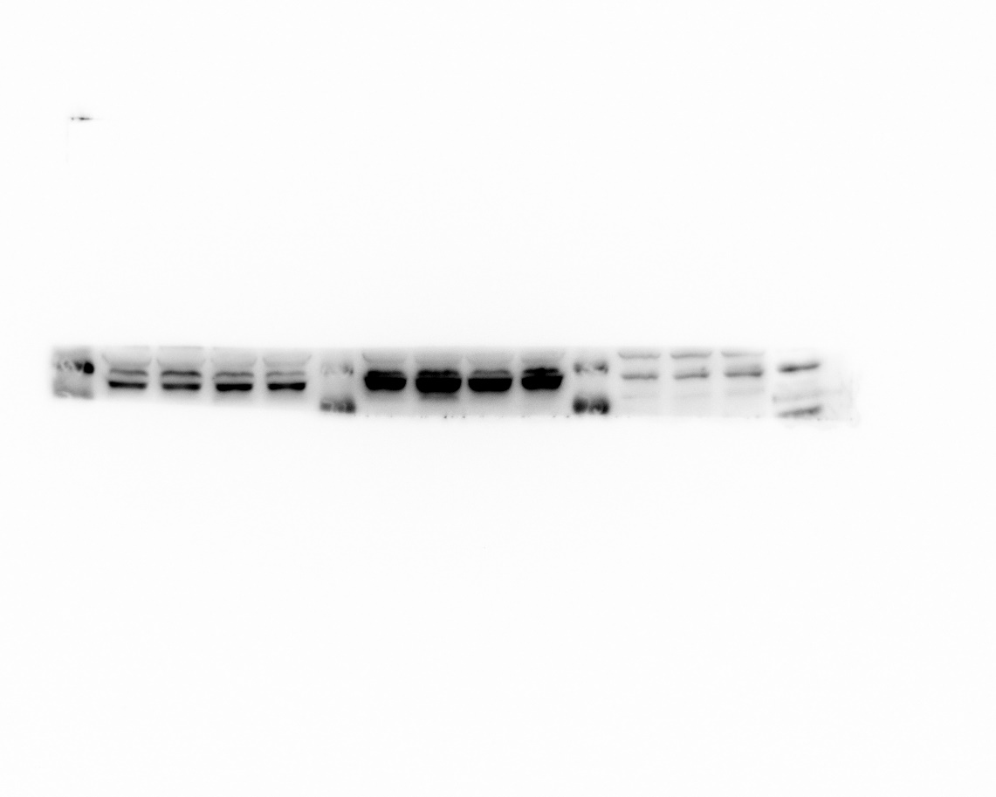
PI3K-2：
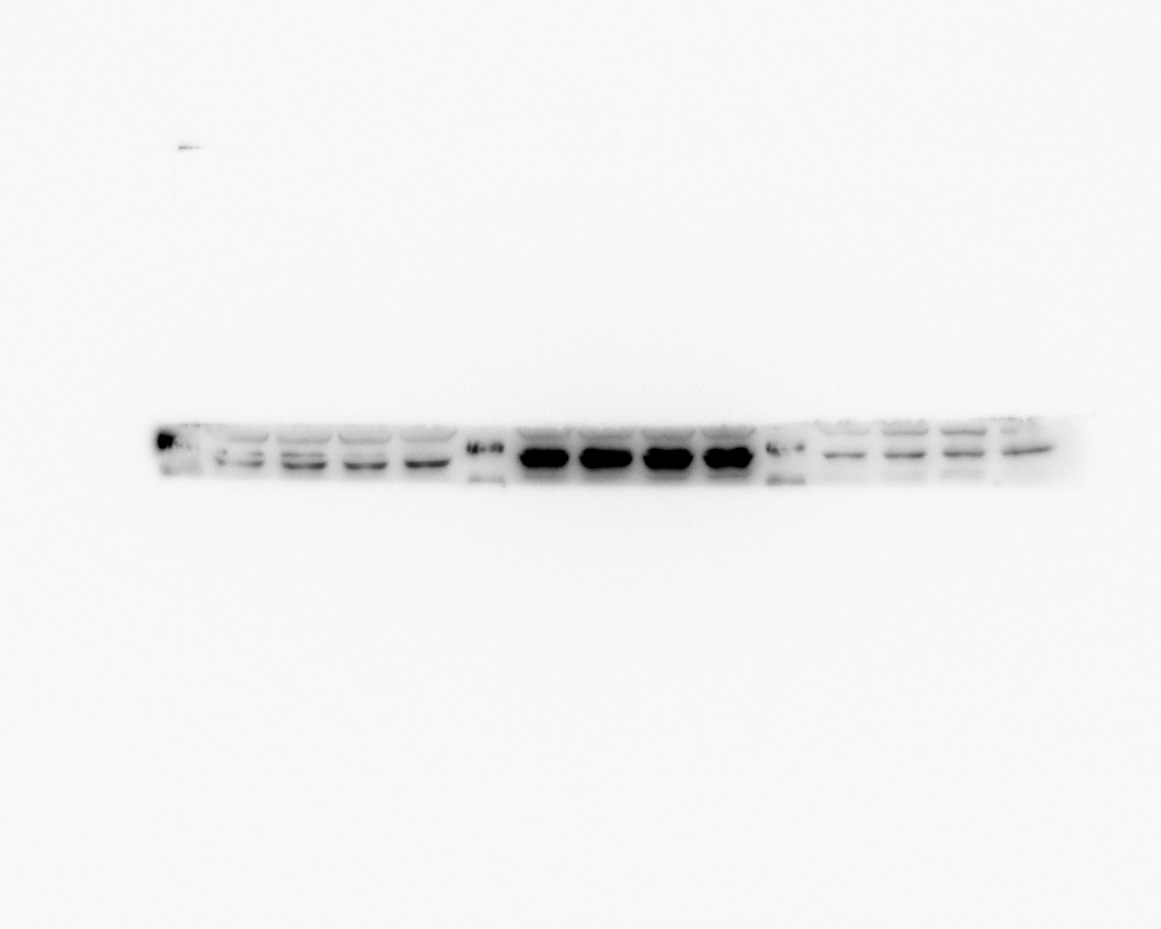

AKT-1:
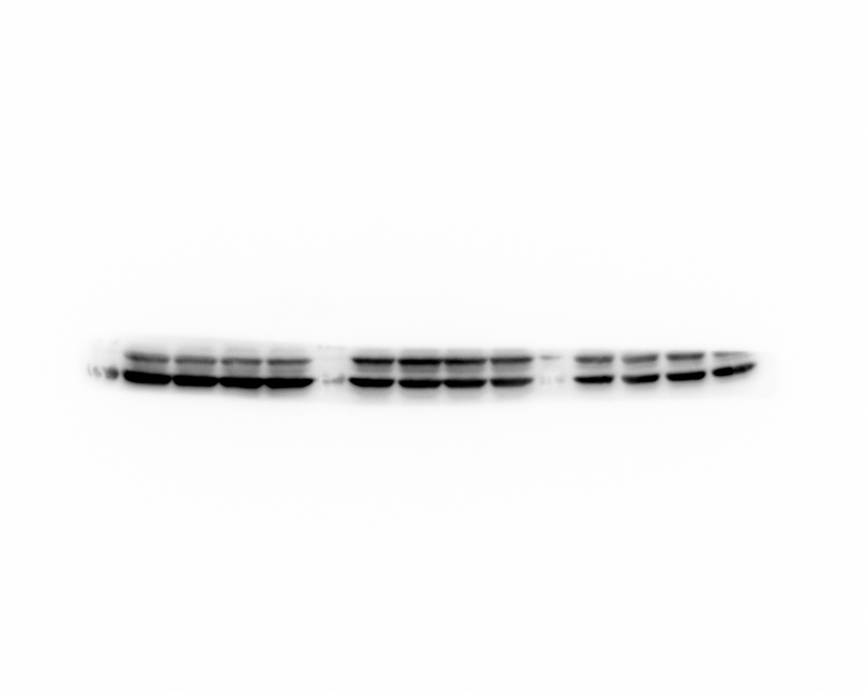
AKT-2:
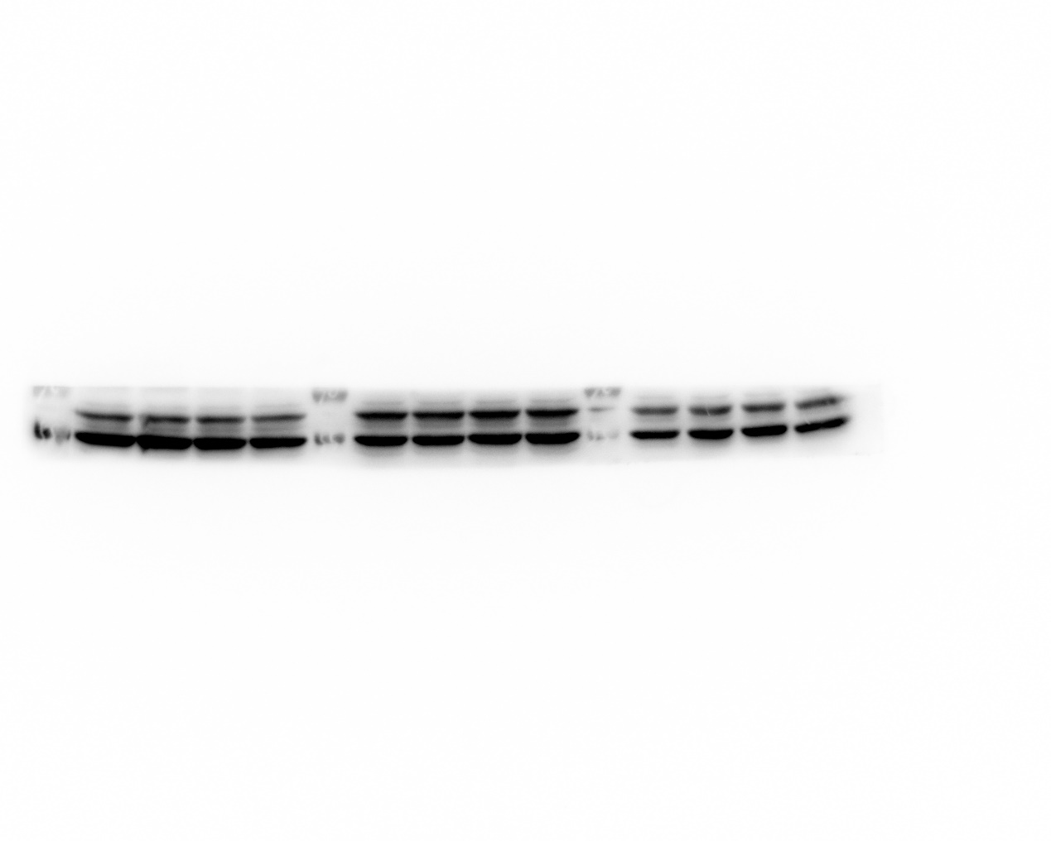
mTOR-1:
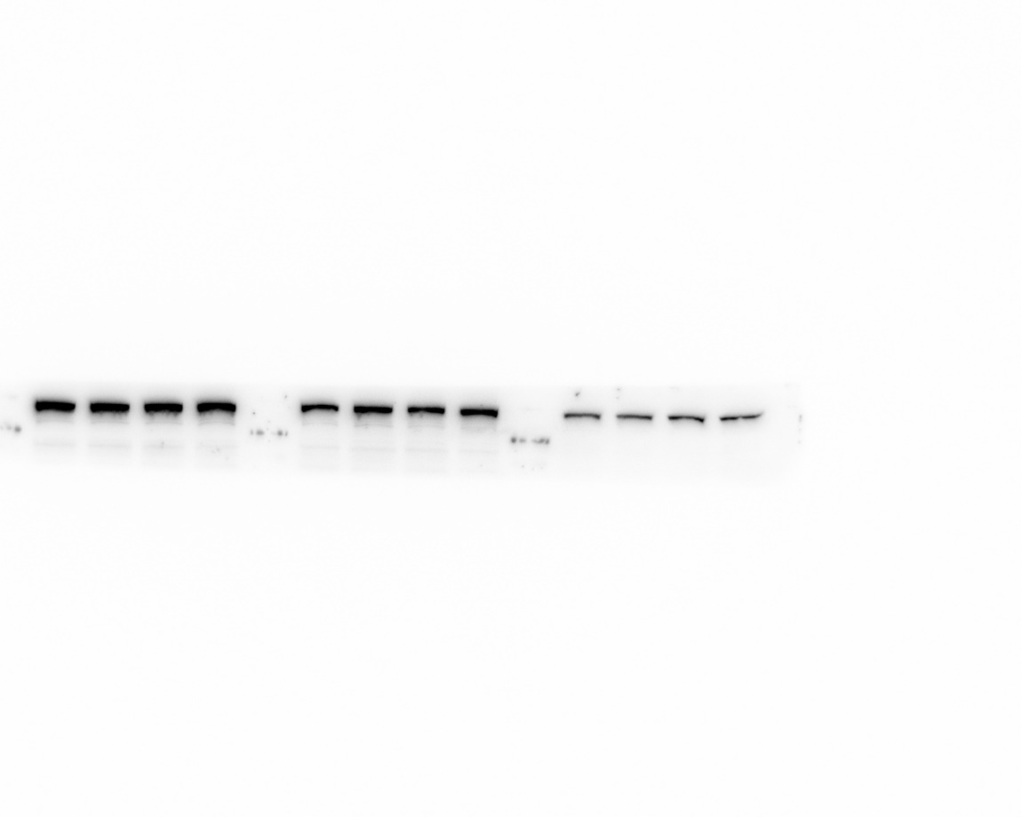
mTOR-2:
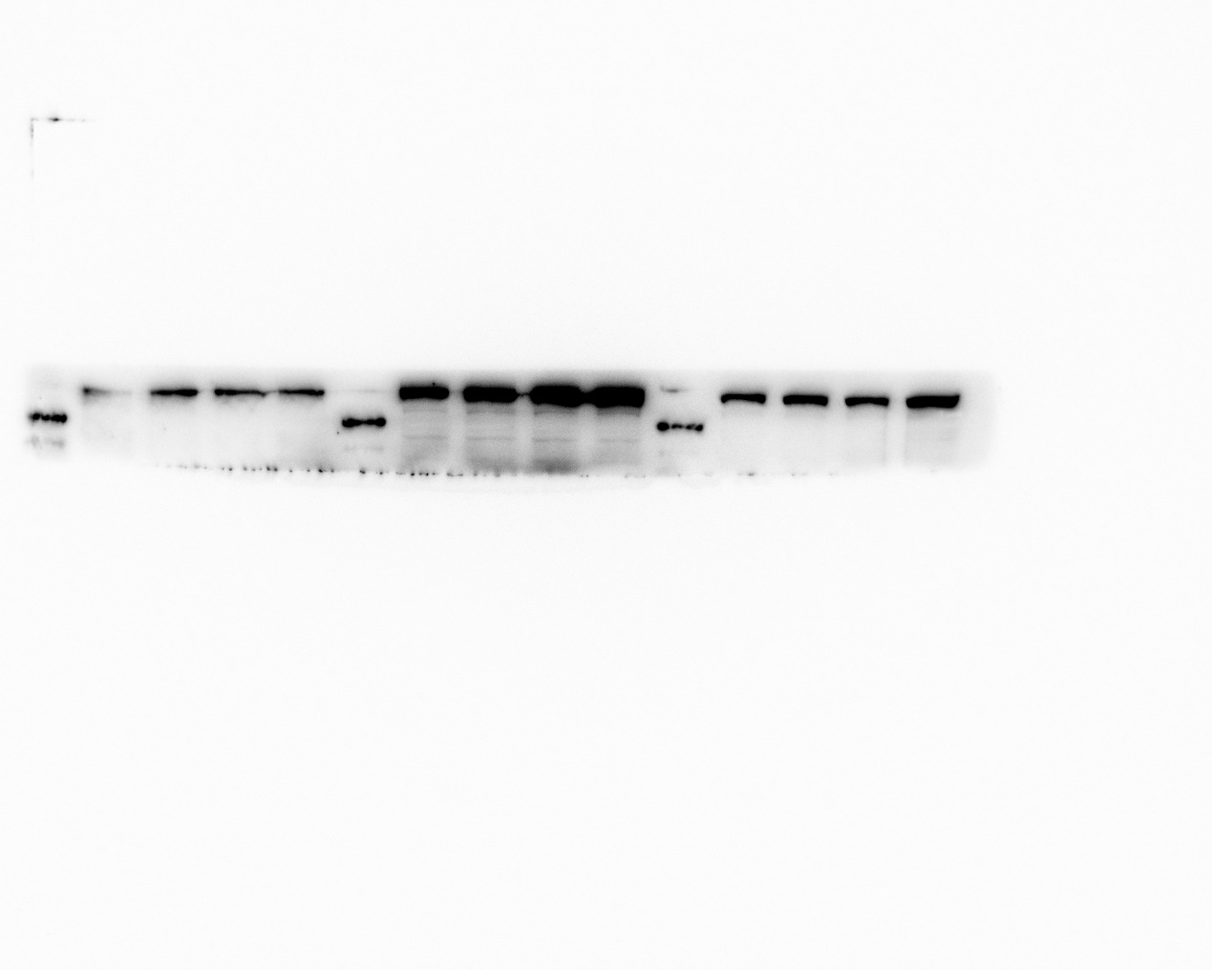
p-PI3K-1:
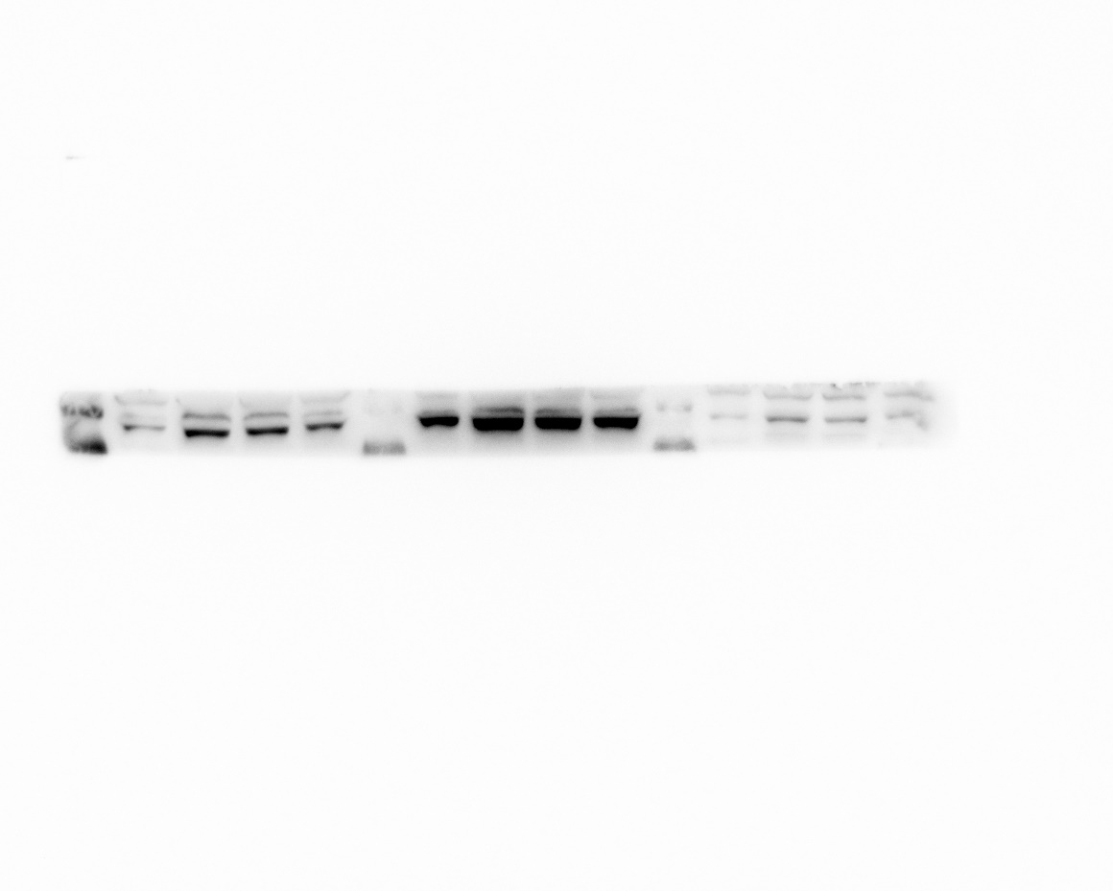
p-PI3K-2:
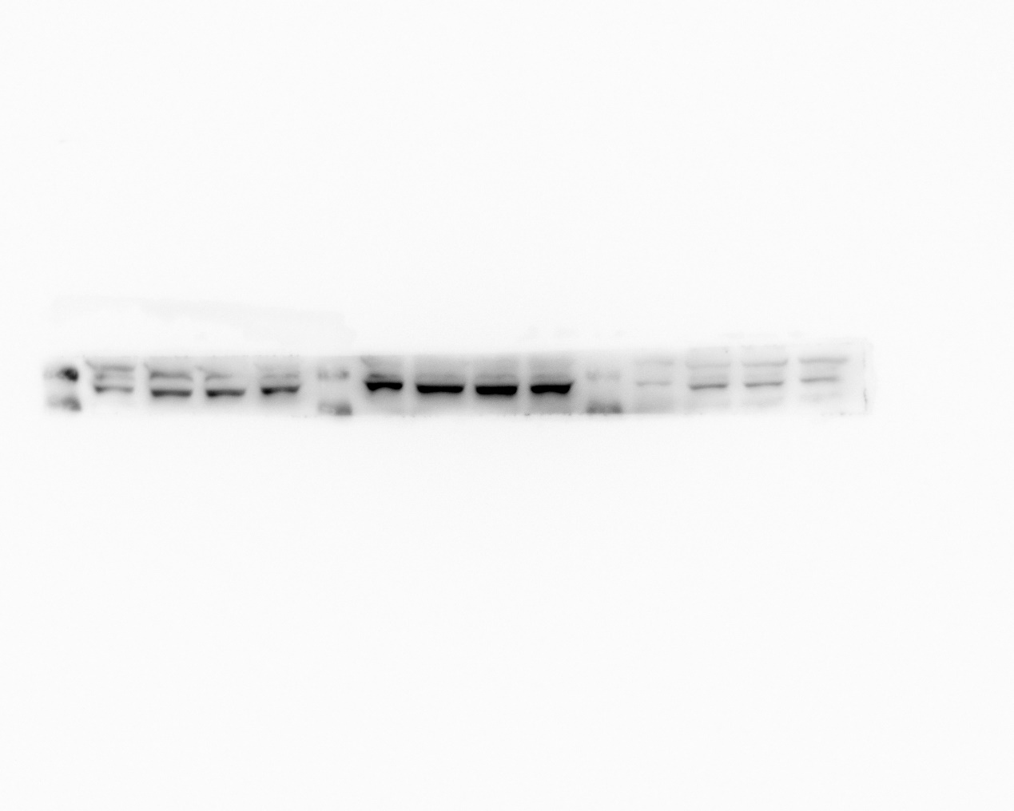
p- mTOR -1:
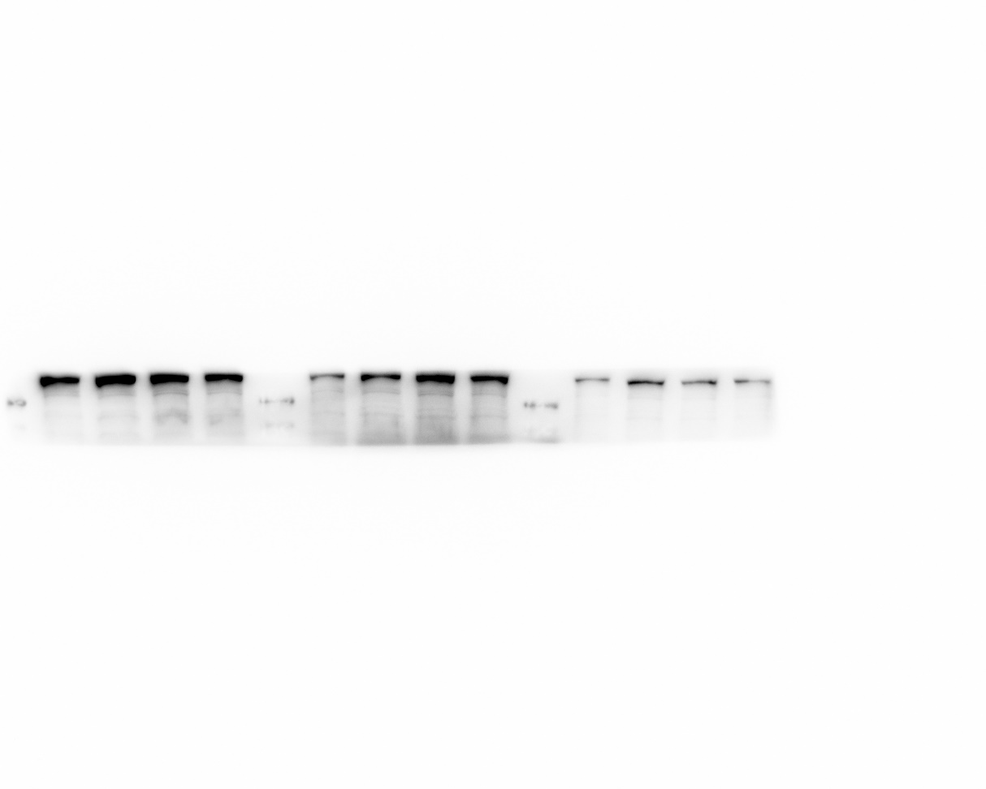
p- mTOR -2:
