Additional file 6. Meta-analysis results

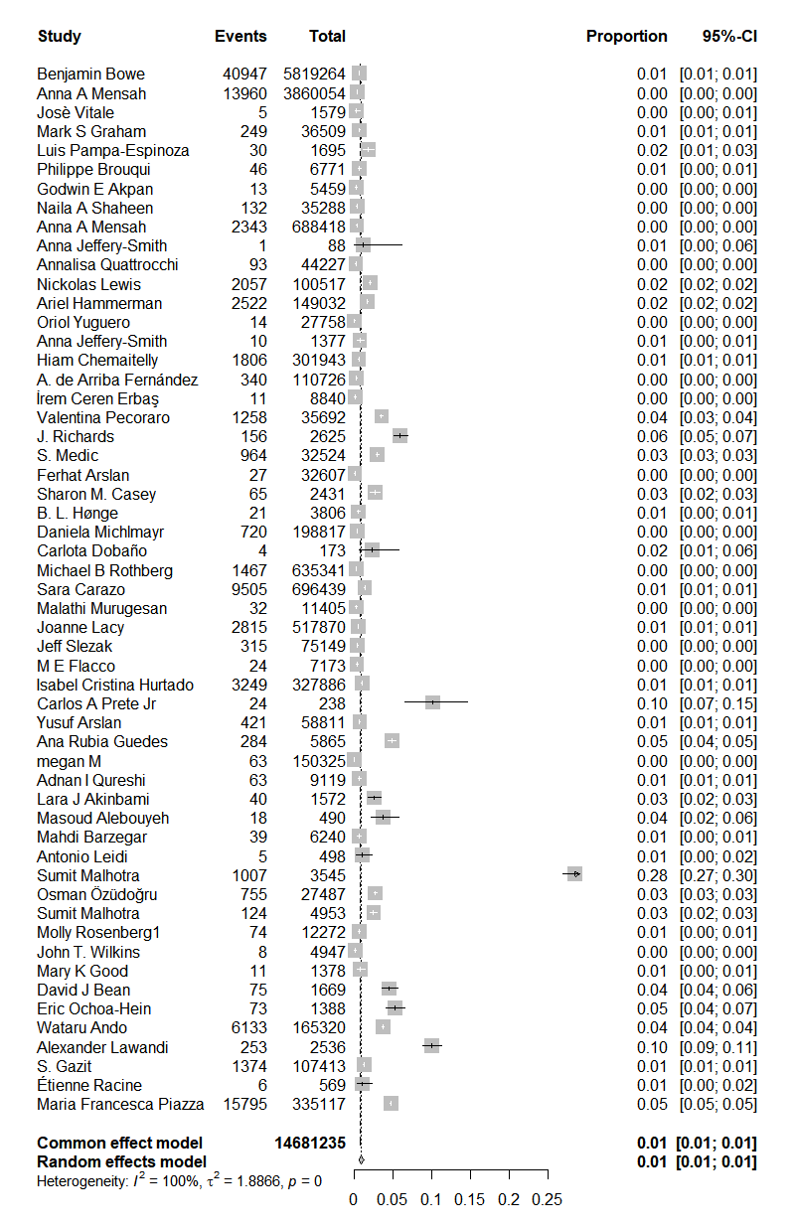
Figure 6-1. General forest map.

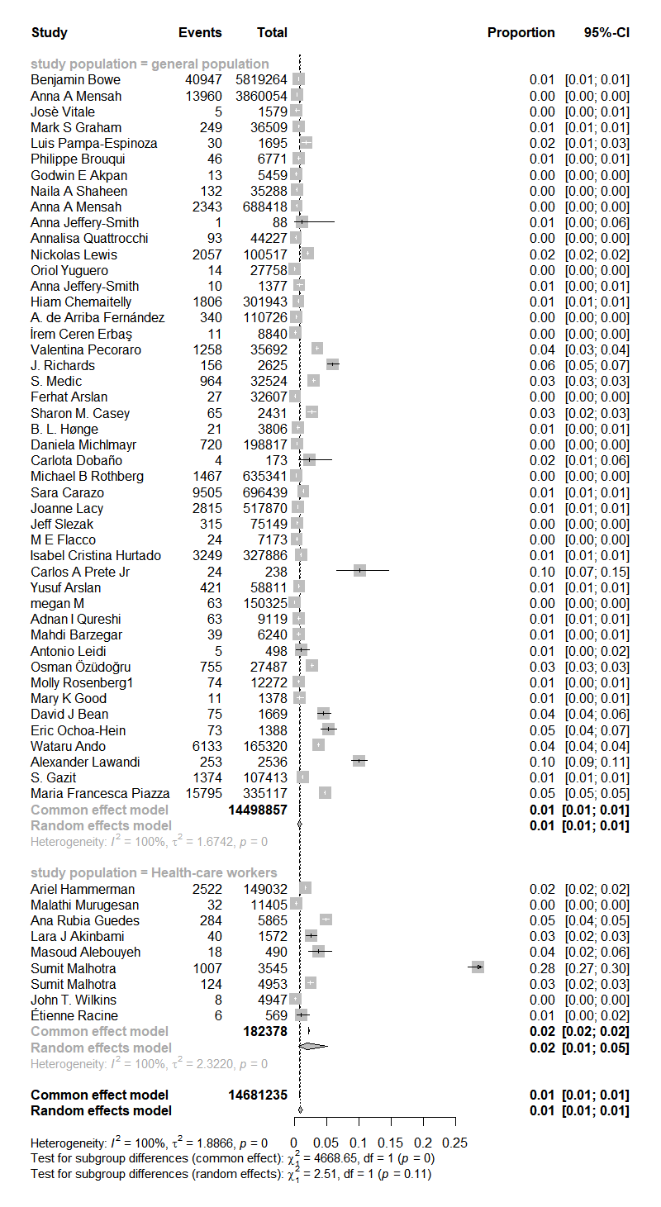
Figure 6-2. Forest plot for subgroup analysis of the study population.

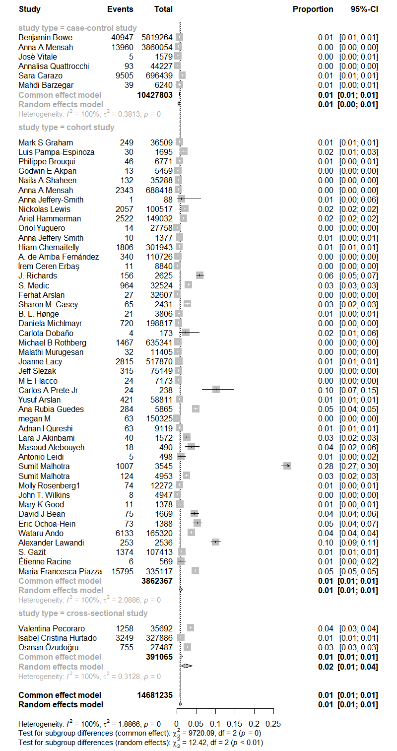
Figure 6-3. Forest plot for subgroup analysis of study type.

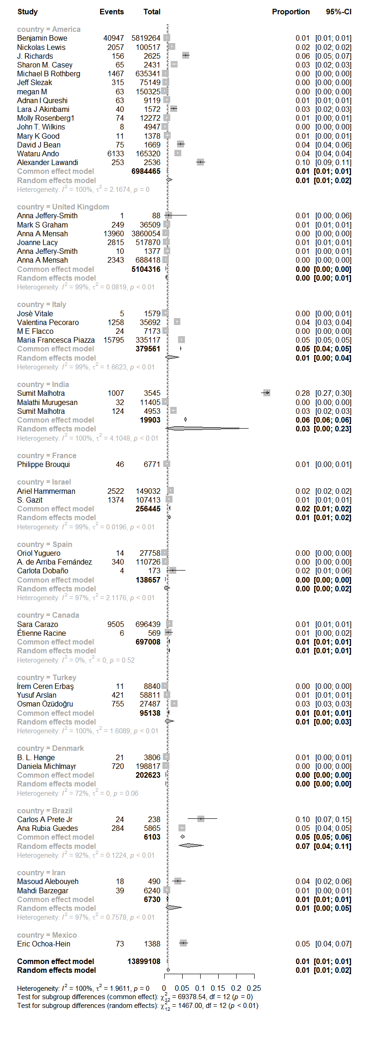
Figure 6-4. Forest map for national subgroup analysis.

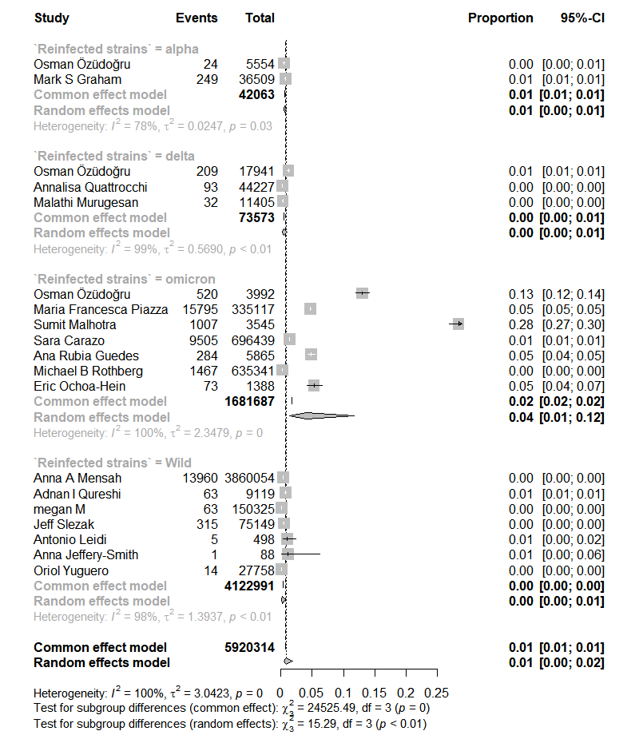
Figure 6-5. Forest plot for subgroup analysis of reinfection strain.
.
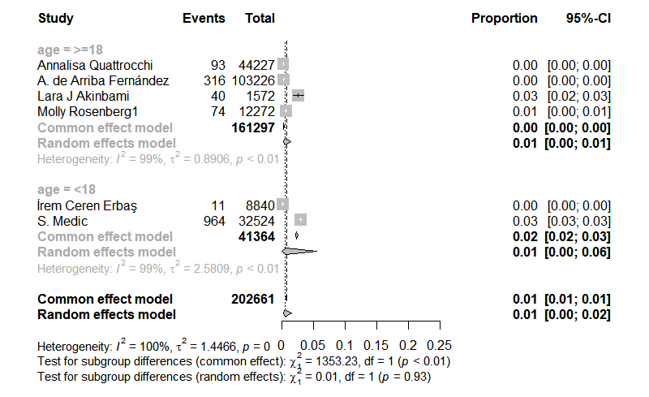
Figure 6-6. Forest plot for subgroup analysis of age.

