Additional file 8. Sensitivity analysis results
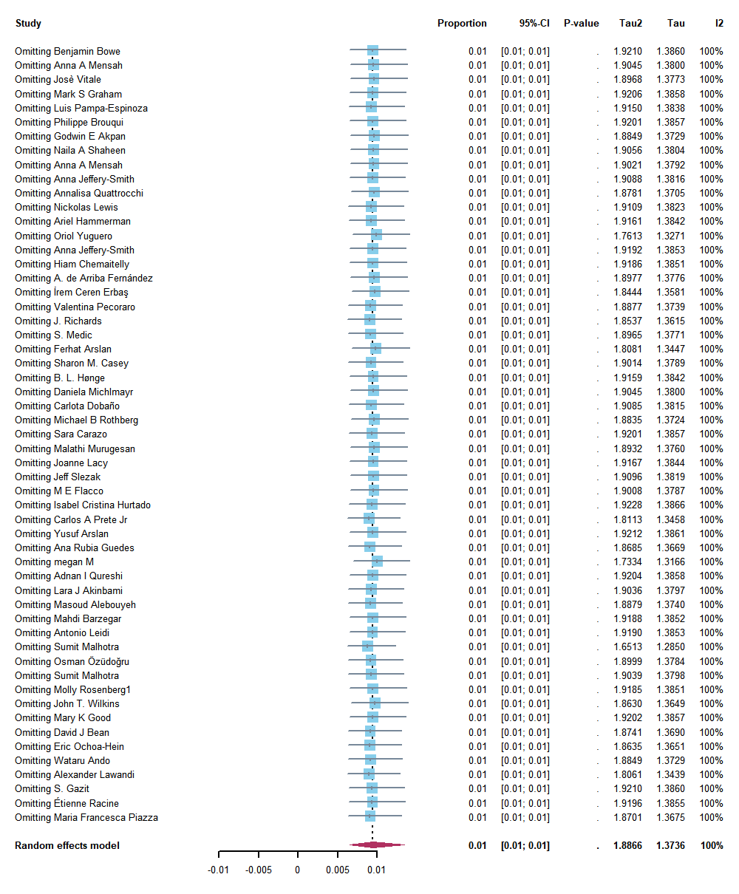

Figure 8-1. Forest plot with sequentially eliminated documents.

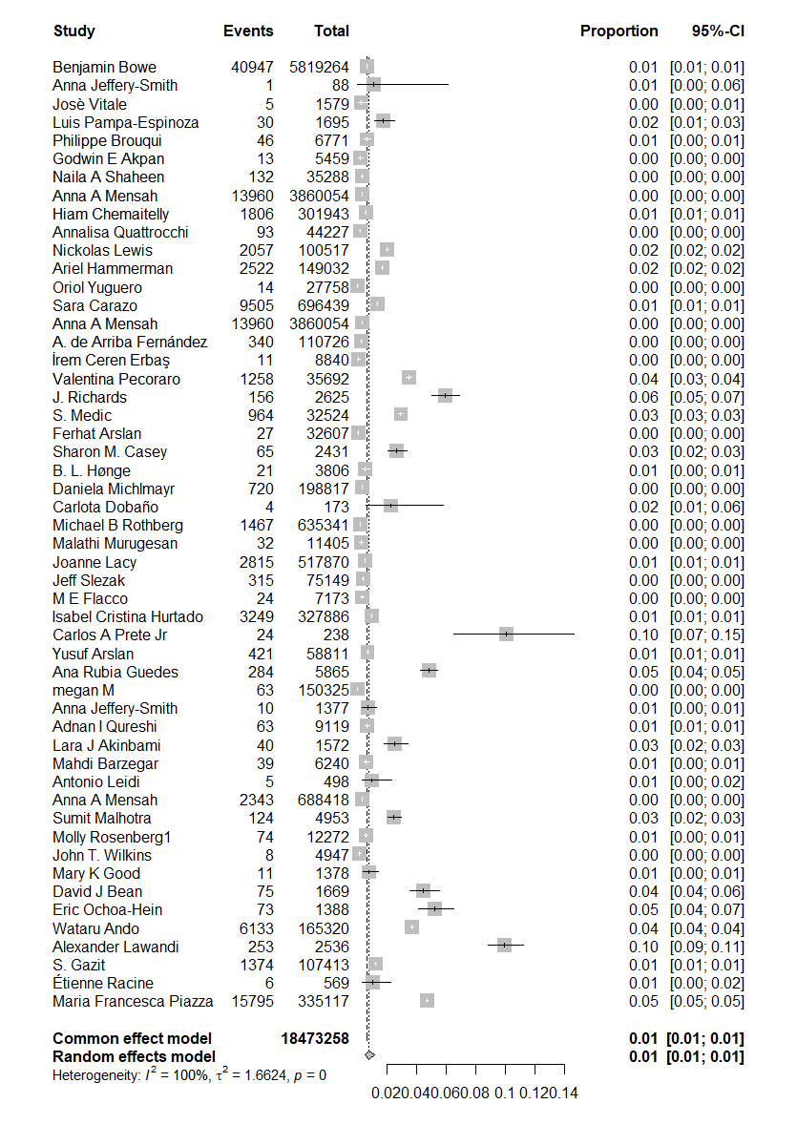
Figure 8-2. Forest maps with high bias literature excluded.

