Additional file 9. Spline regression of reinfection rate

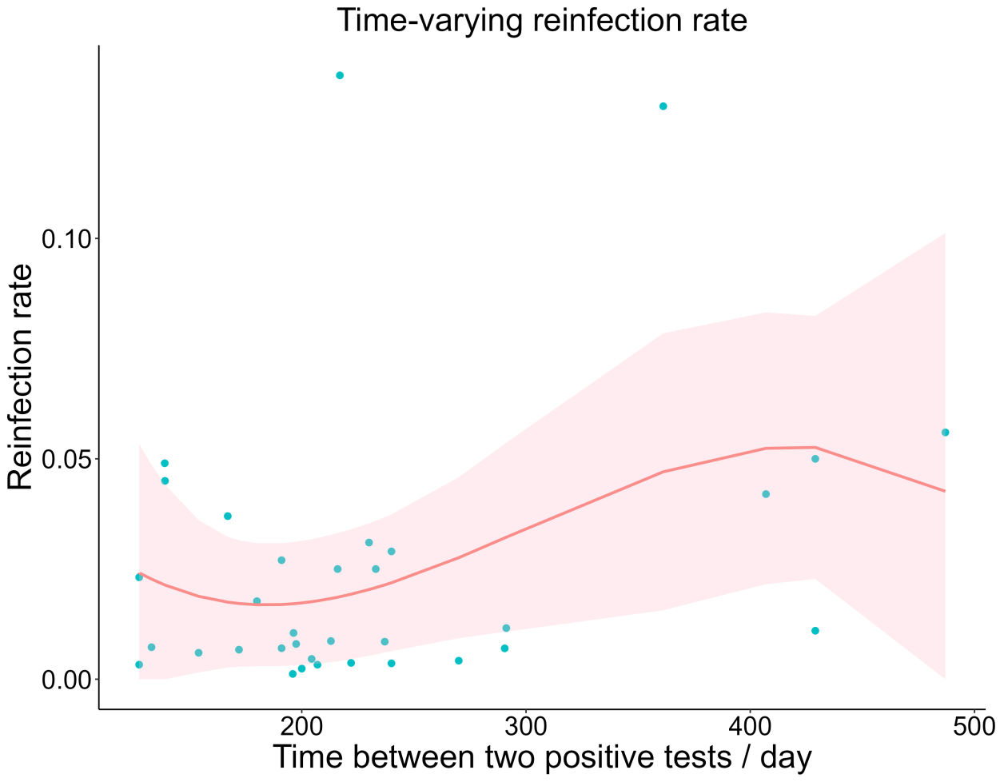
Figure 9-1. Natural spline regression of time-varying reinfection rates (blue dots represent the true values, and shaded part is 95% CI).
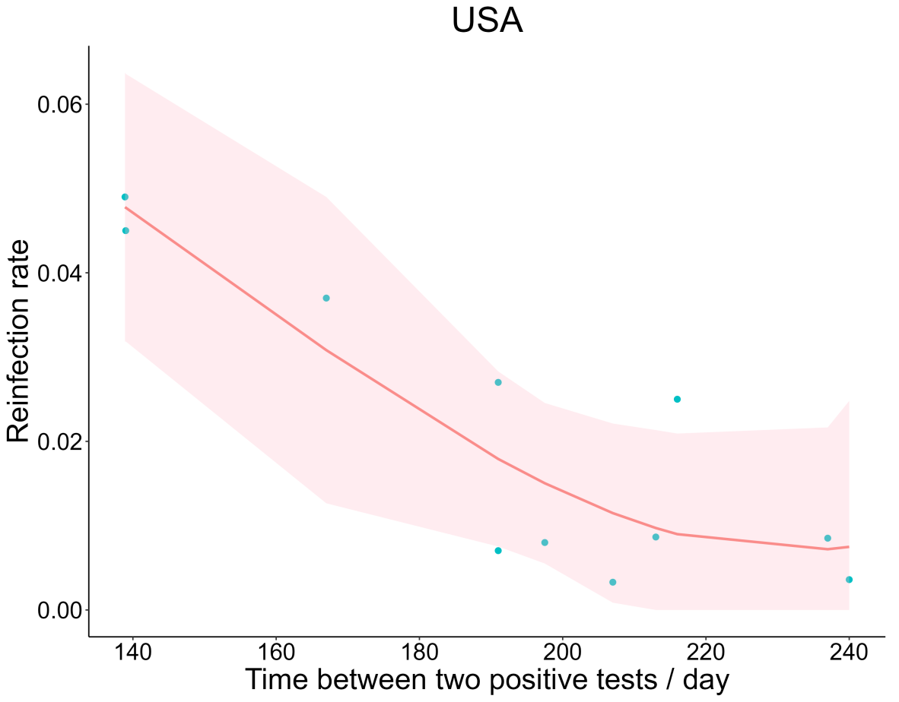
Figure 9-2. Natural spline regression of time-varying reinfection rates in America (blue dots represent the true values, and shaded part is 95% CI).

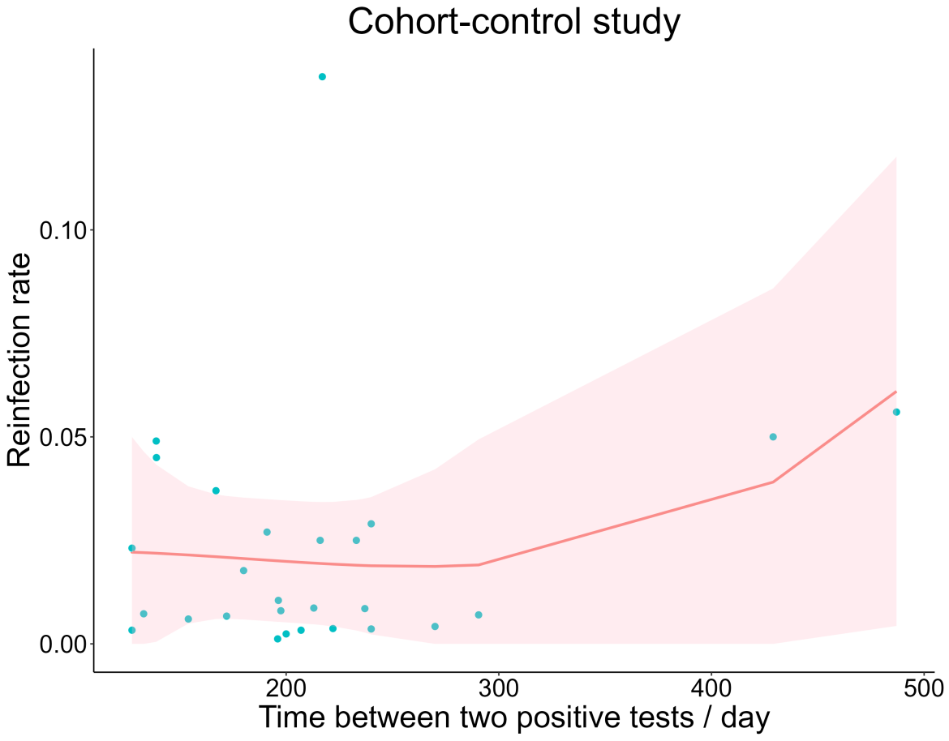
Figure 9-3. Natural spline regression for cohort study (blue dots represent the true values, and shaded part is 95% CI).

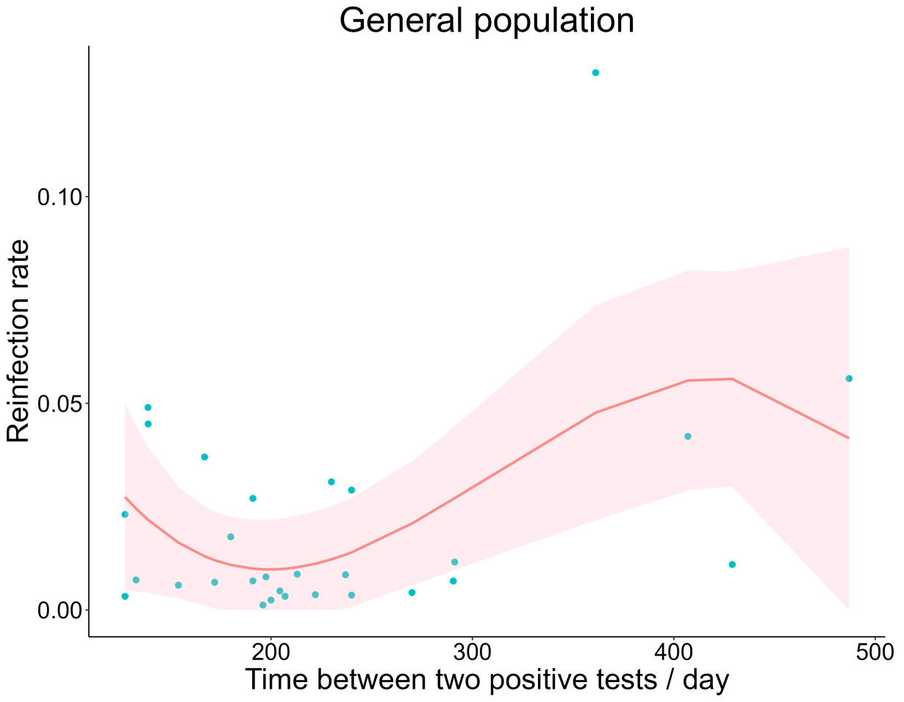

Figure 9-4. Natural spline regression of time-varying reinfection rates in the general population (blue dots represent the true values, and shaded part is 95% CI).

