Supplementary figure 1. The diagnostic performance for different methods of puncture fluid and tissue samples after using antibiotics.
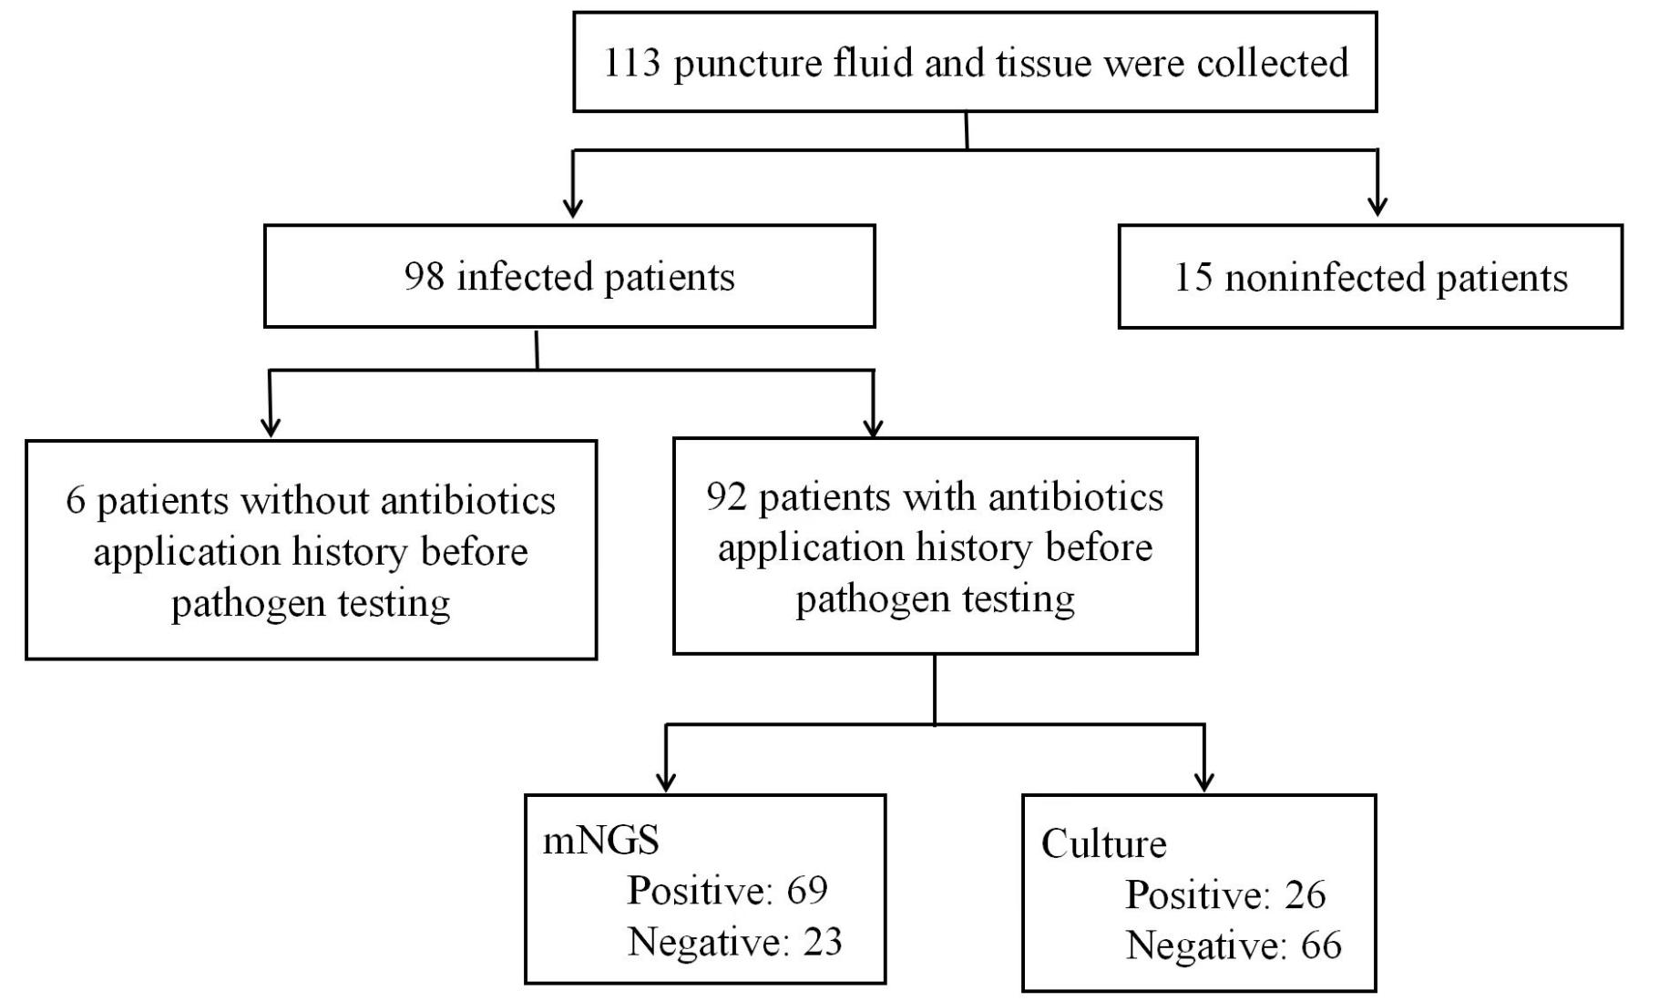

Supplemental table 1. The diagnostic performance of mNGS and culture in different sample types.
 | All |  |  | Blood |  |  | Puncture fluid |  |  | Tissue |  |  | BALF |  |  | CSF
 | mNGS | culture | p | mNGS | culture | p | mNGS | culture | p | mNGS | culture | p | mNGS | culture | p | mNGS | culture | p
Positive rates | 36.41% | 13.59% | 0.000 | 17.98% | 7.30% | 0.004 | 71.83% | 29.58% | 0.000 | 47.62% | 21.43% | 0.021 | 53.54% | 14.43% | 0.000 | 19.44% | 2.78% | 0.061
Sensitivity | 58.01% | 21.65% | 0.000 | 45.07% | 18.31% | 0.001 | 78.46% | 32.31% | 0.000 | 60.61% | 27.27% | 0.006 | 72.73% | 18.18% | 0.000 | 24.14% | 3.45% | 0.052
Specificity | 85.40% | 99.27% | 0.000 | 85.05% | 99.07% | 0.000 | 100% | 100% | 1 | 88.89% | 100% | 1 | 75% | 100% | 0.467 | 85.71% | 100% | 1
PPV | 87.01% | 98.84% | 0.047 | 66.67% | 92.86% | 0.111 | 100% | 100% | 1 | 95.24% | 100% | 1 | 92.31% | 100% | 1 | 87.5% | 100% | 1
NPV | 54.67% | 42.9% | 0.010 | 70% | 64.63% | 0.397 | 30% | 12% | 0.146 | 38.1% | 27.27% | 0.404 | 40% | 22.86% | 0.304 | 21.43% | 20% | 0.889

